Attendance Policy
St. Margaret’s Church of England Primary School
Date of Policy: | June 2024
Responsibility: | Attendance Leader – Ruth Boud
Review Date: | June 2025
Consultation: | This policy was developed, following local and national guidance, in consultation with staff and governors.

ETHOS STATEMENT

It is the aim of the Governing Body of St. Margaret’s Church of England Primary School to develop policies and procedures which support the school’s vision of:

Learn to Love, Love to Learn, Strive to Serve

INTRODUCTION

Improving attendance is everyone’s business. The barriers to accessing education are wide and complex, both within and beyond the school gates, and are often specific to individual pupils and families. Good attendance begins with school being somewhere pupils want to be and therefore the foundation of securing good attendance is that school is a calm, orderly, safe, and supportive environment where all pupils are keen and ready to learn.

Some pupils find it harder than others to attend school and therefore, at all stages of improving attendance, schools and partners should work in partnership with pupils and parents collaboratively to remove any barriers to attendance by building strong and trusting relationships and working together to put the right support in place.

AIMS

The Staff and Governing Body at St. Margaret’s Church of England Primary School give a high priority to its pupils’ educational achievement and believe that maximum pupil attendance and punctuality are essential in order for all children to achieve their full potential.

We are committed to meeting our obligations with regards to school attendance by:
- Promoting good attendance and reducing absence, including persistent absence
- Ensuring every pupil has access to full-time education to which they are entitled
- Acting early to address patterns of absence

We will also support parents/carers in their legal duty to ensure their children registered at the school attend regularly and punctually.

2. LEGISLATION & GUIDANCE

All children of compulsory school age are entitled to receive an efficient, full-time education suitable to their age, ability and aptitude and any special educational needs that they may have. It is the legal responsibility of every parent/carer to make sure their child receives that education either by attendance at a school or by education otherwise than school.

Whilst compulsory school age begins the term after a child turns 5 years old, all parents/carers who choose St. Margaret’s Church of England Primary for Nursery and Reception are expected to comply with the guidance set out in this Attendance Policy.

This policy meets the requirements, set out by the Department for Education (DfE), in Working Together to Improve School Attendance.

The policy further draws on the DfE’s statutory guidance about School Attendance Parents Responsibility Measures as well as the following legislation setting out the legal powers and duties that govern school attendance:
- Part 6 of The Education Act 1996
- Part 3 of The Education Act 2002
- Part 7 of The Education and Inspections Act 2006
- The Education (Pupil Registration) (England) Regulations 2006 (and 2010, 2011, 2013, 2016 amendments)
- The Education (Penalty Notices) (England) (Amendment) Regulations 2013

This policy also refers to the DfE’s guidance on the school census, which explains the persistent absence threshold.

3. ROLES & RESPONSIBILITIES

Statutory responsibilities for parents/carers, schools, governing bodies and local authorities are laid out in the Summary Table of Responsibilities for School Attendance. document. These responsibilities include, but are not limited to, the following:

3.1 The Governing Body:
The Governing Body is responsible for monitoring attendance figures for the whole school on at least a termly basis. It also holds the headteacher to account for the implementation of this policy.

They will:
- Recognise the importance of school attendance and promote it across the school’s ethos and policies. Ensure school leaders fulfil expectations and statutory duties.
- Regularly review attendance data, discuss, and challenge trends, and help school leaders focus improvement efforts on the individual pupils or cohorts who need it most.
- Ensure school staff receive adequate training on attendance.

3.2 The Head Teacher:
The Head Teacher, supported by the ECM Team in certain aspects, is responsible for:
- Effective implementation of this policy at the school
- Monitoring school-level absence data and reporting it to governors
- Supporting staff with monitoring the attendance of individual pupils
- Reviewing leave of absence requests and authorising the issuing of fixed-penalty notices, where necessary
- Maintaining oversight/authorisation of the removal from roll for any pupils (inc. elective home education requests) and part time timetable arrangements

3.3 The Attendance Leader:
The school Attendance Leader:
- Monitors attendance & lateness data across the school, at an organisational level as well as individual pupil level, and ensures appropriate completion/reconciliation of daily attendance registers
- Promotes a culture of attendance matters through effective communication with all stakeholders and an expectation of high standards related to attendance
- Reports concerns about attendance/absence (inc. persistent absence) to the Head Teacher, in order to agree appropriate support required
- Works with local authority education welfare officers & attendance support services to tackle persistent absence by providing support or enforcing expectations
- Arranges calls and meetings with parents to discuss attendance issues and formalise support
- Advises the Head Teacher when a penalty notice is appropriate in individual circumstances.

3.4 Class Teacher:
Class teachers are responsible for recording attendance on a daily basis, using the correct codes, and submitting this information to the school office. They will:
- Ensure that registers are taken at the start of each session
- Report any concerns relating to attendance to the Attendance Lead or Head Teacher
- Discuss attendance with parents/carers during parents evening appointments
- Promote a culture of attendance matters and respond to any training given in this area

3.5 Parents/Carers:
Parents/Carers have a key role to play, with legal responsibilities attached, in order to ensure regular attendance for their child at school. They will:
- Plan holidays outside of term time
- Consider whether it is wholly appropriate for the child/children to accompany adults in some circumstances where leave of absence in term time is required
- Complete all appropriate paperwork, and provide evidence requested, when children are absent from school
- Ensure their child attends school regularly in accordance with the Home School Agreement
- Seek to arrange any medical appointments outside of the school day hours
- Notify the school by phone by 8.50am on the day, or in advance, when their child is absent from school using the Attendance Line – 0121 357 2758 e.g. sickness or medical appointments

4. RECORDING ATTENDANCE

4.1 Attendance Register:
We will keep an attendance register and place all pupils onto this register. We will take our attendance register at the start of the first session of each school day and once during the second session. It will mark whether every pupil is:
- Present
- Absent

If a pupil is absent, codes will be applied appropriately in line with DfE guidance (see appendix 1). In order to support staff in entering the correct code, parents/carers may be requested to provide certain documentation.

Parents/carers will be given a printed summary of their child’s attendance record annually with end of year reports.

The sessions/timings of the school day are as follows:

DETAILS | NURSERY |  | RECEPTION | Y1 - Y2 | Y3-Y6
START OF DAY | 8.40am  (doors open at 8.35am) | 9.00am  (doors open at 8.45am)
END OF  AM SESSION | 11.40am |  | 12.10pm | 12.10pm | 12.20pm
START OF PM SESSION | 12.30pm |  | 1.10pm | 1.10pm | 1.20pm
END OF DAY | 3.30pm

Pupils must arrive in school by 9.00am on each school day. Gates are open between 8.45am – 9.00am to allow flexi- drop off. If a pupil arrives after this time, they will need to enter via the main entrance and will be marked as Late in the attendance register. Registers close promptly at 9.15am. Therefore, if a child arrives in school after this time, they will be marked as absent for the session.

If a child is not able to be present for their attendance mark, due to illness or a medical appointment (which cannot be made outside of school hours), certain evidence may be requested, e.g. hospital or GP letter. Where a child has a medical appointment in school hours, they are expected to return to school immediately after this if they are well enough to do so.

The register for the second session will be taken immediately after lunch at the start of the afternoon lessons. Registers close 10mins after the start of each session.

Punctuality will be monitored closely alongside attendance and action for unauthorised absences, due to arriving late after the register has closed, will be the same as an unauthorised session. If children are collected before the end of the day, their afternoon session may be marked as unauthorised and further action could be taken.

4.2 Unplanned Absence:
The pupil’s parent/carer must notify the school on the first day of an unplanned absence by 8.50am, or as soon as practically possible, (see also section 7) by:
- Calling the Attendance Line to speak with our admin team on 0121 357 2758
- Emailing the Office at postbox@st-margarets.sandwell.sch.uk

Parents/carers should not report absences to a child’s class teacher via another parent/carers or pupil. It is important that the office is informed directly from somebody who has parental responsibility for the child not attending school.

We will mark absence due to illness as authorised unless the school has a genuine concern about the authenticity of the illness and/or evidence requested has not been provided.

If the authenticity of the illness is in doubt, or a pupil has had a significant amount of absence due to ill health, the school may ask the pupil’s parent/carer to provide medical evidence, such as a doctor’s note, prescription, appointment card or other appropriate form of evidence. We will not ask for medical evidence unnecessarily.

If the school is not satisfied about the authenticity of the illness, the absence will be recorded as unauthorised and parents/carers will be notified of this in advance. Where an absence hasn’t been reported, parents/carers will be contacted during the morning requesting a response and reason for absence. Where this is not forthcoming, the absence will be classed as unauthorised and further action could be taken inc. home visits, welfare referrals (to police or social care) or further monitoring.
4.3 Planned Absence:
Parents/carers must also apply for other types of term-time absence as far in advance as possible of the requested absence (see Section 5 for more details).

Attending a medical or dental appointment will be counted as authorised as long as the pupil’s parent/carer notifies the school in advance of the appointment using the same methods as detailed above (for unplanned absences).

Wherever possible, all medical and dental appointments should be made outside of school time. Furthermore, it is expected that every effort is made to minimise the amount of time that the child is absent for the appointment, i.e. not leaving until just before the appointment and returning immediately afterwards. If an appointment is unavoidable, siblings must not be taken out of school. If they are taken out of school, this would be recorded as an unauthorised absence.

The school may request confirmation of medical appointments or medical support of illness or injury. Medical evidence can include items such as a GP slip or letter, appointment card or letter, the original prescribed medication or the prescription itself. Parents/carers should note that not all illnesses or injuries require a child to be absent from school. Further information about whether an illness requires time off from school or not can be found on the NHS website: www.nhs.uk/live-well/healthy-body/is-my-child-too-ill-for-school.

4.4 Lateness and Punctuality:
A pupil who arrives late:
- Before the register has closed will be marked as late, using the appropriate code
- After the register has closed will be marked as absent, using the appropriate code

Lateness is monitored, in the same way as pupil absence, by our Attendance Leader. Where concerns or patterns are spotted, parents/carers may be contacted and requested to attend a meeting to agree strategies to improve this. Where there is no improvement, further action could be taken or the case escalated to the Head Teacher and/or the Local Authority’s School Attendance Support Service.

The Attendance Leader also monitors attendance of classes, year groups or groups of pupils (e.g. FSM or SEND). Where data identifies trends or patterns, action will be taken by school staff to consider strategies to support or promote attendance for this group. This could include bespoke communication to those parents/carers or some individual programmes to strengthen expectations.

4.5 Absence Monitoring:
Where any pupil on our roll does not attend school, either on odd days/sessions or stops attending altogether, the school will:
- Follow up on their absence with their parent/carer to ascertain the reason on the first day of absence and any subsequent period of unexplained absence
- Ensure proper safeguarding action is taken where necessary
- Consider any support that may be necessary/appropriate for the pupil or their family
- Identify whether the absence is approved or not and/or whether referrals need to be made to any appropriate safeguarding or welfare services (inc. social workers and/or youth offending teams where necessary
- Identify the correct attendance code to use

4.6 Reporting Absence to Parents/Carers:
In addition to any ‘ad-hoc’ reporting of absence (e.g. when a concern has been identified), parents/carers are informed of their child’s attendance at least twice each year within mid-year and end of year reports. This information will include their child’s attendance and any appropriate comparison data such as class or national averages.

Parents/carers are given a printed summary of their child’s attendance record annually with end of year reports.

5. AUTHORISED & UNAUTHORISED ABSENCE

Absence will only be authorised if it is unavoidable, such as illness or a medical appointment which cannot be made outside of school time. In these circumstances, proof such as a hospital letter or prescription may be requested.

If no reason is given for an absence, this will be recorded as unauthorised. It is the responsibility of the parent/carer to notify the school of any absences and give valid reasons for them. Failure to report absences within the guidelines set out in this policy will automatically result in that absence being recorded in the register as unauthorised. This may result in further action being taken if we are not informed of the whereabouts of the pupil and could possibly result in a missing child referral.

5.1 Term Time Leave of Absence Requests:
The Head Teacher will only grant a leave of absence to pupils during term time if they consider there to be 'exceptional circumstances'. A leave of absence is granted at the Head Teacher’s discretion and this decision is final (i.e. it is not possible to appeal the decision taken with the Governing Body). The law does not grant parents the automatic right to take their child out of school during term time and the judgement of the Supreme Court in the case of R v Platt [2017] asserts that even one day of missed school could be an infraction of the law.

In line with the Department of Education regulations, which came into effect in September 2013, the Head Teacher may only grant a leave of absence during term time if there are exceptional circumstances which include, as examples, the following circumstances:
- Death of parent/carer or sibling of the pupil
- Life threatening or critical illness of parent or sibling of the pupil
- Parent/carer recuperation and convalescence from critical illness or surgery (leave request to be made within 6 months of recovery and medical evidence required)
- Leave for armed forces personnel who are prevented by operational duties to take leave at any other time
- Leave of absence already granted by a previous school or local authority (granted within the last six months and supported by documentation from the previous school)

Absences from school for the purposes of a term-time holiday will not be authorised unless there are exceptional circumstances which are considered on a case by case basis.

It is a legal requirement that parents/carers obtain the permission of the Head Teacher before removing their child from school. If a parent/carer wishes to make an application for a term-time absence, this must be done in advance of the absence by the parent/carer with whom the child normally lives. This request must be made in writing by completing a Leave Of Absence Form which can be obtained from the school office or available to download from the school website.

This must be then handed in to the office for the Head Teacher to review at least six weeks in advance. The Attendance Lead, in consultation with the Head Teacher, will formally reply to any applications. This reply will explain whether the absence is authorised or not and explain any action needed, e.g. contact with the Head Teacher to sign a home-school contract.

The Head Teacher (or a representative of the Head Teacher) and the Governing Body are within their rights to decline an application and refuse permission for parents/carers to take their children out of school during term time. Such a decision will have been made in the best interest of the pupils’ educational progress and attainment and with due regard to their previous attendance record. If the child is subsequently taken out of school this absence will be recorded as ‘unauthorised’.

Parents/carers who take their children out of school during term time without the authorisation of the Head teacher not only damage their children’s educational opportunities but also risk being issued with a penalty notice, being prosecuted in court and losing the child’s place at the school.

Where absence has been authorised, failure to agree and/or return a home-school contract, or not return to school by the agreed date, could cause further action to be taken, including the pupil losing his/her place at the school.

When making a decision, the Head Teacher will consider a range of circumstances in addition to reason for absence including the child’s previous attendance, the dates requested (e.g. impact on public examinations or assessments), the length of absence and the welfare needs of the child.

Family emergencies need careful consideration. It is not always in the best interests of the child nor wholly appropriate for them to miss school for family emergencies that are being dealt with by adult members. School and school friendships/relationships can provide the children with stability and care during difficult times. The routine of school can provide a safe and familiar anchor to life during times of upheaval.

However, where the Head Teacher judges there to be genuine and pressing reasons for a child to be absent during term time, they may only agree up to a maximum of 5 days’ absence in any one school year. It must be clear that the 5 days is not an entitlement for any individual but can be used, at the discretion of the Head Teacher, for exceptional circumstances.

If a child is involved in a sporting event or a performance, which requires time out of school, then a license may need to be applied for. In this situation, parents/carers should write to the Head Teacher with the details and official confirmation from the organising body. The Head Teacher will then liaise with the Local Authority’s licensing team.

If a parent/carer chooses to electively home educate their child, and effectively remove them from roll at St. Margaret’s Church of England Primary School, they must put this in writing. Parents/Carers should ensure their child still attends school until a removal from roll date has been agreed, in writing, with the Head Teacher.

5.2: Religious & Cultural Observance:
St. Margaret’s Church of England Primary School acknowledge and welcomes the multi-faith nature of our school community and recognise that some families’ important religious festivals may fall within term time.

Government guidance says a pupil can be absent “on a day exclusively set aside for religious observance by the religious body to which the parent/carer belongs”. However, attending school regularly and on time is also an important legal responsibility for parents/carers. Therefore, there are occasions where the Head Teacher may request a conversation with parents/carers about time requested for religious observance if there are wider concerns about a child’s attendance.

At the Head Teacher’s discretion, a limited amount of time may be authorised for religious observance. This would usually be no more than one day per term and a maximum of three days in any academic year for religious observance. In order to authorise this absence, the Head Teacher may request additional written confirmation from the place of worship to which a family belongs.

In addition to religious observance, St. Margaret’s Church of England Primary School regonises the importance of cultural identity for its pupils and understands the conflicting pressures for families living in the UK from abroad. Nevertheless, whilst sympathetic to the need of families to remain in contact with relatives and their ‘heritage’ overseas, The Head Teacher will seldom authorise exceptional leave of absence for extended visits abroad because of the consequences for pupils’ attendance and learning. In line with guidance detailed above, if the Head Teacher determined there are exceptional circumstances for a pupil to be absent from school, a maximum of 5 days in any academic year would be authorised.

5.3 Penalty Notices:
A penalty notice is an out of court settlement which is intended to change behaviour without the need for criminal prosecution. If repeated penalty notices are being issued and they are not working to change behaviour they are unlikely to be most appropriate tool. Therefore, only 2 penalty notices can be issued to the same parent/carer in respect of the same child within a 3 year rolling period and any second notice within that period is charged at a higher rate:

- The first penalty notice issued to a parent/carer in respect of a particular pupil will be charged at £160 if paid within 28 days. This will be reduced to £80 if paid within 21 days.
- A second penalty notice issued to the same parent/carer in respect of the same pupil is charged at a flat rate of £160 if paid within 28 days.
- A third penalty notice cannot be issued to the same parent/carer in respect of the same child within 3 years of the date of issue of the first. In a case where the national threshold is met for a third time (or subsequent times) within those 3 years, alternative action should be taken instead. This will often include considering prosecution, but may include other tools such as one of the other attendance legal interventions.

Penalty Notices may be issued to parents/carers by Sandwell Metropolitan Borough Council, on behalf of the school, for any unauthorised absences of 10 or more sessions (5 or more days) in a rolling period of 10 school weeks, including, but not limited to, absences for term-time holidays, sporadic unauthorised absences or illness where supporting medical evidence has been requested by the school but not supplied by the parent/carers.

During the 10 week period (which can span different school years), the school will attempt to make at least three points of contact (i.e. phone, letter or home visit). If, at any point, there are safeguarding concerns (i.e. we are not able to locate a child or make contact) then, we may have no option but to make a referral to Children’s Services and/or the police. This could also result in a referral to the Child Missing Education (CME) team. Therefore, it is always important to maintain contact when children are absent. Furthermore, these attempts at contact demonstrate that a referral for a penalty notice or prosecution really are a last resort.

The amount of a Penalty Notice is £80 per parent/carer, per child if paid within 21 days, rising to £160 if paid between 22 and 28 days. If the Penalty Notice is not paid the parent/carer may be prosecuted for the offence of failing to ensure their child’s regular attendance at school. Any parents/carers with parental responsibility, even if they are currently living at a different address, may also be liable.

Section 23(1) Anti-Social Behaviour Act 2007:
Penalty notices may be issued to the parent of pupils who have unauthorised absence from school. The amount of the penalty is £80.
- If this is not paid within 21 days the amount rises to £120.
- If not paid within 28 days the Local Authority will prosecute under section 444(1) unless it comes to our attention that the penalty notice had been issued in error.

Section 444(1) Education Act 1996:
“If you are the parent of a child of compulsory school age who fails to attend school regularly, you are guilty of an offence.”
The court can fine each parent up to £1,000 per child, order payment of the prosecution costs and/or make a Parenting Order.

These prosecutions are criminal proceedings and could result in you having a criminal record.

A full copy of Sandwell LA’s ‘Penalty Notice Code of Conduct’ can be obtained upon request either at school or by contacting Sandwell’s School Attendance Support Service at

attendance_service@sandwell.gov.uk.

5.4 Children Missing Education (CME):
Children are classed as missing education when they are not registered at a school or receiving suitable provision elsewhere and are of compulsory school age. To avoid children becoming CME, it is important that they are placed on and off a school roll according to Department for Education (DfE) guidelines. It is vital that schools and local authorities work together to safeguard children and ensure that they receive their educational entitlement.

At St. Margaret’s Church of England Primary School, we work closely with the Local Authority and inform them when we have concerns over a child missing education.

These are the practices that we have put in place in order to safeguard children from becoming CME:

- Pupils are entered onto the admission register at the beginning of the first day that child is due to attend. If the child fails to attend then enquiries will be made to establish their whereabouts and Sandwell Metropolitan Borough Council (SMBC) will be notified. If a place is enquired about for a child who is not currently on roll at a Sandwell school, and a place is not available, the school will notify SMBC.
- If a pupil does not return to school for ten days after an authorised leave of absence, or is absent without authorisation for twenty days, the pupil can be removed from the admission register. This can only be done if the school and SMBC have made reasonable enquiries to establish the whereabouts of the child.
- If a child is temporarily excluded from school for more than five days, the governing body will arrange suitable alternative full-time education. This must begin no later than the sixth day of exclusion. For permanent exclusions, the local authority will provide alternative education.
- Attendance will be monitored through our daily registers and any unexplained absences will be investigated as part of our safeguarding duty.
- The school will notify SMBC when a pupil’s name is removed from the school admission register at non-standard transition points.
- The school will notify SMBC within five days of adding a pupil’s name to the admission register at a non-standard transition point.
- If the school cannot locate a pupil by reasonable enquiries (emergency contacts, home visits, contacting other professionals involved with the family), then a Pupil Tracking Referral must be made.

If a child is not able to attend school, due to being incapacitated, chronically poorly or for any other long-term medical condition, the school will agree appropriate provision with the parent/carer and any other professionals involved. This could include a hybrid range of activities such as remote education provided by St. Margaret’s Church of England Primary School alongside any other provision allocated such as hospital education or tutoring.

Ordinarily, school would only look to set work/refer to Hospital Education when pupils are absent for 10 consecutive school days or more with decisions being made on a case by case basis.

5.5 Reducing Persistent Absence:
The school has a responsibility to work with parents/carers, and the LA School Attendance Support Service, to reduce persistent absence rates (i.e. to reduce the number of children whose attendance is less than 90% at school). Action is therefore taken, at different stages, to achieve this goal and this is summarised in our Attendance Strategy which is attached in the appendices of this policy.

- Actions include, but are not limited to, the following:
- Meetings with parents/carers and pupils
- Action plans agreed with any support required identified
- Referrals to education welfare/support services as necessary
- Support within school
Where there is no improvement to attendance for pupils identified as persistently absent, legal sanctions may be pursued (as detailed in Section 5.2) where there is no other alternative.
The Attendance Leader monitors attendance for all pupils at the school so may seek to intervene and work with families before a pupil is identified as persistently absent. This is because we know that attendance of less than 95% (i.e. absences of 9.5 days or more out of the 190 pupil days in the school year) has been shown to compromise pupil attainment.

The pupils with the highest attainment at the end of key stage 2 and key stage 4 have higher rates of attendance over the key stage compared to those with the lowest attainment. At KS2, pupils not meeting the expected standard in reading, writing and maths had an overall absence rate of 4.7%, compared to 3.5% among those meeting the expected standard. Moreover, the overall absence rate of pupils not meeting the expected standard was higher than among those meeting the higher standard (4.7% compared to 2.7%). At KS4, pupils not achieving grade 9 to 4 in English and maths had an overall absence rate of 8.8%, compared to 5.2% 9 among those achieving grade 42. The overall absence rate of pupils not achieving grade 9 to 4 was over twice as high as those achieving grade 9 to 5 (8.8% compared to 3.7%). We do not want children’s outcomes being negatively affected by their attendance!

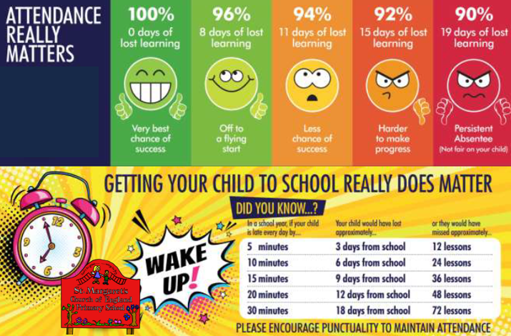

5.5 Part Time Timetables:
In very exceptional circumstances, where it is in a pupil’s best interests, there may be a need for a school to provide a pupil of compulsory school age with less than full-time education through a temporary part-time timetable to meet their individual needs. For example, where a medical condition prevents a pupil from attending school or another setting full-time and a part-time timetable is used to help the pupil access as much education as possible. A part-time timetable should not be used to manage a pupil’s behaviour.

A part-time timetable should:
- Have the agreement of both the school and the parent the pupil normally lives with.
- Have a clear ambition and be part of the pupil’s wider support, health care or reintegration plan.
- Have regular review dates which include the pupil and their parents to ensure it is only in place for the shortest time necessary.
- Have a proposed end date that takes into account the circumstances of the pupil, after which the pupil is expected to attend full-time, either at school or alternative provision. It can, however, be extended as part of the regular review process. In some limited cases, a pupil with a long-term health condition may require a part-time timetable for a prolonged period.

NB: the school’s approach to part time timetables is detailed in a separate protocol document which is available upon request.

6. STRATEGIES FOR PROMOTING ATTENDANCE

At St. Margaret’s Church of England Primary School, we use a variety of strategies to maximise attendance and punctuality including, but not limited to, the following.

- Weekly attendance celebrations within our Friday worship
- Engagement in attendance incentives which are varied each year, e.g. badges for 100% attendance
- Letters home for children who have been working hard to improve their attendance (these are the children who have previously fallen below the expected 96%).
- Attendance leader to have meetings, calls and write letters to parents when attendance becomes a concern.
- Parent contract meetings to take place where a child’s attendance is causing us a concern and having a negative impact on their learning

7. ATTENDANCE MONITORING

The Attendance Leader at our school monitors pupil absence on a daily basis with reports compiled half termly for the Head Teacher and Governing Body.

A pupil’s parent/carer is expected to call the school in the morning if their child is going to be absent due to ill health (see section 4.2). Parents/carers will be advised, when reporting illness on the first day of absence, whether calls are required each day of absence. This will usually depend on the circumstances of their child’s illness.

If a pupil’s absence causes concern, the school will contact the parent/carer of the pupil to discuss the reasons for this.

If a pupil’s absence continues to rise after contacting their parent/carer, we will consider involving an education welfare officer and/or somebody from the LA Attendance Support Service.
The persistent absence threshold is 10%. If a pupil's individual overall absence rate is greater than or equal to 10%, the pupil will be classified as a persistent absentee.

Pupil-level absence data will be collected each term and published at national and local authority level through the DfE's school absence national statistics releases. The underlying school-level absence data is published alongside the national statistics. The school will compare attendance data to the national average and share this with the governing board.

Attendance data will be collected and used to:
- Track the attendance of individual pupils
- Identify whether or not there are particular groups of children whose absence may be a cause for concern
- Monitor and evaluate those children identified as being in need of intervention and support

Attendance is everyone’s business so in many of these cases school will not be able to fully support a pupil without the assistance of a range of other agencies. Therefore, following any monitoring, school should:

- Make use of school nursing services and mental health support teams where they are available.
- Consider whether additional support from other external partners (including the local authority, children and young people’s mental health services, GPs or other health services) would be appropriate and make referrals.
- Where external support is provided work together with those services to deliver any subsequent support.

If the child has an education, health and care plan, school staff should:

- Communicate with the Local Authority where a pupil’s attendance falls or they become aware of barriers to attendance that relate to the pupil’s needs.
- Where possible agree adjustments to its policies and practices that are consistent with the special educational provision set out in the education, health and care plan in collaboration with parents.
- Where needed work with the Local Authority to review and amend the education, health and care plan to incorporate the additional or different attendance support identified.

Our Attendance Leader is Mrs Ruth Boud (Deputy Headteacher) and she can be contacted, via the school office:
- postbox@st-margarets.sandwell.sch.uk
- 0121 357 2758

Sandwell’s School Attendance Support Service can be contact at:

attendance_service@sandwell.gov.uk

8. MONITORING

This policy will be reviewed as guidance from the Local Authority or DfE is updated, and as a minimum, each year in line with the Policy Review Schedule.

9. LINKS WITH OTHER POLICIES

This policy links to the following policies:
- Safeguarding & Child Protection Policy
- Behaviour Policy
- Inclusion Policy

Appendix 1: Attendance Codes
The following codes are taken from the DfE’s guidance on school attendance:

Attending the school
/ \ | Present at the school / = morning session \ = afternoon session
L | Late arrival before the register is closed
K | Attending education provision arranged by the local authority
V | Attending an educational visit or trip
P | Participating in a sporting activity
W | Attending work experience
B | Attending any other approved educational activity
D | Dual registered at another school
Absent – Leave of absence
C1 | Leave of absence for the purpose of participating in a regulated performance or undertaking regulated employment abroad.
M | Leave of absence for the purpose of attending a medical or dental appointment
J1 | Leave of absence for the purpose of attending an interview for employment or for admission to another educational institution
S | Leave of absence for the purpose of studying for a public examination
X | Non-compulsory school age pupil not required to attend school
C2 | Leave of absence for a compulsory school age pupil subject to a part-time timetable
C | Leave of absence for exceptional circumstance
Absent – other authorised reasons
T | Parent travelling for occupational purposes
R | Religious observance
I | Illness (not medical or dental appointment)
E | Suspended or permanently excluded and no alternative provision made
Absent – unable to attend school because of unavoidable causes
Q | Unable to attend the school because of a lack of access arrangements
Y1 | Unable to attend due to transport normally provided not being available
Y2 | Unable to attend due to widespread disruption to travel
Y3 | Unable to attend due to part of the school premises being closed
Y4 | Unable to attend due to the whole school site being unexpectedly closed
Y5 | Unable to attend as pupil is in criminal justice detention
Y6 | Unable to attend in accordance with public health guidance or law
Y7 | Unable to attend because of any other unavoidable cause
Absent – unauthorised absence
G | Holiday not granted by the school
N | Reason for absence not yet established
O | Absent in other or unknown circumstances
U | Arrived in school after registration closed
Administrative Codes
Z | Prospective pupil not on admission register
# | Planned whole school closure

Appendix 2: Attendance Strategy
The school’s attendance strategy is summarised as follows:

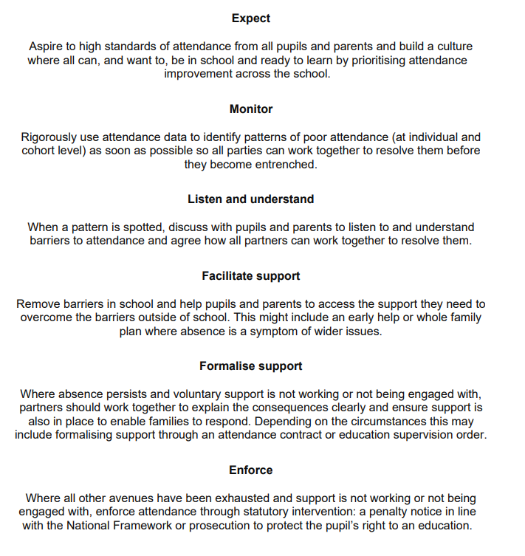

Appendix 3: Effective School Attendance Management
The school adopts the following approach in its improvement and management of school attendance:

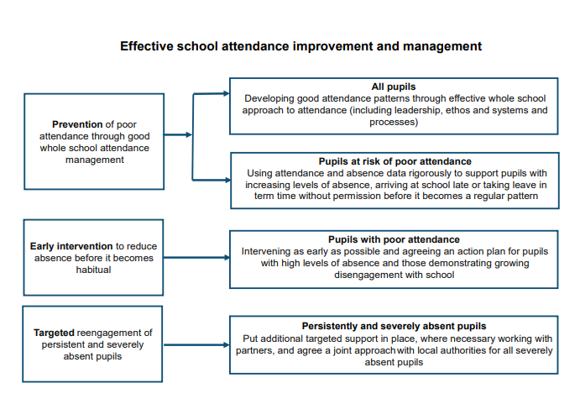

Appendix 4: Support First, Enforce Later
The school’s policy and procedures are designed to work with families in a supportive way before any enforcement strategies are considered:

