**ST MARGARET’S CE VA PRIMARY SCHOOL**

MENTAL HEALTH AND WELLBEING POLICY

“Encourage one another and build each other up”

1 Thessalonians 5:11

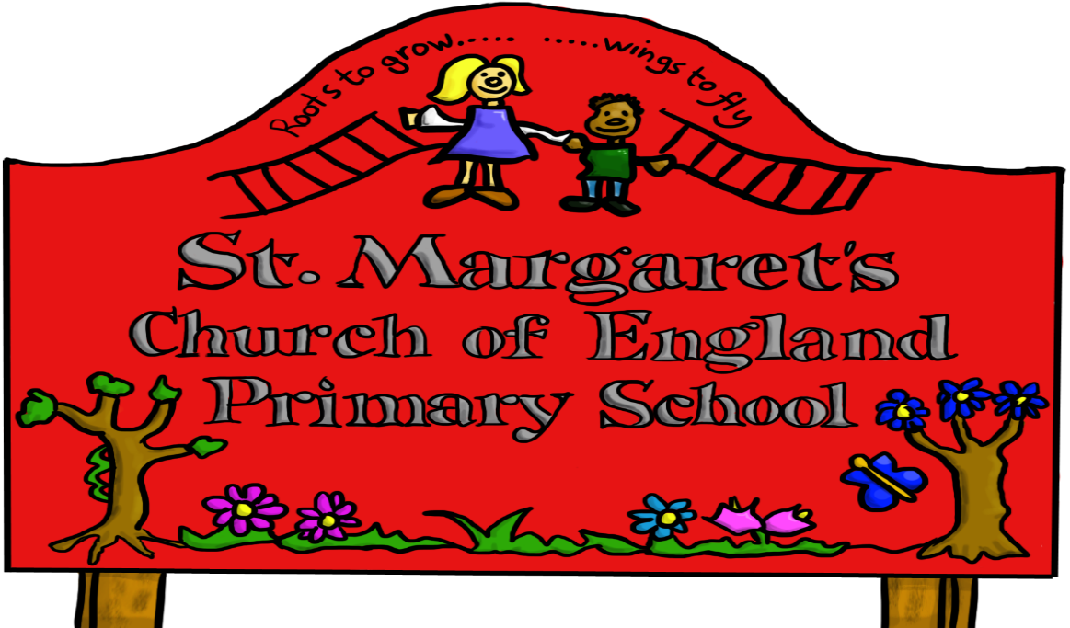

|  |  |  |
| --- | --- | --- |
| **Approved by:** | Governors | **Date:** |
| **Last reviewed on:** | March 2022 | |
| **Next review due by:** | December 2025 | |

**Policy Statement**

At St Margaret’s CE Primary School, we are committed to supporting the emotional health and wellbeing of our pupils and staff.

We have a supportive and caring ethos and our approach is respectful and kind, where each individual and contribution is valued.

At our school we know that everyone experiences life challenges that can make us vulnerable and at times, **anyone** may need additional emotional support. We take the view that positive mental health is everybody’s business and that we all have a role to play.

At our school we:

* help children to understand their emotions and feelings better
* help children feel comfortable sharing any concerns or worries
* help children socially to form and maintain relationships.
* promote self- esteem and ensure children know that they count.
* encourage children to be confident and ‘dare to be different’
* help children to develop emotional resilience and to manage setbacks.

We promote a mentally healthy environment through:

* Promoting our school values and encouraging a sense of belonging.
* Promoting pupil voice and opportunities to participate in decision-making
* Celebrating academic and non-academic achievements
* Providing opportunities to develop a sense of worth through taking responsibility for themselves and others
* Providing opportunities to reflect.
* Access to appropriate support that meets their needs

We pursue our aims through:

* Universal, whole school approaches
* Support for pupils going through recent difficulties including bereavement.
* Specialised, targeted approaches aimed at pupils

**Scope**

This policy should be read in conjunction with our Medical policy and our SEND policy in cases where pupils mental health needs overlap with these. This policy should also be read in conjunction with policies for Behaviour and Anti-bullying, and PSHE and SMSC policies. It should also sit alongside child protection procedures.

**Lead Members of Staff**

Whilst all staff have a responsibility to promote the mental health of students, staff with a specific, relevant remit include:

* Mrs J Stackhouse- Designated Safeguarding Lead
* Mr S Jones – Deputy Designated Safeguarding Lead / Mental Health and Emotional wellbeing lead / SENCo
* Miss Emma Hale- Nursery Teacher / SENCo Assistant
* Mrs K Hamilton- Learning Mentor

**Teaching about Mental Health**

The skills, knowledge and understanding needed by our students to keep themselves mentally healthy and safe are included as part of our developmental PSHE curriculum- Jigsaw. Teaching will also include resources from the ‘Healthy Mind, Happy Me’ Curriculum.

The specific content of lessons will be determined by the specific needs of the cohort we’re teaching but we will also use the PSHE Association Guidance to ensure that we teach mental health and emotional wellbeing issues in a safe and sensitive manner.

**Targeted support**

The school will offer support through targeted approaches for individual pupils or groups of pupils which may include:

o Circle time approaches or ‘circle of friends’ activities.

o Targeted use of SEMH resources.

o Managing feelings resources e.g. ‘worry boxes’

o Managing emotions resource

o Primary Group Work/Mental health and wellbeing groups

o Therapeutic activities including art, lego and relaxation and mindfulness techniques.

The school will make use of resources to assess and track wellbeing as appropriate including:

o Strengths and Difficulties questionnaire

o The Boxall Profile

**Signposting**

We will ensure that staff, pupils and parents are aware of what support is available within our school and how to access further support.

**Identifying needs and Warning Signs**

All staff will be aware of and consider the following indicators that may suggest a child or staff member is in need of support:

* Attendance
* Punctuality
* Relationships
* Approach to learning
* Physical indicators
* Negative behaviour patterns
* Family circumstances
* Recent bereavement
* Health indicators

School staff may also become aware of warning signs which indicate a student is experiencing mental health or emotional wellbeing issues. These warning signs should always be taken seriously and staff observing any of these warning signs should communicate their concerns with the designated child protection and safeguarding lead or the emotional wellbeing lead as appropriate.

Possible warning signs include:

* Changes in eating / sleeping habits
* Becoming socially withdrawn
* Changes in activity and mood
* Talking or joking about self-harm or suicide
* Expressing feelings of failure, uselessness or loss of hope
* Repeated physical pain or nausea with no evident cause
* An increase in lateness or absenteeism

**Working with Parents**

In order to support parents we will:

* Highlight sources of information and support about mental health and emotional wellbeing on our school website
* Share and allow parents to access sources of further support e.g. through parent forums.
* Ensure that all parents are aware of who to talk to, and how to get about this, if they have concerns about their child.
* Make our emotional wellbeing and mental health policy easily accessible to parents
* Share ideas about how parents can support positive mental health in their children.
* Keep parents informed about the mental health topics their children are learning about in PSHE and share ideas for extending and exploring this learning at home.

**Working with other agencies and partners**

As part of our targeted provision the school will work with other agencies to support children’s emotional health and wellbeing including:

o The school nurse

o Educational psychology services

o Behaviour support through Inclusion Support

o Paediatricians

o CAMHS (child and adolescent mental health service)

o Counselling services

o Therapists

**Training**

As a minimum, all staff will receive regular training about recognising and responding to mental health issues as part of their regular child protection training in order to enable them to keep students safe.

The MindEd <https://www.minded.org.uk/> learning portal provides free online training suitable for staff wishing to know more about a specific issue.

Training opportunities for staff who require more in-depth knowledge will be considered as part of our performance management process and additional CPD will be supported throughout the year where it becomes appropriate due to developing situations with one or more pupils.

S Jones

Mental Health and Wellbeing Lead

March 2022