“Encourage one another and build each other up”

1 Thessalonians 5:11

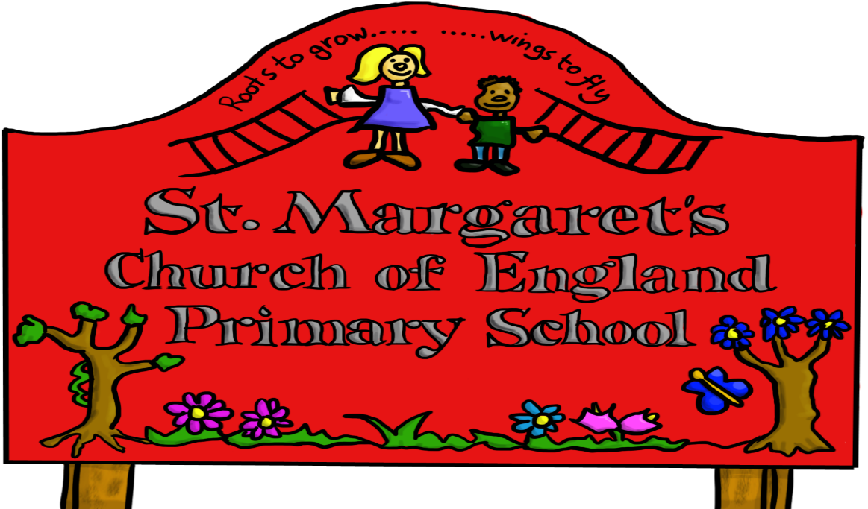

Reviewed Jan 2021

We tell your children that **they should not behave any differently when they are out of school or using their own device or home network.** What we tell pupils about behaviour and respect applies to all members of the school community, whether they are at home or school:

**“Treat yourself and others with respect at all times; treat people in the same way when you are online or on a device as you would face to face.”**

# What am I agreeing to?

1. I understand that St Margaret’s CE VA Primary uses technology as part of the daily life of the school when it is appropriate to support teaching & learning and to help prepare the children and young people in our care for their future lives.
2. I will promote positive online safety and model safe, responsible and positive behaviours in my own use of technology, including on social media: not sharing other’s images or details without permission and refraining from posting negative, threatening or violent comments about others, including the school staff, volunteers, governors, contractors, pupils or other parents/carers.
3. The impact of social media use is often felt strongly in schools, which is why we expect certain behaviours from pupils when using social media. I will ensure always check the minimum age limits on games and apps.
4. I will follow the school’s digital images and video policy, which outlines when I can capture and/or share images/videos. I will not share images of other people’s children on social media and understand that there may be cultural or legal reasons why this would be inappropriate or even dangerous. The school sometimes uses images/video of my child for internal purposes such as recording attainment, but it will only do so publicly if I have given my consent on the relevant form.
5. I understand that for my child to grow up safe online, s/he will need positive input from school and home, so I will talk to my child about online safety.
6. **I understand that my child needs a safe and appropriate place to do remote learning if school or bubbles are closed (similar to regular online homework). When on any video calls with school, it would be better not to be in a bedroom but where this is unavoidable, my child will be fully dressed and not in bed, and the camera angle will point away from beds/bedding/personal information etc. Where it is possible to blur or change the background, I will help my child to do so.**
7. I understand that whilst home networks are much less secure than school ones, I can apply child safety settings to my home internet. Internet Matters provides guides to help parents do this easily for all the main internet service providers in the UK. There are also child-safe search engines e.g. swiggle.org.uk and YouTube Kids is an alternative to YouTube with age appropriate content.
8. I understand that it can be hard to stop using technology sometimes, and I will talk about this to my children, and refer to the principles of the Digital 5 A Day: [childrenscommissioner.gov.uk/our-work/digital/5-a-day/](https://www.childrenscommissioner.gov.uk/our-work/digital/5-a-day/)
9. I understand and support the commitments made by my child in the Acceptable Use Policy (AUP) which s/he has signed.

To find out more about online safety please read our Online Safety Policy

**I/we have read, understood and agreed to this policy.**

**Signature/s: _______________________________________**

**Name/s of parent / guardian: _______________________________________**

**Parent / guardian of: _______________________________________**

**Date: _______________________________________**