
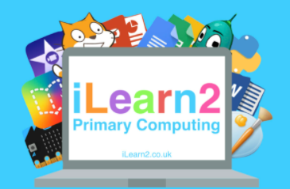
Computing
Whole School Overview
EYFS
In Nursery and Reception, they use interactive toys and games which involve different computing aspects. Computing is taught in a cross-curricular approach weekly. Here are different apps/websites they use within lessons throughout the academic year.

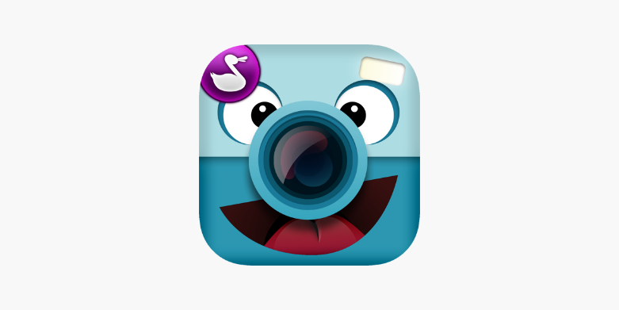
Camera – using an iPad to take a picture of people, objects and plants.
Chatterkid - using technology to create a talking character (taking a picture with an iPad and recording a voice)
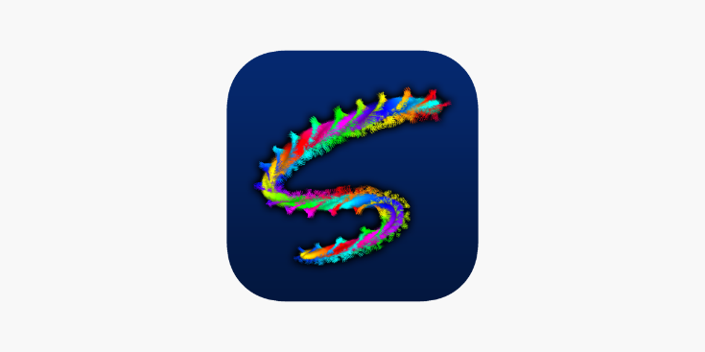
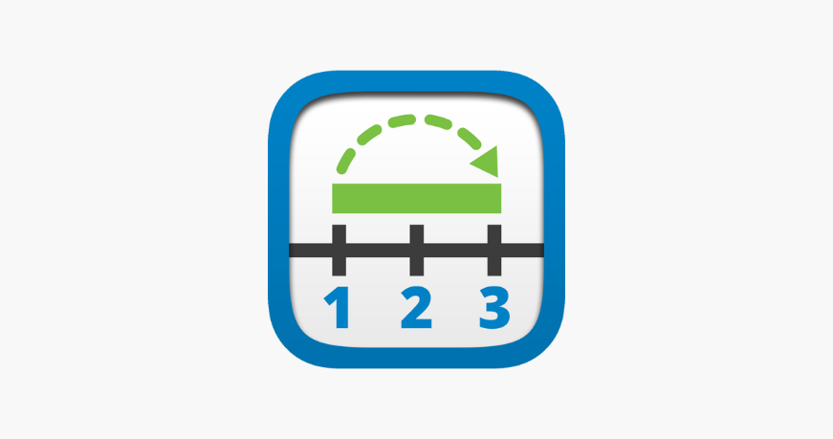
Scribblify – digital art using your finger. (Phonics writing and creating pictures)
Interactive Number lines in Maths (using a touchscreen and dragging items)

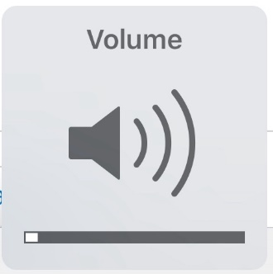

Sound/volume – using headphones and sound buttons to listen to videos and clicking pause/play
Top Marks website – literacy/phonics and maths games involving drag and drop and double clicking
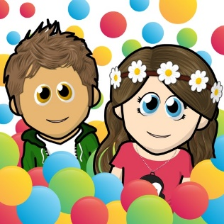
Wonder world – creating a character (using drag and drop with your finger to select different outfits and styles)


GarageBand – listen to sounds of different instruments and identify pitch

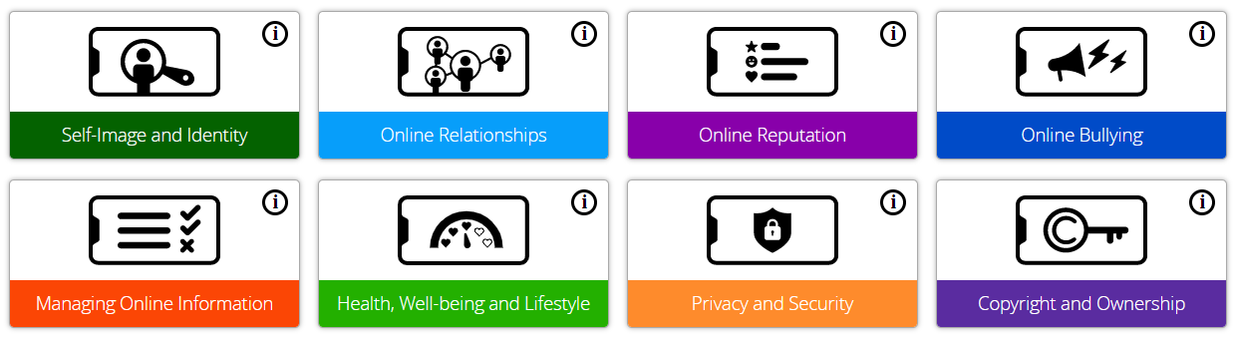
All year groups teach the following online safety strands throughout the academic year:

Year 1
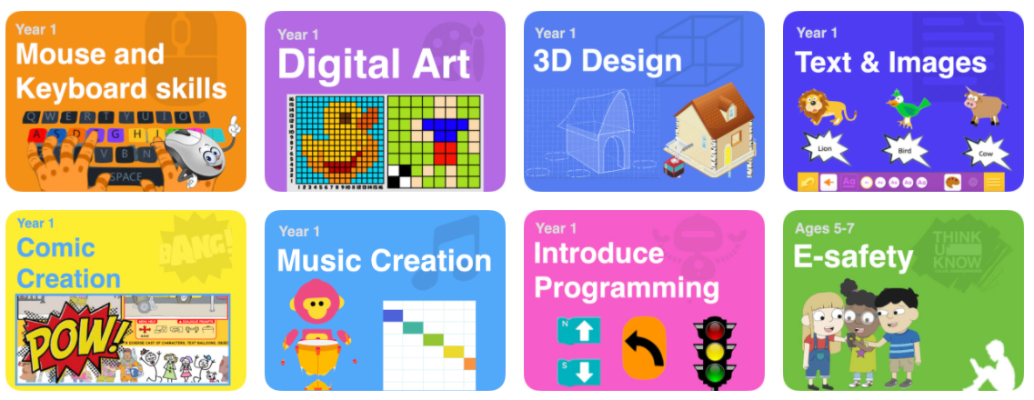
Mouse and keyboard skills is an on-going topic throughout the year
Autumn term |  |  |  |  | Music creation  Text & images
Spring term |  |  |  |  | Comic creation  Digital Art
Summer term |  |  |  |  | Introducing Programming  3D design
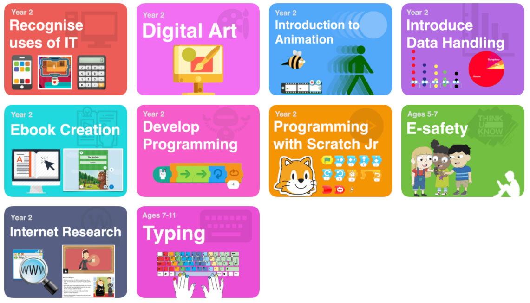
Year 2
Typing is an on-going topic throughout the year
Autumn term |  |  |  | Recognise uses of IT  Digital Art  Animation
Spring term |  |  |  | Internet Research  Develop programming  Programming with Scratch Jr
Summer term |  |  |  | Data Handling  e-Book creation
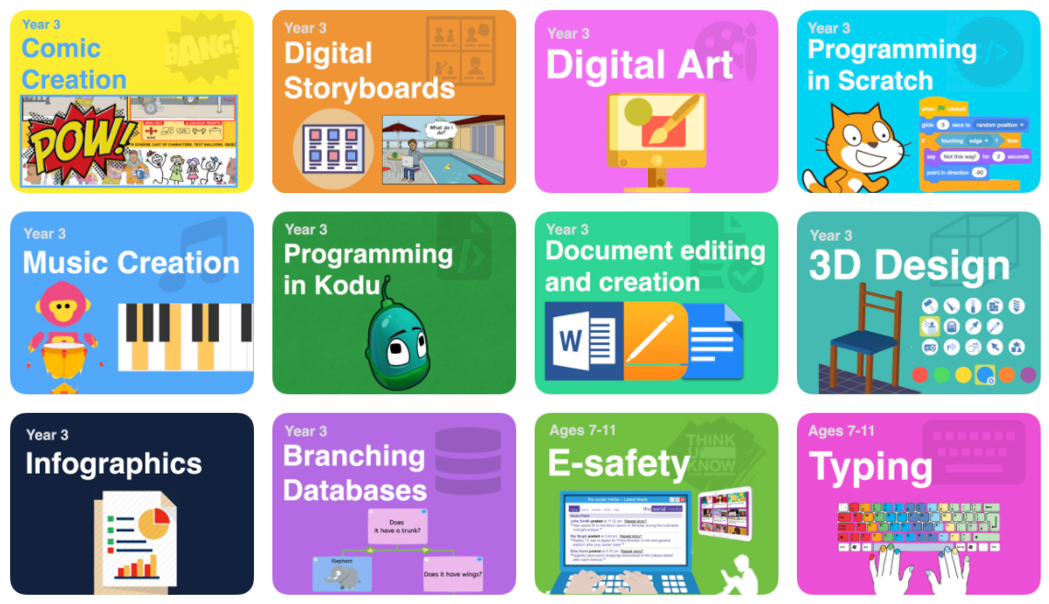
Year 3
Typing is an on-going topic throughout the year
Autumn term |  | Programming in Kodu  Comic creation  Digital Art
Spring term |  | 3D design  Music Creation  Digital Storyboards  Document editing and creation
Summer term |  | Branching Databases  Infographics  Programming in Scratch
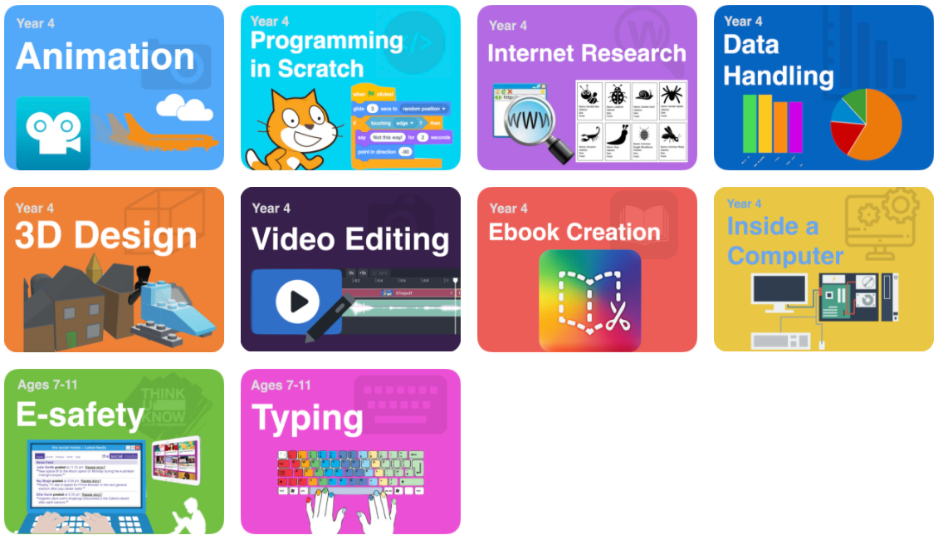
Year 4
Typing is an on-going topic throughout the year
Autumn term |  |  | Programming in Scratch  Animation
Spring term |  |  | Internet Research  E-book creation
Summer term |  |  | Data handling  3D design  Video editing
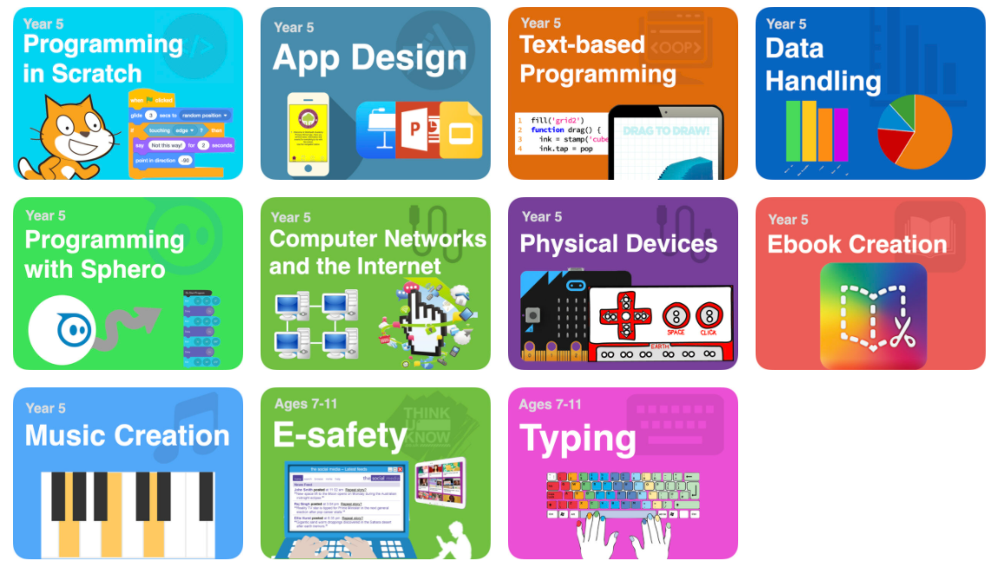
Year 5
Typing is an on-going topic throughout the year
Autumn term |  | App design  Data Handling  Compter Networks
Spring term |  | Music Creation  eBook creation  Programming in Scratch
Summer term |  | Text based programming  Programming with Sphero  Physical devices
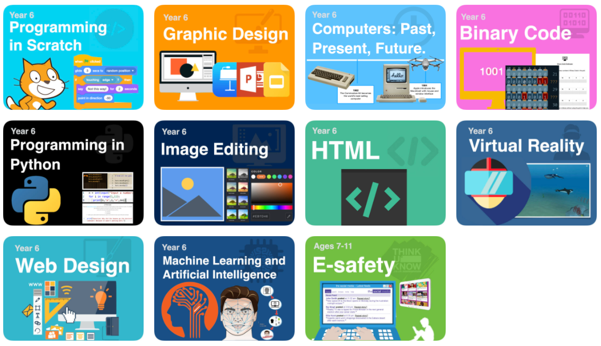
Year 6
Autumn term | Programming in Scratch  Binary Coding  Graphic design  Machine Learning & Artificial Intelligence
Spring term | HTML  Programming in Python  Web design  Image Editing
Summer term | Computers: Past, Present and future  Virtual Reality

