Parent Survey 2020-2021

July 2021

40 Responses

1. My child enjoys school

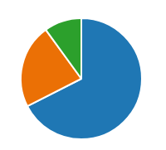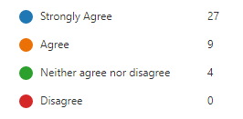

90% Agree or strongly agree that their child enjoys school

1. My child feels safe at school

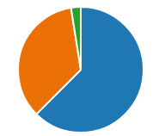 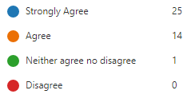

97.5% feel that their child feels safe at school

1. The school knows my child well

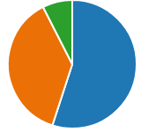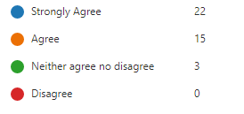

92.5% Feel that the school knows their child well

1. My child learns well while in school

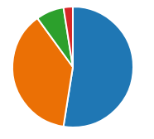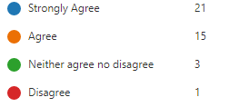

90% feel that their child learns well in school. 2.5% feel that this is not the case.

1. The school communicates with me effectively

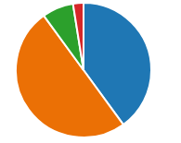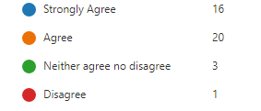

90% feel that the school communicates effectively. 2.5% feel that this is not the case.

1. The school encourages and promotes high standards of behaviour

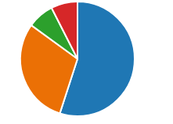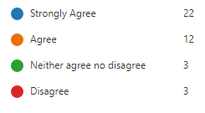

87.5% feel that the school encourages and promotes high standards of behaviour. 7.5% feel that this is not the case.

1. The school deals effectively with any concerns

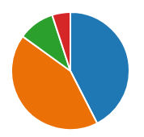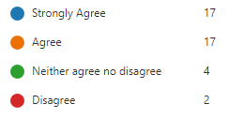

85% feel that the school deals effectively with concerns. 5% disagreed.

1. The school managed the COVID-19 lockdown and restrictions well

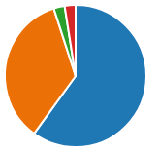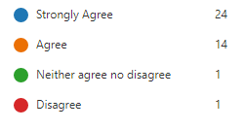

95% felt that the school dealt well with the COVID-19 lockdown and restrictions.

1. The school helped to minimise disruption to my child’s learning due to COVID-19

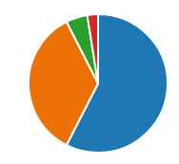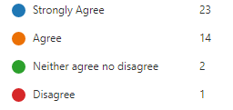

92.5% agreed that school helped to minimise the disruption to learning.

1. The school is approachable

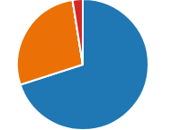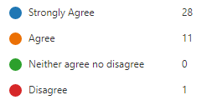

97.5% agreed. 2.5% disagreed

1. The school is welcoming and inclusive

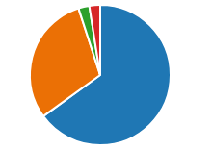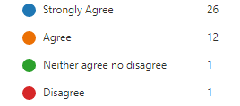

95% agreed. 2.5% disagreed

1. I think the school values are an important part of my child’s education

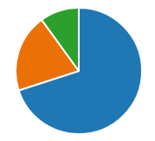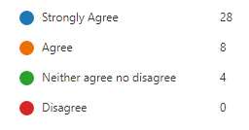

90% agreed

1. I would recommend the school to another parent

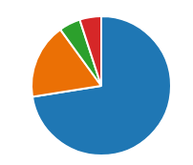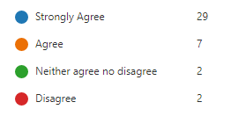

90% agreed. 5% did not.

1. In your opinion what are the school’s strengths? (sample of responses)

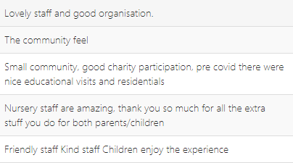

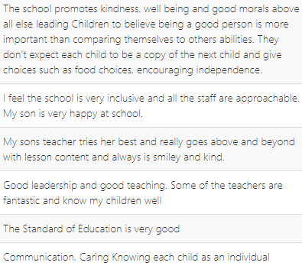

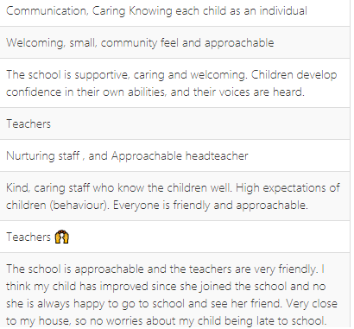

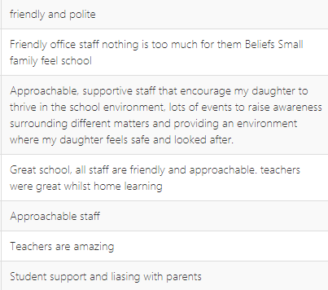

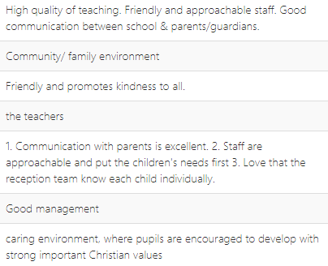

1. In your opinion what does the school need to do to improve? (sample of responses)

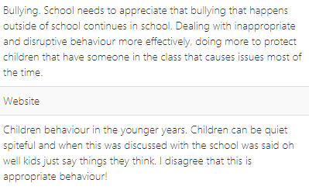

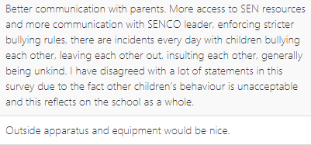

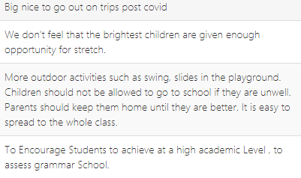

1. Three words to describe the school are: (all responses)

