# E:\Users\simon.roche\AppData\Local\Microsoft\Windows\Temporary Internet Files\Content.Word\Evidencing the Impact of the Primary PE and Sport Premium Template 2019 7.3 Images_Page_1.jpg

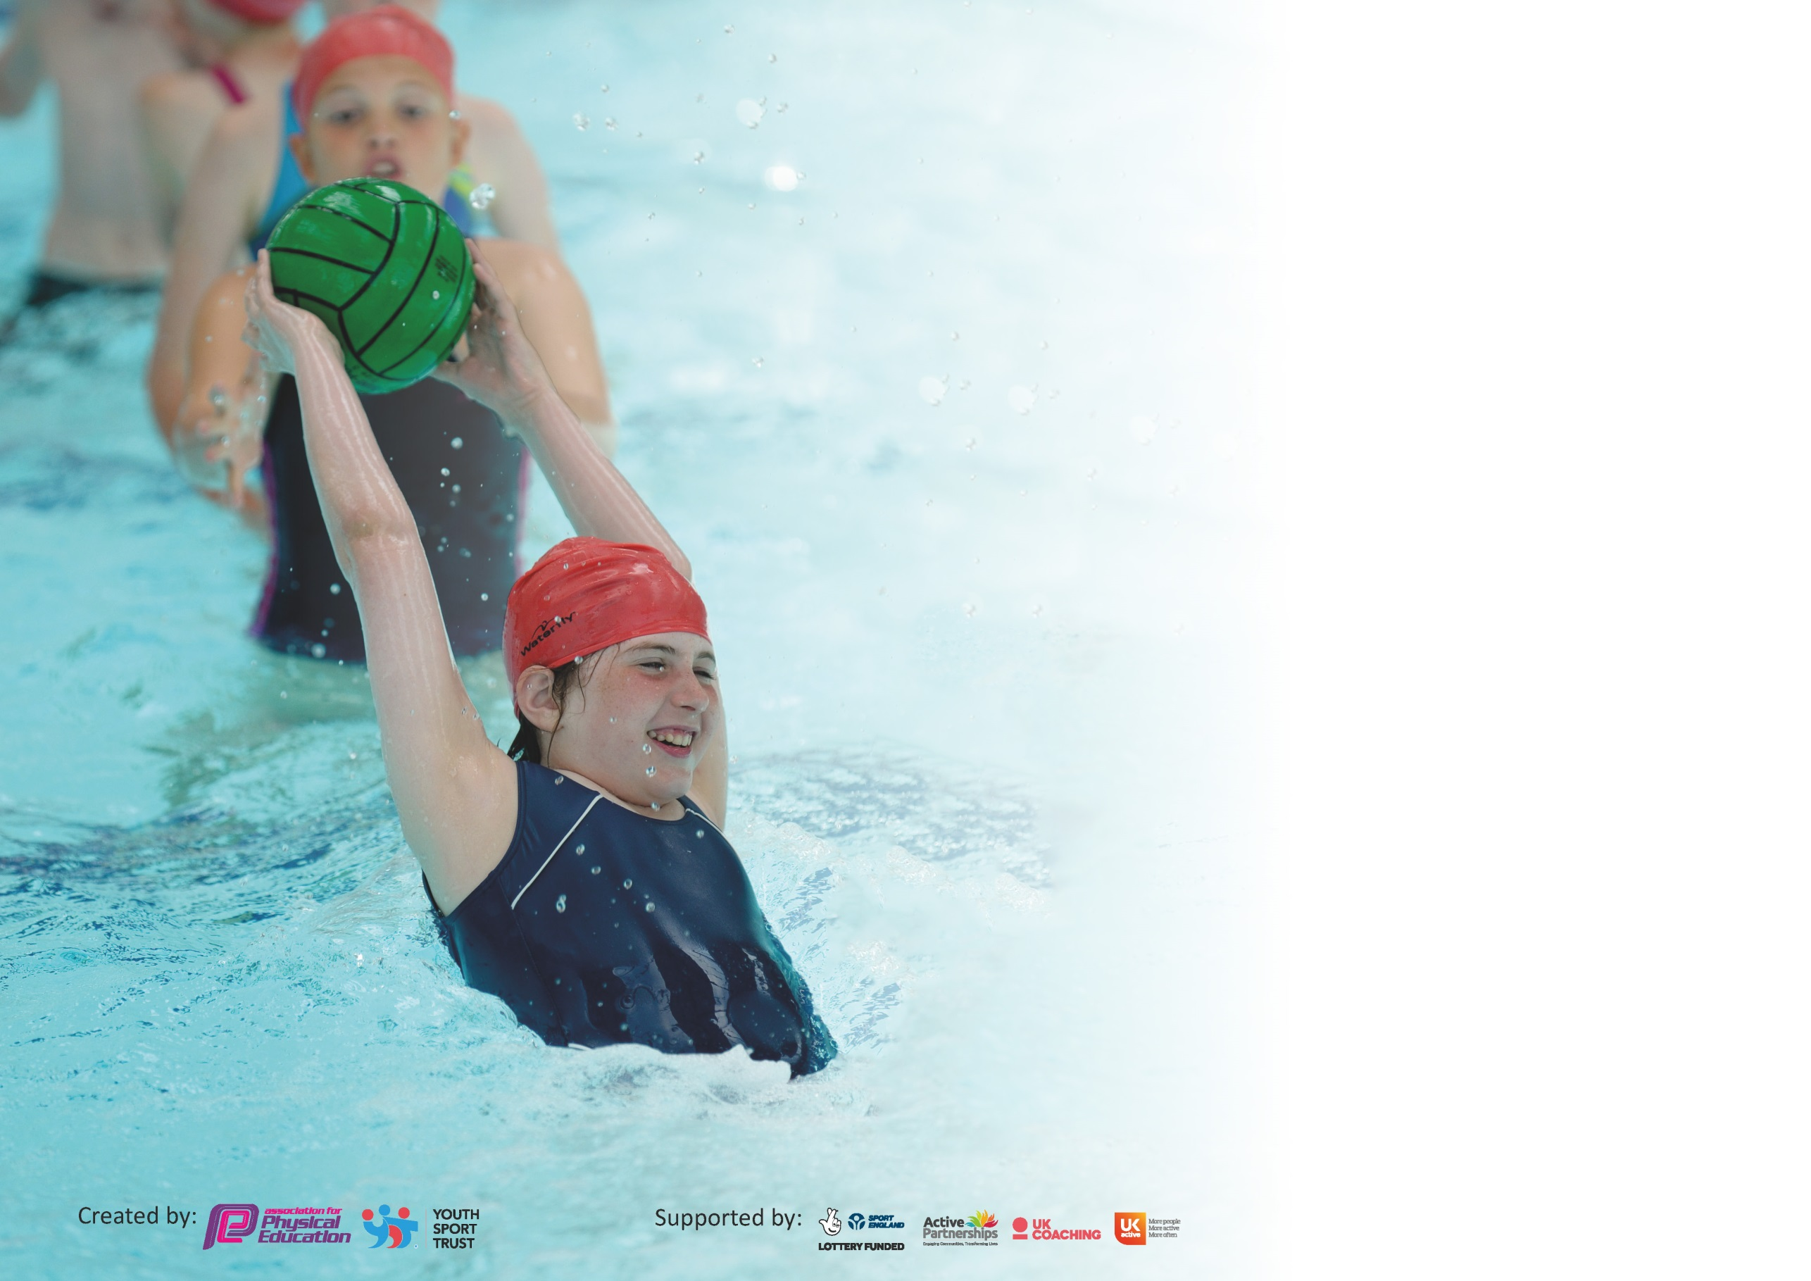

It is important that your grant is used effectively and based on school need. The [Education Inspection Framework](https://assets.publishing.service.gov.uk/government/uploads/system/uploads/attachment_data/file/843108/School_inspection_handbook_-_section_5.pdf) (Ofsted 2019 p64) makes clear there will be a focus on **‘whether leaders and those responsible for governors all understand their respective roles and perform these in a way that enhances the effectiveness of the school’**.

Under the [Quality of Education criteria](https://assets.publishing.service.gov.uk/government/uploads/system/uploads/attachment_data/file/843108/School_inspection_handbook_-_section_5.pdf) (p41) inspectors consider the extent to which schools can articulate their curriculum (INTENT), construct their curriculum (IMPLEMENTATION) and demonstrate the outcomes which result (IMPACT).

To assist schools with common transferable language this template has been developed to utilise the same three headings which should make your plans easily transferable between working documents.

Schools must use the funding to make **additional and sustainable** improvements to the quality of Physical Education, School Sport and Physical Activity (PESSPA) they offer. This means that you should

use the Primary PE and Sport Premium to:

* Develop or add to the PESSPA activities that your school already offer
* Build capacity and capability within the school to ensure that improvements made now will benefit pupils joining the school in future years

Please visit [gov.uk](https://www.gov.uk/guidance/pe-and-sport-premium-for-primary-schools) for the revised DfE guidance including the 5 key indicators across which schools should demonstrate an improvement. This document will help you to review your provision and to report your spend. DfE encourages schools to use this template as an effective way of meeting the reporting requirements of the Primary PE and Sport Premium.

We recommend you start by reflecting on the impact of current provision and reviewing the previous spend.

Schools are required to [publish details](https://www.gov.uk/guidance/what-maintained-schools-must-publish-online#pe-and-sport-premium-for-primary-schools) of how they spend this funding as well as on the impact it has on pupils’ PE and sport participation and attainment by the end of the summer term or by **31st July 2020** at the latest.

We recommend regularly updating the table and publishing it on your website throughout the year. This evidences your ongoing self-evaluation of how you are using the funding to secure maximum, sustainable impact. Final copy must be posted on your website by the end of the academic year and no later than the 31st July 2020. To see an example of how to complete the table please click [HERE](http://www.afpe.org.uk/physical-education/wp-content/uploads/afPE-Example-Template-Indicator-2018-Final.pdf).

Support for review and reflection - considering the 5 key indicators from DfE, what development needs are a priority for your setting and your pupils now and why? Use the space below to reflect on previous spend and key achievements and areas for development.

|  |  |
| --- | --- |
| Key achievements to date until July 2019: | Areas for further improvement and baseline evidence of need: |
| We have run the PECS programme for 5 years and staff are now more confident in the delivery of PE.  Pupil fitness has improved as evidenced in our Healthy Active Schools database.  Increased participation in competitive sports. Last year we had 4 inter school competitions. Intra school competition has also increased.  New curriculum to support staff and ease teacher workload in planning, also to ensure a development in skills is provided in less familiar areas such as gym and dance. Staff training in gym and dance through Aspire PECS programme and Dancedesk.  Yoga programme for YR pupils has highlighted new ways of being active to the whole school, this is now being replicated in Nursery.  School has again achieved School Games Mark Bronze | Pupils to experience Yoga in KS2.  Year 6 to have yoga as a pre SATs workshop.  Increase pupils engagement in after school sports clubs  5 Year 6 pupils will not have met swimming requirements- therefore funds are being allocated to provide additional swimming tuition for those pupils this year.  More school games competition- aim for Silver School Games Mark  Staff development work  **\*\*COVID-19 SCHOOL CLOSURES HAVE IMPACTED ON MANY PLANS THIS YEAR\*\*** |

|  |  |
| --- | --- |
| Meeting national curriculum requirements for swimming and water safety. |  |
| What percentage of your current Year 6 cohort swim competently, confidently and proficiently over a distance of at least 25 metres?  **N.B.** Even though your pupils may swim in another year please report on their attainment on leaving  primary school at the end of the summer term 2020. | 83% |
| What percentage of your current Year 6 cohort use a range of strokes effectively [for example, front crawl, backstroke and breaststroke]? | 83% |
| What percentage of your current Year 6 cohort perform safe self-rescue in different water-based situations? | 83% |
| Schools can choose to use the Primary PE and Sport Premium to provide additional provision for swimming but this must be for activity **over and above** the national curriculum requirements. Have you used it in this way? | Yes/No  NOT CARRIED OUT- SCHOOL CLOSURES |

**Action Plan and Budget Tracking**

Capture your intended annual spend against the 5 key indicators. Clarify the success criteria and evidence of impact that you intend to measure to evaluate for pupils today and for the future.

|  |  |  |  |  |
| --- | --- | --- | --- | --- |
| **Academic Year:** 2019/20 | **Total fund allocated:** £ 17,780 | **Date Updated: 21/04/2020** | |  |
| **Key indicator 1:** The engagement of all pupils in regular physical activity – Chief Medical Officer guidelines recommend that primary school pupils undertake at least 30 minutes of physical activity a day in school | | | | Percentage of total allocation: |
| 14% |
| **Intent** | **Implementation** | | **Impact** |  |
| Pupils have access to high quality lunchtime physical activity in order to help them meet the daily target of 30 minutes. | Train 29 year 5 pupils as Play Activators in order to support and encourage play (Aspire Sports).  Aspire Sports coach leads lunchtime focused activity one lunchtime per week. | £700  £1591 | Evidence of impact: what do pupils now know and what can they now do? What has changed?  Training delivered 04/11/19 and 22/10/19, as a result 14 Y5 pupils work on a rota basis supporting peers to engage in physical activity (PA) on a daily basis, there is opportunity for all pupils (YR-6) to engage in 30 minutes of PA in school daily. | Sustainability and suggested next steps: these pupils help to ensure a high level of activity is available to all children throughout the school day. Children learn new games and are keen to become play leaders when they come to year 5. |
| Swimming Intervention for the 5 pupils now in Y6 yet to meet NC requirements despite prior school swimming provision. | Swimming lessons x1 per week for 8 week period in Summer term | £200 | **Plans affected by school closures, no swimming has taken place this year** | Swimming intervention will be utilised again when possible. |
| Maintain safe physical activity for all pupils in school during partial closure caused by Covid-19. | Purchased every child in school a tennis ball, bean bag and skipping rope | £130.72 | **Pupils able to engage in individual physical activity.** | Resources purchased can be disinfected and put back into whole school circulation when appropriate. |
| **Key indicator 2:** The profile of PESSPA being raised across the school as a tool for whole school improvement | | | | Percentage of total allocation: |
| 27% |
| **Intent** | **Implementation** | | **Impact** |  |
| Staff become increasingly aware of how increased physical activity can improve social and emotional well being of pupils as well as curricular attainment in non sports subjects. A less active group of girls identified in the year 5 cohort who are also not on track for maths with receive active maths intervention in order to increase activity levels and maths achievement. | KS2 Yoga sessions to develop mindfulness and concentration as well as exposing children to a new activity.  Year 6 to have a six week pre SATs Yoga and mindfulness | Funding allocated:  £2500 | Evidence of impact: what do pupils now know and what can they now do? What has changed?:  Yoga data: (Y5 Autumn term) Pupils improved by 21% across 10 targeted areas. Confidence average score increased by 21.3%. Ability to concentrate increased by 19.6%. Biggest improvements were seen expressing themselves positively, range of motion in joints and coordination | Sustainability and suggested next steps:  School closure in Spring and Summer term meant Yoga ceased and could not take place. Provision to double next year to ensure all pupils YR-6 have the opportunity to participate in sessions. |
|  | 6 Year 5 pupils engage in Maths on the Move (Aspire Sports) 1 hour per week. | £1591 | Pupils maths results increased by an average of 21.6% over the course of the programme. Pupils attitudes to doing maths on the move were very positive, pupils looked forward to the sessions, despite the fact that they were held over part of break time. |  |
|  | Uniform for staff purchased to raise profile of PE and increase staff confidence | £500 | Uniform purchased and worn by staff delivering lessons consistently. | Staff wearing uniform consistently. |
|  | Road to Tokyo Workshops | £910 | **Postponed due to school closure** | Taking place next academic year |

|  |  |  |  |  |
| --- | --- | --- | --- | --- |
| **Key indicator 3:** Increased confidence, knowledge and skills of all staff in teaching PE and sport | | | | Percentage of total allocation: |
| 22% |
| **Intent** | **Implementation** | | **Impact** |  |
| Subject leader supported in developing the subject across school – providing high quality PE which raises standards and outcomes in pupils. | Membership of Dancedesk Hub- provides membership of AfPE, One Dance UK and Youth Sport Trust (Level 1) | Funding allocated: £600 | Dancedesk membership has proved invaluable in supporting PE especially through closure. Subject leader has upskilled knowledge by actively participating in AfPE webinars | Sustainability and suggested next steps:  Knowledge acquired by subject leader disseminated to all staff |
|  |  |  |  |  |
|  |  |  |  |  |
|  |  |  |  |  |
|  |  |  |  |  |
| Subject leader supported in developing the subject across school – providing high quality PE which raises standards and outcomes in pupils. | Subject leader complete Level 5 In PE and School Sport Leadership through Aspire Sports | £1000 | **Postponed due to Covid-19** | Carried over to next year |
| Increased knowledge and skill of HLTA in delivering PE, therefore increasing school capacity to deliver high quality PE. | HLTA subject knowledge and practice increased through team teaching and Aspire Sports PECS programme. | £2216.30 | HLTA has worked along side the coach from Aspire Sports to deliver PE lessons with year 6.  Impact on pupils: Across the 4 units- Dance, Tag Rugby, Gymnastics, Rounders- 30.7% pupils achieved beyond year group expectations.  55.75 pupils met year group expectations and 12.5% were below. The first unit of dance had 25.81% pupils below, compared to just 3% below in the final unit of gymnastics. Showing the impact of the HLTA confidence and skills upon the pupils. | Y1- HLTA to receive training through PECS programme in 2020-21.  Programme will also rotate through other staff |
| **Key indicator 4:** Broader experience of a range of sports and activities offered to all pupils | | | | Percentage of total allocation: |
| 23% |
| **Intent** | **Implementation** | | **Impact** |  |
| Children experience a wider range of physical activity. Largely aimed at developing good habits in early years but also broaden the horizons of pupils across school. | Yoga Bugs to carry out Impact and Change Programme with KS2. | Funding allocated: £2500 (allocated in Key Indicator 1) | See Key indicator 1. | Sustainability and suggested next steps: |
| Aspire Sports to deliver Balanceability bike training with Reception class- Spr 1  Road to Tokyo Workshops | £675  £910 (allocated in key indicator 2) | **Postponed due to school closure** | Carried over to next year. Staff in school have used knowledge from previous sessions to deliver Balanceability for children coming to school during partial closure. |
|  |  |  |  |
|  |  |  |  |
|  |  |  |  |
|  |  |  |  |
| After School Club 1x per week to introduce new sports to children  Equipment to ensure pupils can participate in AS clubs  Yoga after school club for pupils and parents Spring and summer term (2x10 week programmes) | £1591  £800  £900 | After School Club: Autumn 1: KS2 Sports Exteme: Fitball, Sepak Takraw, Ga-ga, Tchoukball, Ultimate Frisbee, Body Kombat  100% attendance, 100% positive feedback  Autumn 2: Y1-3 Multi skills  100% attendance  Spring 1: KS2 Basketball 100% attendance  Spring 2: Years 1 and 2 Multi sports 50% attendance  Yoga: 18 attendees, 100% positive feedback, asked to continue |  |

|  |  |  |  |  |
| --- | --- | --- | --- | --- |
| **Key indicator 5:** Increased participation in competitive sport | | | | Percentage of total allocation: |
| 6% |
| **Intent** | **Implementation** | | **Impact** |  |
| To increase participation in competitive through the School games programme. School to aim for the School Silver games mark | Funding set aside to provide transportation for competitions. | Funding allocated:  £1000 | School closures have meant that  School has not been able to achieve this. | Sustainability and suggested next steps:  We will look to engage with virtual competitions net year through SGO. |
|  |  |  |  |  |
|  |  |  |  |  |
|  |  |  |  |  |
|  |  |  |  |  |
|  |  |  |  |  |

|  |  |
| --- | --- |
| Signed off by | |
| Head Teacher: |  |
| Date: |  |
| Subject Leader: |  |
| Date: |  |
| Governor: |  |
| Date: |  |