read all about it!
Reading at st Margaret’s
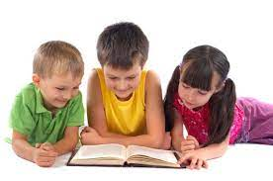  Reading develops life long skills  Our intent  Learning to read is one of the most important things your child will learn at St Margaret’s. Everything else depends on it, so we put as much energy as we possibly can into making sure that every single child learns to read as quickly as possible.  We want your child to love reading – and to want to read for themselves. This is why we work hard to ensure that children develop a love of books as well as simply learning to read.  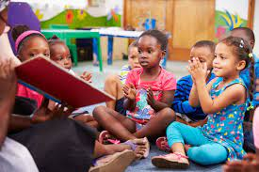  Regular story times are a vital part of school life. | 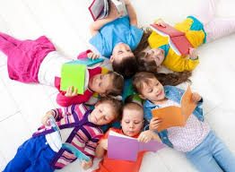  Reading starts in the Early Years. Children learn in a vocabulary rich environment.  Firm Foundations
 | Reading starts in Nursery, where we begin to teach phonics following the ‘Phase One’ as set out in ‘Letters and Sounds’. In Nursery, we begin by encouraging children to listen out for sounds in the environment and experiment with a range of sounds using their whole body.  A love of reading begins as soon as your child starts at St Margaret’s as we read regularly with our children through story times and shared reading in our continuous provision. | In Reception and Key Stage 1, we follow the teaching sequence in Letters & Sounds. Here, we continue teaching phonics with a daily phonics lesson. Children are taught how to read the sounds in words and how these sounds can be written down. This is essential for reading but also helps children with their spelling. Children also learn to read and spell ‘tricky words’ such as ‘the’, ‘have’, and ‘there’.  We are investigating published phonics schemes from the DfE validated list to compliment and enhance our phonics teaching.
How do our pupils feel about reading?
I love adventure books. they’re exciting. it’s hard to stop reading.  Jack, Y6 | i like our reading lessons. they’re interesting.  Scarlett, Y1 | reading helps expand your vocabulary.  Rouhan, Y4

Home Reading |  | Reading Lessons  In KS1, children have a weekly guided reading session and in KS2 children take part in Reciprocal Reading. Guided reading consists of children taking turns to read a shared book with an adult and answer focussed comprehension questions based on their needs. To support reading we have developed a range of characters linked to the decoding skills. For example, the character ‘Iggy Inference’ helps children to focus on inference skills whereas ‘Predicting Pip’ helps children with their prediction skills.  In Reciprocal Reading, the children take on these roles for themselves and take it in turns to be the ‘questioner’ or the ‘director’. This helps to build their confidence, not only in reading and understanding but also in thinking about specific types of questions.  All classes from Reception to Y6 have a weekly comprehension lesson where they are taught the key skills needed to become fluent readers, such as the meaning of new, less familiar words, predictions about a text, and inference. In Years 1 to 3, children have characters to help them identify key reading skills which are presented as cartoon dogs. The children enjoy getting to know these characters and they really help them to understand which skill they are practising. Y4 learn reading skills with the character A.V.Crisp, which stands for Author Choice, Vocabulary, Compare, Contrast & Comment, Retrieval, Inference, Summary, Prediction.  home reading  Parental support  To help parents support reading at home, each year group runs a reading workshop at the beginning of the year. Home reading records are checked regularly by staff and we value that communication between home and school about how children are getting on with their reading. In Reception, children are heard read twice a week and have sets of words sent home. In Years 1-6, children are heard read once a week where books are changed and any words that the children are learning are checked and changed as appropriate.
Once children are blending sounds together to read words, they practise reading books that match the phonics and the tricky words that they know. This is when children start to believe that they can read and this does wonders for their confidence! In Reception, children are given a decodable book from the Dandelion Readers scheme, although we do supplement with other appropriate phonics scheme books, such as Jelly and Bean. We also give children the opportunity to choose a book from a colour band appropriate to their reading level. These have fun activities attached to do at home and really encourages a love of reading.  Starting with picture books where children are encouraged to tell a story from the pictures and answer questions, children then move on to books with simple words and captions that match their phonic ability. As their decoding skills and comprehension improves, children progress through books which are banded into colours according to difficulty, using the book bands as set out by Oxford University Press, until they become an ‘extended reader’, which means that they are reading fluently and understanding and interpreting the text to a high level. | 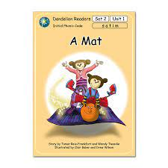  An example of a Dandelion Reader book  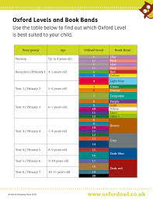  Our book banded progression map
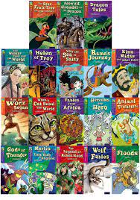
Examples of books from Key Stage 2 home readers

National data

Phonics Check and SATs The Love of Reading
The school is measured nationally how well we are teaching phonics and reading. In Year 1 all children complete a phonics check, and in Years 2 and 6, children have statutory tests where their ability to answer questions about a text are measured. In order to prepare our children for these checks, we ensure that our teaching includes lots of opportunities to discuss characters, settings and events. Reading for meaning is so important – not just reading the words. | Teachers read regularly to the children. This helps children get to know and appreciate all sorts of different stories, poetry and information books. As well as promoting reading for pleasure, this helps to extend their vocabulary and comprehension, as well as supporting their writing. To support this, we not only read fiction books, but also share non-fiction texts with the children based on their interests. We also have a range of texts available in each class reading area which includes fiction, non-fiction, comics and magazines. Class texts from the year are displayed on a central display.
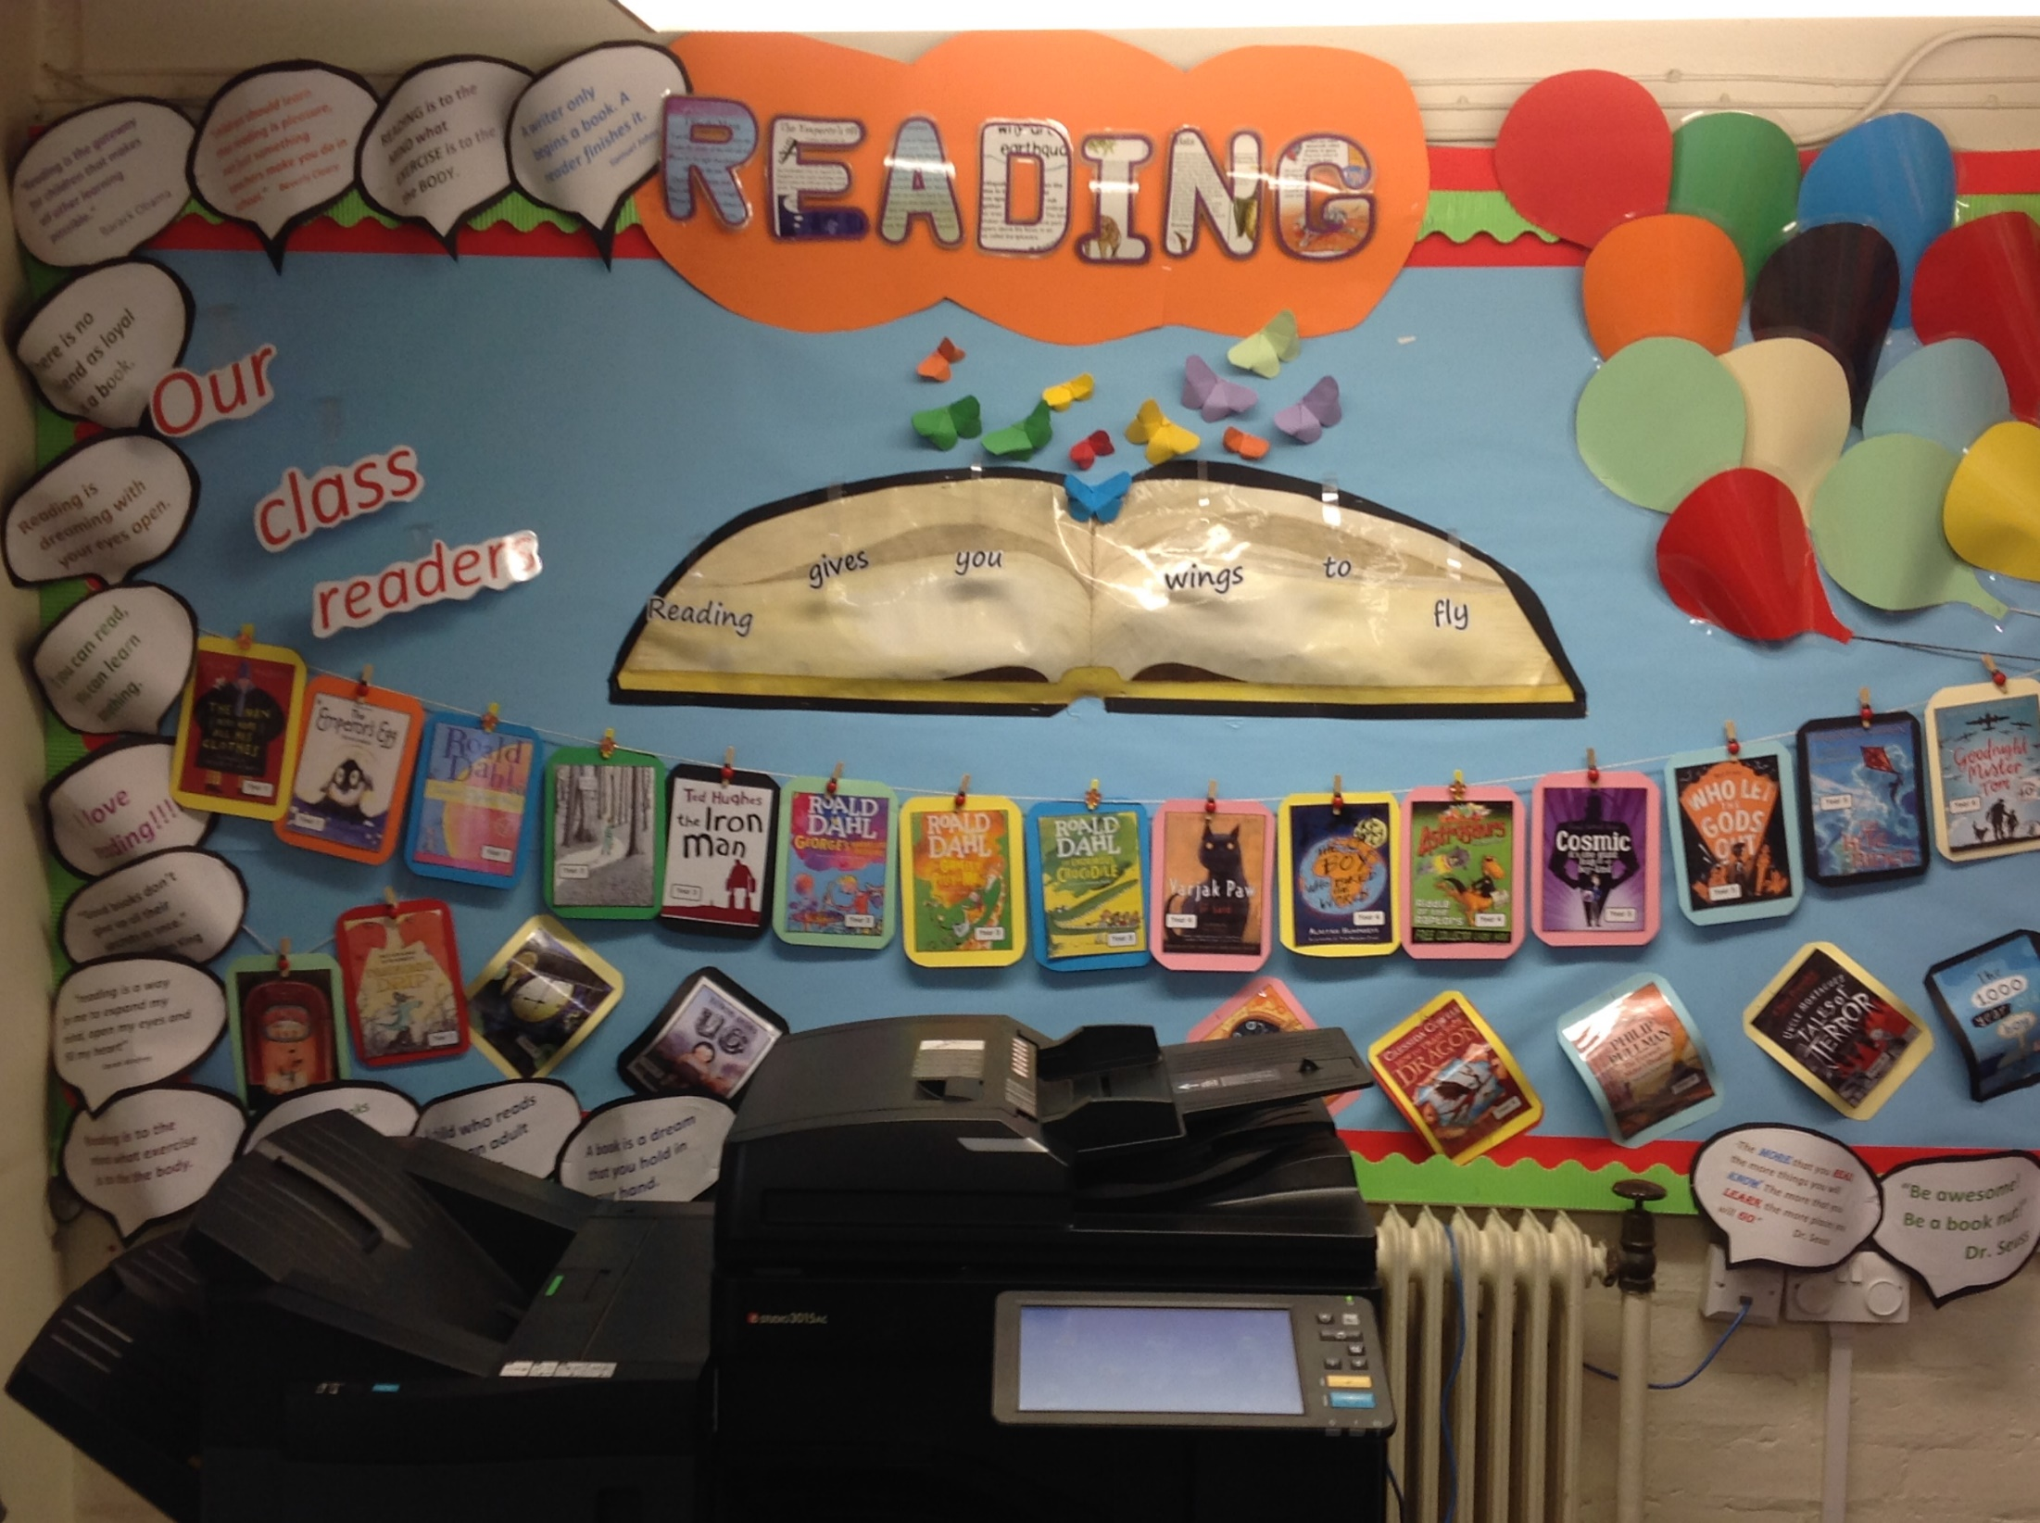

Our Class Readers display

