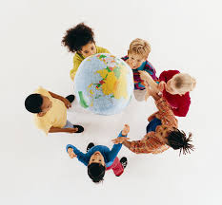**St Margaret’s CE VA Primary School Geography Units**

**Nursery**

* **The weather**
* **Walks around school**
* **Seasons**

**Reception**

* A Place Called Home (Autumn)
* Gateway to Geography (Spring)
* Out and About (Spring)
* The United Kingdom (Summer)

**Year 1**

* **What’s the geography of where I live like?** (Autumn 1 )
* **Why don’t penguins need to fly?** (Spring 1)
* **Why do we love being beside the seaside so much?** (Summer 1)

**Year 2**

* **How does the weather affect our lives?** (Autumn 1)
* **Why does it matter where our food comes from?** (Spring 1)
* **How does the geography of Africa compare with where I live?** (Summer 1)

**\*Uganda used in Yr2 rather than Kampong Ayer to tie in with school links**

**Year 3**

* **How and why is my local environment changing?** (Autumn 2)
* **Beyond the Magic Kingdom: What is the Sunshine State really like?**

(Spring 2)

* **Why do so many people live in megacities?** (Summer 2)

**Year 4**

* **Why do the biggest earthquakes not always cause the most damage?** (Autumn 2)
* **How can we live more sustainably?** (Spring 2)
* **Why are jungles so wet and deserts so dry?** (Summer 2)

**Year 5**

* **What is a River?** (Autumn 2)
* **Who are Britain’s National Parks for?** (Spring 2)
* **How is climate change affecting the world?** (Summer 2)

**Year 6**

* **Why are mountains so important?** (Autumn 1)
* **How do volcanoes affect the lives of the people on Hiemaey?** (Spring 1)
* **Why is Fairtrade Fair?** (Summer 1)