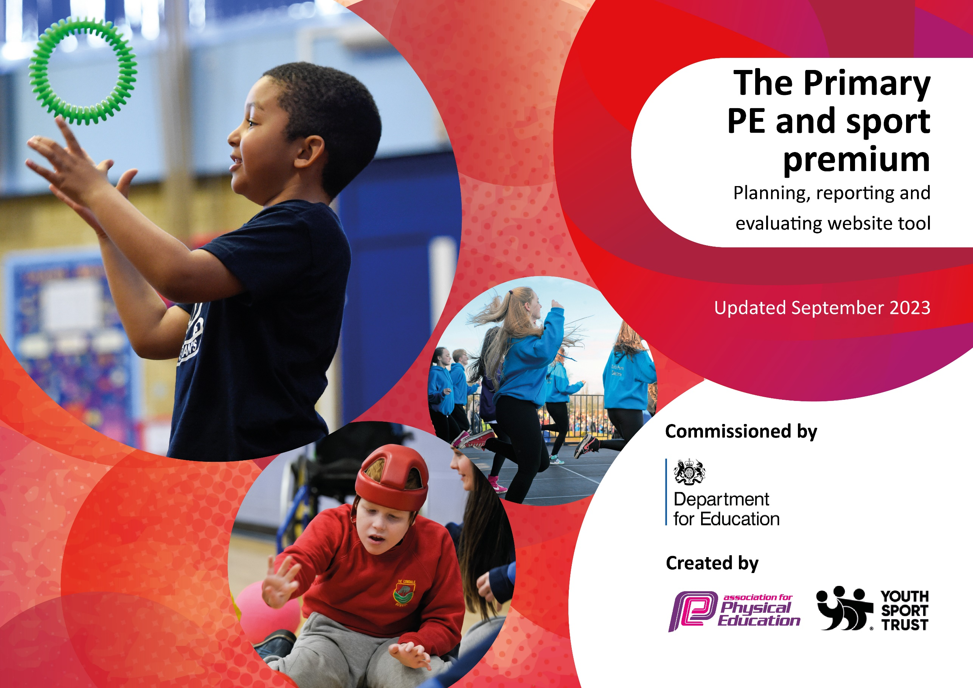

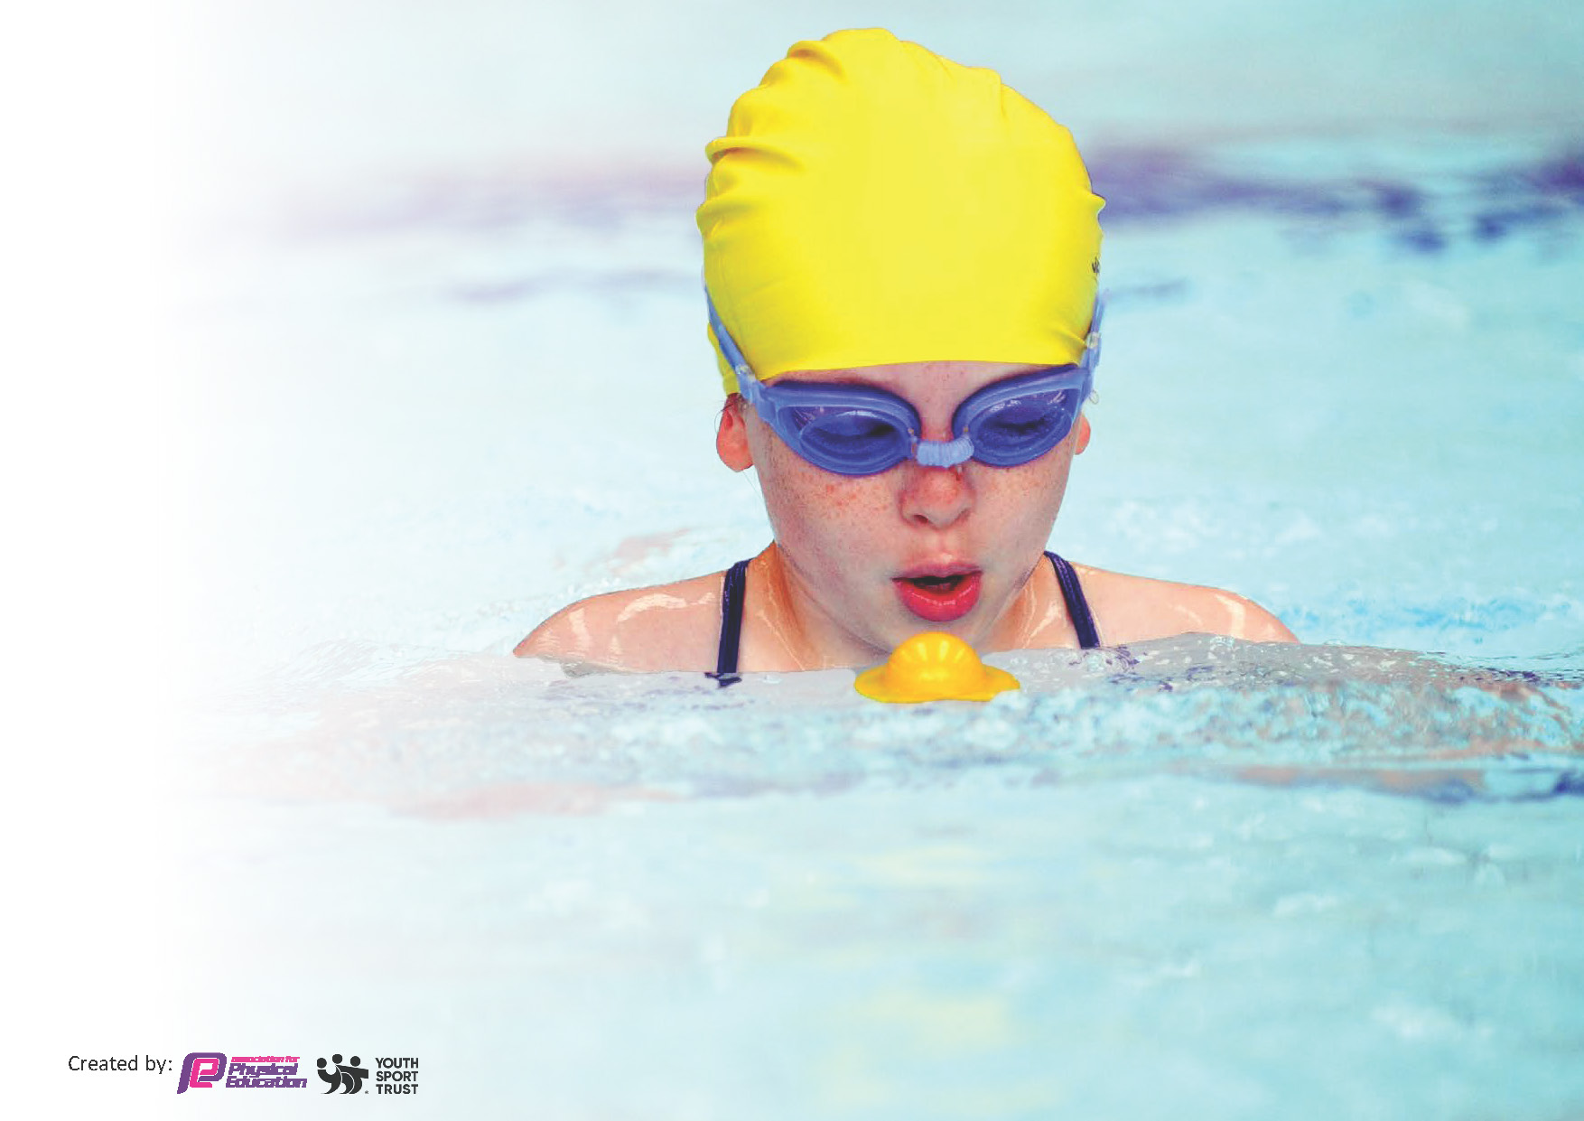
This template can be used for multiple purposes:
by:
- It enables schools to effectively plan their use of the Primary PE and sport premium
- It helps schools to meet the requirements (as set out in guidance) to publish information on their Primary PE and sport premium
- It will be an effective document to support Ofsted inspections enabling schools to evidence progress in Physical Education (PE) and evidence swimming attainment, which forms part of the PE National Curriculum. We would recommend schools consider
the Intent, Implementation and Impact of any spend, as examined within the Education Inspection Framework.

It is important that your grant is used effectively and based on school need.

Schools must use the funding to make additional and sustainable
improvements to the quality of the PE, School Sport and Physical Activity (PESSPA)
they offer. This means that you should use the Primary PE and sport premium to:

- Build capacity and capability within the school to ensure that improvements made now will benefit pupils joining the school in future years
- Develop or add to the PESSPA activities that your school already offers.

The Primary PE and sport premium should not be used to fund capital spend projects; the school’s core budget should fund these. Further detail on capital expenditure can be found in the updated Primary PE and sport premium guidance.

The Primary PE and sport premium guidance, outlines 5 key priorities that funding should be used towards. It is not

necessary that spending has to meet all the key priorities, you should select the priorities that you aim to use any funding towards.

Although completing this template is not a requirement for schools, schools are required to publish details of how they spend this funding. Schools must also outline what the impact this funding has had on pupils’ PE and sport participation and attainment and how any spending will be sustainable in the future. All funding must be spent by 31st July 2024.

The Department for Education has worked closely with the Association for Physical Education (afPE) and the Youth Sport Trust (YST) to develop this template and encourages schools to use it. This template is an effective way of meeting the reporting requirements of the Primary PE and sport premium.
Review of last year’s spend and key achievements (2022/2023)

We recommend you start by reflecting on the impact of current provision and reviewing your previous spend.

Activity/Action | Impact | Comments

Key priorities and Planning
This planning template will allow schools to accurately plan their spending.

Action – what are you planning to do | Who does this action impact? | Key indicator to meet | Impacts and how sustainability will be achieved? | Cost linked to the action
Improve enjoyment of Dance through high quality tuition and exciting dance events | Teachers- able to observe professional dance teacher  pupils – as they will take part. | Key Indicator 1: Increased confidence, knowledge, and skills of all staff in teaching PE and sport.  Key indicator 2 -The engagement of all pupils in regular physical activity – the Chief Medical Officer guidelines recommend that all children and young people aged 5 to 18 engage in at least 60 minutes of physical activity per day, of which 30 minutes should be in school.  Key indicator 4: Broader experience of a range of sports and activities offered to all pupils. | More pupils meeting their daily physical activity goal, more pupils encouraged to take part in PE and Sport Activities.  Teachers feel more confident to teach dance well.  Pupils achieve well in dance and enjoy dance | £3950 for dance tuition from FABRIC dance  £300 dance showcase event from ACE Dance

Upskill new teachers in the delivery of PE to ensure better provision and improved pupil outcomes  New SL supported in developing leadership skills in PESSPA  Pupils develop leadership skills and lead lunchtime activities | Teachers and subject leader  Year 5 and 4 do sports leadership training through Aspire Sports  Year 3 do the Archbishops Young Leaders Award | Key Indicator 1: Increased confidence, knowledge, and skills of all staff in teaching PE and sport.  Key indicator 2 -The engagement of all pupils in regular physical activity – the Chief Medical Officer guidelines recommend that all children and young people aged 5 to 18 engage in at least 60 minutes of physical activity per day, of which 30 minutes should be in school.  Key indicator 4: Broader experience of a range of sports and activities offered to all pupils. | Primary teachers more confident to deliver effective PE supporting pupils to undertake extra activities inside and outside of school, and as a result improved % of pupil’s attainment in PE.  Pupils are confident to deliver sessions at lunchtime increasing the active time for all pupils | £7215 Aspire Sports PECS programme of curriculum support  £750 membership of dancedesk to support subject leader  £1237.50 3 year subscription to GetSet4PE  Road 2 Paris workshop £500  AYLA £324  Aspire Play makers awards £800  Equipment for Y6 Olympics day £1500  Equipment for play times £600  Maintaining equipment £200

Key achievements 2023-2024
This template will be completed at the end of the academic year and will showcase the key achievements schools have made with their Primary PE and sport premium spending.

Activity/Action | Impact | Comments
Improve enjoyment of Dance through high quality tuition and exciting dance events.  Upskill new teachers in the delivery of PE to ensure better provision and improved pupil outcomes.  New SL supported in developing leadership skills in PESSPA  Pupils develop leadership skills and lead lunchtime activities. | Dance data: 80% children working within, 15% children working beyond  Teacher feedback: Staff felt that children had improved attitudes and performance had improved in dance.  Teachers also felt more confident to take the dance lesson with the support they have received.  Aspire Sports PECS programme undertaken by new staff, staff said they feel more prepared and confident to deliver PE lessons. They really enjoyed completing PECS programme.  SL feedback: the membership of Dancedesk PE network and the membership of Aspire leadership portal has been an enormous help to the leaderships skills and delivery of PE in school. It has supported me with developing my leadership skills in PESSPA.  Children feedback: Year 5 pupil- it was great learning all skills to lead sessions on the playground. We are looking forward to delivering more sessions.  We have learnt some really great activities we can deliver to other children at lunchtime.  Year 4: It has given us the skills to carry on through school. Given us confidence to deliver sessions. We love delivering the sessions.  Year 3: We really enjoyed taking part in the Archbishops Young Leaders Award.  It was great fun and enjoyable. | School have had dance CPD now for 2 years. This will not continue in 2024/25. Pupil and teacher confidence in dance have increased.  School have had PECS programme this year with great success in the delivery of PE to ensure pupils have the provision and better-quality outcomes.  Membership of Dancedesk PE network  Membership of Aspire leadership portal.  Year 5 and 4 do sports leadership training through Aspire Sports which will continue next year with the skills the children have acquired.  Year 3 do the Archbishops Young Leaders Award

Swimming Data
Meeting National Curriculum requirements for swimming and water safety.
Priority should always be given to ensuring that pupils can perform safe self-rescue even if they do not fully meet the first two requirements of the National Curriculum programme of study

Question | Stats: | Further context  Relative to local challenges
What percentage of your current Year 6 cohort can swim competently, confidently and proficiently over a distance of at least 25 metres? | 77% | We are struggling to get pool space due to our local pool closing so we have had to use a much smaller local school pool. We have had to limit the number of pupils attending swimming lessons during one term which means some pupils have attended fewer swimming lessons than others.
What percentage of your current Year 6 cohort can use a range of strokes effectively [for example, front crawl, backstroke, and breaststroke]? | 77% | We are struggling to get pool space due to our local pool closing so we have had to use a much smaller local school pool. We have had to limit the number of pupils attending swimming lessons during one term which means some pupils have attended fewer swimming lessons than others.

What percentage of your current Year 6 cohort are able to perform safe self-rescue in different water-based situations? | 77% | We are struggling to get pool space due to our local pool closing so we have had to use a much smaller local school pool. We have had to limit the number of pupils attending swimming lessons during one term which means some pupils have attended fewer swimming lessons than others.Use this text box to give further context behind the percentage.
If your schools swimming data is below national expectation, you can choose to use the Primary PE and sport premium to provide additional top-up sessions for those pupils that did not meet National Curriculum  requirements after the completion of core lessons. Have you done this? | Yes/No
Have you provided CPD to improve the knowledge and confidence of staff to be able to teach swimming and water safety? | Yes/No

Signed off by:

Head Teacher: | Stuart Jones
Subject Leader or the individual responsible for the Primary PE and sport premium: | Mary Nokes (Class teacher and PE Lead)
Governor: | Ian Simms (Chair)
Date: | 17/07/24

