About Me and My School Key Stage 1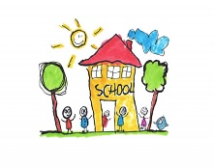

Results July 2018

|  |  |  |  |
| --- | --- | --- | --- |
|  | **Yes** | **Don’t Know** | **No** |
| 1.Do you enjoy being in school? | 99% | 1% |  |
| 2.Are your lessons interesting? | 98% |  | 2% |
| 3.Do you know what to do when you get stuck? | 96% |  | 4% |
| 4. Do you have to work hard? | 98% |  | 2% |
| 5. Do teachers show you how to improve your work? | 97% | 2% | 1% |
| 6. Do you have lots of friends in school? | 97% | 1% | 2% |
| 7. Is there an adult you go to if you are worried in school? | 99% | 1% |  |
| 8. Do you feel safe in school? | 100% |  |  |
| 9. Do you think home learning helps you? | 93% | 3% | 3% |
| 10. Do you think our children are well behaved? | 94% | 6% |  |

Thank you for 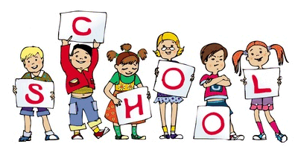your help!!

your help.