**ST MARGARET’S CE VA PRIMARY SCHOOL**

Spirituality Policy

“Encourage one another and build each other up”

1 Thessalonians 5:11

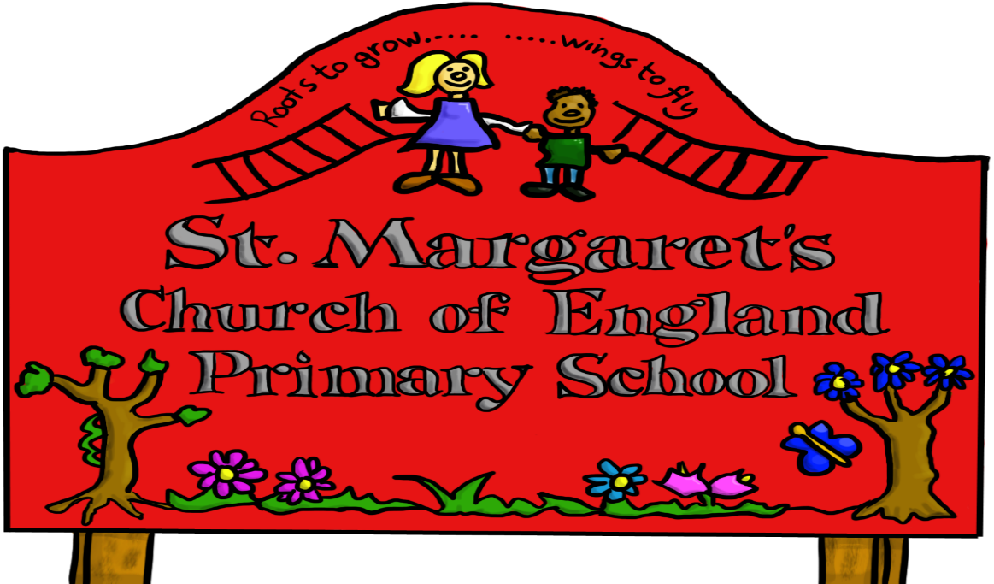

|  |  |  |
| --- | --- | --- |
| **Approved by:** | Governors | **Date:** |
| **Last reviewed on:** | Sept 2020 | |
| **Next review due by:** | Sept 2023 | |

 ST MARGARET’S CE VA PRIMARY SCHOOL

SPIRITUALITY POLICY

At St Margaret’s CE Primary School we hold the Christian belief that human beings are created in the image of God, and that each shares in God’s purposes to bring life and allow creation to flourish. This underpins the values and work of the school and is endorsed in our vision statement.

Spirituality is a powerful force that determines what we are, and our self -understanding. It forms the basis for successful relationships, and shapes our behaviour and outlook on life, others and the world.

Spiritual development relates to that aspect of inner life through which we acquire insight into our personal experiences which are of enduring worth.

At St Margaret’s the spiritual dimension is expressed through our strong Christian faith, and the recognition of the spiritual nature of mankind.

Our ethos enables and encourages all children to grow and flourish spiritually.

It is our aim that the children’s individual spiritual development is fostered as an integral element of the range of learning opportunities and experiences they encounter as part of the curriculum, and that it permeates all strands of school life.

The aims for spirituality at St Margaret’s are:

* To develop a set of Christian personal beliefs and values by which to live.
* To develop an awareness of God’s love and care for them personally.
* To provide a context of faith, security and loving relationships to support each child’s spiritual search.
* To foster the spiritual development of each child, regardless of age, sex, ability or cultural background.
* To foster self-awareness and promote a feeling of self-worth.
* To develop a set of values, principles and beliefs.
* To develop positive human qualities.
* To develop the language of spirituality.
* To develop respect and empathy for other people and their beliefs.
* To understand and respect people’s feelings and values which may be different to their own.
* To develop the children’s enthusiasm to explore and learn through enquiry and first hand experiences.
* To enable the children to attribute meaning interpretation to their experiences.
* To develop their ability to reflect and the importance of stillness.
* To foster a sense of meaning, purpose and direction in their life.
* To encourage imagination and creativity.
* To develop a sense of awe and wonder at the miracle of creation, life and the natural world.
* To enable the children to experience a sense of enjoyment, fascination and excitement in learning about themselves, others, and the world around them, including the intangible.
* To share Christian stories and respond to Christian festivals, rituals and symbols, particularly those from the Anglican tradition.

To develop their ability to be resilient when life gets difficult and when things don’t go their way

**Organisation and Implementation**

Spiritual development is an important element of a child’s education and fundamental to all other areas of learning.

Without curiosity, without the inclination to question, and without the exercise of imagination, insight and intuition, children would lack the motivation to learn.

In view of this teaching styles are adopted which:

* Value the children’s questions and give them space for their own thoughts, ideas concerns and opinions.
* Enable the children to make connections between aspects of their learning.
* Encourage the children to relate their learning to a wider frame of reference, e.g. asking ‘why?’, ‘how?’, and ‘where?’ as well as ‘what?’

Spirituality is not taught, but is an inherent interwoven part of all aspects of school life and is nurtured and promoted as a natural element of the curriculum.

The following opportunities will be made available, as an integral part of the school’s practice, in order to facilitate the development of spirituality:

* To explore values and beliefs, including religious beliefs, and the way in which they impact on peoples’ lives.
* Where children already have religious beliefs, to support and develop these beliefs in ways which are personal and relevant to them as an integral part of the school’s practice.
* To engage in enquiry and exploration as part of experiential, first hand learning.
* To look attentively and observe carefully.
* To use the gifts of creativity and imagination.
* To listen with discernment.
* To reflect and respond to issues in moments of quiet or inspired through music, art, text, film or artefacts.
* To explore and develop what animates themselves and others.
* To understand human feelings and emotions, the way they impact on people and how an understanding of them can be helpful.
* To value what is good and worthwhile and to make value judgements through discussion and exchange of views.
* To work collaboratively with peers, valuing the contribution made by others.
* To respect all, as modelled by staff in their relationships with others.
* To be quiet and reflect on life and the world and develop an awareness of God.
* To work and live in harmony with others in the school and wider community.
* To have confidence to express ideas, views and opinions, even if others do not agree.
* To be strong in their own beliefs and to have the courage to justify themselves when required.

Opportunities for spiritual development are presented or naturally arise, and are promoted in all aspects of the curriculum and school life as the children become actively engaged in an enquiry based curriculum, which provides a wide range of experiential learning opportunities that enables them to question, consider, reflect and respond, and consider their own values, beliefs and feelings and those of others, with whom they are working alongside or with.

Outlined below are some of the main ways in which spiritual development is nurtured and promoted in the curriculum:

**In Physical Education:**

* Being a team member.
* Pushing yourself to the limits.
* Extremes of skill, endurance and achievement.
* Emotion in sport.
* Personal limitation and failure.
* Sportsmanship.

**In Design and Technology:**

* Discovering how something works.
* Appreciating genius.
* Beauty in design.
* Perseverance to solve problems.
* Personal achievement.
* Learning from others and nature.

**In English:**

* Empathy with authors and the characters in stories and plays.
* The appreciation of beauty in language.
* Emotions and sentiments in writing and speech.
* Heroes and heroines in literature.
* Imagining oneself as someone else.
* Escaping into other worlds through literature.
* The element of wonder in literature.

**In Maths:**

* Infinity and nothing.
* Pattern and shape and order around them.
* Truth, certainty and likelihood.
* The universality of mathematics over time and space.
* Maths is reflected in nature and life.
* The wonder of numbers, formulae and equations.

**In Science:**

* Wonder as the basis of science.
* Questions of beginning, creation and evolution.
* Discovering the limits of experimentation.
* Birth, life, death and renewal.
* The universe and beyond.
* Regularity and order in science.
* Beliefs in science and the faith of scientists.
* The impact on life and the world of scientific achievements.
* The idea of mystery and questions with no clear answers.

**In Computing:**

* The wonder of worldwide instant communication.
* The speed of the growth of knowledge.
* The accessibility of knowledge and contact with other people worldwide.
* The question –how it all works and we cannot see it!

**In the Creative Arts (Art, Music, Drama and Dance):**

* The work of creative artists from a variety of times and places.
* Beauty, truth and goodness.
* Expressing, interpreting and exploring deep feelings and profound beliefs.
* Artistic creativity.
* The effects of the arts on emotions and senses.
* The arts as means of expressing mood.
* Skill in creation and performance, and particularly in personal reflection upon their own creativity using various art forms.
* Personal response and preference.

**In Geography:**

* Wonder at the diversity of environments and people.
* Questions about the care of the environment.
* The beliefs behind particular causes and campaigns.
* Land formation –rivers, mountains, volcanoes.
* Empathy with people from other parts of the world.

**In History:**

* Being in touch with past people, things and ideas.
* Being part of history.
* Handling artefacts.
* Influential events and people.
* The commitment of significant people in history.
* War and peace.
* Interpretation in history.
* Empathy with people from other times in history.

**In Religious Education:**

* People, places, things, books, actions and ideas held by religious believers to be holy.
* Ultimate questions of meaning and purpose.
* Ideas of the divine/questions of God.
* Different forms of worship and the emotions created.
* Use of music, art and drama to express beliefs.
* Varieties of beliefs, celebrations and rituals.
* Ideas of commitment and belonging to groups and institutions.
* The idea of mystery and questions with no clear answers.

**In Collective Worship:**

* Opportunities for reflection and response are planned into worship.
* Stillness.
* Personal and collective beliefs are respected.
* Sharing and celebrating common beliefs.
* Celebrating success.
* Sharing happiness, sorrow, hurt, excitement, anticipation, fear, etc.
* Common activities such as singing, listening, laughing, praying, reflecting on a theme.
* Remembering and celebrating the lives of people of spiritual significance.
* Emphasising common purpose and values.
* Experiencing and sharing emotions.

**In addition, as part of the curriculum, our children have opportunities:**

* To visit places of beauty, interest and challenge.
* To admire and wonder at the natural environment and human creative efforts.
* To work out personal relationships in unusual and challenging situations.
* To experience community cohesion links at a local, national and global level.
* To engage in activities that will make a difference to others.
* To participate in a wide range of events and activities, involving a range of outside agencies, coaches, etc.

In order to facilitate spiritual development the organisation of the school and the environment for learning are such that:

* Everyone involved in the life of the school is valued and seen to be valued.
* Policies and practices are clearly seen to reflect the worth of individuals.
* Behaviour and people management policies and practices are collectively arrived at and discussed regularly.
* All adults recognise the need to set good examples of mutual respect and considerate behaviour.
* The quality and nature of the learning environment and displays reflect the value placed on pupils and staff.
* Aesthetic awareness is encouraged.
* The atmosphere of the school welcomes differences in beliefs and values, and invites everyone to belong.
* The achievements, successes and efforts of everyone are recognised and celebrated.

**Assessment**

Spirituality will be assessed as an integral part of curriculum practice and the children’s involvement in the life of the school community. These are areas in which children are expected to grow as part of their spiritual development:

* Reflect on their experiences with increasing sensitivity.
* Question and explore the meaning of their experience.
* Understand and evaluate a range of possible reasons and interpretations.
* Develop personal views and insights.
* Apply insights gained with increasing degrees of perception to their own lives.
* Know that belief is valued and that the Christian belief is endorsed by the whole school community.

**Monitoring and Review**

Provision for spiritual development is monitored and reviewed by:

* Monitoring of teaching and learning and work scrutiny by RE/Collective Worship Leader, senior management, Head Teacher and governors.
* Pupil Discussions.
* Discussions at staff and Governing Body meetings.
* Audits of policies and schemes of work.
* RE and Collective Worship Development Plans.

Written Sept 2020

Policy Review

Sept 2023