Behaviour Policy & Guidance

St Margaret’s CE VA Primary School

|  |  |
| --- | --- |
| Date of Policy: | June 2024 |
| Responsibility: | Senior Leadership Team |
| Review Date: | June 2025 |
| Consultation: | This policy was developed in consultation with staff and governors following recommendations from Education Endowment Foundation Research and on the principles of work by Paul Dix.  The policy is also in compliance with any DfE guidance or advice. |

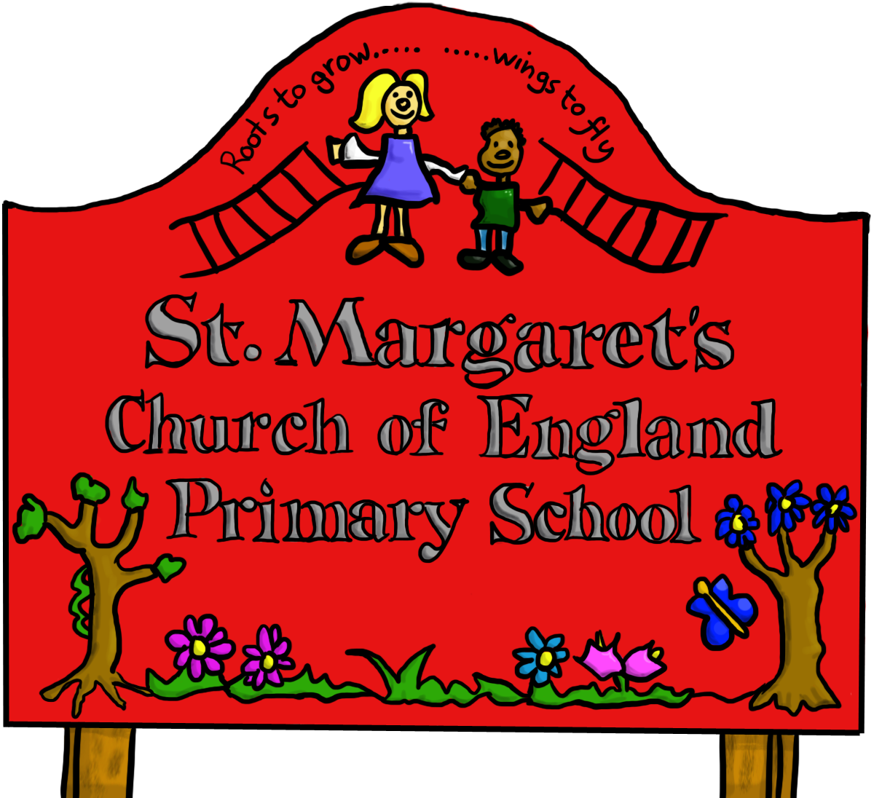

ETHOS STATEMENT

It is the aim of the Governing Body of St Margaret’s CE VA Primary School to develop policies and procedures which support the school’s vision of:

***“Learn to Love, Love to Learn, Strive to Serve”***

INTRODUCTION & AIMS

All aspects of this policy fully comply with DfE guidance, statutory responsibilities or the law as detailed including, but not limited to, the following publications:

* [Behaviour in Schools](https://assets.publishing.service.gov.uk/government/uploads/system/uploads/attachment_data/file/1089687/Behaviour_in_Schools_guidance_July_2022.pdf) – Advice for headteachers and school staff
* [Searching, Screening and Confiscation](https://assets.publishing.service.gov.uk/government/uploads/system/uploads/attachment_data/file/1091132/Searching__Screening_and_Confiscation_guidance_July_2022.pdf) – Advice for schools
* [Suspension and Permanent Exclusion](https://www.gov.uk/government/publications/school-exclusion) – Guidance for schools

At St Margaret’s CE VA Primary School, we have an expectation that children are caring & compassionate individuals who are respectful, tolerant and kind towards others. We do not leave this to chance and the aim of this policy is to provide guidance and support for staff in nurturing and developing the positive behaviours that we expect within our school and our community as well as outlining the processes and procedures which will be followed when any behaviour does not meet our expectations or, indeed, the national minimum expectation defined by [Ofsted](https://www.gov.uk/government/publications/school-inspection-handbook-eif/school-inspection-handbook). Consequently, this will support our belief that everybody should have the right to feel safe, valued and respected at our school.

The behaviour policy contains information about processes and systems, including rewards and sanctions, but recognises that many of these will have a ‘shelf life’ and need review. However, it is our intention that the principles and philosophy which underpin this policy become deeply embedded within the culture of St Margaret’s.

It is our aim that the approach to managing behaviour at St Margaret’s is both positive and restorative with respectful relationships at the centre of the work we do. We want to develop a culture of intrinsic motivation whereby children make positive behaviour choices because it is important to them rather than because of the rewards they receive. We recognise children may make poor choices at times but we aim to utilise these as a learning experience for the pupil so that they grow up understanding the impact of their behaviour on others.

**BEHAVIOUR CURRICULUM – THE ST MARGARET’S WAY**

At St Margaret’s, we develop children’s character through the ‘St Margaret’s Way’ curriculum. In order to build character, we define the behaviours and habits that we expect children to demonstrate. We want to support our children to grow into adults who are responsible, respectful, thankful, forgiving and resilient individuals.

We believe that behaviour is a key part of this development and that, as children practise behaviours over time, these become habits which positively shape how they feel about themselves and how other people perceive them. As philosopher Will Durant states, “We are what we repeatedly do. Excellence, then, is not an act, but a habit.” (1926)

**Teaching the Behaviour Curriculum**

The behaviour curriculum is taught explicitly during the first week in the Autumn term as part of the annual ‘Learning to Learn’ week. Children should learn the content of this curriculum explicitly so that they can recall the information and act upon it. At the start of each subsequent term, the ‘St Margaret’s Way’ curriculum is revisited with children and will continue to be reinforced throughout the year. As with other curriculum content, this should be taught using explicit teaching based on the ‘Principles of Instruction’ set out by Rosenshine including regular quizzing to check and strengthen retention.

Teachers will also demonstrate these behaviours and ensure children have many opportunities to practise these (particularly in the first few days of each term). For example, a lining up order should be taught in the classroom but must be reinforced in different locations and times throughout the school day e.g. at lunchtime or playtime. It is expected that all children will know this content.

As Tom Bennett describes in ‘Running The Room’, the process for teaching behaviour explicitly is as follows –  
1. Identify the routines you want to see  
2. Communicate in detail your expectations

3. Practise the routines until everyone can do them  
4. Reinforce, maintain and patrol the routines constantly

It is essential that all staff know the details of this curriculum, teach it explicitly to children and continuously maintain the high standards we set. By doing so we support each other to create a culture where individuals feel safe and are able to learn in an optimised environment and where teachers are free to teach unimpeded.

While this curriculum is intended for all children, it will be applied differently in different year groups depending on age and may be applied differently depending on individual’s SEND needs. For example, children who have autistic spectrum conditions may find it very uncomfortable to maintain eye-contact with adults. Sensitivity must be applied at all times when teaching the behaviour curriculum.

**PRINCIPLES**

**At St Margaret’s Primary School, our approach to managing behaviour is based upon four key principles:**

|  |  |  |  |
| --- | --- | --- | --- |
| **Relentless Routines** | **Visible Consistency, Visible Kindness** | **Relationships Matter** | **Over & Above Recognition** |

**“The standard you walk past is the standard you accept”**

These principles are put into action, and supported by training for staff, in different ways as the table below illustrates:

|  |  |  |
| --- | --- | --- |
| **PRINCIPLE** | **SUMMARY/RATIONALE** | **APPLICATION STRATEGIES** |
| **Relentless**  **Routines** | Consistency and coherence at whole-school level are paramount. Relentless routines will help children understand expectations from one class to the next and enable them to live up to these. | **STAR in EVERY class**:   * **S**it Up * **T**rack the speaker * **A**sk & Answer questions * **R**espect those around you   **PIP & RIP:**   * **P**raise **I**n **P**ublic * **R**eprimand **I**n **P**rivate   **Scripted Conversations:**   * All staff consistently using shared language and/or scripted conversations to resolve difficult situations (details in appendices) |
| **Visible Consistency, Visible Kindness** | Adults should be the role models to children. We do this by showing kindness consistently and for promoting positivity. | **Restorative Approaches:**   * We do not shout (there is a clear difference between raising your voice and shouting) as this is a loss of control. People make mistakes but we have to help them repair and rebuild in a restorative way.   **First Attention for Best Conduct:**   * 95% of children will always make the right choice. They must not be forgotten and our attention should always be primarily focused on best conduct. |
| **Relationships Matter** | Nobody really wants to hurt or upset people they care about. This is why it is important to build relationships which are based on mutual respect. | **Daily Meet & Greets:**   * Each morning an adult will welcome children in to the classroom with a smile and a greeting. This starts the day in a positive way.   **PWOMS:**   * What would you do if you had a ‘parent watching over my shoulder’? We should be nurturing our children with the same love and care that a parent/carer would. |
| **Over & Above Recognition** | It is important our attention is focused on ‘catching them being good’ rather than the opposite. Our time and energy needs to be invested to ensure go over and above to recognise positive choices. | **Recognition Boards in EVERY class:**   * Starting at Green (Fresh Start) * Building to Bronze * Striving for Silver * Going for Gold   **Home Contact:**   * Strategies to let the parents/carers know positive news inc. phone calls and postcards home. |

## In order to embed our approaches to restorative practice, it is important that we recognise:

* All **behaviour is communication** so every effort must be made to understand it; children should be given the opportunity to take responsibility for explaining their behaviour and supported to learn new ways to express themselves. In addition, emphasis should be placed in using de-escalation techniques in order to ensure support is scaffolded for children so that they learn to manage and improve their own behaviour.
* All **consequences must be viewed as a conversation** by ensuring appropriate responses are given to different behaviours. The repair stage is the most important!
* All **responses to behaviour should be consistent** so that children understand expectations are shared across the school.

**RULES & BEHAVIOURS**

**There are three very simple rules which apply at St Margaret’s Primary School. These are designed with the philosophy of:**

**“Love your neighbour, as yourself”**

|  |  |  |
| --- | --- | --- |
| **Our Rules** | | |
| Be **READY** | Be **RESPECTFUL** | Be **SAFE** |

All aspects of our behaviour expectations are encompassed by these three statements. These can also be used as question prompts to scaffold children’s understanding of positive behaviour choices, e.g.:

* Are you ready to learn?
* Are you being respectful?
* Are you being safe?

At St Margaret’s Primary School, children will be regularly reminded that they are responsible for their behaviour. Whilst we understand that some behaviours are reciprocating another behaviour, we teach the following:

**E + R = O**

**(EVENTS + your RESPONSE = OUTCOME)**

Our approach to behaviour management at St Margaret’s goes beyond a simple enforcement of rules. Every interaction between adults and children is underpinned by our five core values. As part of this work, staff will work to make behaviours linked to these values explicit by highlighting the positive action for reasons similar to those outlined in the table below:

|  |  |  |  |  |
| --- | --- | --- | --- | --- |
| **Our Core Values & Behaviours** | | | | |
| **RESPONSIBILITY** | **RESPECT** | **FORGIVENESS / TRUTHFULNESS** | **PERSEVERANCE** | **THANKFULNESS** |
| I can follow rules & instructions without reminders | I show good manners all of the time | I am able to keep my word and show I can be trusted | I have a positive attitude in all that I do | I say well done to show I am proud of others |
| I work hard in lessons and strive to achieve targets | I am kind & look after others around me | I am able to say sorry and admit when I am wrong | I set myself goals which help me get better at learning | I am confident and talk about things I am good at |
| I put my hand up to answer questions in class | I listen to others and respect any differences | I am able to forgive others in the spirit of reconciliation | I keep going even when things are tough | I can express what is important to me in my community |

**APPLICATION OF POLICY**

**The Senior Leadership Team will have joint responsibility for ensuring that staff are well trained and supported in delivering the expectations of this policy. The rewards & sanctions described shall provide tools to support staff in the delivery of our expectations so that the conduct of children is in line with our vision, values & rules.**

**It is the intention that this policy is applied in all necessary circumstances in order to regulate the conduct of children both within and away from school premises (including online conduct). This is in line with DfE guidance which states, “Schools have the power to sanction pupils for misbehaviour outside of the school premises to such an extend as is reasonable.” Although not a definitive list, examples of when this could be seen to be reasonable include:**

* **Taking part in any school-organised or school-related activity off site**
* **Travelling to or from school**
* **Any activity outside of school where the pupil is wearing a school uniform or is identifiable as a member of the school**

Furthermore, the school may discipline a pupil at any time, whether or not the conditions above apply, if their behaviour:

* Could have repercussions for the orderly running of the school
* Poses a threat to another pupil or a member of the public
* Could adversely affect the reputation of the school

Regulations state that the school can only discipline the pupil on school premises or elsewhere when the pupil is under the lawful control of the staff member i.e. a school trip. DfE guidance states that:

*“In cases when a member of staff or headteacher suspects criminal behaviour, the school should make an initial assessment of whether an incident should be reported to the police only by gathering enough information to establish the facts of the case. These initial investigations should be fully documented, and schools should make every effort to preserve any relevant evidence. Once a decision is made to report the incident to police, schools should ensure any further action they take does not interfere with any police action taken. However, schools retain the discretion to continue investigations and enforce their own sanctions so long as it does not conflict with police action.”*

Therefore, if a member of staff from the school is aware of a pupil demonstrating behaviour which has the potential to cause injury or harm to another, is unlawful or discriminatory then appropriate action will be taken by informing other authorities, e.g. the police when this is outside of the school premises.

Sanctions for other behaviours, which are not unlawful but are inappropriate, will be applied in line with those detailed later in this policy where it meets the conditions outlined above and where authorised by the Senior Leadership Team. Wherever possible, and appropriate, the school shall seek to work in partnership with parents/carers so that they take responsibility for managing behaviour and applying sanctions for anything their pupil does outside of school.

**BEHAVIOUR INCIDENTS ONLINE**

The way in which pupils relate to one another online can have a significant impact on the culture at school. Negative interactions online can damage the school’s culture and can lead to school feeling like an unsafe place. Behaviour issues online can be very difficult to manage given issues of anonymity, and online incidents occur both on and off the school premises. However, we are clear that the same standards of behaviour are expected online as they apply offline. Everyone should be treated with kindness, respect and dignity.

Inappropriate online behaviour including bullying, the use of inappropriate language, the soliciting of nude or semi-nude images and videos and sexual harassment shall be addressed in accordance with the same principles as offline behaviour. This includes following the Safeguarding Policy and any associate procedures where an incident occurs including, but not limited to, the involvement of the Children’s Services and/or the police. Any incidents involving nude or semi-nude images and/or videos will be automatically referred to the designated safeguarding lead.

Many online behaviour incidents amongst pupils occur outside the school day and off the school premises. Parents/carers are responsible for this behaviour. However, often incidents that occur online will affect the school culture. Therefore, where necessary or appropriate, the school shall sanction pupils when their behaviour is deemed to meet the criteria above.

**STRATEGIES & SYSTEMS**

***REWARDS -***

At St Margaret’s, we believe that children should be encouraged to behave well and work hard. Whilst our aim is to develop a sense of intrinsic motivation, i.e. the children behaving well because it is the right thing to do, we recognise the rewards and praise can promote our ethos, core values and expected behaviours.

The system used to promote our expectations of children is a very clear process across the whole school:

|  |  |
| --- | --- |
| **Starting at GREEN** |  |
| **Building to BRONZE**  **(1 Praise Point)** |
| **Striving for SILVER**  **(3 Praise Points)** |
| **Going for GOLD**  **(5 Praise Points)** |

Each class will display a recognition/zone board so that children see visible signs of success within the classroom. As praise is given and behaviours rewarded, children should move up through the different zones. All children will begin the day in the Green Zone as each day is a fresh start. Whilst children can move up and down through the different zones, they cannot be moved lower than green as this goes against our principles of PIP & RIP. If a pupil’s behaviour is not enabling them to move in a positive direction, staff should make use of the sanctions’ guidance.

At the end of each day, children should have Praise points added to the system based on where they ended the day on the recognition/zone boards. In addition to the points, any pupil who is regularly ending the day in Gold Zone should have additional praise. This could include:

* A phone call home to parents/carers (either directly by the teacher or via the weekly SLT Praise Log)
* A ‘well done’ post card sent in the post
* A visit to SLT for praise

In addition to the points given out, staff can also praise children in various ways including:

* Staff praise
* Messages/postcards/telephone calls home
* Stickers/certificates
* Termly Tally of Praise points
* Green cards (for lunchtimes)
* Celebration assemblies
* Golden Time (used sparingly at the discretion of teacher/SLT)

It is recognised that children do not all respond to the same rewards. Therefore, a teacher will have discretion around how they reward individuals beyond the minimum requirement of daily Praise points, congratulations assemblies & Green Cards. Praise and verbal positive recognition is at the heart of what we do so that our children understand exactly how proud we are of them without becoming reliant on physical rewards or prizes.

Children will be organised in to houses across the school the four houses will compete for the most Praise points in a termly tally and the school shall promote this cross-school community regularly, e.g. through events inc. Sports Day. Children shall remain in their house as they move throughout the school.

**Behaviour Badges**

In addition to teams competing to gain the most Praise points each half term in order to be awarded a golden time playtime in the final part of that half term as recognition for winning, we recognise individual behaviour through awarding behaviour badges to pupils. There are a total of 6 badges which a pupil can gain by the end of the year; each half term is an opportunity to gain a badge.

Every half term a ‘pupil target’ will be shared by class teachers with their class. This will be the minimum number of Praise points a pupil must achieve for that half term in order to be awarded their badge. Every class will have the same Praise target to ensure consistency across the school. Each half term is a new opportunity to be awarded a behaviour badge; if a pupil misses the Praise target in one half term, the next half term sees all pupils start afresh.

Badges issued in recognition of meeting your half term Praise target:

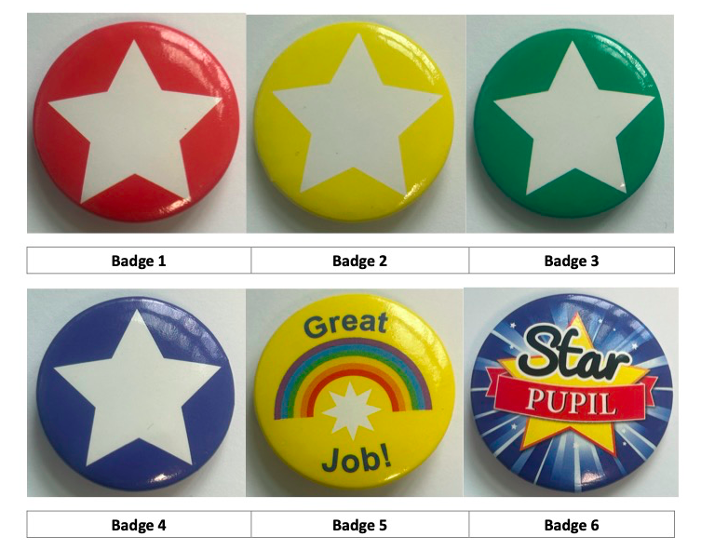

***SANCTIONS –***

At St Margaret’s, we recognise that any system of rewards and sanctions cannot be applied universally and there will need to be some bespoke elements to meet the needs of children in our care. However, for 95% of the ‘low-level’ disruption or poor behaviour choices that staff have to deal with, the following simple process shall be followed:

|  |  |
| --- | --- |
| **REMINDER** |  |
| **CAUTION** |
| **LAST CHANCE** |
| **TIME OUT & DISCUSSION** |
| **IMPOSITION** |
| **REPAIR** |

Wherever possible, this approach of sanctions should be followed sequentially, i.e. rather than jumping straight to time out, and conducted in line with PIP & RIP. This means we do not display or write names on a board when carrying out sanctions with children. Remember, our first attention should be for best conduct.

All staff shall be trained in scripts and language that can support them at each stage of this process and further details about the stages are included in the appendices of this policy & guidance. It is recognised that there are some behaviours which require the assistance of a member of SLT/non-class-based member of staff but, as part of our restorative approach, the support from SLT is not simply about imposing a consequence but is focused on how to repair and rebuild.

Any misbehaviour should be responded to predictably, promptly and assertively with the first priority always being to ensure the safety of pupils and staff as well as the need to restore a calm environment as quickly as possible. The aims of any sanctions should be to maintain the culture of the school, restore a calm and safe environment in which all pupils can learn and thrive and prevent the recurrence of misbehaviour.

To achieve these aims, a response to behaviour may have various purposes including:

* **deterrence:** sanctions can often be effective deterrents for a specific pupil or a general deterrent for all pupils at the school.
* **protection:** keeping pupils safe is a legal duty of all staff. A protective measure in response to inappropriate behaviour, for example, removing a pupil from a lesson, may be immediate or after assessment of risk.
* **improvement:** to support pupils to understand and meet the behaviour expectations of the school and reengage in meaningful education. Pupils will test boundaries, may find their emotions difficult to manage, or may have misinterpreted the rules. Pupils should be supported to understand and follow the rules. This may be via sanctions, reflective conversations or targeted pastoral support.

Where appropriate, staff should take account of any contributing factors that are identified after a behaviour incident has occurred: for example, if the pupil has suffered bereavement, experienced abuse or neglect, has mental health needs, has been subject to bullying, has needs including SEND (including any not previously identified), has been subject to criminal exploitation, or is experiencing significant challenges at home.

There are a range of tools that are available to staff & SLT when dealing with negative behaviours including:

* verbal reprimand and reminder of behaviour expectations
* setting of written tasks such as an account of their behaviour (THINK sheet)
* loss of privileges (inc. loss of responsibilities or opportunities to attend clubs/represent the school in a team)
* detentions (outside of lesson time)
* school based community service such as tidying a classroom or litter picking
* time out (within class or in a partner class) for a maximum of 15mins in any one lesson and for a maximum of 30mins across any one day (this behaviour should be reported so SLT can support/monitor if this is happening regularly)
* yellow/red cards (for lunchtimes) using guidance in the appendices
* reports using guidance in the appendices
* internal isolation (within lesson time) or detentions (outside of lesson time) when authorised by SLT
* suspensions/permanent exclusions when only if authorised by HT
* meetings with parents/carers (inc. discussions about managed moves)

In line with the ‘repair’ phase of our policy, strategies should be considered to help pupils understand how to improve their behaviour and meet the expectations of the school. These might include:

* a targeted discussion with the pupil, including explaining what they did wrong, the impact of their actions, how they can do better in the future and what will happen if their behaviour fails to improve. This may also include advising them to apologise to the relevant person, if appropriate
* a phone call with parents/carers, and the Virtual School Head for looked after children (where applicable)
* inquiries into the pupil’s conduct with staff involved in teaching, supporting or supervising the pupil in school
* inquiries into circumstances outside of school, including at home, conducted by the designated safeguarding lead or a deputy
* considering whether the support for behaviour management being provided remains appropriate

**‘AT RISK’ PUPILS**

If a pupil is at risk of suspension of permanent exclusion, they will be logged as ‘At Risk’ with SLT and a staged support procedure will be applied to support the pupil with their behaviour. ‘At Risk’ means that a pupil is not responding to the school’s normal range of strategies or support and that the intervention of external agencies may be required.

|  |
| --- |
| **STAGE 1:** |
| Referred to SLT to begin the staged support system for individual pupils. Referred by Key Stage Phase Leaders for persistent breaches of the behaviour policy or for a serious behaviour incident. |
| Stage meeting with parents/carers and SLT. |
| Individual Behaviour Plan (IBP) put in place with a review meeting involving parents/carers planned within the time of the report. The duration of the report may vary depending on the age of the pupil and the negative behaviour being demonstrated.  The IBP should not be used to replace provision maps for learning plans or SEND assessment processes; pupils should still be taken through the appropriate graduated response in line with the SEN Code of Practice.  The aim of the IBP is to involve the pupil in the shared challenge of improving his/her behaviour and social skills. The meeting to write the IBP will look at positive points, issues arising and support available. The pupil should be involved in helping set his/her targets and these should be closely monitored (lesson by lesson) and reviewed weekly. |
| Pupil put on behaviour report to monitor and improve behaviour. |

|  |
| --- |
| **STAGE 2:** |
| Pupil at Stage 1 continuing to breach behaviour policy or serious incident from pupil at Stage 1. Pupil moves to Stage 2. |
| Pupil may be isolated, suspended or excluded (the length may vary dependent on the incident leading to Stage 2). A ‘Post-Exclusion Meeting’ must always be held following any period of external exclusion in order to reflect on the initial incident, gain the views of both parents/carers and pupil in order to establish a risk assessment of the pupil’s behaviour. This meeting will also consider reflections from the school.  This meeting will also provide a useful forum to identify resources and support needed to provide the necessary provision for the pupil moving forward. These discussions will form the reintegration plan and feed into class provision/ additional action plans. |
| Meeting with SLT (including either DHT and/or HT). Pupil continues on report to monitor and improve behaviour. |
| Behaviour risk assessment put in place where appropriate. |
| Update of the IBP and fortnightly reviews with parents/carers. The aim of the IBP is to involve the pupil in the shared challenge of improving his/her behaviour and social skills. The IBP meeting will look at positive points, issues arising and support available. The pupil should be involved in helping set his/her targets and these should be closely monitored (lesson by lesson) and reviewed weekly. |
| Early intervention outreach to be considered, e.g. ALP. |

|  |
| --- |
| **STAGE 3:** |
| Pupil may be suspended or excluded (the length may vary dependent on the incident leading to Stage 3). This is followed by post-exclusion meeting and reintegration plan. |
| This is the final stage before a permanent exclusion (if there has been a lead up to an incident which results in a permanent exclusion, i.e. some extremely serious incidents could automatically lead to a permanent exclusion without a pupil being identified as being ‘at risk’). |
| Case study of the current provision completed. |
| Panel meeting with Governors to review behaviour and review of school support. |
| Discuss a manged move or alternative provision with relevant parties. |
| Inform Local Authority of a high priority case. |

**SUSPENSIONS & PERMANENT EXCLUSIONS**

We do not wish to suspend or exclude any pupil from St Margaret’s Primary School. However, where we feel that this is necessary & we have exhausted all other options available to us prior to that, we adhere to all the current guidance and procedures from the Local Authority (LA) & the [DfE](https://www.gov.uk/government/publications/school-exclusion). These decisions are always made as a last resort but are necessary as all pupils are entitled to an education where they are protected from disruption and can learn in a calm, safe and supportive environment.

Before reaching a decision to suspend or exclude permanently, the Head Teacher will:

* Consider all the relevant facts and such evidence as may be available to support the allegations made, taking into account the school’s expectations of core values/behaviours and equality policies and duties
* Allow the pupil, and/or their advocate, to give their version of events
* Check whether the incident may have been provoked, for example, by racial, homophobic or sexual harassment
* Consult others where appropriate, being careful not to involve anyone who may have a role in the any statutory review of the exclusion (e.g. members of the Governing Body)
* Consider the pupil’s needs (e.g. SEND) and understanding

A pupil’s behaviour outside school can be considered grounds for a suspension or permanent exclusion. Any decision of the Head Teacher, including suspension or permanent exclusion, is made in line with the principles of administrative law, i.e., that it is: lawful (with respect to the legislation relating directly to suspensions and permanent exclusions and a school’s wider legal duties); reasonable; fair; and proportionate.

When establishing the facts in relation to a suspension or permanent exclusion decision the Head Teacher is required to apply the civil standard of proof, i.e., ‘on the balance of probabilities’ it is more likely than not that a fact is true, rather than the criminal standard of ‘beyond reasonable doubt.’ This means that the Head Teacher should accept that something happened if it is more likely that it happened than that it did not happen. The Head Teacher must take account of their legal duty of care when sending a pupil home following an exclusion.

Suspension & permanent exclusions can be used for serious or significant breaches of this Behaviour Policy. The decision to permanently exclude a pupil may be for one of the following reasons:

* In response to persistent or serious breaches of the school’s Behaviour Policy
* Consistently demonstrating negative behaviours (as detailed in the information about Red/Yellow cards in the appendices)
* Where allowing the pupil to remain in school would seriously harm the education or welfare of the pupil or others in school

These may include, but are not limited to, the following:

* Verbal abuse or threatening behaviour (against pupils or adults)
* Use, or threat of use, of an offensive weapon or prohibited item which is not permitted in school
* Bullying (which may include online bullying/comments made on social media)
* Homophobic, sexist or racist language or behaviour or abuse relating to disability or any of the other [protected characteristics](https://www.gov.uk/discrimination-your-rights) (inc. online/social media comments)
* Assault/fighting (against pupils or adults) or the encouragement of others to do so
* Persistently disruptive or defiant behaviour
* Persistent failure to follow the school Behaviour Policy
* Behaviour which is beyond the care and control of the school, e.g. criminal activity
* Wilful and repeated transgression of protective measures in place to protect public health

**Once consideration has been made of the above factors, ultimately, the decision to suspend or exclude is an operational one made by the Head Teacher.**

**PUPIL TRANSITION & SUPPORT**

Alternatives to exclusion will always be explored and, where possible, interventions put in place to support children at risk of exclusion. These include:

* Pastoral support/individual behaviour plans (IBPs)
* Individual mentoring/coaching & behaviour support
* Working with parents/carers
* Change of class/teaching groups
* A managed move/negotiated transfer
* Assessment of SEND needs and consideration of alternative provision
* Allocation of a key adult where possible
* Counselling, where available, or nurture provision
* Restorative practice methods
* Peer mentoring

A ‘Post Exclusion Meeting’ must always be held following any suspension in order to reflect on the incident and actions taken by the school, gain the views of the parent/carer and pupil and to establish a risk assessment and reintegration support plan where relevant. This meeting will also provide a useful forum to discuss the pupil’s overall needs and how any support can be incorporated in to class activity in a sustainable way. A part-time timetable should not be used to manage a pupil’s behaviour but, where this has been agreed for other reasons, it must be for the shortest time possible.

Although attendance of parents/carers at this meeting is strongly encouraged, pupils should not be prevented from returning to school if parents/carers are unable or unwilling to attend the meeting.

Only the Head Teacher of the school can suspend or permanently exclude a pupil on disciplinary grounds. In the case of suspensions, the Head Teacher may exclude a pupil for one or more fixed periods (up to a maximum of 45 days in one academic year). Exclusions are operational decisions made by the Head Teacher (or acting Head Teacher) who then informs the LA and the Governing Body. However, where appropriate, the Full Governing Body will convene a ‘Pupil Discipline Committee’ to consider representations made by parents/carers. A separate Appeals Committee can be convened if either party wishes to contest the decision taken.

If any pupil is suspended or excluded permanently, suspended for more than 15 school days (where these days are an accumulation of days for more than one incident) in a term or where the suspension would result in a pupil missing a statutory assessment, this must be reviewed by the Pupil Discipline Committee.

It is not possible for the Head Teacher to convert a suspension into a permanent exclusion. If further evidence has come to light, a further suspension or permanent exclusion may be issued to begin immediately after the end of the initial suspension.

**PLAYTIME AND LUNCHTIME DETENTIONS**

On occasions it may be necessary to place children in detention. St Margaret’s Primary School does not issue detentions outside of normal school hours. Therefore, any detentions are within a child’s playtime or lunchtime and can only occur if authorised by SLT.

This may involve missing all or part of a playtime or lunch period. During this time, children will be given reasonable time to eat, drink and use the toilet but they will also be asked to complete appropriate work or carry out appropriate duties, e.g. helping to tidy a classroom.

Whenever a pupil has made a wrong choice, it is important that they understand there are consequences. However, staff must always ensure that they deal with negative incidents in a ‘restorative’ manner, i.e. by talking to the children about the impact of their behaviour.

It will be the decision of the designated staff member overseeing the detention to agree what action needs to be taken by the pupil to ‘repair’ the situation following any misbehaviour (verbal apology, letter of apology etc). As part of this restorative conversation, a ‘think sheet’ may be completed by the pupil (with adult support if needed). The completion of this sheet is crucial, as it supports the thinking process following an incident of inappropriate behaviour. Key questions focus on:

* What do you think you did wrong?
* Why do you think it happened?
* Who else do you think was hurt or upset by your behaviour?
* What would your parents/carers think about your behaviour?
* How do you think you can avoid behaviour like this in the future?

**INTERNAL ISOLATION & TIME OUT**

As with detentions, there may be occasions when it is necessary to provide time out or to internally isolate a pupil. The decision to provide time out for a pupil is taken by class teachers in response to low-level (amber) behaviours in class. Time out should be taken in another class (i.e. the nearest class of another year group) for a maximum of 15mins at any one time (and no more than 30mins in a day).

Time out is intended as an opportunity for a pupil to reflect on their behaviour and have time to regulate any emotions. Depending on the age of the child, or consideration of needs, individual pupils may need to be supported in time out by an adult (usually teaching assistant) from their usual class. They should be given work to continue during this time. Under no circumstances, should time out be independent outside of a classroom/in a corridor. It may be agreed that a pupil works independently with an additional member of staff in a corridor space. However, unless this is part of a planned intervention, the time should be limited for time out purposes. For some pupils time out will be with SLT. The decision will be taken by Senior Leaders in discussion with class teachers. For some identified pupils, time out with a senior member of staff is needed due to patterns identified in behaviour and frequency of incidents.

Internal isolation may involve working away from the pupil’s classroom in another location for a set period of time (which is more than 15mins/30mins in a day), depending on the severity and type of behaviour displayed. Internal isolation can only occur if authorised by SLT and, where it does occur, it must be a considered approach so that a behaviour issue is not simply moved from one classroom to another.

During this time, the pupil will be given their class work to complete with the expectation it will be completed to the same standard as if they were in their own classroom. Support, from the pupil’s usual class, may need to be reallocated to support in the alternative room.

The school reserves the right to enforce this sanction for pupils where their behaviour is unacceptable or clearly goes against the school aims and ethos. The same principle of restorative practice will be applied as in the case of a detention (see above), a think sheet must be completed to aid self-reflection and help the pupil understand the consequences of the action, not just for themselves but for others.

Whenever a pupil has a period of internal isolation or detention, SLT will record on Record forms and inform parents/carers ensuring the incident and sanction is communicated clearly with expectations for behaviour reinforced and understood by all concerned. Any internal isolation should conclude with a ‘reintegration’ conversation so that the pupil and staff are aware of adaptations or changes required when a pupil returns to their own class.

**INVOLVING PARENTS, AGENCIES & OTHER STAFF**

In handover meetings each year, class teachers are asked to communicate the behaviour needs of children in their class in order to ensure effective transition can take place. In addition, at key points during the year, reviews are carried out by the SENDCO for any children with additional needs (inc. SEMH needs) This is an opportunity to review and evaluate the support that is offered to individuals or groups of children, before setting new targets and outlining strategies in place to enable them to achieve these. These targets are further informed by the views of both parents and children.

If behaviours continue to escalate, despite support in place, the SENDCO will decide, in consultation with the Senior Leadership Team, whether or not outside agencies need to be involved for support/guidance and will inform the parents/carers of concerns. If the pupil is at risk of exclusion, an Individual Behaviour Plan (IBP) will be put in place. “At risk” means that a pupil is not responding to the school’s normal range of strategies and support (repeated suspensions might be an indicator) and that the intervention of external agencies may be required. The aim of the IBP is to involve the pupil in the shared challenge of improving his/her behaviour and social skills. The IBP meeting will look at positive points and main issues. The pupil should be involved in helping set his/her targets and these should be closely monitored (lesson by lesson) and reviewed in line with guidance previously detailed in this policy. The IBP should not be used to replace IEPs or Special Educational Needs assessment process; pupils should still be taken through the appropriate stages of the SEN Code of Practice.

**MANAGED MOVES**

Where there are ongoing concerns about a pupil’s behaviour, discussions may include consideration of a ‘managed move’ process in order to initiate a process which leads to the transfer of a pupil to another mainstream school permanently in order to improve their behaviour.

Where interventions or targeted support have not been successful in improving a pupil’s behaviour, off-site direction should be used to arrange time-limited placements at an Alternative Provision (AP) or another mainstream school.

Depending on the individual needs and circumstances of the pupil, off-site direction into AP can be full-time or a combination of part-time support in AP and continued mainstream education. A proposed maximum period of time should be discussed and agreed upon as part of the planning phase for an off-site direction. As part of planning, alternative options should be considered once the time limit has been reached, including a managed move on a permanent basis (if a pupil is in a mainstream school) upon review of the time-limited placement.

Managed moves should be offered as part of a planned intervention where it is in the pupil’s best interests. The original school should be able to evidence that appropriate initial intervention has been carried out, including, where relevant, multi-agency support, or any statutory assessments were done or explored prior to a managed move.

Parents/Carers, and the Virtual School where applicable, are involved in discussions about managed moves. If a parent/carer believes that they are being pressured into a managed move or is unhappy with a managed move, they can take up the issue through the school’s formal complaints procedure with the governing board and, where appropriate, the Local Authority.

**CHILD ON CHILD ABUSE**

Following any report of child-on-child abuse, including sexual violence or harassment (online or offline), the school will follow its safeguarding procedures and policies which are compliant with the principles set out in [Keeping Children Safe in Education](https://assets.publishing.service.gov.uk/government/uploads/system/uploads/attachment_data/file/1080047/KCSIE_2022_revised.pdf) (KCSIE) – especially Part5.

Sexual violence and sexual or gender harassment are never acceptable and will not be tolerated. Pupils whose behaviour falls short of expectations will be sanctioned and any actions taken will be considered in order to provide any support required for the victim and alleged perpetrator.

**SEARCHING, SCREENING OR CONFISCATING**

Searching can play a critical role in ensuring that schools are safe environments for all pupils and staff. It is a vital measure to safeguard and promote staff and pupil welfare, and to maintain high standards of behaviour through which pupils can learn and thrive***.***

The Head Teacher, and any staff they authorise, have a statutory power to search a pupil or their possessions where they have reasonable grounds to suspect that the pupil may have a prohibited item or any other item that could be used to breach the school rules.

Prohibited items: This can include knives or weapons, alcohol, illegal drugs and stolen items, tobacco and cigarette papers, fireworks, pornographic images and any other items as defined as such from time to time. It shall also include any article that a member of staff reasonably suspects has been, or is likely to be, used to commit an offence or to cause personal injury to, or damage to the property of, any person including the pupil; any other items as defined in law as such from time to time; and items such as tobacco and cigarette papers, alcohol or any other drug (inc. vapes), fireworks and pornographic (inc. nude and semi-nude images).

Prohibited items also include items which are not permitted in school, e.g. mobile phones or communication devices which are not authorised for the purpose of safer travel (Y5 & Y6 only)/handed in to staff, pop/drinks/snacks which do not adhere to school policy.

Being in possession of a prohibited item – especially knives, weapons, illegal drugs or stolen items – may mean that the pupil is involved, or at risk of being involved, in anti-social or criminal behaviour including gang involvement, and in some cases may be involved in child criminal exploitation. A search may play a vital role in identifying pupils who may benefit from early help or a referral to the Local Authority Children’s Services and/or police.

Under common law, school staff authorised by the Head Teacher have the power to search a pupil for any item if the pupil agrees. The member of staff should ensure the pupil understands the reason for the search and how it will be conducted so that their agreement is informed. Only the Head Teacher, or a member of staff authorised by the Head Teacher, can carry out a search. The headteacher can authorise individual members of staff to search for specific items, or all items set out in the school's Behaviour Policy.

Any searches are undertaken in line with statutory [Searching, Screening and Confiscation](https://assets.publishing.service.gov.uk/government/uploads/system/uploads/attachment_data/file/1091132/Searching__Screening_and_Confiscation_guidance_July_2022.pdf) guidance from the DfE. Prior to searching, the authorised member of staff should make an assessment of how urgent the need for a search is and should consider the risk to other pupils and staff.

Before any search takes place, the member of staff conducting the search should explain to the pupil why they are being searched, how and where the search is going to take place and give them the opportunity to ask any questions.

The authorised member of staff should always seek the co-operation of the pupil before conducting a search. If the pupil is not willing to co-operate with the search, the member of staff should consider why this is. Reasons might include that they:

* are in possession of a prohibited item
* do not understand the instruction
* are unaware of what a search may involve
* have had a previous distressing experience of being searched

Informed consent: The school staff may search a pupil with their consent for any item. Appropriate consideration will be given to factors that may influence the pupil's ability to give consent. If the pupil refuses sanctions will be applied, where relevant, in accordance with this policy.

Searches without consent: In relation to prohibited items, as defined above, the Head Teacher, and staff authorised by the Head Teacher, may search a pupil or a pupil’s possessions, without their consent, where they have reasonable grounds for suspecting that a pupil has a prohibited item in their possession. Searches without consent will only be carried out on the school premises or where the member of staff has lawful control or charge over the pupil, for example, on school trips.

If the member of staff authorised to search still considers a this to be necessary regardless of consent, but is not required urgently, they should seek the advice of the Head Teacher, designated safeguarding lead (or deputy) or pastoral member of staff who may have more information about the pupil. During this time the pupil should be supervised and kept away from other pupils.

If the pupil still refuses to co-operate, the member of staff authorised to search should assess whether it is appropriate to use reasonable force to conduct the search. **This must be done in consultation with the Head Teacher.** A member of staff can use such force as is reasonable to search for any prohibited items identified above, but not to search for items which are identified only in the school rules, e.g. mobile phones.

The decision to use reasonable force should be made on a case-by-case basis. The member of staff, in consultation with the Head Teacher, should consider whether conducting the search will prevent the pupil harming themselves or others, damaging property or from causing disorder

Searches Guidance:

The law states the member of staff conducting the search must be of the same sex as the pupil being searched. There must be another member of staff present as a witness to the search. There is a limited exception to this rule. This is that a member of staff can search a pupil of the opposite sex and/or without a witness present only:

if the member of staff carrying out the search reasonably believes there is risk that serious harm will be caused to a person if the search is not carried out as a matter of urgency; and

in the time available, it is not reasonably practicable for the search to be carried out by a member of staff who is same sex as the pupil or it is not reasonably practicable for the search to be carried out in the presence of another member of staff.

When a member of staff conducts a search without a witness they should immediately report this to another member of staff, and ensure a record of the search is kept.

If staff believe a pupil is in possession of a prohibited item, it may be appropriate for a member of staff to carry out:

* a search of outer clothing; and / or
* a search of school property, e.g. children’s drawers; and / or
* a search of personal property (e.g. bag or pencil case).

Strip searches will not be undertaken unless there are highly exceptional circumstances, e.g. an immediate risk of harm due to the concealment of an object. Where reasonably possible, staff should inform parents/carers in advance of a search taking place but, in all circumstances, when a search has taken place. Any searches must be logged on RECORD FORMS with appropriate information including:

* the date, time and location of the search;
* which pupil was searched;
* who conducted the search and any other adults or pupils present;
* what was being searched for;
* the reason for searching;
* what items, if any, were found; and
* what follow-up action was taken as a consequence of the search.

Parents/carers should always be informed of any search for a prohibited item that has taken place, and the outcome of the search as soon as is practicable. A member of staff should inform the parents of what, if anything, has been confiscated and the resulting action the school has taken, including any sanctions applied.

Searches will be conducted in such a manner as to minimise embarrassment or distress. Any search of a pupil or their possessions will be carried out in the presence of the pupil and another member of staff.

Where the Head Teacher, or staff authorised by the Head Teacher, find anything which they have reasonable grounds for suspecting is a prohibited item, they may seize, retain and dispose of that item as appropriate in accordance with the DfE guidance:

* An authorised staff member carrying out a search can confiscate any item that they have reasonable grounds for suspecting:
* poses a risk to staff or pupils;
* is prohibited, or identified in the school rules for which a search can be made; or
* is evidence in relation to an offence.

Electronic devices, including mobile phones, can contain files or data which relate to an

offence, or which may cause harm to another person. This includes, but is not limited to,

indecent images of children, pornography, abusive messages, images or videos, or evidence

relating to suspected criminal behaviour.

As with all prohibited items, staff should first consider the appropriate safeguarding response

if they find images, data or files on an electronic device that they reasonably suspect are

likely to put a person at risk. Staff may examine any data or files on an electronic device they

have confiscated as a result of a search if there is good reason to do so and this has been

authorised by the Head Teacher.

Schools’ general power to discipline enables a member of staff to confiscate, retain or

dispose of a pupil’s property as a disciplinary penalty, where reasonable to do so.

**USE OF REASONABLE FORCE/ POSITIVE HANDLING**

Any use of force by staff will be reasonable, proportionate and lawful. Reasonable force or ‘positive handling’ will be used in accordance with the DfE guidance [‘Use of reasonable force: advice for Headteacher, teachers and governing bodies’](https://assets.publishing.service.gov.uk/government/uploads/system/uploads/attachment_data/file/444051/Use_of_reasonable_force_advice_Reviewed_July_2015.pdf) and only when necessary.

Any use of reasonable force is for the minimum time necessary to prevent a pupil from doing or continuing to do any of the following:

* Committing a criminal offence;
* Injuring themselves or others;
* Causing damage to property (including their own);
* Engaging in any behaviour prejudicial to good order and discipline at the school or among any of its children, whether that behaviour occurs in a classroom or elsewhere.

Positive handling is used in the school in order to:

* + Restrain a pupil who has lost emotional self-control until the situation is diffused.
  + Limit the amount of harm that the pupil involved can do to their self or others.
  + Demonstrate to children that they are within a safe environment in which adults can contain a pupil’s anger and other erratic emotions.
  + Protect all children against any form of physical intervention which is unnecessary, inappropriate, excessive or harmful.
  + Positive handling will be limited to emergency situations and used only as a measure of last resort.

Where restraint/ positive handling is used by staff, this is recorded in writing and logged in a bound book stored in the Head Teacher’s office. The pupil’s parents/carers will be informed at the earliest possible opportunity. Force is never used as a form of punishment. Full details are available in our Positive Handling Policy.

Where a pupil’s behaviour is regularly volatile or unpredictable, or where there have been frequent occasions to use positive handling within a short space of time, consideration is given to the creation of Personal Support Plan (PSP) in order to consider proactive strategies for de-escalation and avoid the use of reasonable force on future occasions.

**BEHAVIOUR OF PUPILS WITH SEND**

Adjustments can be made to routines for pupils with additional needs, where appropriate and reasonable, to ensure all pupils can meet behavioural expectations. These adjustments may be temporary. Adjustments should be made proactively and by design where possible. For example, a pupil who has recently experienced a bereavement may need to be pre-emptively excused from a routine to give them time and space away from their peers. The school is mindful that not all pupils requiring support with behaviour will have identified SEND.

The school has the need to manage pupil behaviour effectively, whether or not the pupil has underlying needs. When a pupil is identified as having SEND, the graduated approach should be used to assess, plan, deliver and then review the impact of the support being provided.

The school’s culture consistently promotes high standards of behaviour for everyone and we provide the necessary support to ensure all pupils can achieve and thrive both in and out of the classroom. St Margaret’s Primary School has a whole-school approach meets the needs of all pupils in the school, including pupils with SEND, so that everyone feels they belong in the school community and high expectations are maintained for all pupils. The school creates calm environments which will benefit pupils with SEND, enabling them to learn.

**STAFF INDUCTION, DEVELOPMENT & SUPPORT**

All staff are introduced to the school’s Behaviour Policy and Blueprint overview as part of the induction process, regardless of role. Beyond that, any more specific training and support is provided through CPD, coaching and mentoring depending on individual level of responsibilities.

Early Career Teachers are support through access to additional training but all staff receive regular training and input related to behaviour including matters such as SEND, mental health and pastoral provision. Those with more senior responsibilities have access to nationally accredited programmes such as the NPQ scheme for Leading Behaviour & Culture (NPQLBC).

**MALICIOUS ALLEGATIONS AGAINST STAFF**

Where a pupil makes an accusation against a member of staff and the accusation is shown to have been deliberately invented or malicious, the Head Teacher will consider whether to take disciplinary action in accordance with this policy. This may include a referral to the police to consider if that action might be appropriate.

**ROLES & RESPONSIBILITIES**

***SENIOR LEADERSHIP TEAM:***

The Senior Leadership Team will:

* be highly visible and routinely engage with pupils, parents/carers and staff in order to set and maintain the behaviour culture at the school so that there is a calm environment and everyone feels safe and supported
* implement and monitor the effectiveness of this policy throughout the school and, where appropriate, report to governors
* support the staff in the understanding and implementation of procedures outlined in this policy and guidance where necessary
* provide training, coaching and mentoring for staff and pupils as required
* keep records of any significant negative behaviour incidents and report to the LA or governors as necessary with detailed analysis reports produced by the behaviour leader at least every half term
* liaise with external agencies as necessary in order to support individuals with specific needs

The Head Teacher will follow guidance from the DfE and LA if a suspension or permanent exclusion is deemed necessary*.*

***STAFF***

Staff have an important role in developing a calm and safe environment for pupils and establishing clear boundaries of acceptable pupil behaviour. Staff will:

* uphold the whole-school approach to behaviour by teaching and modelling expected behaviour and positive relationships, as defined by the school behaviour policy, so that pupils can see examples of good habits and are confident to ask for help when needed.
* challenge pupils to meet the school expectations and maintain the boundaries of acceptable conduct
* communicate the school expectations, routines, values and standards both explicitly through teaching behaviour and in every interaction with pupils.
* consider the impact of their own behaviour on the school culture and how they can uphold the school rules and expectations.
* utilise any opportunity in the curriculum to promote the school rules and values
* engaging effectively with pupils and/or parents/carers in order to proactively manage and improve behaviour

***GOVERNORS***

The Governors will:

* review a written statement of principles, policy & guidance to support the Head Teacher and school staff in determining measures for managing behaviour & discipline.
* notify the Head Teacher and offer further guidance where it feels that particular measures introduced or issues addressed regarding behaviour are inappropriate, unfair or contrary to any local or national guidance or regulations.

***PARENTS/CARERS***

The parents/carers will:

* support their child’s learning and co-operate with the school
* promote positive behaviours and values at home as well as at school
* read any documentation that is sent home
* meet with members of the school staff as necessary to discuss any concerns
* contact the school if they have any concerns or questions about the contents of this policy

***CHILDREN***

The children will:

* try their best to demonstrate the core values & linked behaviours
* follow the 3 simple rules at all times
* take responsibility for their actions
* consider the effects of their actions
* work with others, including staff, to agree on consequences and next steps as a result of their actions

**MONITORING & REVIEW**

The Behaviour Policy & Guidance is reviewed on an annual basis through consultation with all stakeholders.

The Head Teacher monitors the effectiveness of this policy on a regular basis and reports to the Governing Board as appropriate, including making recommendations for improvement.

A variety of records are held in school regarding behaviour. This includes records of behaviour held by class teachers, incidents logged by the Senior Leadership Team and action plans/ other relevant paperwork held by the SENDCO. Any incidents of behaviour which have to be reported to the LA, e.g. racist incidents, are also logged by the Head Teacher/Deputy Head Teacher/ Assistant Head.

A half termly report is produced by the lead teacher for behaviour, along with the collation of other information throughout the year, so that the governing body can consider:

* behaviour incident data, including on removal from the classroom;
* attendance, permanent exclusion and suspension data;
* use of pupil support units, off-site directions and managed moves;
* incidents of searching, screening and confiscation; and
* anonymous surveys for staff, pupils, governors, trustees and other stakeholders on their perceptions and experiences of the school behaviour culture.

The Head Teacher keeps a record of any suspensions or permanent exclusions that have been enforced at St Margaret’s Primary School.

**APPENDIX 1: BEHAVIOUR BLUEPRINT**

**St Margaret’s CE VA Primary School**

**BEHAVIOUR BLUEPRINT**

|  |
| --- |
| **Our Vision** |
| St Margaret’s CE VA Primary School is a unique and special place where our community matters and children are at the centre of all that we do.  **Learn to Love, Love to Learn, Strive to Serve** is our commitment to ensure we unlock the potential inside all of our children. We aim to create an inclusive & exciting environment in which every child succeeds and achieves the best they can. |

|  |  |  |  |  |
| --- | --- | --- | --- | --- |
| **Our Core Values & Behaviours** | | | | |
| **RESPONSIBILITY** | **RESPECT** | **FORGIVENESS / TRUTHFULNESS** | **PERSEVERANCE** | **THANKFULNESS** |
| I can follow rules & instructions without reminders | I show good manners all of the time | I am able to keep my word and show I can be trusted | I have a positive attitude in all that I do | I say well done to show I am proud of others |
| I work hard in lessons and strive to achieve targets | I am kind & look after others around me | I am able to say sorry and admit when I am wrong | I set myself goals which help me get better at learning | I am confident and talk about things I am good at |
| I put my hand up to answer questions in class | I listen to others and respect any differences | I am able to forgive others in the spirit of reconciliation | I keep going even when things are tough | I can express what is important to me in my community |

|  |  |  |
| --- | --- | --- |
| **Our Rules** | | |
| **“Love your neighbour as yourself”** | | |
| Be **READY** | Be **RESPECTFUL** | Be **SAFE** |

|  |
| --- |
| **Our Behaviour Principles** |
| **“The standard you walk past is the standard you accept”** |

|  |  |  |  |
| --- | --- | --- | --- |
| **Relentless Routines** | **Visible Consistency, Visible Kindness** | **Relationships Matter** | **Over & Above Recognition** |
| STAR & PIP/RIP | Restorative Approaches (we do not shout!) | Daily Meet & Greets | Recognition Boards |
| Scripted Conversations | First Attention for Best Conduct | PWOMS | Home Contact |

|  |  |
| --- | --- |
| **Our Rewards & Sanctions** | |
| **Rewards** | **Sanctions** |
| Starting at Green (Fresh Start)  Building to Bronze  Striving for Silver  Going for Gold | Reminder  Caution  Last Chance  Time Out & Discussion  Imposition  Repair |
| Staff Praise  Messages home  Stickers/certificates  Praise Points (Termly House Tally)  Weekly Congratulations | Time Out  Yellow/Red Cards  Reports  Internal/External Exclusions  Meetings with Parents/Carers |

**APPENDIX 2: Challenging behaviour script**

|  |
| --- |
| **Dealing with challenging behaviour:**  **30 second script** |
| 1. “[NAME], I notice that you are… [Specify unwanted behaviour].” 2. “It was the rule about being [Ready/ Respectful/ Safe] that you broke.” 3. “If it continues then you have chosen to [explain sanction e.g. go to another class, talk to teacher at break, sit on bench for X mins].” 4. “Do you remember last week when you [highlight example of the child succeeding in following the rule]? 5. “That is who I need to see now [NAME].” 6. “I know you can succeed.” 7. “We will talk about this at the end of the session.”   Then walk away to give ‘take up time’ and to avoid getting into a negotiation or shifting of blame. |

**APPENDIX 3: THREE SIMPLE RULES**

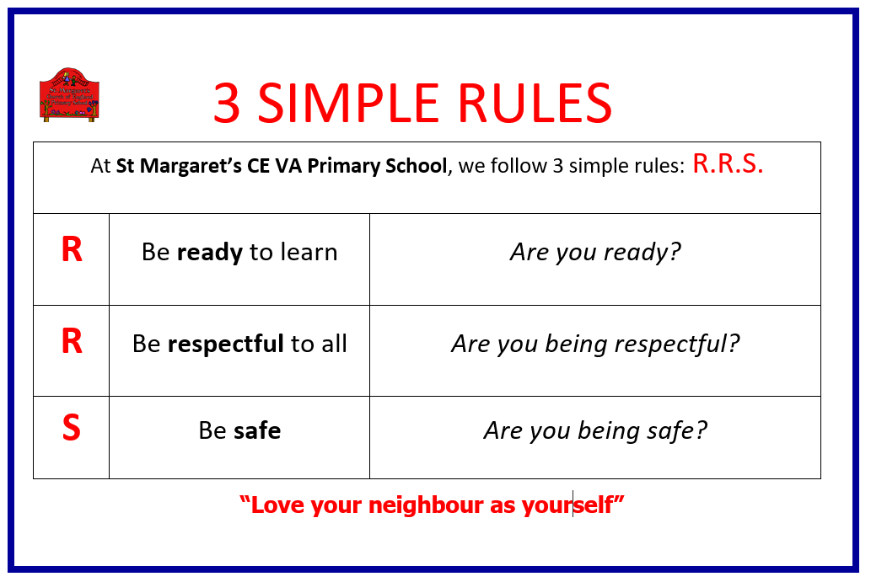

**APPENDIX 4: NEGATIVE BEHAVIOUR (RED/YELLOW CARD) GUIDE**

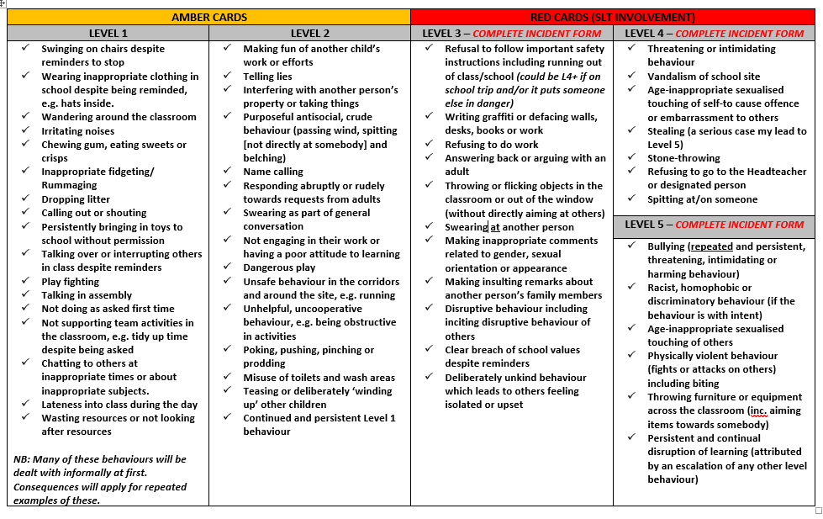

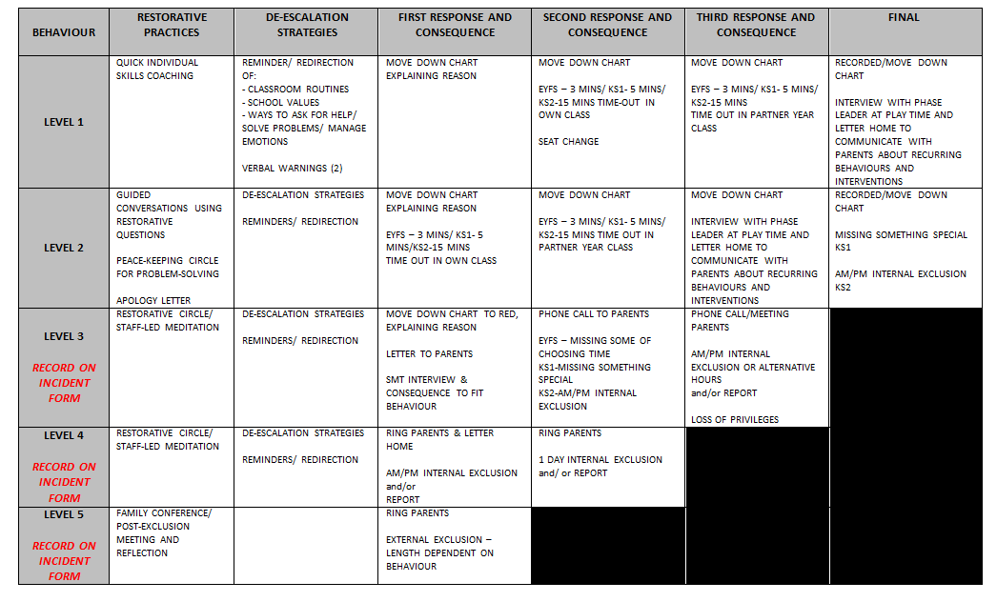

**APPENDIX 6: SANCTIONS PROCESS**

