“Encourage one another and build each other up”

1 Thessalonians 5:11

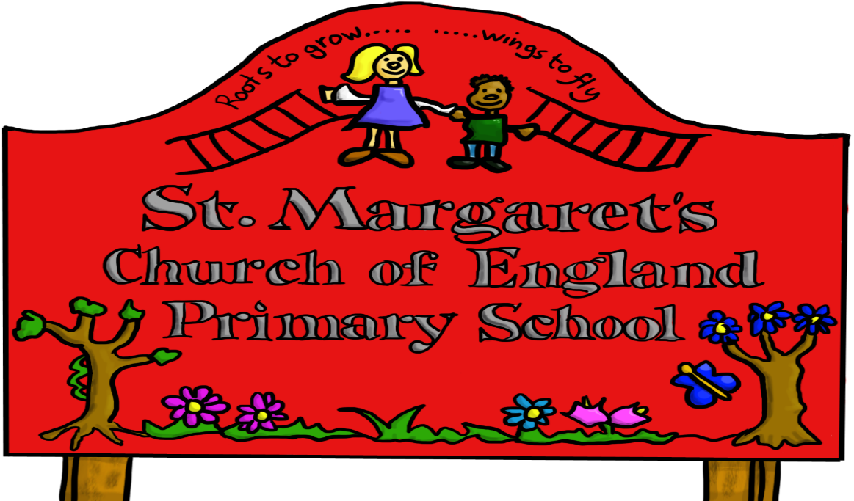

Reviewed Jan 2021

To find out more about online safety, please read our Online Safety Policy.

You can find support and online safety resources for parents at [parentsafe.lgfl.net](https://parentsafe.lgfl.net)

Please discuss the following with your child:

**My name is ____________________ Year Group**

: [childrenscommissioner.gov.uk/our-work/digital/5-a-day/](https://www.childrenscommissioner.gov.uk/our-work/digital/5-a-day/)

|  |  |
| --- | --- |
| To stay **SAFE online and on my devices**, I follow the Digital 5 A Day and: | **✓** |
| 1. I only **USE** devices or apps, sites or games if an adult I trust says I am allowed to |  |
| 1. I **ASK** for help if I’m stuck or not sure |  |
| 1. I **TELL** an adult I trust if I’m upset, worried, scared or confused |  |
| 1. If I get a **FUNNY FEELING** in my tummy, I talk to an adult |  |
| 1. I look out for my **FRIENDS** and tell someone if they need help |  |
| 1. I **KNOW** people online aren’t always who they say they are |  |
| 1. Anything I do online can be shared and might stay online **FOREVER** |  |
| 1. I don’t keep **~~SECRETS~~** or do **DARES AND CHALLENGES** just because someone tells me I have to |  |
| 1. I don’t change **CLOTHES** or get undressed in front of a camera |  |
| 1. I do not share my name, address or school name when I am online |  |
| 1. I am **KIND** and polite to everyone |  |

**My adults I trust are:**

**____________________ at school**

**____________________ at home**