 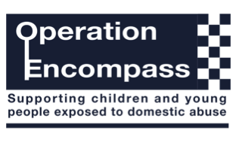

Wednesday 26th September 2018

Dear Parent/Carer,

The school has been given the opportunity to take part in a project called Operation Encompass that will be run jointly between schools and West Midlands Police. This is an early intervention scheme which supports children and young people who are exposed to domestic abuse.

Operation Encompass is reporting to schools, prior to the start of the next school day, when a child or young person has been exposed to, or involved in, any domestic incident.

Operation Encompass will ensure that a member of the school staff, known as a Key Adult, is trained to allow them to liaise with the local authority and to use the information that has been shared, in confidence, while ensuring that the school is able to make provision for possible difficulties experienced by children, or their families, who have been involved in, or exposed to, a domestic abuse incident.

We are keen to offer the best support possible to all our pupils and we believe this will be extremely beneficial for all those involved.

Signed

Mrs Stackhouse

Head Teacher

