PE Funding

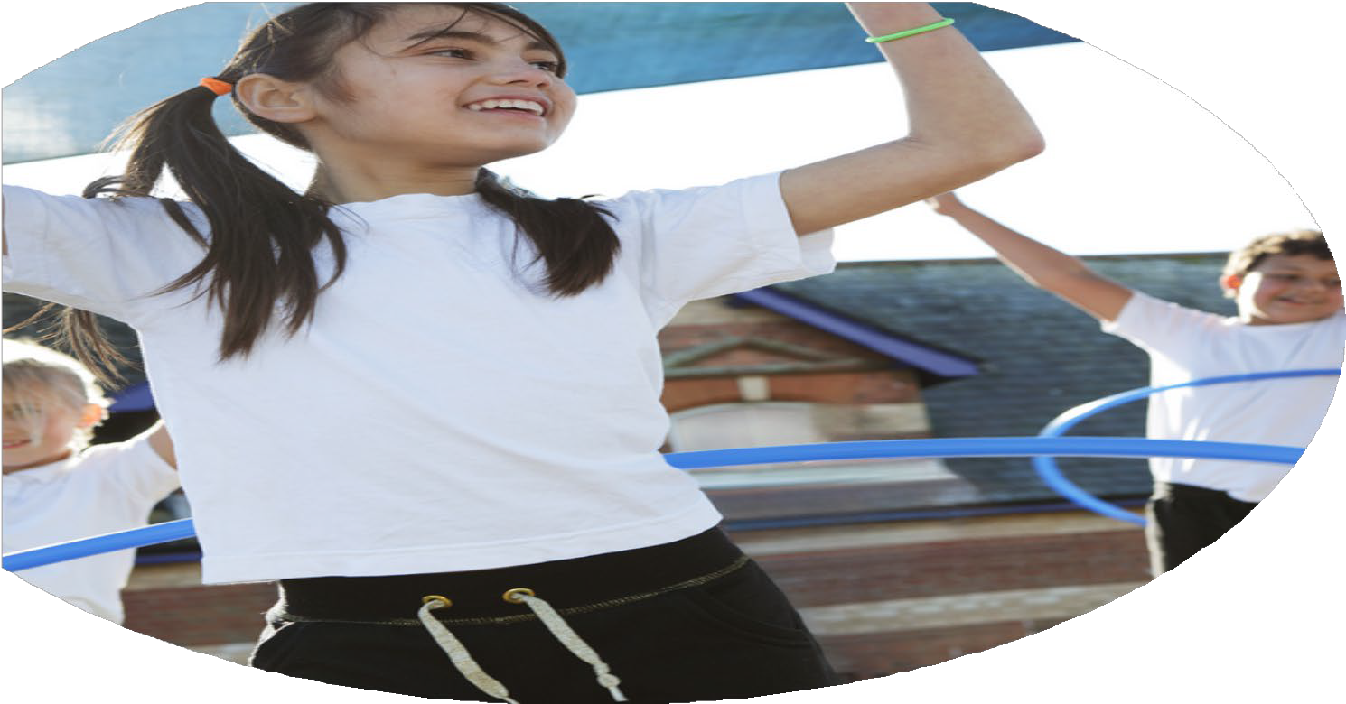

Evaluation Form

**Commissioned by**

**Created by**

Images courtesy of Youth Sport Trust

**PE Funding Evaluation Form**

 It is intended that this template should be used as preparation for the completion of the statutory digital reporting tool being introduced this academic year. You can upload data (including swimming) from this template onto this platform once it becomes accessible.

 Before you decide how you are going to use the funding for this academic year you should reflect and evaluate the impact of your use of the funding in 2023/24.

 All spending of the funding must conform with the terms outlined in the Conditions of Grant document.  The template is a working document that you can amend/update during the year.

 Based on your evaluation of last year’s funding you should decide what you intend to do this academic year, how you will do it, and what impact you expect it to have.

It is important that the funding is used effectively and based on your school’s needs.

 You must use the funding to make additional and sustainable improvements to the PE and sport in your school.  You must develop and add to the PESSPA activities that your school already offers.

*Summative digital reporting from June 2025 will continue to include swimming and water safety information therefore funding can be used to provide top-up lessons where necessary to ensure pupils meet national curriculum swimming requirements.*

**We recommend that you start by reflecting on the impact of current provision and reviewing your previous spend**

|  |  |  |  |
| --- | --- | --- | --- |
| What went well? | How do you know? | What didn’t go well? | How do you know? |
|  |  |  |  |

|  |  |
| --- | --- |
| What are your plans for 2024/25? | How are you going to action and achieve these plans? |
| Intent | Implementation |
| Upskill new staff members in the delivery of PE.  Increased physical activity across the curriculum  CPD for PE Leader  Effective PE Curriculum in place from EYFS to Y6  Effective swimming provision | CPD programme from Aspire Sports: PE Curriculum support programme (PECS).  Purchase of Now Press Play and its use across the curriculum  Membership of Dancedesk network. Membership of Aspire:Ed  Membership of Get Set 4 PE  Swimming development work for specific staff members |
|  |  |

|  |  |
| --- | --- |
| What impact/intended impact/sustainability are you  expecting? | How will you know? What **evidence** do you have or  expect to have? |
| Staff targeted have increased confidence and competence in the delivery of PE with their particular year groups.  Increased physical activity across school  Increase in quality of swimming provision | Observation and reports on staff involved show increased ability in the delivery of PE, feedback shows an increase in confidence.  Participation numbers in lunchtime and after school clubs. All classes utilise Now Press Play resource- pupil and staff feedback  Pupil data, staff and pupil feedback |

|  |  |
| --- | --- |
| What **impact/sustainability** have you seen? | What **evidence** do you have? |
| All classes participated in Now Press Play resources at least once per term. This was also used to provide active reward for class behaviour- silent discos. Sample activities include Rainforests and the mayans. Staff and pupil feedback was very positive. |  |