**ST MARGARET’S CE VA PRIMARY SCHOOL**

PSHE (Personal, Social, Health Education) Policy

Including Relationships and Health Education

Draft

“Encourage one another and build each other up”

1 Thessalonians 5:11

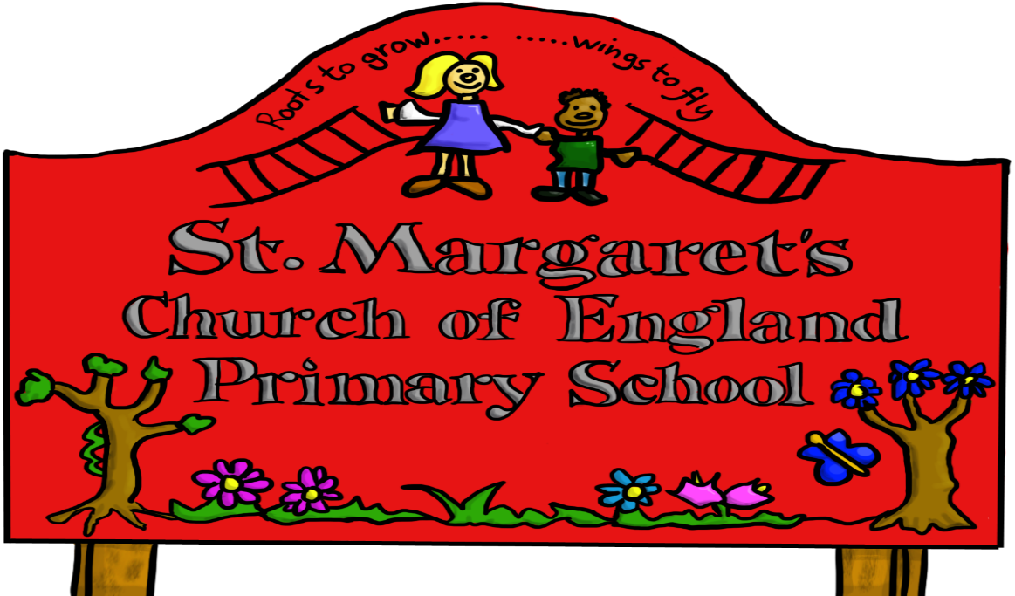

|  |  |  |
| --- | --- | --- |
| **Approved by:** | Governors | **Date:** |
| **Last reviewed on:** | March 2022 | |
| **Next review due by:** | March 2023 | |

**Introduction**

From September 2020 all schools in England and Wales must deliver the mandatory programme of Relationships Education and Health Education. At St Margaret’s we welcome this development, while also recognising that this is only a partial curriculum within a wider context of Personal, Social, Health and Economic Education (PSHE).

The Church of England’s “Vision for Education’ document clearly articulates that good education must promote,” life in all its fullness” John 10:10. The focus on the education and development of the whole child is essential to this, enabling children to learn and grow to become the best they can be.

Within this policy, as in the DFE guidance, Relationships Education is defined as teaching about the fundamental building blocks and characteristics of positive relationships, with particular reference to friendships, family relationships, and relationships with other children and adults.

**Rationale and Ethos**

Pupils’ social, moral, spiritual, vocational, cultural, physical, health and emotional development are promoted in our school by a very supportive school ethos and curriculum, where all are valued and encouraged, where positive relationships are seen as important and there is a safe and secure learning atmosphere. All of which are underpinned by our six core values, which are at the centre of everything we do.

Through our PSHE programme we aim to provide our children with the knowledge, skills and understanding they need to lead confident, healthy independent lives and to become informed, active and responsible citizens. In providing children with an understanding of healthy and respectful relationships and appropriate boundaries we consider RSE to be a fundamental part of our approach to supporting pupils to grow into confident, caring and respectful citizens.

PSHE is lifelong learning about personal, physical, moral and emotional development. It is set in the context of clear values about the understanding of the importance of loving relationships, respect, and care for family life. It should teach children to develop and form positive values, attitudes, personal and social skills and increase their knowledge and understanding of how to make informed decisions and life choices.

**School Vision**

Rooted in our Christian foundation we are an aspirational community, loving and serving God. We seek to recognise and develop our unique gifts in accordance with the biblical principles of inclusiveness, tolerance and love, preparing children to be educated citizens in a global world.

As Christian educators, we acknowledge that our role is to help each unique individual to fulfil their potential in all aspects of their life: physically, academically, socially, morally, culturally and spiritually.

We teach PSHE as a whole school approach to underpin children’s development as people and because it also supports their learning capacity.

We have adapted the Jigsaw Programme which offers a comprehensive and spiral curriculum which provides consistency and progression for our children’s learning. The overview of our programme can be seen on our website. Along with our Intent Statement

Jigsaw offers a mindful approach to PSHE which underpins all the teaching.

**Aims**

Relationships Education at our school is to develop the following attitudes:

* Respect for the dignity of every human being;
* Responsibility for their own actions and recognise the impact of these on others;
* Honesty and trustworthiness and recognise that we all make mistakes but we can learn from these;
* Joy in the created world;

To develop the following personal and social skills:

* Making good choices which are respectful of the individual’s commitments;
* Managing personal emotions and those of others within a relationship;
* Managing conflict and disagreement, recognising the value of difference;
* Learning to forgive and to show humility, mercy and compassion for others;
* Developing self esteem and confidence to talk about feelings and emotions;
* Building resilience and recognising the influence and impact of the media, internet and peer groups and so developing the ability to assess pressures and respond appropriately;

To know and understand:

* How to keep themselves healthy, safe and clean;
* To know the physical and psychological changes that accompany puberty;
* The importance of family and relationships

What do we teach?

The table below gives the learning theme for each term

|  |  |  |
| --- | --- | --- |
| Term | Theme or Puzzle unit | Content |
| Autumn 1 | Being Me in My World | Includes understanding my own identity and I how I fit well in the class, school and global community. |
| Autumn 2 | Celebrating Difference | Includes anti-bullying (cyber and homophobic bullying) and understanding |
| Spring 1 | Dreams and Goals | Includes goal setting aspirations who do we want to become and what would we like to do for work and contribute to society |
| Spring 2 | Healthy Me | Includes alcohol education, self -esteem and confidence as well as healthy lifestyles choices, sleep, nutrition, rest and exercise |
| Summer 1 | Relationships | Includes friendships, family and other relationships, conflict resolution and communication skills, bereavement and loss |
| Summer 2 | Changing Me | Includes Relationships and how our bodies change. |

We teach a PSHE session each week in order to develop our children’s knowledge and skills and in age appropriate way. These sessions are reinforced and enhanced in our Collective Worship, Reward Systems, and through our relationships child to child, adult to child and adult to adult across school. We aim to live what is learnt and apply it to everyday situations in the school community.

Class teachers deliver weekly lessons to their own classes

**Relationships Education**

Relationship education will cover Families and people who care for me, Caring friendships, Respectful relationships, Online relationships and Being Safe. The Relationship unit in Jigsaw covers most of the statutory Relationships Education, some of the outcomes are also taught elsewhere eg. the Celebrating Difference unit helps children to appreciate that there are many types of family composition and that each is important to the children involved.

**Health Education**

Health Education will cover ‘Mental wellbeing’, ‘Internet safety and harms’, Physical health and fitness’, Healthy eating’, ‘Drugs, alcohol and tobacco’, ‘Health and prevention’, ‘Basic First Aid’, ‘Changing adolescent body’.

This is taught in the Healthy Me Unit and covers most of the statutory Health Education, some of the outcomes are taught elsewhere in Jigsaw e.g. emotional and mental health is nurtured every lesson through the Calm me time, social skills are grown every lesson through the Connect us activity and respect is enhanced through the use of the Jigsaw Charter.

Also, teaching children about puberty is now a statutory requirement which sits within the Health Education part of the DfE guidance within the ‘Changing adolescent body’ strand, and in Jigsaw this is taught as part of the Changing Me Unit with the support of the school nurse service.

**Sex Education**

Puberty is taught as a statutory requirement of Health Education and covered by our Jigsaw PSHE Programme in the ‘Changing Me’ Unit, and we conclude from the DFE Guidance that sex education refers to Human Reproduction. In order to teach this in a scientific context, and knowing that National Curriculum Science requires children to know how mammals reproduce, we have opted to teach this within our Science curriculum, not within PSHE or Relationships and Sex Education as we believe this is most appropriate for our children.

**All Staff**

PSHE is a whole school issue. All teachers have responsibility of care; as well as fostering academic progress they should actively contribute to the guidance of the physical, moral, and spiritual well -being of their pupils. All teachers will be responsible for delivering RSE. Appropriate training will be made available for all staff teaching RSE. The RSE Lead will provide support to other staff.

**Staff are responsible for**:

* Delivering PSHE Education in a sensitive way
* Modelling positive attitudes to Relationships Education
* Responding to the needs of individuals

**Inclusivity**

**Special Educational Needs and Learning Differences**

Our pupils have different needs based on their emotional and physical development, life experiences and learning differences but we aim to ensure that all pupils are properly included in PSHE. Teachers will plan and deliver work in a variety of ways, in order to meet the needs of individual pupils with SEN or learning differences. We focus on activities that increase a pupil’s assertiveness, communication and relationship skills, their self-esteem and understanding.

Lessons will also help pupils to realise the nature and consequences of discrimination, teasing, bullying and aggressive behaviours, use of prejudice language and how to respond and ask for help.

**Equalities and Diversity**

Schools like all public institutions have specific responsibilities in relation to equality and protected characteristics.

All PSHE is taught without bias and in line with legal responsibilities such as those contained within the Equality Act (2010). Topics are presented using a variety of views and beliefs so that pupils are able to form their own, informed opinions but also respect others who may have different opinions.

**Monitoring and Review**

The Teaching and Learning Committee will monitor this policy and report its findings and recommendations to the Full Governing Body.