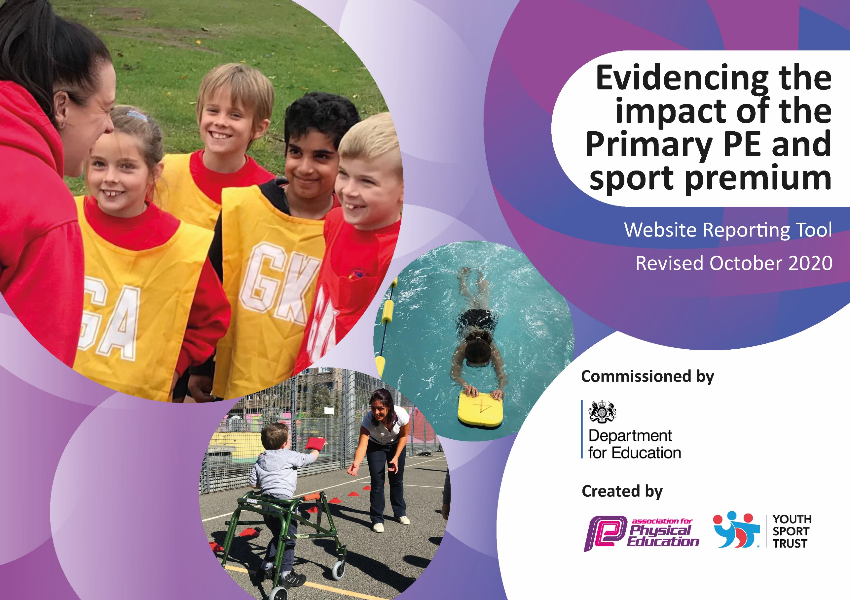

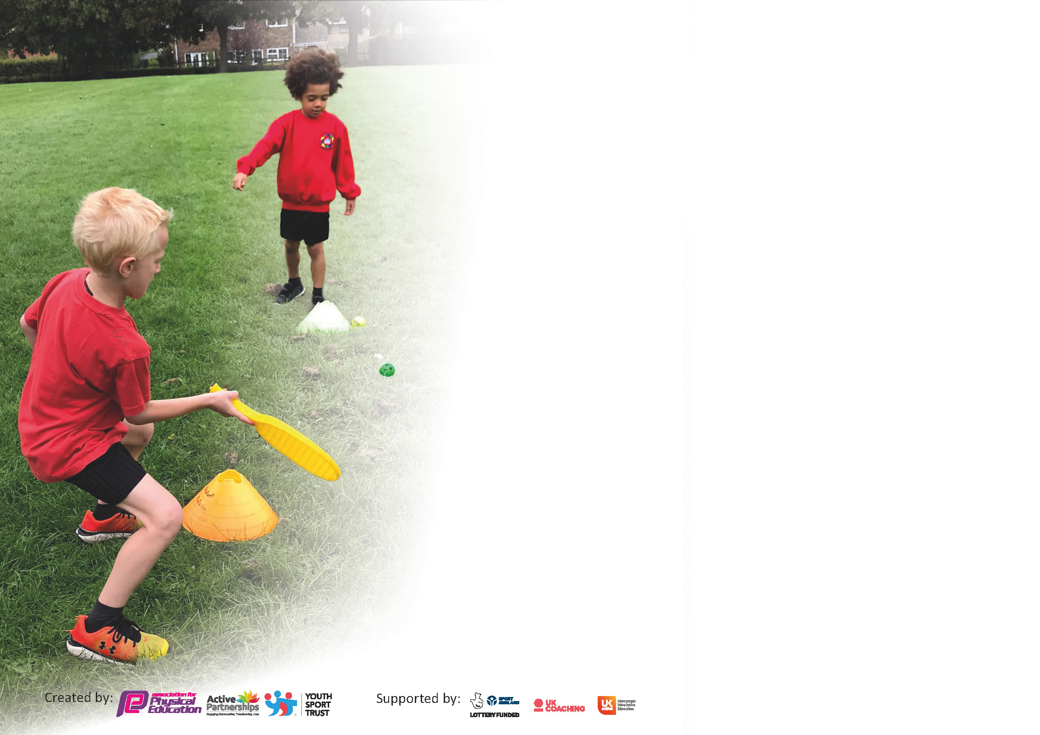

It is important that your grant is used effectively and based on school need. The Education Inspection Framework (Ofsted 2019 p64) makes clear there will be a focus on **‘whether leaders and those responsible for governors all understand their respective roles and perform these in a way that enhances the effectiveness of the school’**.

Under the Quality of Education criteria (p41) inspectors consider the extent to which schools can articulate their curriculum (INTENT), construct their curriculum (IMPLEMENTATION) and demonstrate the outcomes which result (IMPACT).

To assist schools with common transferable language this template has been developed to utilise the same three headings which should make your plans easily transferable between working documents.

Schools must use the funding to make **additional and sustainable** improvements to the quality of Physical Education, School Sport and Physical Activity (PESSPA) they offer. This means that you should use

the Primary PE and sport premium to:

* Develop or add to the PESSPA activities that your school already offer
* Build capacity and capability within the school to ensure that improvements made now will benefit pupils joining the school in future years

Please visit gov.uk for the revised DfE guidance including the 5 key indicators across which schools should demonstrate an improvement. This document will help you to review your

provision and to report your spend. DfE encourages schools to use this template as an effective way of meeting the reporting requirements of the Primary PE and sport premium.

We recommend you start by reflecting on the impact of current provision and reviewing the previous spend.

Schools are required to publish details of how they spend this funding as well as on the impact it has on pupils’ PE and sport participation and attainment by the end of the summer term or by **31st July 2021** at the latest.

# ** In the case of any under-spend from 2019/20 which has been carried over this must be used and published by 31st March 2021.

We recommend regularly updating the table and publishing it on your website throughout the year. This evidences your ongoing self-evaluation of how you are using the funding to secure maximum, sustainable impact. Final copy must

be posted on your website by the end of the academic year and no later than the 31st July 2021. To see an example of how to complete the table please click HERE.

Created by: Supported by:

Please note: Although there has been considerable disruption in 2020 it is important that you publish details on your website of how you spend the funding - this is a legal requirement.

Support for review and reflection - considering the 5 key indicators from DfE, what development needs are a priority for your setting and your pupils now and why? Use the space below to reflect on previous spend and key achievements and areas for development.

N.B. In this section you should refer to any adjustments you might have made due to Covid-19 and how these will influence further improvement.

|  |  |
| --- | --- |
| Key achievements to date until July 2020: | Areas for further improvement and baseline evidence of need: |
| We have run the PECS programme for 6 years and staff are now more confident in the delivery of PE.  Increased participation in competitive sports.  New curriculum to support staff and ease teacher workload in planning, also to ensure a development in skills is provided in less familiar areas such as gym and dance.  Yoga programme for YR-Y6 pupils has highlighted new ways of being active to the whole school, this is now being repeated as some classes had their schedule affected by school closure and covid restrictions | Year 6 to have yoga as a pre SATs workshop.  Increase pupils engagement in after school sports clubs  5 Year 6 pupils will not have met swimming requirements- therefore funds are being allocated to provide additional swimming tuition for those pupils this year.  More school games competition- aim for Silver School Games Mark  Staff development work on dance  More equipment needed for developing skills in after school clubs |

Did you carry forward an underspend from 2019-20 academic year into the current academic year? YES

# If YES you must complete the following section

**If NO, the following section is not applicable to you**

If any funding from the academic year 2019/20 has been carried over you MUST complete the following section. Any carried over funding MUST be spent by 31 March 2021.

|  |  |  |  |  |
| --- | --- | --- | --- | --- |
| **Academic Year: September 2020 to March 2021** | **Total fund carried over: £1000** | **Date Updated: 05/11/20** |  | |
| What Key indicator(s) are you going to focus on?  Key indicator 1: The engagement of all pupils in regular physical activity – Chief Medical Officers guidelines recommend that primary school pupils undertake at least 30 minutes of physical activity a day in school | | | | Total Carry Over Funding: |
| £1000 |
| **Intent** | **Implementation** | | **Impact** |  |
| Increase the pupils level of fitness as they have returned to school on the whole a lot less fit than when the national lockdown closed the wider opening of school. | Provide activities that are Covid-19 Friendly and enable ALL pupils to engage in regular physical activity:  Skip2bFit Workshop and 6 week Skipping Challenge.  60 Skipping ropes purchased for use at break and lunchtimes.  Equipment purchased to enable ALL pupils to engage in playground activities, such as netball, basketball, skipping and hoop games. Playgrounds divided into bubble areas to allow this to safely take place | Carry over funding allocated:  £360  £280  £662 | Evidence of impact: How can you measure the impact on your pupils; you may have focussed on the difference that PE, SS & PA have made to pupils re-engagement with school. What has changed?:  Initially on the return to school it was clear that pupils seemed ‘lost’ when on the playground and needed some more structure to support their play and physical activity. After the skipping worship and new equipment was provided there was a clear improvement.  The 6 week skipping challenge has motivated pupils from years 1-6 and 134 pupils bought their own skipping ropes with counter through the school. | Sustainability and suggested next steps and how does this link with the key indicators on which you are focussing this academic year?: |

|  |  |
| --- | --- |
| Meeting national curriculum requirements for swimming and water safety.  N.B Complete this section to your best ability. For example you might have practised safe self-rescue techniques on dry land. | Swimming is done in years 5 and 6 in the Summer term, and could not take place due to Covid-19. |
| What percentage of your current Year 6 cohort swim competently, confidently and proficiently over a distance of at least 25 metres?  **N.B.** Even though your pupils may swim in another year please report on their attainment on leaving primary school at the end of the summer term 2020. | % |
| What percentage of your current Year 6 cohort use a range of strokes effectively [for example, front crawl, backstroke and breaststroke]? | % |
| What percentage of your current Year 6 cohort perform safe self-rescue in different water-based situations? | 100% (Pupils did this in a classroom based learning programme from Super Sharkeys Swimming School) |
| Schools can choose to use the Primary PE and sport premium to provide additional provision for swimming but this must be for activity **over and above** the national curriculum requirements. Have you used it in this way? | Yes/No We planned to but it couldn’t be carried out due to Covid |

**Action Plan and Budget Tracking**

Capture your intended annual spend against the 5 key indicators. Clarify the success criteria and evidence of impact that you intend to measure to evaluate for pupils today and for the future.

|  |  |  |  |  |
| --- | --- | --- | --- | --- |
| **Academic Year:** 2020/21 | **Total fund allocated:** £ 16,915 | **Date Updated: 6/11/20** | |  |
| **Key indicator 1:** The engagement of all pupils in regular physical activity – Chief Medical Officers guidelines recommend that primary school pupils undertake at least 30 minutes of physical activity a day in school | | | | Percentage of toal allocation: |
| 18.9% |
| **Intent** | **Implementation** | | **Impact** |  |
| Your school focus should be clear what you want the pupils to know and be able to do and about  what they need to learn and to  consolidate through practice: | Make sure your actions to achieve are linked to your intentions: | Funding allocated: | Evidence of impact: what do pupils now know and what can they now do? What has changed?: | Sustainability and suggested next steps: |
| Pupils provided structured play activities led by a sports coach | Aspire Sports Lunch time club  Aspire Sports ASC club (currently suspended due to lockdown restrictions for November) | £1603  £1603 | The ASC restarted when restrictions lifted. Opened up one bubble identified as having regressed physically in the lock down (Y5) there was uptake from 22/30 pupils. Feedback from pupils was fantastic and their performance in PE and academically improved. | Will fully fund all ASC next year and assess whether this increases uptake. |
| **Key indicator 2:** The profile of PESSPA being raised across the school as a tool for whole school improvement | | | | Percentage of total allocation: |
| % |
| **Intent** | **Implementation** | | **Impact** |  |
| Your school focus should be clear what you want the pupils to know and be able to do and about  what they need to learn and to  consolidate through practice: | Make sure your actions to achieve are linked to your intentions: | Funding allocated: | Evidence of impact: what do pupils now know and what can they now do? What has changed?: | Sustainability and suggested next steps: |
| Not an area of focus this year |  |  |  |  |

|  |  |  |  |  |
| --- | --- | --- | --- | --- |
| **Key indicator 3:** Increased confidence, knowledge and skills of all staff in teaching PE and sport | | | | Percentage of total allocation: |
| 29.1% |
| **Intent** | **Implementation** | | **Impact** |  |
| Your school focus should be clear | Make sure your actions to | Funding | Evidence of impact: what do | Sustainability and suggested |
| what you want the pupils to know | achieve are linked to your | allocated: | pupils now know and what | next steps: |
| and be able to do and about | intentions: |  | can they now do? What has |  |
| what they need to learn and to |  |  | changed?: |  |
| consolidate through practice: |  |  |  |  |
| The teaching of PE is good across school and all PE areas.  Subject leader develops knowledge of Primary School dance in order to ensure quality first delivery of dance and improved pupil outcomes  Subject leader develops knowledge of Primary School Gymnastics | Aspire Sports PECS Programme  Autumn 1: Y4 (Gymnastics), Y3 (Dance), Y1(Dance)  Autumn 2: Y3 (Gymnastics) Y2 (Gymnastics) Y1 (Multiskills)  One Dance UK CPD Programme  Get Set 4 PE Virtual CPD Worskhop on Gymnastics | £4809  £90  £25 | Subject leader completed One Dance UK CPD Programme- hugely increased knowledge and ability to review and plan the dance curriculum. This will lead to improved outcomes in dance. The same from the gymnastics workshop. | Staff survey at the end of the academic year highlighted that staff needed further development in dance |
| **Key indicator 4:** Broader experience of a range of sports and activities offered to all pupils | | | | Percentage of total allocation: |
| 18.1% |
| **Intent** | **Implementation** | | **Impact** |  |
| Your school focus should be clear | Make sure your actions to | Funding | Evidence of impact: what do | Sustainability and suggested |
| what you want the pupils to know | achieve are linked to your | allocated: | pupils now know and what | next steps: |
| and be able to do and about | intentions: |  | can they now do? What has |  |
| what they need to learn and to |  |  | changed?: |  |
| consolidate through practice: |  |  |  |  |
| Additional achievements: | Yogabugs delivering Impact and Change Programme across school Autumn: Y4 and Y1  Spring: Y6 and Y2  Summer: Y3 and Y5 | £3062 | All classes participated in yoga sessions- Though Y6 and Y2 were delivered remotely. This really supported pupil return to school and the development of mindfulness |  |

|  |  |  |  |  |
| --- | --- | --- | --- | --- |
| **Key indicator 5:** Increased participation in competitive sport | | | | Percentage of total allocation: |
| % |
| **Intent** | **Implementation** | | **Impact** |  |
| Your school focus should be clear | Make sure your actions to | Funding | Evidence of impact: what do | Sustainability and suggested |
| what you want the pupils to know | achieve are linked to your | allocated: | pupils now know and what | next steps: |
| and be able to do and about | intentions: |  | can they now do? What has |  |
| what they need to learn and to |  |  | changed?: |  |
| consolidate through practice: |  |  |  |  |
| No spend in this area this year |  |  |  |  |

|  |  |
| --- | --- |
| Signed off by | |
| Head Teacher: |  |
| Date: |  |
| Subject Leader: |  |
| Date: |  |
| Governor: |  |
| Date: |  |