**ST MARGARET’S CE VA PRIMARY SCHOOL**

Low Level Concerns Policy

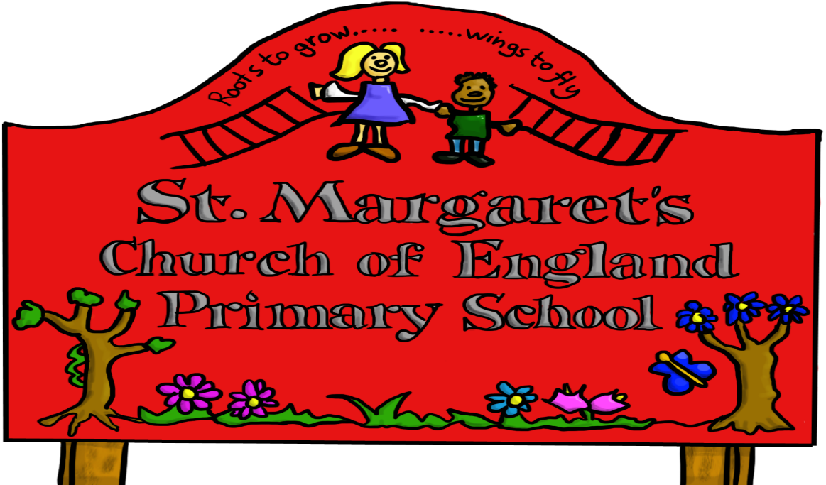

|  |  |  |
| --- | --- | --- |
| **Approved by:** | Governors | **Date:** October 2023 |
| **Last reviewed on:** |  | |
| **Next review due by:** | October 2024 | |

**PRINCIPLES**

St Margaret’s Primary School are committed to ensuring low-level concerns are monitored, recorded and dealt with appropriately to create a safer culture for all staff, pupils and visitors.

St Margaret’s Primary School has a moral, legal, and social responsibility to provide a safe environment for all those attending our school.

**SCOPE AND REFERENCES**

This Policy sets out good practice and provides guidance on how to deal with situations and put in safeguards where a low-level concern may be encountered. This policy is aimed at promoting of a safe culture and preventing possible harm within St Margaret’s Primary School. It should be read in conjunction with all policies and procedures, including, but not exclusively limited to:

* Safeguarding Policy
* Code of Conduct
* KCSIE
* GDPR Policy
* Health & Safety Policy
* Behaviour Policy
* Safer Recruitment Policy

,

**DISTINCTION BETWEEN AN ALLEGATION AND A LOW-LEVEL CONCERN**

A culture encouraging reporting of low-level concerns enables to staff to share any concerns they may have, no matter how small, about their own or their colleagues’ behaviour.

Concerns should not be limited to Safeguarding but could relate to behaviour (including behaviour outside of school) which does not meet the professional standards expected within St Margaret’s Primary School.

The term ‘**allegation**’ means that it is alleged that a person who works with children has:

* behaved in a way that has harmed a child, or may have harmed a child and/or;
* possibly committed a criminal offence against or related to a child and/or;
* behaved towards a child or children in a way that indicates he or she may pose a risk of harm to children; and/or
* behaved or may have behaved in a way that indicates they may not be suitable to work with children.

An **allegation** can also relate to an adult’s behaviour outside of work, and their relationships with others, if they:

* have behaved in a way in their personal life that raises safeguarding concerns. These concerns do not have to directly relate to a child but could, for example, include an arrest for the possession of a weapon;
* have, as a parent or carer, become subject to child protection procedures;
* are closely associated with someone in their personal lives (e.g. partner, member of the family or other household member) who may present a risk of harm to child/ren for whom the adult is responsible in their employment/volunteering.

A **low-level concern** is any concern about an adult’s behaviour towards a child that does not meet the allegation threshold set out above, or is not otherwise serious enough to consider a referral to the LADO.

A **low-level concern** is any concern – no matter how small, and even if no more than a ‘nagging doubt’ – that an adult may have acted in a manner which:

* is not consistent with an organisation’s Code of Conduct, and/or
* relates to their conduct outside of work which, even if not linked to a particular act or omission, has caused a sense of unease about that adult’s suitability to work with children.

Staff do not need to be able to determine in each case whether their concern is a low-level concern, or if it is in fact serious enough to consider a referral to the LADO, or meets the threshold of an allegation. Once staff share what they believe to be a low-level concern, that determination should be made by the Designated Safeguarding Lead.

Examples of low-level concerns could include, but are not limited to:

* being over friendly with children;
* having favourites;
* taking photographs of children on their mobile phone;
* engaging with a child on a one-to-one basis in a secluded area or behind a closed door; or,
* using inappropriate sexualised, intimidating or offensive language.

**IMPORTANCE OF SHARING LOW-LEVEL CONCERNS**

It is necessary to ensure a culture of openness and trust is fostered within an organisation in which staff can share any concerns about the conduct of colleagues and be assured that these will be received in a sensitive manner.

It is well documented that organisational child sexual abuse is often preceded by grooming, and that such conduct was observed and considered questionable. This could be targeted at protective adults, not just children or vulnerable adults. This behaviour was rarely reported to the relevant individual in the organisation, was not recorded, and not available later for evaluation of patterns emerging. Research has shown that it is not possible for individuals to accurately judge people, as there is no one profile to describe everyone who abuses a child, so focus should be placed upon specific behaviours.

To minimise the risk of situational offending, there needs to be a culture of allowing the confidence to speak out. This requires a robust framework, policy, training, support and leadership to facilitate this and a willingness to accept that abuse could happen in any organisation.

**IMPLEMENTING A WRITTEN LOW-LEVEL CONCERNS POLICY**

This policy is not intended to exist as a stand-alone policy. As indicated previously, it should be read in conjunction with various other policies and procedures. This policy is simply to provide additional guidance and support as well as explicitly convey the importance of sharing low-level concerns.

Leaders, including the Designated Safeguarding Lead, will promote the contents of this policy at many opportunities during the year in order to promote an open and transparent culture in which there is a shared understanding of ‘it could happen here’ when considering safeguarding risk.

This will be also incorporated in both the safeguarding induction training for new staff and the annual safeguarding training for all staff.

Any concerns or issues relating to the Low-Level Concern Policy will be included in the termly Safeguarding Report provided by the DSL for the Full Governing Body.

**DATA PROTECTION**

The Data Protection Act 2018 makes specific provision for the processing of personal data necessary for safeguarding children from harm. The Information Sharing Code of Practice (Information Commissioner’s Office 2019) specifically cites safeguarding of children as a ‘clear example of a compelling reason’ to share personal data. Where a concern is low-level, rather than an allegation, the balance between safeguarding interest and personal data rights will be considered carefully to ensure it is a reasonably necessary measure that the data should be shared.

**HOW SHOULD LOW-LEVEL CONCERNS BE HELD**

Records should be retained (including those subsequently deemed to relate to behaviour which is entirely consistent with the Code of Conduct) in the Low Level Concerns Log which is kept securely in the Head Teacher and Deputy Head Teacher’s Office. Staff will be informed of any entries made in this log which relate to them unless, by sharing information, compromises the safeguarding of others or threatens the anonymity of the person who shared the concern.

Where there are multiple low-level concerns relating to the same individual these will be kept in chronological order as a running record. These records are kept confidential and held securely by the Head Teacher with restricted access to DSLs or HR as required.

Where concerns also involve issues of misconduct or poor performance, or disciplinary, grievance or whistleblowing procedures are triggered, the normal records required would still be made and kept according to procedure in addition to the Low-Level Concerns records.

Where the low-level concern is serious enough to be referred to either the LADO, the relating records will be placed and retained on the staff member’s personnel file in line with any information about the management of staff allegations. Where a low-level concern is reclassified as an allegation, then the records relating to it will be treated accordingly.

.

**REVIEW OF THE CENTRAL LOW-LEVEL CONCERNS FILE**

The Head Teacher, or Designated Safeguarding Lead responsible for logging concerns, will review the central Low-Level Concerns File upon making any new entries to ensure such concerns are being dealt with promptly and appropriately and that any potential patterns of concerning, problematic or inappropriate behaviour are identified. Any information arising from a review of records should be noted on the information sheets within the log.

**HOW LONG TO KEEP RECORDS OF A LOW-LEVEL CONCERN**

There is currently no statutory guidance on the retention of low-level concerns. However, St Margaret’s Primary School will retain the information for the duration of an individual’s employment with the school. At this point the content of the file may be reviewed to ensure it still has value (either as a safeguarding measure or because of its possible relevance to future claims) but would usually be discarded unless there is a compelling reason to keep this.

**SHOULD LOW-LEVEL CONCERNS BE REFERRED TO IN A REFERENCE?**

St Margaret’s Primary School follows all guidance within KCSIE regarding the sharing of information related to low-level concerns. This means that low-level concerns should not be included in references unless the information relates to any issues which would normally be included in references, e.g. conduct issues.

Allegations which are proven to be false, unsubstantiated or malicious, should not be included in employer references. Likewise, a history of repeated concerns which have all been found to be false, unsubstantiated or malicious should also not be included in any reference.

Misconduct or consistent poor performance, where relevant, may be included. This would not normally include low-level safeguarding concerns unless the threshold is met for referral and found to be substantiated, where it should then be referred to in a reference. Where KCSIE does not apply, consideration must be given to legal obligations and duty of care in giving accurate references.

**ROLE OF THE BOARD**

The DSL will include information about low-level concerns in the termly Safeguarding Report to the Full Governing Body. This includes information about the implementation of the Low-Level Concern Policy and any evidence as to its effectiveness, with any relevant data.

The Designated Governor for Safeguarding will have the opportunity to review an anonymised sample of low-level concerns at regular intervals, in order to ensure that these concerns have been responded to promptly and appropriately.