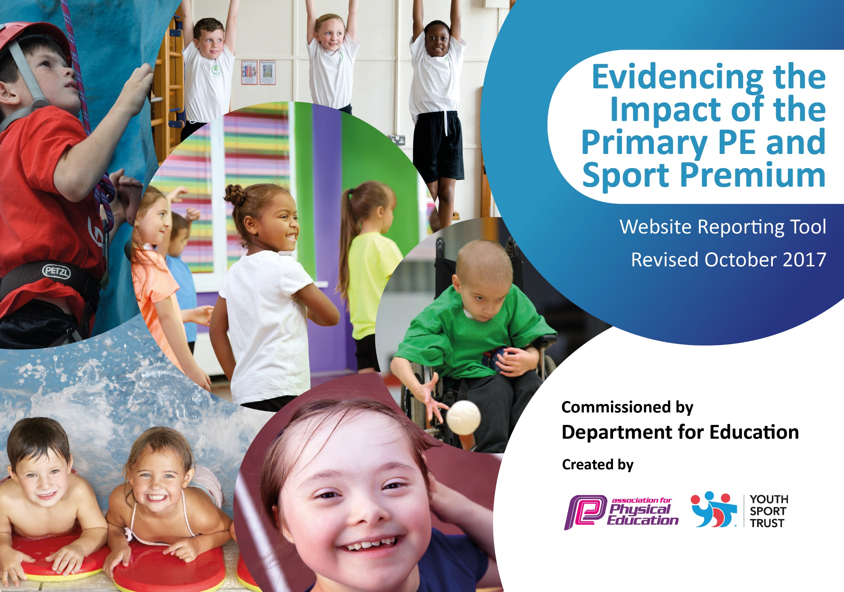

Schools must use the funding to make **additional and sustainable** improvements to the quality of PE and sport they offer. This means that you should use the Primary PE and Sport Premium to:

* develop or add to the PE and sport activities that your school already offers
* 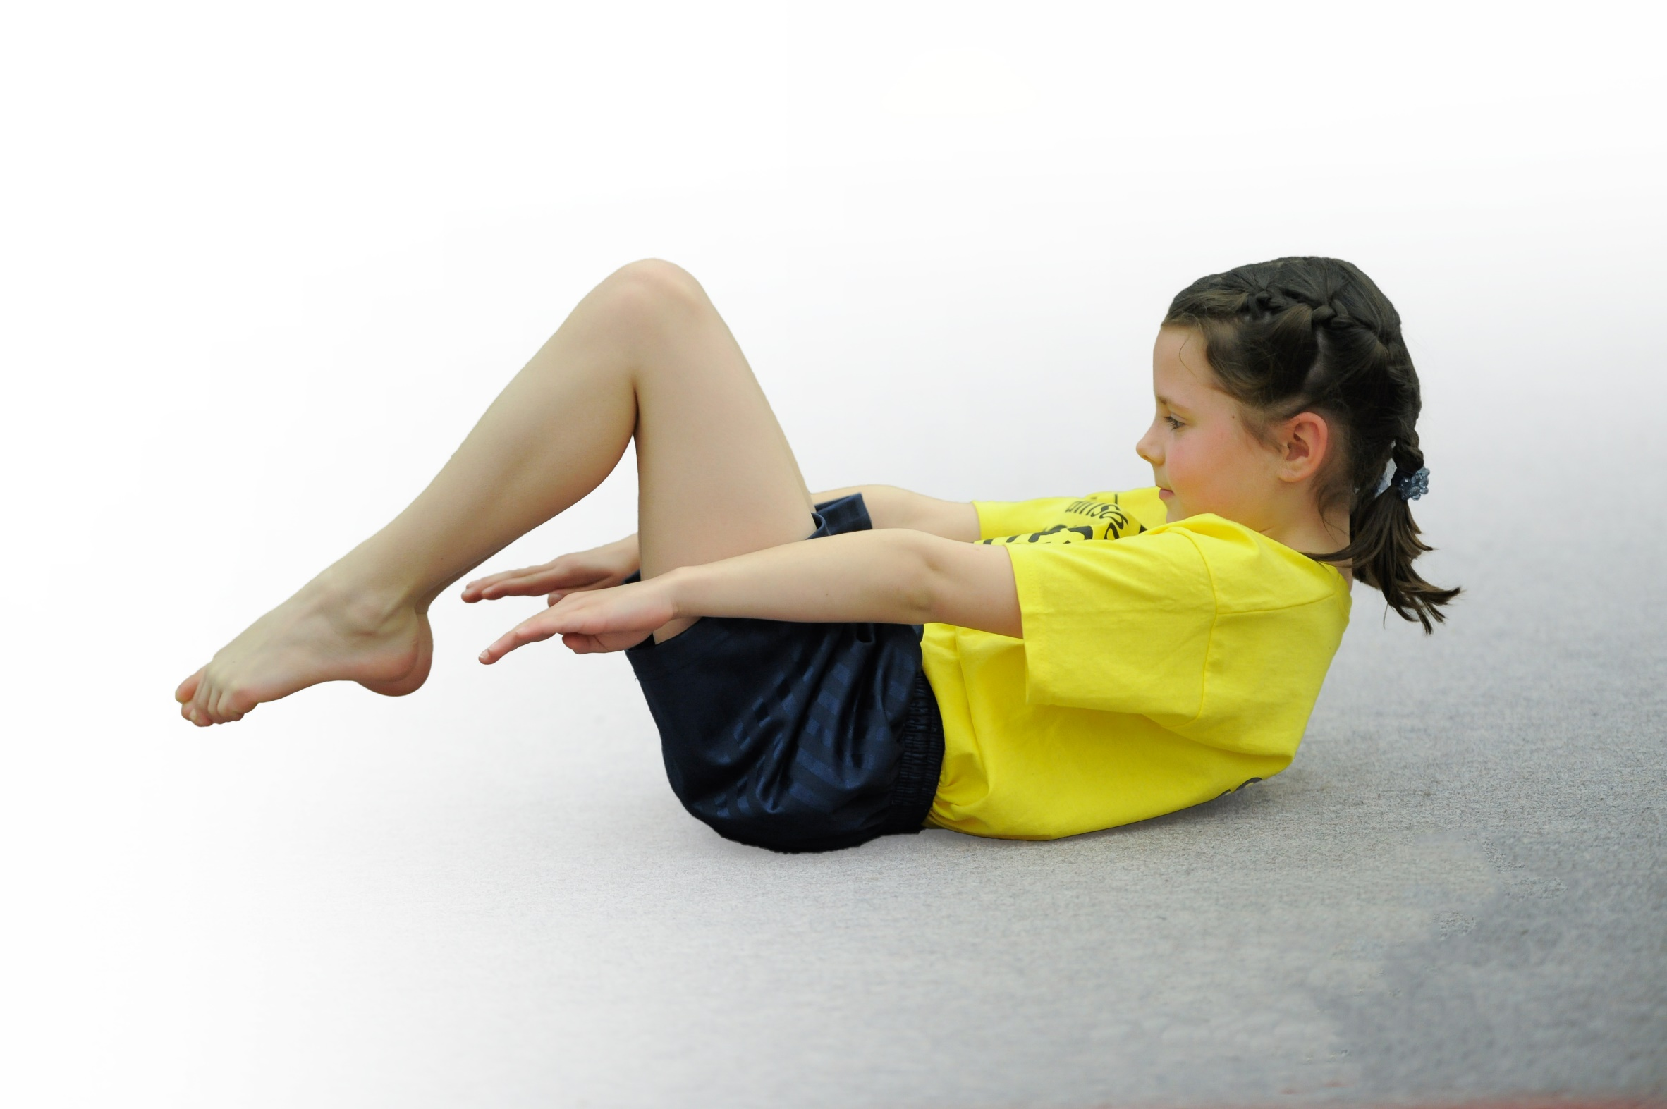build capacity and capability within the school to ensure that improvements made now will benefit pupils joining the school in future years

Please visit [gov.uk](https://www.gov.uk/guidance/pe-and-sport-premium-for-primary-schools) for the revised DfE guidance including the 5 key indicators across which schools should demonstrate an improvement. This document will help you to review your provision and to report your spend. DfE encourages schools to use this template as an effective way of meeting the reporting requirements of the Primary PE and Sport Premium.

We recommend you start by reflecting on the impact of current provision and reviewing the previous spend.

Under the [Ofsted Schools Inspection Framework](https://www.gov.uk/government/publications/school-inspection-handbook-from-september-2015), inspectors will assess how effectively leaders use

the Primary PE and Sport Premium and measure its impact on outcomes for pupils, and how effectively [governors](https://www.gov.uk/government/publications/governance-handbook) hold them to account

for this.

Schools are required to [publish details](https://www.gov.uk/guidance/what-maintained-schools-must-publish-online#pe-and-sport-premium-for-primary-schools) of how they spend this funding as well as on the impact it has on pupils’ PE

and sport participation and attainment.

We recommend regularly updating the table and

publishing it on your website as evidence

of your ongoing review into how you are using the money

to secure maximum, sustainable impact. To see an example of how to complete the table please click [HERE](http://www.afpe.org.uk/physical-education/wp-content/uploads/Template-Exemplification.pdf).

Support for review and reflection - considering the 5 key indicators from DfE, what development needs are a priority for your setting and your students now and why? Use the space below to reflect on previous spend, identify current need and priorities for the future.

|  |  |
| --- | --- |
| Key achievements to date: | Areas for further improvement and baseline evidence of need: |
| We have run the PECS programme for 3 years and staff are now more confident in the delivery of PE.  Pupil fitness has improved as evidenced in our Healthy Active Schools database. | Increased participation in competitive sports. Last year we had no inter school competition. Intra school competition to be increased.  New curriculum to support staff and ease teacher workload in planning, also to ensure a development in skills is provided in less familiar areas such as gym and dance. Staff training in gym and dance through Aspire PECS programme and Dancedesk. |

|  |  |
| --- | --- |
| Meeting national curriculum requirements for swimming and water safety | Please complete all of the below: |
| What percentage of your Year 6 pupils could swim competently, confidently and proficiently over a distance of at least 25 metres when they left your primary school at the end of last academic year? | 97% |
| What percentage of your Year 6 pupils could use a range of strokes effectively [for example, front crawl, backstroke and breaststroke] when they left your primary school at the end of last academic year? | 97% |
| What percentage of your Year 6 pupils could perform safe self-rescue in different water-based situations when they left your primary school at the end of last academic year? | 97% |
| Schools can choose to use the Primary PE and Sport Premium to provide additional provision for swimming but this must be for activity **over and above** the national curriculum requirements. Have you used it in this way? | Yes/No |
|  | |

**Action Plan and Budget Tracking**

Capture your intended annual spend against the 5 key indicators. Clarify the success criteria and evidence of impact that you intend to measure to evaluate for students today and for the future.

|  |  |  |  |  |
| --- | --- | --- | --- | --- |
| **Academic Year:** 2017/18 | **Total fund allocated:** £17,000 | **Date Updated: 23/03/18** | |  |
| **Key indicator 1:** The engagement of all pupils in regular physical activity – Chief Medical Officer guidelines recommend that primary school children undertake at least 30 minutes of physical activity a day in school | | | | Percentage of total allocation: |
| 17 % |
| School focus with clarity on intended **impact on pupils**: | Actions to achieve: | Funding allocated: | Evidence and impact: | Sustainability and suggested next steps: |
| Pupils have access to high quality lunchtime physical activity in order to help them meet the daily target of 30 minutes. | Train 16 year 5 pupils as Play Activators in order to support and encourage play (Aspire Sports).  All year 5 pupils undergo Sports Leader training with the Albion Foundation.  Aspire Sports coach leads lunchtime focused activity one lunchtime per week. | £360  £1500  £1108.15 | 16 Pupils trained as play activators October 2017. Operating as play leaders on KS1 and KS2 playgrounds, providing opportunity for 40 minutes physical activity per day for all pupils.  15 children each Wednesday lunchtime have focused active play with the sports coach. | Pupils will be able to support next year’s Y5 pupils in this role. |
| **Key indicator 2:** The profile of PE and sport being raised across the school as a tool for whole school improvement | | | | Percentage of total allocation: |
| 24 % |
| School focus with clarity on intended **impact on pupils**: | Actions to achieve: | Funding allocated: | Evidence and impact: | Sustainability and suggested next steps: |
| Staff become increasingly aware of how increased physical activity can improve social and emotional well being of pupils as well as curricular attainment in non sports subjects.  Reception children to increase in focus and concentration- showing improved listening skills. | Maths on the Move Programme (Aspire Sports)  Maths of the Day resource purchased.  Conduct research programme into the effects of activity on pupil attainment.  Yoga Programme for Reception | £1108.15  £500  Free  £2500* | 10 pupils in Y6 engaged in the MOTM Programme. 100% reported increased confidence in maths following the autumn term. 100% made progress in maths skills over the autumn term.  Research programme highlighted that Y5 made an average improvement of 23% following activity and year 6 an average of 17%.  Yoga bugs data collection will be in the summer term (July). | The results of the research programme support the idea that increased activity levels can and do help to improve academic results. This will be used to inform future planning of maths intervention particularly.  Yoga programme will continue for Reception children into year 1 |

|  |  |  |  |  |
| --- | --- | --- | --- | --- |
| **Key indicator 3:** Increased confidence, knowledge and skills of all staff in teaching PE and sport | | | | Percentage of total allocation: |
| 14 % |
| School focus with clarity on intended  **impact on pupils**: | Actions to achieve: | Funding  allocated: | Evidence and impact: | Sustainability and suggested  next steps: |
| Subject leader supported in developing the subject across school – providing high quality PE which raises standards and outcome sin pupils.  Pupils to show increased ability and fitness- highlighted in termly fitness assessments. | Membership of Dancedesk Hub- provides membership of AfPE and Youth Sport Trust (Level 1)  PECS Programme with teachers (Aspire Sports)  Purchase of new curriculum to support staff (Rising Stars Champions) | £600  £1108.15  £600 | PE Lead attended conference. Was able to feed back to HT and governors about the expectations and requirements for reporting on effective use of the PE and Sports Premium.  Programme- 100% of teachers involved reported an increase in confidence in the delivery of PE and the development of skills in delivery. This is to be monitored in the summer term.  The Champions scheme is being used across years 1-6. Staff have reported that they feel supported in the delivery of PE and that the scheme has excellent resources. This has resulted in a reduction in unnecessary teacher workload.  Spring term: All classes (1-6)achieve bronze+ on Healthy Active Schools Assessments. 3 classes achieve Silver+ 2 classes achieved Gold. |  |
| **Key indicator 4:** Broader experience of a range of sports and activities offered to all pupils | | | | Percentage of total allocation: |
| 10 % |
| School focus with clarity on intended  **impact on pupils:** | Actions to achieve: | Funding  allocated: | Evidence and impact: | Sustainability and suggested  next steps: |
| Children experience a wider range of physical activity. Largely aimed at developing good habits in early years but also broaden the horizons of pupils across school. | Yoga Bugs to carry out Impact and Change Programme with Reception children.  Aspire Sports to deliver Balanceability bike training with Reception class- Spr 1  After School Club 1x per week to introduce new sports to children | £2500* (already accounted in KI 2)  £675  £1108.15 | After School Club: Autumn 1- Fencing, Flag Football, Dodgeball (KS2) 22 pupils attended  Autumn 2: Tri-Golf (KS1) 12 Pupils attended. Spring 1: KS1 Multi skills 22 pupils attended. Spring 2: KS2 Fitness 25 pupils attended.  Balanceability delivered Spring 1 2018. 100% pupils made good progress. 24/30 were able to ride bikes without stabilizers by the end of the programme (80%). |  |
| **Key indicator 5:** Increased participation in competitive sport | | | | Percentage of total allocation: |
| 12 % |
| School focus with clarity on intended  **impact on pupils**: | Actions to achieve: | Funding  allocated: | Evidence and impact: | Sustainability and suggested  next steps: |
| To increase participation in competitive through the School games programme. School to aim for the School games mark | Funding set aside to fund transportation to competitions | £2000 | £165 spent to send Y5/6 Boys football team to a School Games tournament at Albion Dome (18/10/17. Pupils performed well W2, D1, L2.  Sportmanship was outstanding.  £165 spent to send Y5/6 Girls football team to a School Games tournament at Albion Dome. Pupils (08/11/17)  £95 spent to transport 8 pupils to a gymnastics competition at Wood Green Academy (23/4/18) |  |