**ST MARGARET’S CE VA PRIMARY SCHOOL**

**Home Learning Policy**

“Encourage one another and build each other up”

1 Thessalonians 5:11

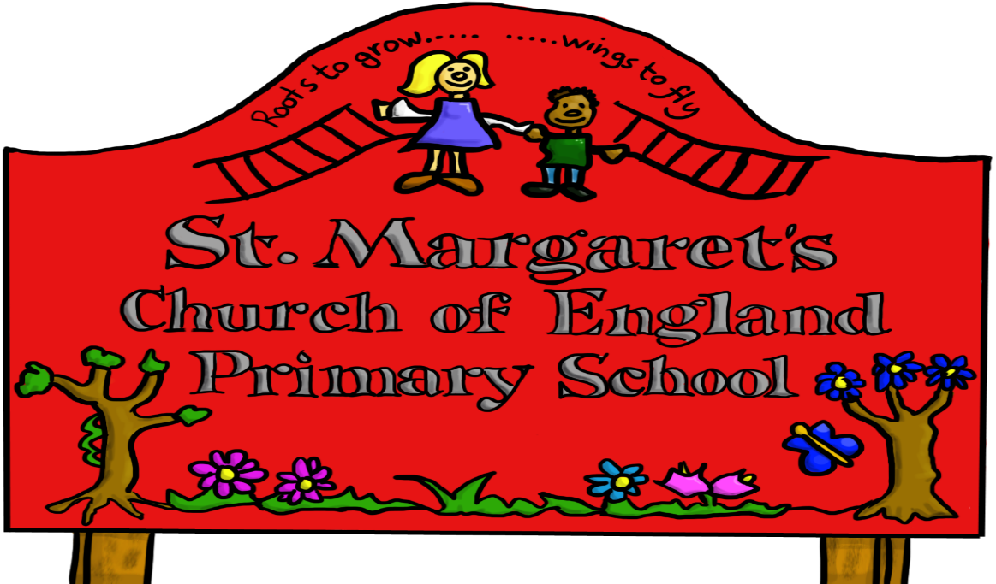

|  |  |  |
| --- | --- | --- |
| **Approved by:** | Governors | **Date:** |
| **Last reviewed on:** | Sept 2021 | |
| **Next review due by:** | Sept 2024 | |

# bd07223_

# **ST MARGARET’S C OF E PRIMARY SCHOOL**

## **HOME LEARNING**

**INTRODUCTION**

At St Margaret’s School we aim to work with parents in the education of their child/children. Therefore, home learning is an integral part of a child’s learning journey. At all times it should support and extend further their learning experiences.

**THE PURPOSE OF HOME LEARNING**

* To develop an effective learning partnership between the school and parents and also between the parents and their child/children
* To extend a child’s learning beyond the classroom.
* To reinforce and consolidate skills and understanding
* To develop research skills and the ability to work on particular projects which are guided by the learner.
* To encourage children to develop their personal study skills.

AIMS

Through this policy we aim to:

* Ensure a consistent approach throughout school in regards to setting, managing and marking home learning tasks
* Ensure progression towards independence and individual responsibility
* Ensure the needs of the individual child are considered.
* Provide opportunities for parents, carers, children and school to work together. It is a partnership.

**OUR HOME LEARNING**

Over the year each class will have the following home learning.

Foundation Stage-we use a combination of game packs, foundation packs and word games.

Year 1-reading books, reading activity sheets, weekly maths games, weekly spellings, research tasks related to specific subjects

Year 2 -reading books, reading activity sheets, weekly spellings and sentence writing.

Year 3 –English and Maths tasks, reading books, weekly spellings, research tasks related to specific subjects.

Year 4 – English and Maths tasks, weekly spellings, tasks related to specific subjects, reading books and research activities

Year 5 – English and Maths tasks, weekly spellings, research activities, reading books and science tasks.

Year 6 – English and Maths tasks, research projects, SAT tasks and science activities

Home Learning Guidelines

Years 1 and 2 60 minutes per week

Years 3 and 4 90 minutes per week

Years 5 and 6 30 minutes each day

It is important that all children read daily including upper Key Stage 2 children.

Please remember that it is more important that the home learning helps your child to learn than whether it takes a certain amount of time. It is a fine balance between encouraging children to learn and turning them off learning. Every child is an individual and therefore these home learning times are just guidelines.

During school holidays (Easter, October/Whitsun half terms) children may be given home learning tasks or projects to complete. If for any reason a parent does not want any home learning tasks then they will need to inform the teacher. Also, if a parent wants help or advise about home learning they will need to make an appointment to see the class teacher.

All home learning tasks will come home in a specific folder provided by the school, which may contain an exercise book in which to do their tasks. Also, some tasks will be done on sheets of paper. These folders will go home on set days and need to be returned on set days or when requested by the class teacher, in order to ensure the work can be marked,

Sometimes work is marked by pupils themselves and discussed in lessons whilst other times it is marked by the teacher. The home learning folder is the responsibility of each child and therefore if it is lost or damaged a replacement book/folder will need to be

purchased by parents.

**THE ROLE OF PARENTS**

It is important that you as carer or parent provide a quiet area where your child can concentrate and focus on their home learning. Sometimes your child will need support to complete the tasks whilst other times it may be task, which needs to be done independently. Please encourage your child to do the various learning tasks to show them that learning is important and that it is a partnership between home and school.