ST Margaret’s CE VA Primary Behaviour Policy
Encourage one another and build each other up”
1 Thessalonians 5:11

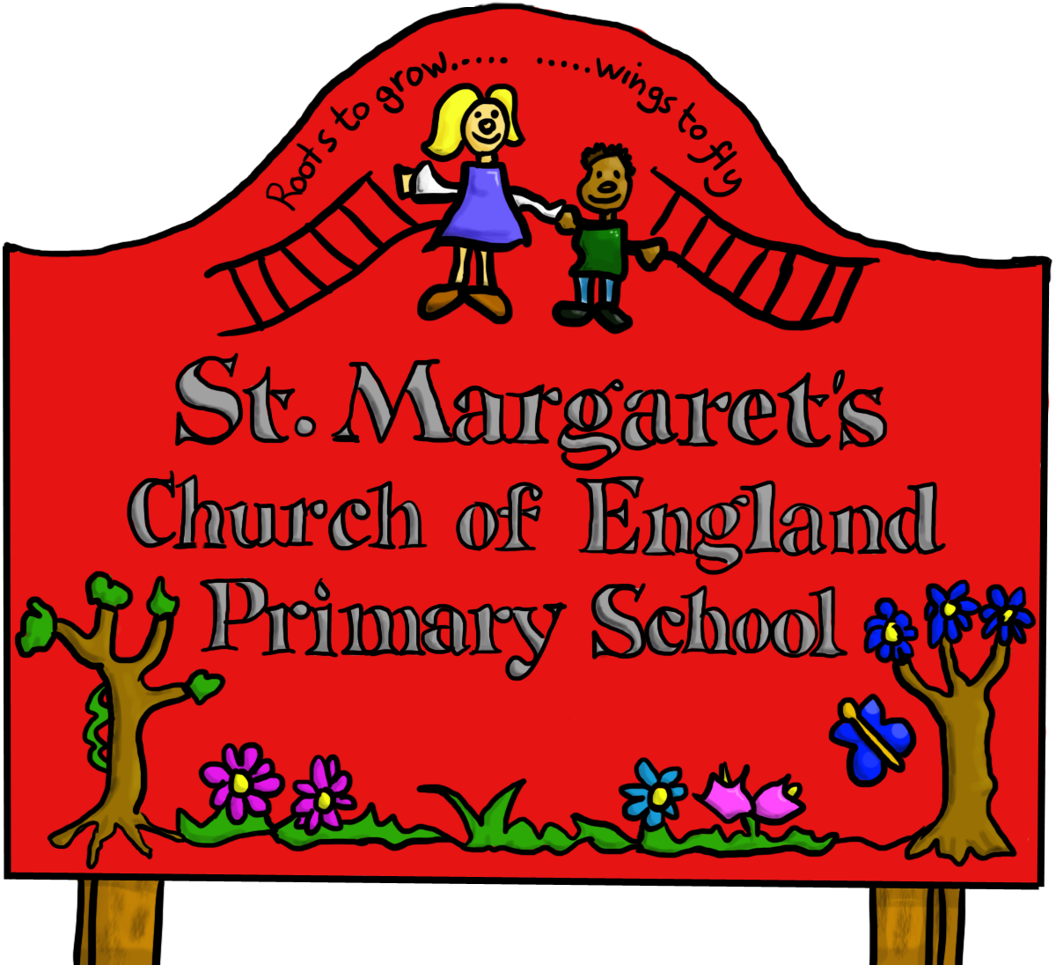
Last reviewed on: | Jan 2024
Next review due by: | Jan 2025

Contents
1. Aims 3
2. Legislation and statutory requirements 3
3. Behaviour Principles 4
4. Role and Responsibilities 4
5. Pupil code of conduct 5
6. Rewards and sanctions 6
7. Behaviour Management 7
8. Anti Bullying 8
9. Pupil transition 9
10. Training 9
11. Monitoring arrangements 9
12. Links with other policies
13 Home School Agreement 9
Appendix 1 Behaviour Log……………………………………………... 10

Equal Opportunities Statement

This policy will be implemented on an equal opportunities basis, ensuring that it does not discriminate in any way against any pupil group, regardless of gender, ability, disability, religious or cultural belief, or ethnic background.

INTRODUCTION
At St Margaret’s we set high expectations with regard to pupil behaviour and pupil’s attitude towards learning. Our 2022 Ofsted Report states that ‘Pupils at St. Margaret’s Church of England Primary are happy and exceptionally well behaved. They live and breathe the school’s values.’ We believe that good behaviour and a positive attitude towards learning enables children to be successful learners and therefore achieve high standards and make good progress.
St Margaret’s continually strives to develop pupils who are confident and have the attributes of perseverance, resilience and determination in everything they do.
It is the responsibility of all staff and governors at St Margaret’s School to promote good behaviour both on and off the school site.

1. Aims
This policy aims to:
- Provide a consistent approach to behaviour management
- Outline how pupils are expected to behave
- Summarise the roles and responsibilities of different people in the school community with regards to behaviour management
- Outline our system of rewards and sanctions

2. Legislation and statutory requirements
This policy is based on advice from the Department for Education (DfE) on:
- Behaviour and discipline in schools
- Searching, screening and confiscation at school
- The Equality Act 2010
- Supporting pupils with medical conditions at school
- Keeping Children Safe in Education
- Use of Reasonable force in schools
It is also based on the special educational needs and disability (SEND) code of practice.
In addition, this policy is based on:
- Section 175 of the Education Act 2002, which outlines a school’s duty to safeguard and promote the welfare of its pupils
- Sections 88-94 of the Education and Inspections Act 2006, which require schools to regulate pupils’ behaviour and publish a behaviour policy and written statement of behaviour principles, and give schools the authority to confiscate pupils’ property
- Following DfE guidance that the Behaviour Policy will be published online.

3. Behaviour Principles
- Our Christian distinctiveness and our Six Core Values – forgiveness, Responsibility, Truthfulness, Perseverance, thankfulness and Respect underpin everything we do at St Margaret’s and are at the heart of our approach to behaviour. These values are frequently discussed in our worship, PSHE, and RE lessons.
- All members of our school community behave in a polite and considerate manner showing respect towards themselves and others.
- Pupils behave in a manner which supports their own learning and that of others.
- All members of our school community including, staff, governors, students and volunteers are expected to be an excellent role model.
- Our emphasis is on encouraging positive behaviour through high expectations; a focus on learning; and appropriate praise and reward.
- Time will be given to pupils to reflect on their behaviour and learn from any wrong choices. Thinking about how they would deal with a similar situation next time and what would the best choice be.
- Pupils will receive behavioural support according to their need.
- The focus on positive behaviour, forgiveness and reconciliation will significantly reduce the need for exclusion. However, when making decisions, the Headteacher must balance the needs of the individual with those of the wider community and where a pupil’s behaviour places others at risk, the safety of other pupils is paramount. Considering this, the Governing Body support the right of the Headteacher to exclude for a single offence, permanently, where it is considered that allowing the pupils to remain in school would seriously harm the education of that pupil or others in the school.
- When appropriate school will seek advice and support from outside agencies

4. Roles and Responsibilities
4.1 The Governing Body
St Margaret’s Governing Body is responsible for reviewing and approving the written statement of behaviour principles (appendix 1) and will review this behaviour policy in conjunction with the headteacher and monitor the policy’s effectiveness, holding the headteacher to account for its implementation.
4.2 The headteacher
The headteacher is responsible for reviewing this behaviour policy in conjunction with the Governing Body, giving due consideration to the school’s statement of behaviour principles (appendix 1). The headteacher will also approve this policy.
The headteacher will ensure that the school environment encourages positive behaviour and that staff deal effectively with poor behaviour, and will monitor how staff implement this policy to ensure rewards and sanctions are applied consistently.
4.3 Staff
Staff are responsible for:
- Implementing the behaviour policy consistently
- Modelling positive behaviour
- Providing a personalised approach to the specific behavioural needs of particular pupils
- Recording behaviour incidents (see appendix 3 for a behaviour log)
The senior leadership team will support staff in responding to behaviour incidents.
4.4 Parents
Parents are expected to:
- Support their child in adhering to the pupil code of conduct (see Appendix 1)
- Inform the school of any changes in circumstances that may affect their child’s behaviour
- Firstly, to discuss any behavioural concerns with the class teacher promptly

5. Pupil code of conduct

BEHAVIOUR IN SCHOOL
- Pupils are expected to demonstrate good behaviour to/from school.
- Pupils are reminded that their behaviour is a reflection of the school when they are on school trips/visits.
- All pupils are expected to demonstrate the school values in all aspect of school life

- At the end of the day pupils are expected to leave the school premises in a sensible manner and without delay.

Behaviour when moving around the school
- Pupils walk quietly, in single file, along the corridors.
- Pupils show good manners to everyone in school.

Behaviour in the classroom
- Pupils are ready to learn and with the appropriate equipment
- Pupils demonstrate a high standard of behaviour.
- Pupils listen and concentrate on the task set.
- Pupils use their time positively and complete tasks to the best of their ability.
- Pupils do not engage in activity, which disturbs the learning of others.
- Pupils are polite and courteous at all times to everyone.
Behaviour in the playground
These rules are discussed with the children:
- Pupils play together and look after each other.
- Pupils allow others to get on with their own games.
- When the whistle blows, pupils stop and stand still until they are asked to walk sensibly to their line/ classroom.
- Pupils tell an adult if they feel frightened/ sad or are hurt.
- Pupils support each other on the friendship benches.

Behaviour in the Dining Room
- Pupils walk in the dining room and queue quietly.
- Pupils remember their manners when collecting their lunch
- Pupils remain seated whilst eating lunch

Behaviour when using computing equipment
Pupils are regularly reminded about how to use computers/ iPads safely and of the importance of Online-safety. When pupils work independently in the computer room, they are expected to do this in a safe and well- behaved manner.
Please see Policy for procedures to follow when there is an Online-safety issue.

Behaviour on School Visits and at Clubs/ Special Events/ Activities
A very high standard of behaviour is expected of all pupils taking part in school visits and special activities. Attendance at clubs/ activities/ visits is dependent upon children demonstrating good behaviour and a positive learning attitude in lessons. If this is not evident, it will be recommended that a pupil does not attend. The safety and well being of others is also part of the decision process.
If a pupil demonstrates serious misbehaviour during a visit or residential stay, then parents will be contacted and asked to collect their child. If they are unable to do this, then a senior member of staff plus an LSP will collect them.
If there is any poor behaviour/ attitudes shown during activities or club sessions, pupils will be removed from the session and potentially any further sessions.

6.Rewards and Sanctions
As a school we feel it is important to focus on and promote ‘positive’ behaviour from the children. However, children also need to be made aware that unacceptable behaviour will not be tolerated and sanctions will be used in such cases.
6.1 List of rewards and sanctions

Positive behaviour may be rewarded with:
- Praise
- Badges, stickers and stars
- House Points
- Special responsibilities/privileges
- Certificates
- Weekly Celebration Assemblies
- Head/ Deputy special awards

The school may use one or more of the following sanctions in response to unacceptable behaviour:
- A verbal communication
- Giving the pupil a time out
- Expecting work to be completed at break or lunchtime
- Missing of break or lunchtime to reflect on behaviour
- Referring the pupil to a senior member of staff
- Phone calls home/ meetings to parents
- Pupil Behaviour Log (see Appendix 2) - incidents are recorded and monitored by the Headteacher so that any behaviour patterns can be identified early.
- Any racial or bullying incidents are recorded separately by the Head Teacher and reported to the Governing Body.

6.2 Procedures for Dealing with Major Breaches of Discipline

In response to any identified major issues, the following disciplinary steps may be taken:
- Exclusion from certain areas of the school premises
- If the problem is severe or recurring then exclusion procedures are implemented in consultation with the Governing Body
- Minor fixed- term exclusion
- Major fixed -term exclusion
- Permanent exclusion

NB A very serious problem may result in a change to the normal procedure. In this case a child’s parent will be contacted immediately and this may result in a child being taken home straight away.
If there is a persistent pattern of serious misbehaviour and all other strategies and other agency support has been exhausted and there are no improvements in the child’s behaviour a child may be given a fixed term, or permanent exclusion. If a child’s behaviour is consistently severe then the school will work very closely with the Sandwell Preventing Exclusions Team.
6.3 Malicious allegations
Where a pupil makes an accusation against a member of staff and that accusation is shown to have been malicious, the headteacher will discipline the pupil in accordance with this policy.
Please refer to our Safeguarding Policy for more information on responding to allegations of abuse.
The headteacher will also consider the pastoral needs of staff accused of misconduct
Where a pupil makes an allegation of sexual violence or harassment against another pupil and that allegation is shown to be deliberately invented or malicious, the Headteacher and Governing Body will discsuss the appropriate action to take place in accordance with this policy.

7 Behaviour management

7.1 Classroom management
Teaching and support staff are responsible for setting the tone and context for positive behaviour within the classroom.
They will:
- Create and maintain a stimulating environment that encourages pupils to be engaged
- Display the Jigsaw Charter
- Develop a positive relationship with pupils, which may include:
  - Greeting pupils in the morning/at the start of lessons
  - Establishing clear routines
  - Communicating expectations of behaviour in ways other than verbally
  - Using positive reinforcement
  - Highlighting and promoting good behaviour
  - Concluding the day positively and starting the next day afresh

7.2 Physical restraint
School will follow the Force and Restraint Policy alongside the DFE Guidance
In some circumstances, staff may use reasonable force to restrain a pupil to prevent them:
- Causing disorder
- Hurting themselves or others
- Damaging property
Incidents of physical restraint must:
- Always be used as a last resort
- Be applied using the minimum amount of force and for the minimum amount of time possible
- Be used in a way that maintains the safety and dignity of all concerned
- Never be used as a form of punishment
- Be recorded and reported to parents (see Physical Restraint Policy)

7.3 Pupil support
The school recognises its legal duty under the Equality Act 2010 to prevent pupils with a protected characteristic from being at a disadvantage. Consequently, our approach to challenging behaviour may be differentiated to cater to the needs of the pupil.
The school’s special educational needs co-ordinator along with the Mental Health Lead will evaluate a pupil who exhibits challenging behaviour to determine whether they have any underlying needs that are not currently being met.
Consideration will also be given for in school support for a pupil from our Pupil Mentor. This will depend upon the needs of the pupil and the Mentors timetable availability.
Where necessary, support and advice will also be sought from specialist teachers, an educational psychologist, medical practitioners and/or others, to identify or support specific needs.
When acute needs are identified in a pupil, we will liaise with external agencies and plan support programmes for that child. We will work with parents to create the plan and review it on a regular basis.

8. Anti-Bullying
Bullying is defined as the repetitive, intentional harming of one person or group by another person or group, where the relationship involves an imbalance of power.
Bullying is, therefore:
- Repeated, often over a period of time
- Deliberately hurtful often over a period of time
- Difficult to defend against
‘Several Times On Purpose’
Bullying needs to be differentiated from other forms of behaviour. For example:
- Two friends/non- friends who fall out
- Single incidents should not be classed as bullying
Bullying can take several forms and can be carried out by adults or children. It can include:
- Emotional Bullying – Being unfriendly, tormenting
- Physical Bullying -Hitting. kicking, pushing,
- Verbal- name calling, teasing, insulting, making offensive remarks
- - Racial, Faith, Gendered, Homophobic, Transphobic, Disability

9. Pupil transition
To ensure a smooth transition to the next year, pupils have transition sessions with their new teacher. In addition, staff members hold transition meetings.
To ensure behaviour is continually monitored and the right support is in place, information related to pupil behaviour issues may be transferred to relevant staff at the start of the term or year. Information on behaviour issues will be shared with new settings for those pupils transferring to other schools.

10. Training
Behaviour management will also form part of continuing professional development.

11. Monitoring arrangements
This behaviour policy will be reviewed by the headteacher and St Margaret’s Governing Body every three years. At each review, the policy will be approved by the headteacher.

12. Links with other policies
This behaviour policy is linked to the following policies:
- Exclusions policy
- Safeguarding policy
- Physical Restraint Policy
- Online Safety Policy
- SEND Policy
- Anti -Bullying Policy

13. Home- School Agreement
At St. Margaret’s, we give high priority to developing a positive partnership with parents since they are crucial partners in promoting and maintaining high standards of behaviour.
Where the behaviour of a child is giving cause for concern, it is important that all those working with the child in school are aware of those concerns, and of the steps which are being taken in response. The key professional in this process of communication is the class teacher who has the initial responsibility for the child's welfare. After this, concerns should be communicated to the Leadership Team/Deputy and then to the Head, so that strategies can be discussed and agreed before more formal steps are required.
It is expected that St Margaret’s parents will ensure they have read the following school documents and agree to support school in their implementation. These are available on the school website.
The Behaviour Policy
Attendance Policy
Home Learning Policy
Uniform and School Equipment Statement
Home Learning Policy
Parent code of conduct
Communications Procedures

Appendix 1: St Margaret’s CE Primary Behaviour Log
St Margaret’s CE Primary School
Record of behaviour 2022-2023
Term: Autumn 1 2 Spring 1 2 Summer 1 2
Pupil name: …………………………………………………………………….
Year group | Date | When/Location- Class, hall, playground, lunchtime, time | What happened? | Actions | Outcomes, monitoring, resolution

