ST MARGARET’S CE VA PRIMARY SCHOOL
CURRICULUM
“Encourage one another and build each other up”
1 Thessalonians 5:11

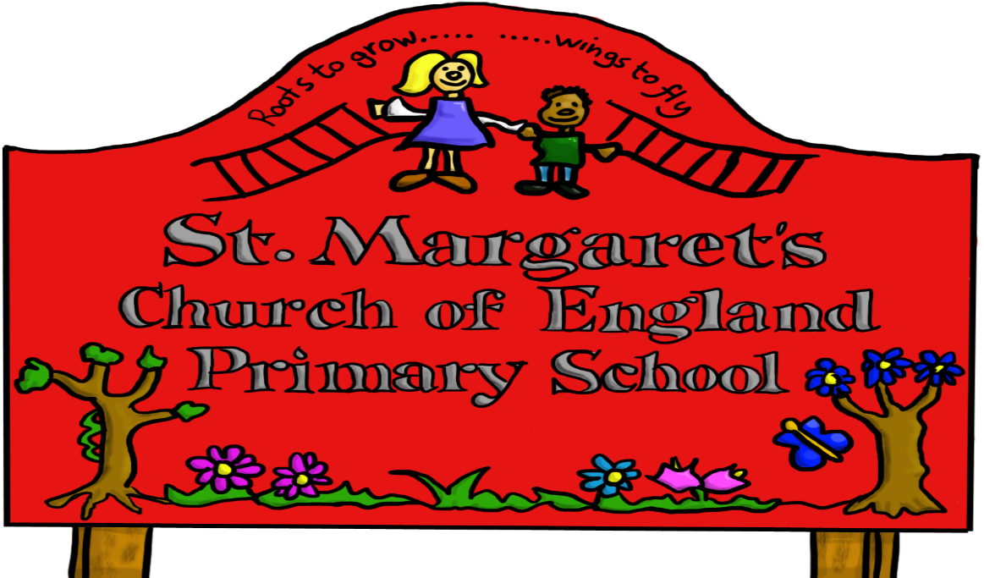

CURRICULUM

GENERAL
We believe that it is vital to offer a broad and balanced curriculum which develops a pupil in the individual subject skills and knowledge so that they are better prepared for secondary education. Each subject is taught by the child’s class teacher.

Foundation Stage
Nursery and Reception
The foundation stage team follow the new EYFS Framework Sept 2021 which focuses on early language and extending vocabulary, developing speech and language skills across all 7 areas as this supports child development in a broad curriculum. This new framework involves practitioners knowing children’s level of achievement and interests and then shaping teaching and learning experiences reflecting that knowledge. A new Reception Baseline has also been introduced this September 2021.

Key Stage 1
Year 1 and Year 2
In Year 1 there is a transition period during the Autumn Term where children may still be working on achieving reception objectives.
Learning for Key Stage 1 children is based on the National Curriculum and its Aims and Programmes of Study. English (including phonics) and Mathematics have a high priority and are taught daily. Children are taught Spellings Punctuation and Grammar, Science, Geography, History, Music, Physical Education, Art, Design Technology, RSHE and Computing.
We aim to develop the children’s knowledge, skills and attitudes in every subject that is followed. The children are given opportunities to present the outcome of their activities in a variety of ways, including orally, visually and in writing.
As a school we try to put our learning in real life contexts so that children can see its relevance and importance.
Pupil reports are sent out at the end of the autumn and summer terms and there is an opportunity to discuss their progress at termly Parental Consultation Meetings. As part of these reports, pupil targets are written to enable parents to support their child.
At the end of Year 1 children take the National Phonics Test and parents are informed if their child has met the standard.
At the end of Year 2 children are assessed more formally and school results are published nationally in School Performance Tables.

Key Stage 2
English and Mathematics are taught daily and there are focus sessions where particular key skills are addressed such as handwriting, spelling, grammar and vocabulary.
Children are taught Science, Geography, History, Music, Physical Education, Art, Design Technology, French, RSHE, Computing and French. As a school we continually try to ensure all learning is relevant and children can see the purpose of learning particular knowledge and skills.

General Information
Informal and formal assessment is continuous and integrated so that your child's teacher is able to monitor progress throughout the year. During each term there are formal assessments where children take tests in Maths and English.
To keep parents informed, year group information booklets and curriculum maps are given out at the beginning of the school year. Parents are then more aware of what is being studied and can help and support if necessary.

Each class teacher across school delivers a Maths/ English workshop to help parents to be informed about the year group curriculum and the various teaching strategies used.

MATHEMATICS
“Mathematics is a creative and highly interconnected discipline that has been developed over centuries, providing the solution to some of history’s most intriguing problems. It is essential to everyday life, critical to science, technology and engineering, and necessary for financial literacy and most forms of employment. A high-quality mathematics education therefore provides a foundation for understanding the world, the ability to reason mathematically, an appreciation of the beauty and power of mathematics, and a sense of enjoyment and curiosity about the subject.”

Aims
The national curriculum for mathematics aims to ensure that all pupils:
▪ become fluent in the fundamentals of mathematics, including through varied and frequent practice with increasingly complex problems over time, so that pupils develop conceptual understanding and the ability to recall and apply knowledge rapidly and accurately.
▪ reason mathematically by following a line of enquiry, conjecturing relationships and generalisations, and developing an argument, justification or proof using mathematical language
▪ can solve problems by applying their mathematics to a variety of routine and non-routine problems with increasing sophistication, including breaking down problems into a series of simpler steps and persevering in seeking solutions.

Maths is evident in all classes and is usually taught during the morning sessions.
Teaching covers all the elements of the programmes of study for Key Stages 1 and 2 from the National Curriculum. They include an introduction to all the relevant aspects of mathematics, including a sound introduction to mathematical language and concepts. Also, the teaching of Mental Maths Strategies is an important aspect of our pupil’s mathematical learning.
Pupils are taught times tables and computation skills from Key Stage 1. In Key Stage 1, the Programmes of Study cover: Number and place value, Measurement, Geometry and Statistics.
In Key Stage 2, the Programmes of Study cover: Number and Place Value, Fractions, Measurement, Geometry and Statistics.
We encourage a home-school partnership approach to learning and hope that what is taught at school is practised and reinforced at home on a regular basis.
At lunchtimes our computer suite is available for KS2 pupils to go and practice their Multiplication Tables using the Rock Stars programme. Our pupils really enjoy this very independent task and it is very popular. They are also able to access the programme at home.

Our aim is to ensure we create a love for mathematics and for our children to be confident Mathematicians.

ENGLISH
“English has a pre-eminent place in education and in society. A high-quality education in English will teach pupils to speak and write fluently so that they can communicate their ideas and emotions to others and through their reading and listening, others can communicate with them. Through reading in particular, pupils have a chance to develop culturally, emotionally, intellectually, socially and spiritually. Literature, especially, plays a key role in such development. Reading also enables pupils both to acquire knowledge and to build on what they already know. All the skills of language are essential to participating fully as a member of society; pupils, therefore, who do not learn to speak, read and write fluently and confidently are effectively disenfranchised.”

Aims
The overarching aim for English in the national curriculum is to promote high standards of language and literacy by equipping pupils with a strong command of the spoken and written word, and to develop their love of literature through widespread reading for enjoyment. The national curriculum for English aims to ensure that all pupils:
▪ read easily, fluently and with good understanding
▪ develop the habit of reading widely and often, for both pleasure and information
▪ acquire a wide vocabulary, an understanding of grammar and knowledge of linguistic conventions for reading, writing and spoken language
▪ appreciate our rich and varied literary heritage
▪ write clearly, accurately and coherently, adapting their language and style in and for a range of contexts, purposes and audiences
▪ use discussion in order to learn; they should be able to elaborate and explain clearly their understanding and ideas
▪ are competent in the arts of speaking and listening, making formal presentations, demonstrating to others and participating in debate.

English is evident in all classes sometime during the morning sessions.
Great emphasis is laid upon the skill areas of reading, grammar, punctuation, spelling, writing, listening and speaking. Our teaching programmes include – drama, oral poetry and story telling, the study of fiction and non-fiction texts and the study of authors. Opportunities to develop English related skills are built into activities in other subject areas so that our pupils' skills in all forms of communication are extended and enriched.
To further support the learning outcomes for Grammar, Punctuation and Spelling (GPS) our Key Stage 2 pupils have access to an online programme at home and also our pupils like working on this during lunchtimes in our computer suite. This is also a task which is completed very independently but can be monitored by the teacher. Each child takes home a reading book along with a reading log in which parents are expected to record comments relating to their child’s home reading. We believe reading is vitally important and that it is important that parents regularly hear their child read.

SCIENCE
Our teaching programmes in science are based upon the programmes of study in the national science curriculum. The following science units are taught - Plants, Living things and their habitats, Animals including humans, Light, Forces and magnets, States of matter, Sound, Electricity, Properties and changes of materials, Earth and space, Forces, and Evolution and inheritance. Children also focus on what it means to work scientifically.
Attention is paid to developing in children an understanding of scientific method, a knowledge of major scientific concepts, and the use of problem-solving approaches. We also believe that it is important that our children learn about famous sciencetists and how science is used in our world today and the impact it has on our every- day lives.

COMPUTING
We aim to equip our children to be confident, competent and creative in using any form of technology.
In order to deliver the computing curriculum, we use iLearn2 published scheme.
Alongside this Online Safety is regularly taught. We strive to ensure that children are safe when using any device. We participate in National Internet Safety Days and the children are taught regularly about the importance of keeping safe. We also have an Online Safety Team who promote the safe use of devices and programmes to their fellow pupils and our parents.

DESIGN & TECHNOLOGY
Our schemes of work in this curriculum area are designed to help children develop their design and making capabilities through activities that lead to the development and production of products. Furthermore, the schemes are intended to develop pupil’s knowledge and understanding required by the Programmes of Study. This includes knowledge and understanding of the following: mechanisms, structures, products and applications, product quality, health and safety issues, appropriate vocabulary for naming and describing equipment, materials and components. DT is sometimes taught in focused weeks or over a number of days/sessions.
We frequently have whole school projects linked to DT and this provides an opportunity for parents to work with their child.

GEOGRAPHY
Our aim in this area of the curriculum is to help pupils acquire a framework of knowledge about locations, regions and significant places. They also learn about the geographical processes which create physical and human features of the world. Children learn how to read maps, use globes, photographs and diagrams to interpret geographical information. As part of the geography curriculum children in KS1 & KS2 are given the opportunity to visit one of the Sandwell Residential Centres to develop their fieldwork skills. We endeavour to encourage high standards in all geography recording to reinforce literacy skills. The use of the Connected Geography materials ensures that the children are stimulated by a question-based topic focus which links into the "real world" and current geographical issues and responses.
It is important that we equip our pupils in the language of geography which also prepares them well for their secondary school.

HISTORY
We follow the elements of the National Curriculum and units of work have been planned accordingly. Emphasis is placed upon the following: the processes of historical study; working with primary and secondary sources; field-work; visits to museums and sites of historical interest. Pupils are encouraged to engage in research at an appropriate level, and are helped to relate their learning to their own historical situation. Our schemes of work aim to secure coverage of the National Curriculum in history whilst giving due weight to our rich and varied local history.
History Home Learning Projects are frequently completed by children.

MUSIC
Music is an important part of school life. The music curriculum aims to engage and inspire pupils to develop a love of music and foster their talent as young musicians. Children’s understanding and enjoyment of music is developed through listening and appraising; singing and playing musical instruments; performing, improvising and composing.
Our aim is to develop a wide appreciation of music. In our daily assemblies, we have listening music from a range of historical periods, genres, styles and traditions, from the works of great classical composers to modern pop artists. Children are encouraged to listen with attention to detail, sharing ideas about instrumentation, pitch, duration, dynamics, tempo, timbre, texture and structure.
Singing is central to music lessons and is an important part of whole school worship time. Children enjoy singing together and use their voices expressively. Pupils in Key stage 2 are given the opportunity to learn and play a musical instrument, receiving lessons from visiting peripatetic teachers on string, woodwind and brass instruments. Instrumentalists perform regularly in assembly time and in celebratory concerts to family and friends.
Pupils follow the Charanga scheme of learning in Key Stage 1 and 2. This enables a progressive approach, giving pupils the opportunity to perform, improvise and compose, using their own voices, tuned and untuned instruments – all whilst having a great time and enjoying learning!
As a church school we also keen to participate in singing events with Lichfield Cathedral. Recently we participated in a Music Share Concert at the cathedral. As a school we love singing and we do it with great enthusiasm.

ART
Our programmes of study for art are intended to develop creativity and technical proficiency as well as build upon existing skills. Using a wide range of techniques, pupils are encouraged to express their ideas and feelings using a range of visual media and to represent the features of the world around them. A variety of artists and their works are studied and children are taught to reflect on and evaluate their own work and that of others. The West Midlands area has many art galleries. As there are many genres to be discovered in the visual arts, we feel that school visits to exhibitions and participation in workshops with professional artists can be both inspiring and beneficial to our young artists.

RELIGIOUS EDUCATION
As a Church Aided Primary School, the Religious Education at St Margaret's is the responsibility of the Governing Body. Our RE Units are a mixture of Understanding Christianity, and the Sandwell SACRE Syllabus as well as some of our own units which we have developed.
In accordance with the Education Act, religious education is a compulsory part of the curriculum. As part of the RE teaching all Key Stage 2 classes visit St Margaret’s Church each term where they work on a variety of RE themes. The RE learning is 80% Christianity and in Key Stage 2 other faiths are studied.
Our Year 6 children often have the opportunity to take part in a unit of study at Lichfield Cathedral.
As a school we also employ a Church Worker who is in school on Tuesdays and Thursdays who supports our delivery of worship and RE. They also lead our own SWITCH Team (See World Issues Through Christian hearts) which includes representatives from each Key Stage 2 classes. Our SWITCH Team leads in our church services and also on our many charity events. Our children are always keen to be part of the SWITCH Team.

P.E. AND GAMES
We see the importance of physical activity and encourage our children to participate in a wide variety of activities. All classes have two hours of PE each week.
A wide range of physical activities are offered within the school, including swimming, athletics, gymnastics, games, outdoor adventure activities and dance. These activities are intended to promote physical development and teach pupils the value of participation and co-operation, as well as competitiveness. The school takes advantage of some outside agencies to help deliver aspects of the curriculum.
As part of the PE provision we are supported by Inspire Sports Company who provide professional development for our staff and run a club at lunchtimes and after school.

SPORTING AIMS AND PROVISION FOR SPORT
The school aims to encourage pupils to develop physical skills, habits and interests that will promote a healthy lifestyle. We try to develop positive attitudes including perseverance, fair play and sporting behaviour and to provide enjoyment in physical activity.
We frequently participate in sporting events across the local authority.

MODERN LANGUAGE
In Key Stage 2 we teach French which incorporates a wide variety of topics. Our children learn both oral and written French. We also have a cultural focus which, enables our children to learn about French traditions, food, life in France and famous events.
We frequently have an International Day across school where each class focuses on learning about a particular country.

