SCIENCE PROGRESSION CHARTS
The National Curriculum Programme of Study for Science describes a sequence of knowledge and concepts, processes and methods. This sequence of knowledge and concepts is arranged as progressive blocks of key ideas in biology, chemistry and physics, alongside a progression in the skills of working scientifically.

The conceptual ideas in Biology, Chemistry and Physics build on each other and children need to develop a strong understanding of each set of ideas in order for the next set to make sense and for them to make progress. The Programme of Study is set out year by year for Key stages 1 and 2 but each science topic is not covered in every year. It is therefore important that teachers and children know where each block of ideas fits into the overall sequence.

In the Snap Science Progression Charts the key ideas within Biology, Chemistry and Physics in the National Curriculum are arranged to show how they are related to each other and how one idea builds on another. The National Curriculum statements have been edited into key ideas statements. The source of each key idea is identified by the year group and the Programme of Study topic heading. Some additional statements have been added to make important links between ideas.

Working Scientifically is taught throughout KS1 and 2, embedded within the content of Biology, Chemistry and Physics. The National Curriculum Programme of Study for Working Scientifically outlines the practical scientific methods, processes and skills that children must be taught to use, divided into three two-year blocks. In every lesson in Snap Science children will use their developing science enquiry skills to answer scientific questions. The Snap Science Progression Chart for Working Scientifically exemplifies the progression in these skills in the key areas of raising questions and planning, collecting and presenting data, drawing and evaluating conclusions.

This progression underpins the sequence of teaching and learning in each Snap Science module and between year groups.

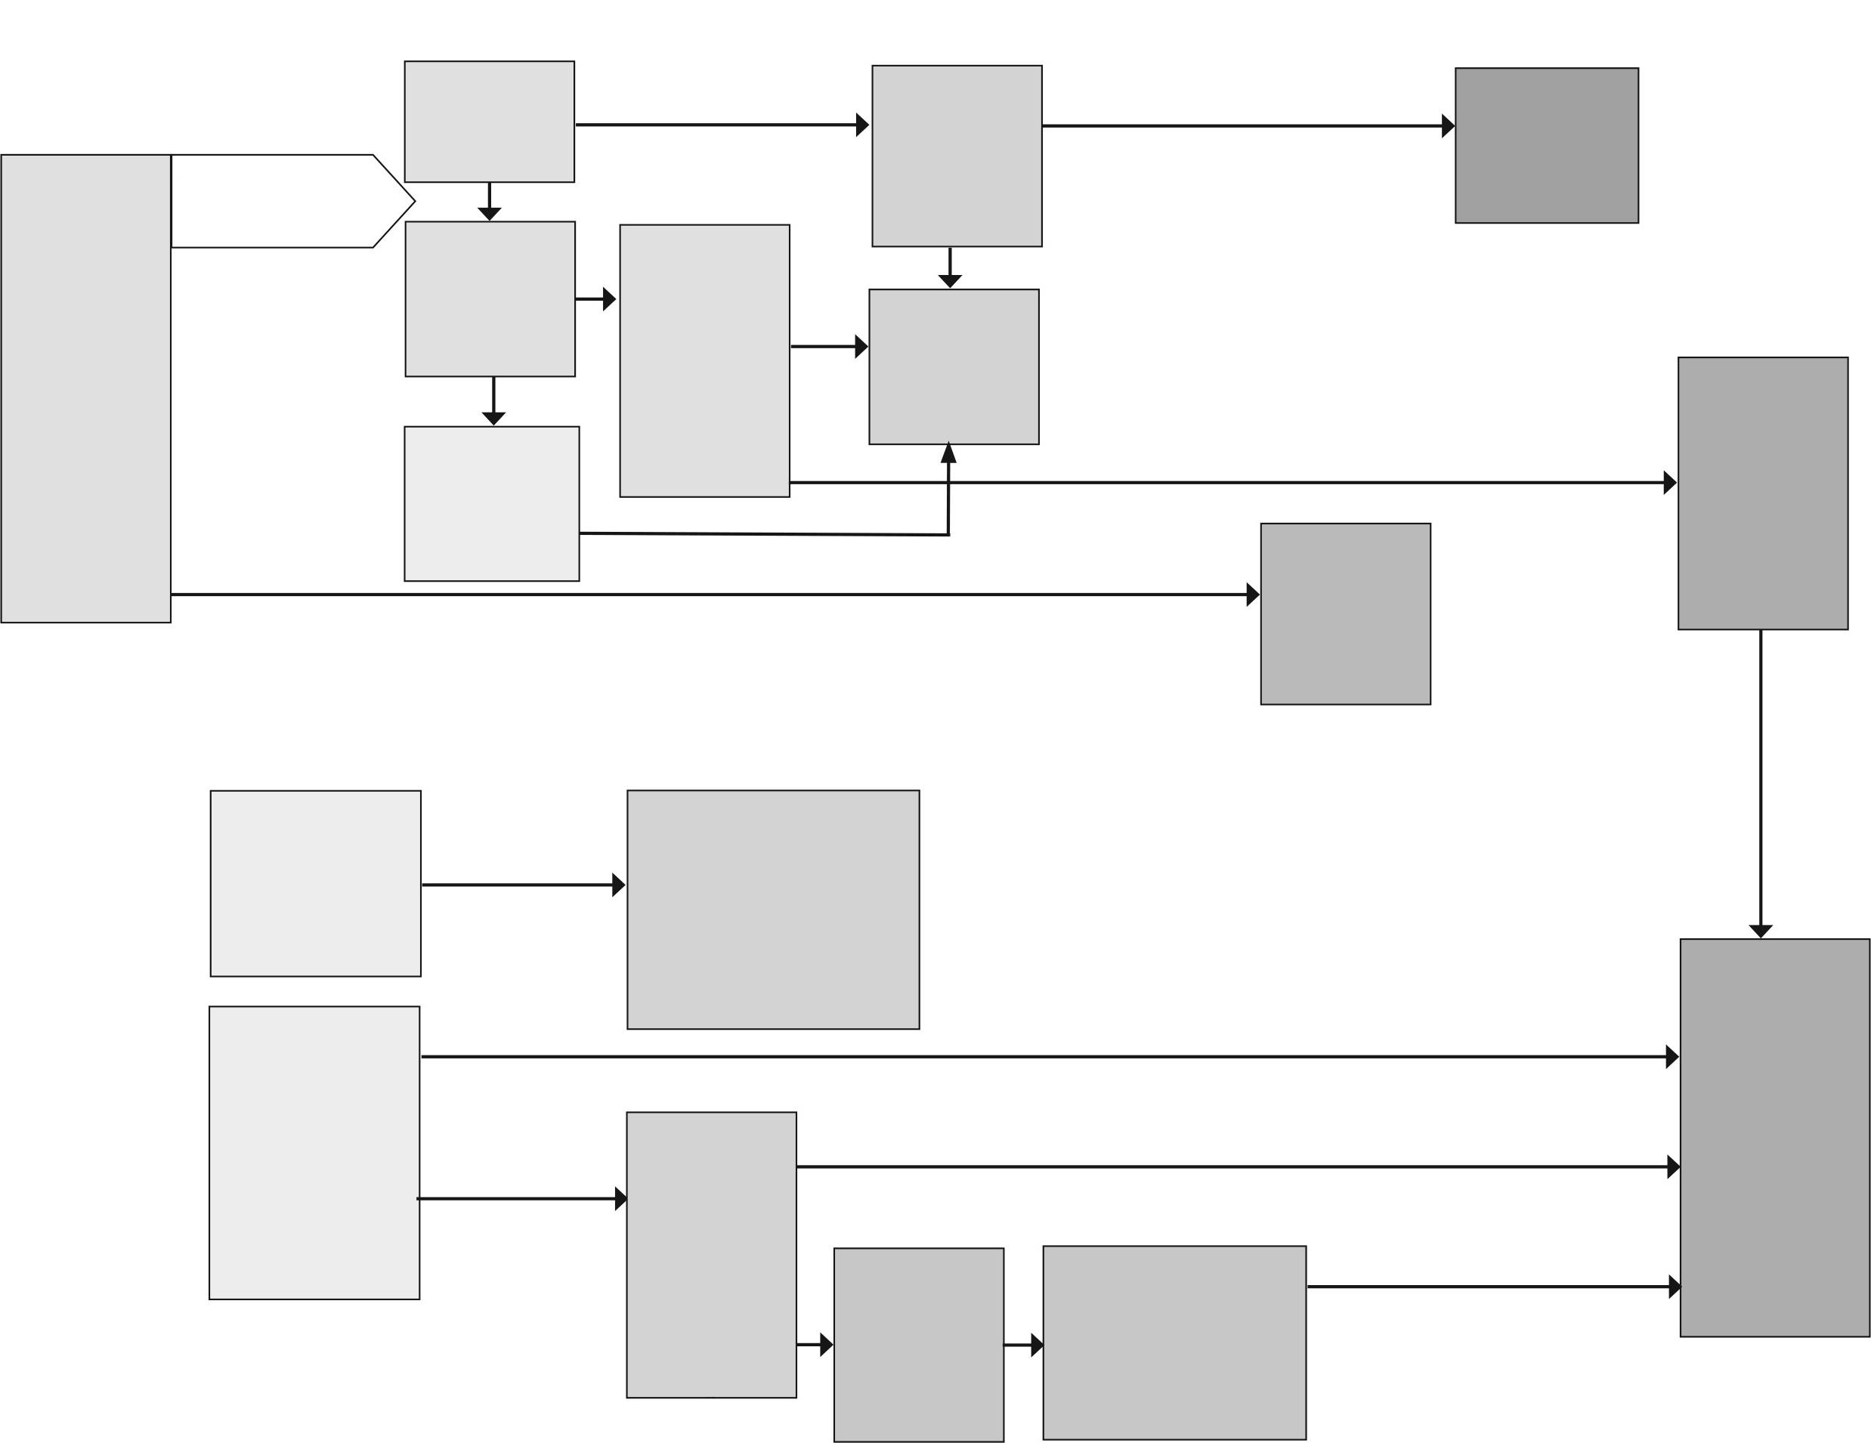
BIOLOGY: progression of ideas through KS1 and 2
LIFE PROCESSES
For living things
to survive
Many animals, including humans, have skeletons and muscles for support, protection and movement
Y3 Animals, including humans

Animals and humans have teeth to help them eat Y4 Animals, including
humans
Food is broken down further in the stomach and intestine and absorbed into the blood stream with water Y4 Animals, including humans
Oxygen is taken into the blood in the lungs; the blood is pumped by the heart to take oxygen and nutrients to the muscles
Y6 Animals,
including humans
Some things are living, some are dead and some
have never
been alive
Y2 Living things and their
habitats
Plants need
water, light and
warmth
Y2 Plants
Animals need
water, food
and air
Y2 Animals,
including humans
Different animals
need different
types of food
Y1 Animals,
including humans
To stay healthy
animals need
exercise, a
balanced diet
and hygiene
Y2 Animals,
including
humans
To stay healthy
plants need
light, water,
nutrients and
room to grow
Y3 Plants
Animals cannot
make their own
food
Y3 Animals,
including humans
Plants use
energy from
sunlight to make
their own food
KS3
Plants and
animals need to
reproduce
Y5 Living
things and their
habitats
Some
substances and
lifestyle choices
can have a
negative impact
on health
Y6 Animals,
including
humans
STRUCTURE AND FUNCTION
Flowering plants have different parts – roots, stems, leaves, ̀ flowers, fruit, seeds Y1 Plants
Animals, including humans, have different body parts ... and these have special functions to help them survive (including senses) Y1 Animals, including humans
Different parts of ̀ flowering plants have different functions Roots and stems – nutrition, transport of water and support Leaves – nutrition Flowers – reproduction Y3 Plants
PLANTS
ANIMALS
HUMANS

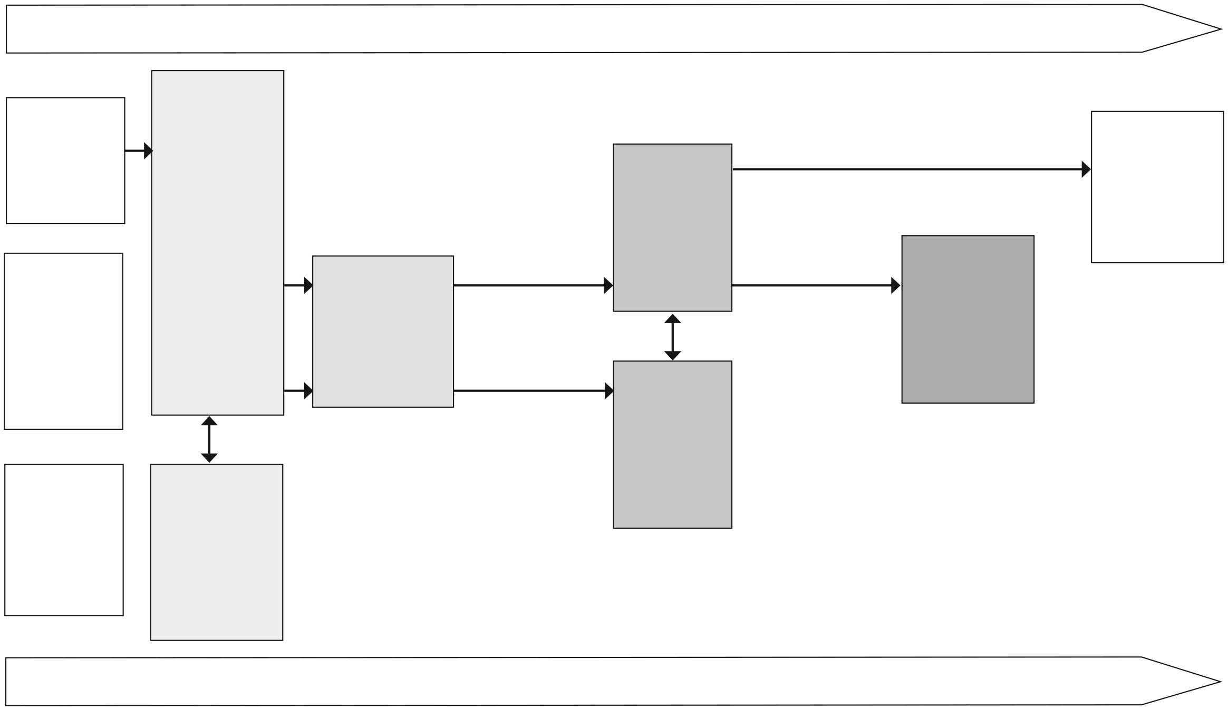
Identifying and classifying increasing range from the familiar to the unfamiliar
There is an enormous range of living things (organisms)
Plants are grouped into common wild and garden plants, deciduous and evergreen trees. Animals are grouped into fish, amphibians, reptiles, birds, mammals Y1 Plants Y1 Animals, including humans
Animals and plants can be identified and grouped. This is linked to habitat.Y2 Living things and their habitats
Organisms are classified into groups at different levels based on similarities in observable characteristics
Plants and animals can be grouped using observable features Y1 Plants Y1 Animals, including humans
Differences between organisms are used to identify and name them as individual species
Plants and animals can be grouped using a wider range of characteristics Y4 Living things and their habitats
Keys are used for the identification of animals and plants Y4 Living things and their habitats
Classifying into more specific groups by increasingly detailed characteristics

The grouping of organisms becomes more detailed, depending on the purpose of the classification
A wider range of living things including micro-organism can be identified Y6 Living things and their habitats
CLASSIFICATION
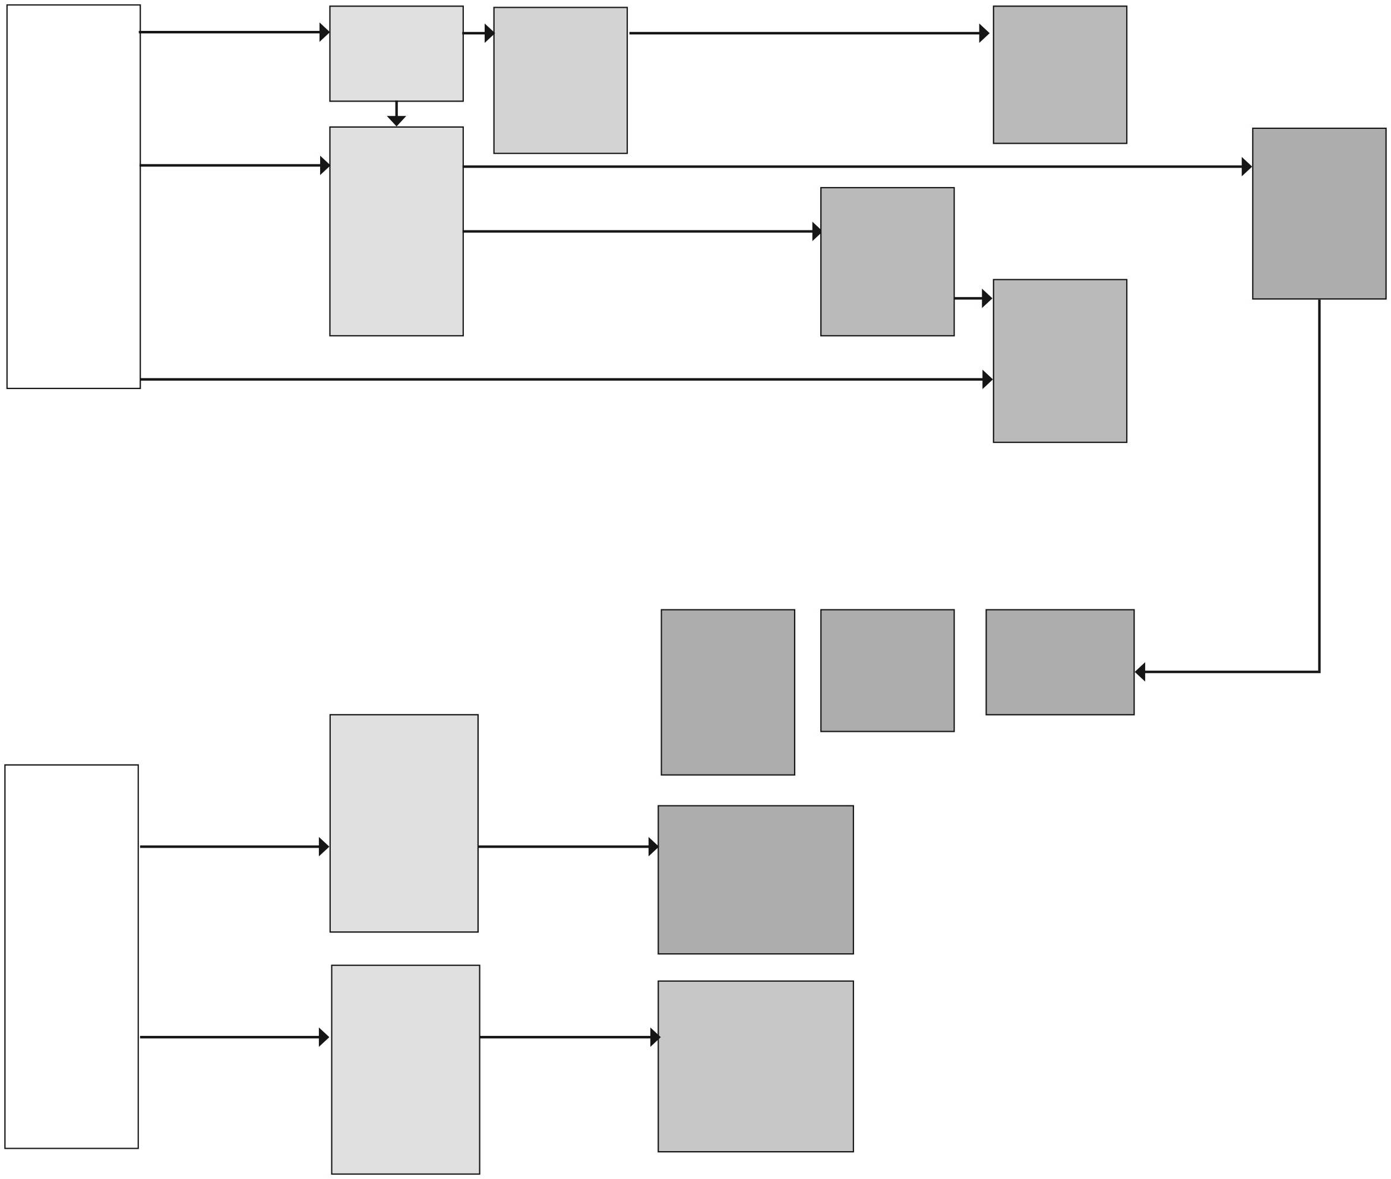
LIFE CYCLES
Animals, including humans, reproduce offspring which grow into adults Y2 Animals, including humans
Life cycles differ for different species Y5 Living things and their habitats
Plants: seeds and bulbs grow into plants Y2 Plants
Plants make seeds to produce more plants (sexual reproduction) Y3 Plants
Plants can reproduce asexually Y5 Living things and their habitats
Living things produce offspring of the same kind, but not identical Y6 Evolution and inheritance
Human development has different stages between birth and death Y5 Animals, including humans
Plants and animals grow and change over the course of their lives
All living things are inter-dependent
Different plants and animals live
in different
places to which they are suited ̶
by giving them food and shelter Y2 Living things and their habitats
Plants and animals are adapted to suit their environment
Y6 Evolution and inheritance
Living things have changed over time Y6 Evolution and inheritance
Adaptation may lead to evolution Y6 Evolution and inheritance
Environmental change and human impact affects different habitats differently Y6 Living things and their habitats
Animals get their food from plants and other animals and in turn are consumed by other animals Y2 Living things and their habitats
Nutrients made by plants move to primary consumers and then to secondary consumers through food chains Y4 Animals, including humans
INTERDEPENDENCE
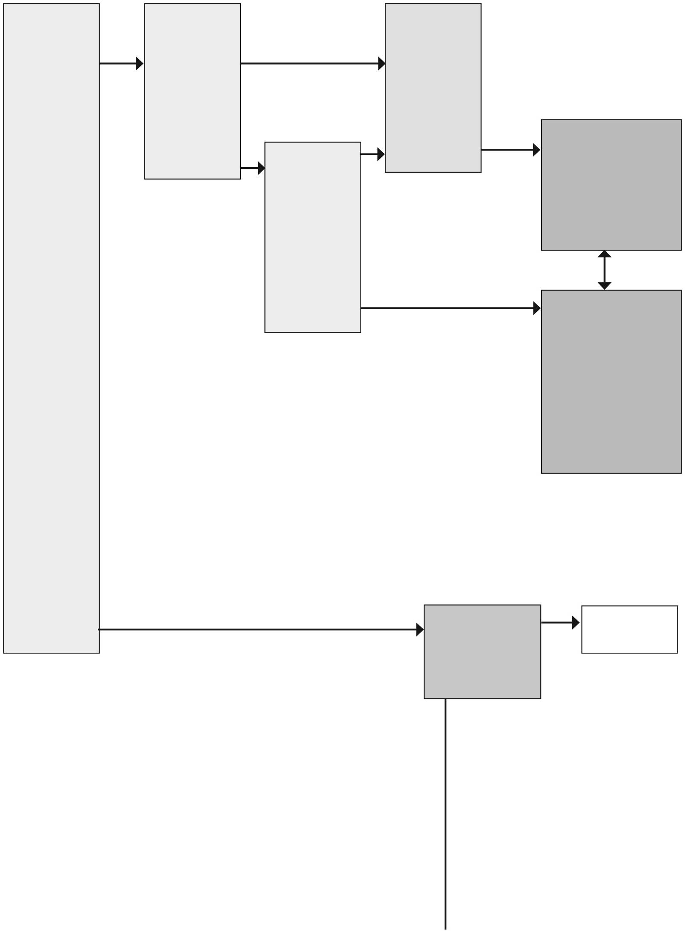
CHEMISTRY: progression of ideas through KS1 and 2
Different materials, including rocks, have different properties
Y1 Everyday materials
Y3 Rocks
Different materials are suitable for different uses (properties that can be observed)
Y2 Uses of everyday materials
MATERIALS
DESCRIBING AND USING MATERIALS
There are different materials and they are used to make different objects
Y1 Everyday materials
Materials can be sorted into groups according to their observable properties Y1 Everyday materials
Different properties make materials suitable for different uses (properties that can be measured) Y5 Properties and changes of materials
Materials can be sorted into groups according to properties including hardness, solubility, transparency, conductivity (electrical and thermal) and response to magnets Y5 Properties and changes of materials

Materials can be solids, liquids or gases
Y4 States of Matter
All materials have mass
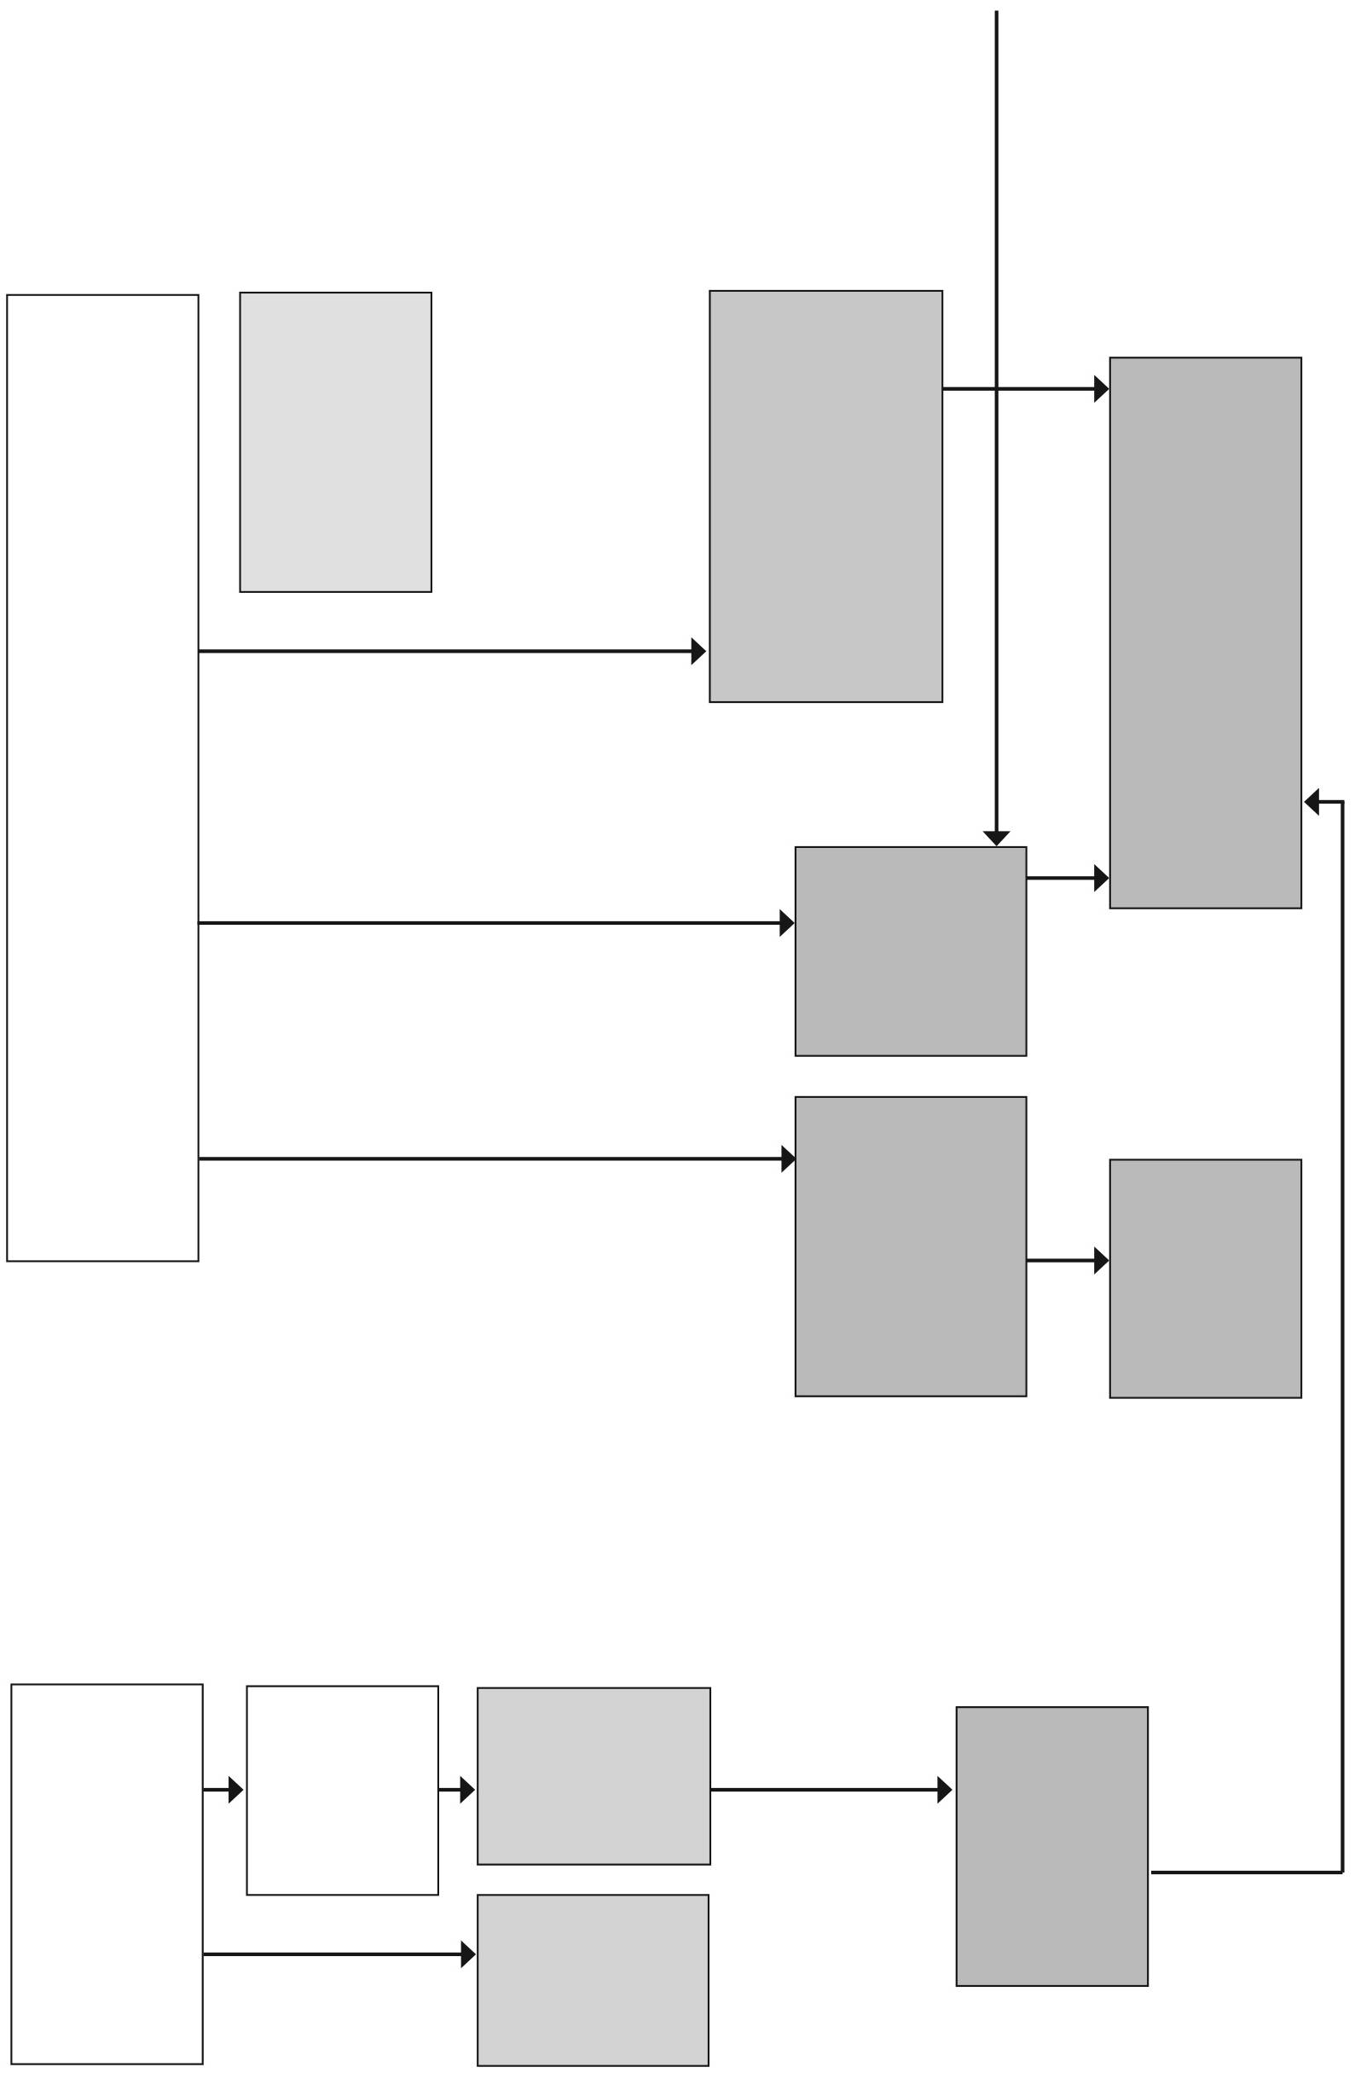
CHANGING MATERIALS
The shape of some solid materials can be changed by a contact force acting on them Y2 Uses of everyday materials
Some materials change state when heated or cooled Heating causes melting and evaporation Removing heat causes condensing and solidifying (freezing)
Y4 States of Matter
Materials can be changed
Dissolving, mixing and changes of state are reversible changes
Y5 Properties and changes of materials
Some materials will dissolve in a liquid
Y5 Properties and changes of materials
Changes including baking, burning and the reaction of certain chemicals result in new materials
Y5 Properties and changes of materials
Changes that result in new materials are not usually reversible
Y5 Properties and changes of materials
Materials can be mixed together
Mixtures occur when materials are mixed together but don’t react to each other
Soils are a mixture of rocks and organic matter Y3 Rocks
Fossils are formed when trapped within rock
Y3 Rocks
Mixtures can be separated by filtering, sieving and evaporating Y5 Properties and changes of materials
MIXING AND SEPARATING MATERIALS

PHYSICS: progression of ideas through KS1 and 2

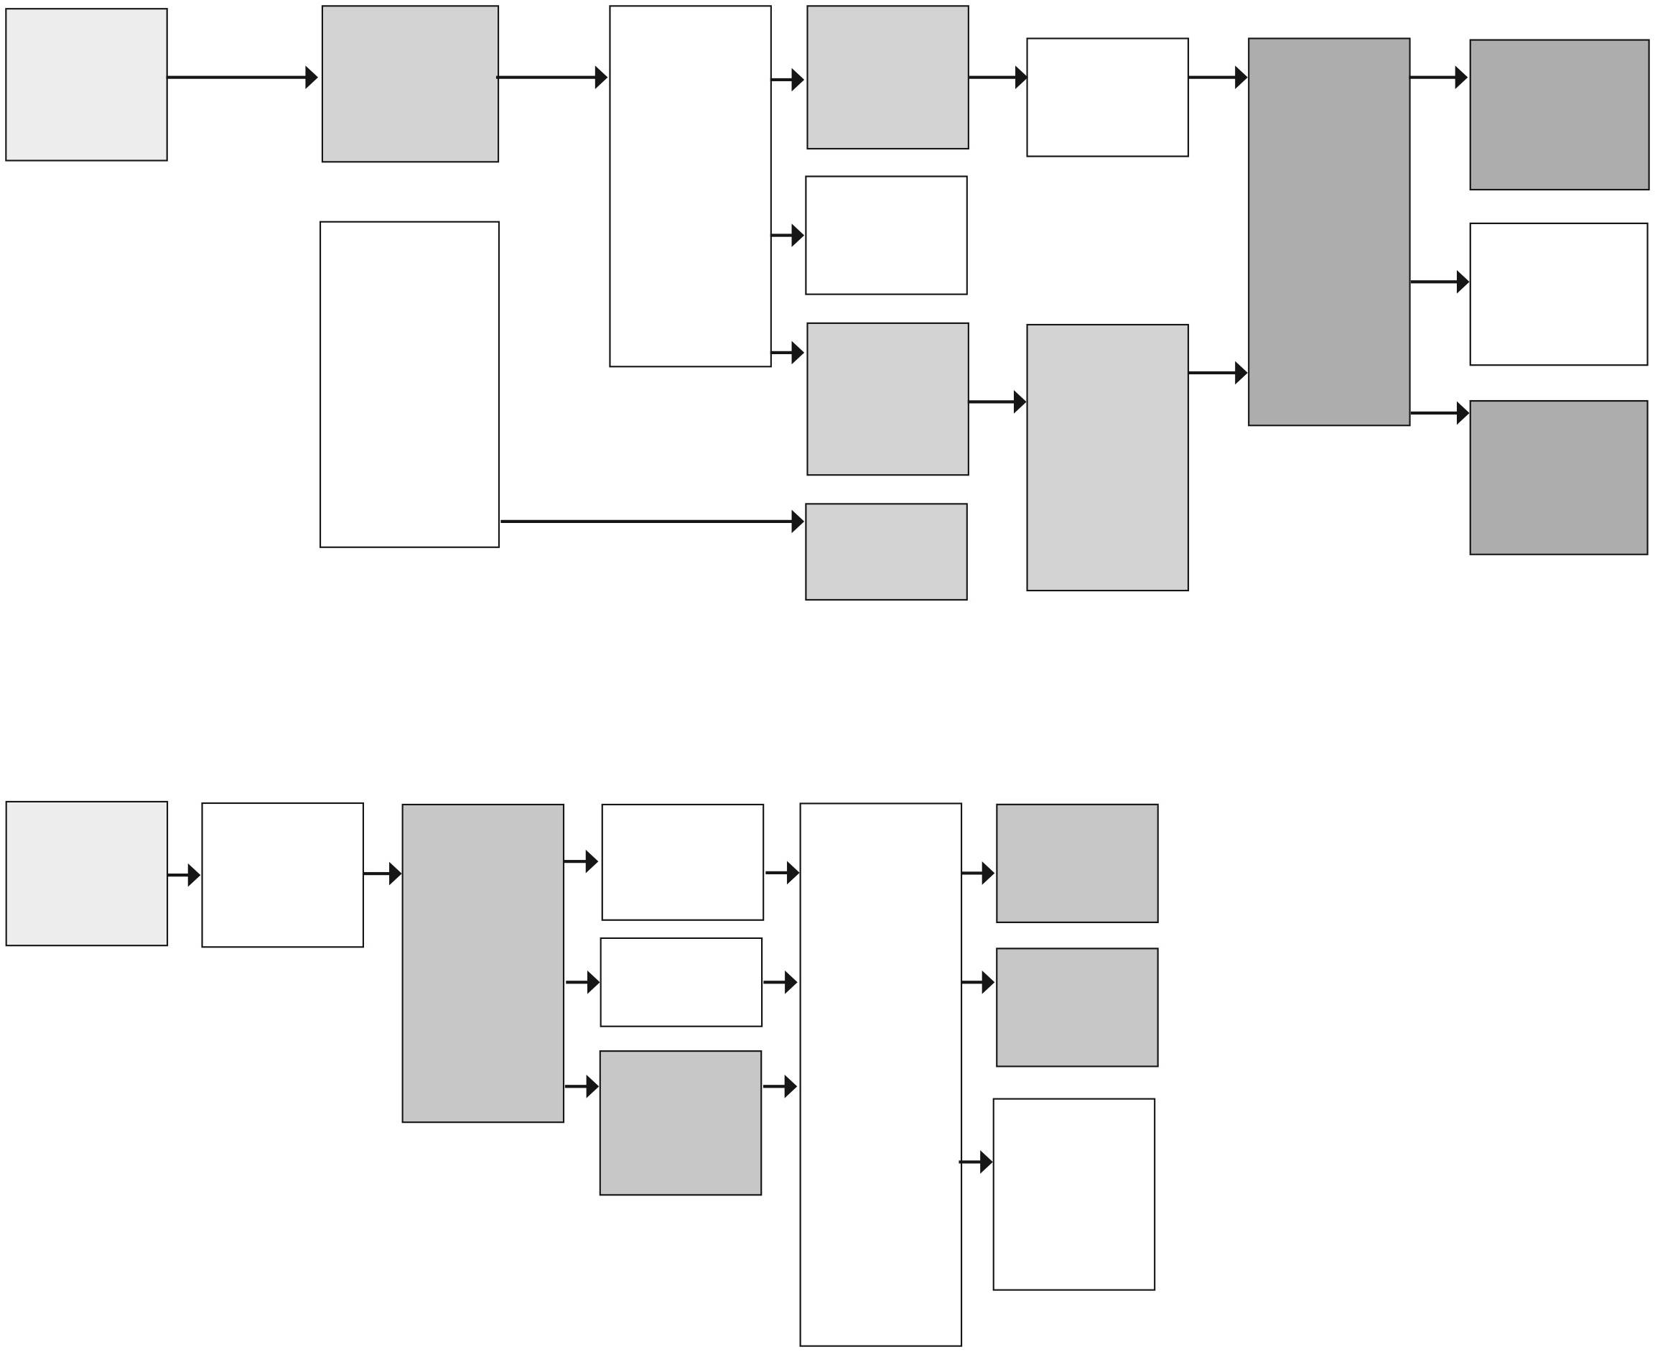
We need light to see things Darkness is the absence of light Y3 Light
When light hits a material, some of it is reflected off the material
Y3 Light
LIGHT
We see with our eyes
Y1 Animals, including humans
Some materials reflect light better than others
Light travels from a light source in a straight line
There is a variety of sources of light, including the Sun
Some materials let light pass through them
Some materials block the light and a shadow is formed
Y3 Light
Sunlight can be dangerous
Y3 Light
The size of shadows change according to the size and shape of objects and distance from the light source Y3 Light
Light travels in straight lines
Y6 Light
We see light from a source reflected off an object into our eyes Y6 Light
Shadows and reflections are different
Shadows have the same shape as the object that casts them
Y6 Light
We hear with our ears Y1 Animals, including humans
Sounds can be different
Sounds are made when something vibrates Y4 Sound
Sound travels through a medium (solid, liquid or gas)
Sound travels in all directions from a source
Sounds get fainter the further they are from the source Y4 Sound
The nature of sounds depends on how the vibrations are produced
The volume of a sound can be changed Y4 Sound
The pitch of a sound can be changed Y4 Sound
Some materials reflect sound; some absorb sound and act as sound insulators
SOUND

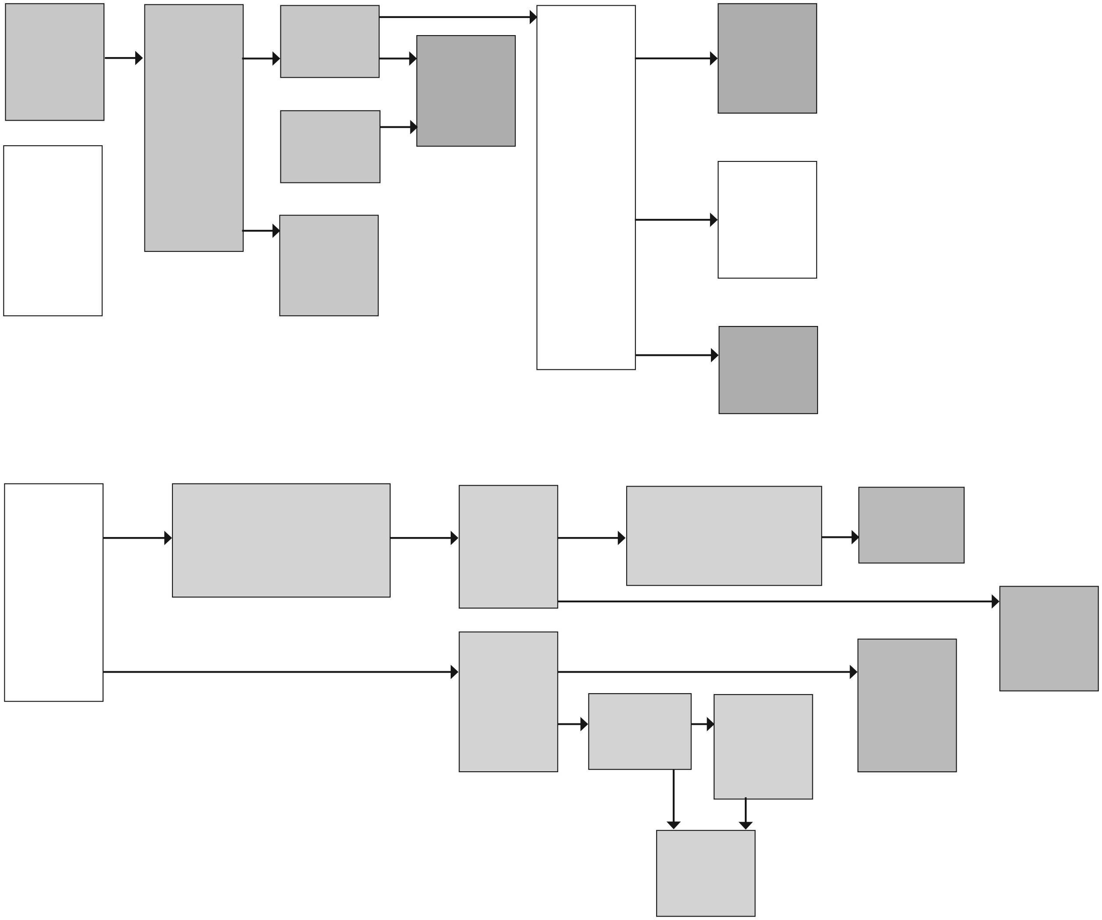
ELECTRICITY
An increase in voltage will cause an increase in current Y6 Electricity
FORCES
Electrical appliances need a source of electricity
to work
Y4 Electricity
Everyday appliances connected to mains electricity must be used safely. Some devices use batteries which can be handled carefully.
A complete circuit is needed for
an electric current to flow
Y4 Electricity
Magnets can act at a distance Y3 Forces and magnets
A switch opens and closes a circuit
Y4 Electricity
Some materials are better conductors than others
Y4 Electricity
There are recognised symbols for circuits and their components Y6 Electricity
When a battery or cell is connected in a circuit, it provides a push (voltage) that causes electrons (current) flow in a circuit
For a fixed voltage an increase in resistance will cause a decrease in current.
Some components can resist the current more than others. Y6 Electricity
Forces arise between two objects
Pushing and /or pulling can make things start moving, stop, go faster or slower
Y3 Forces and magnets or change their shape
Y2 Uses of everyday materials
Some forces need contact between two objects (contact forces) Y3 Forces and magnets
When one object moves over another one there will be a force between them that opposes motion. This is called friction.
Y3 Forces and magnets
Drag forces
resist movement Y5 Forces
Some forces act between objects although they are not in contact (non-contact forces) Y3 Forces and magnets
Some materials are magnetic, some are not
Y3 Forces and magnets
Magnets exert attractive and repulsive forces on each other Y3 Forces and magnets
The force of gravity caused by the Earth pulls objects towards its centre Y5 Forces
Some mechanisms allow a smaller force to have a greater effect Y5 Forces
A circuit is made up of different components
Y4 Electricity

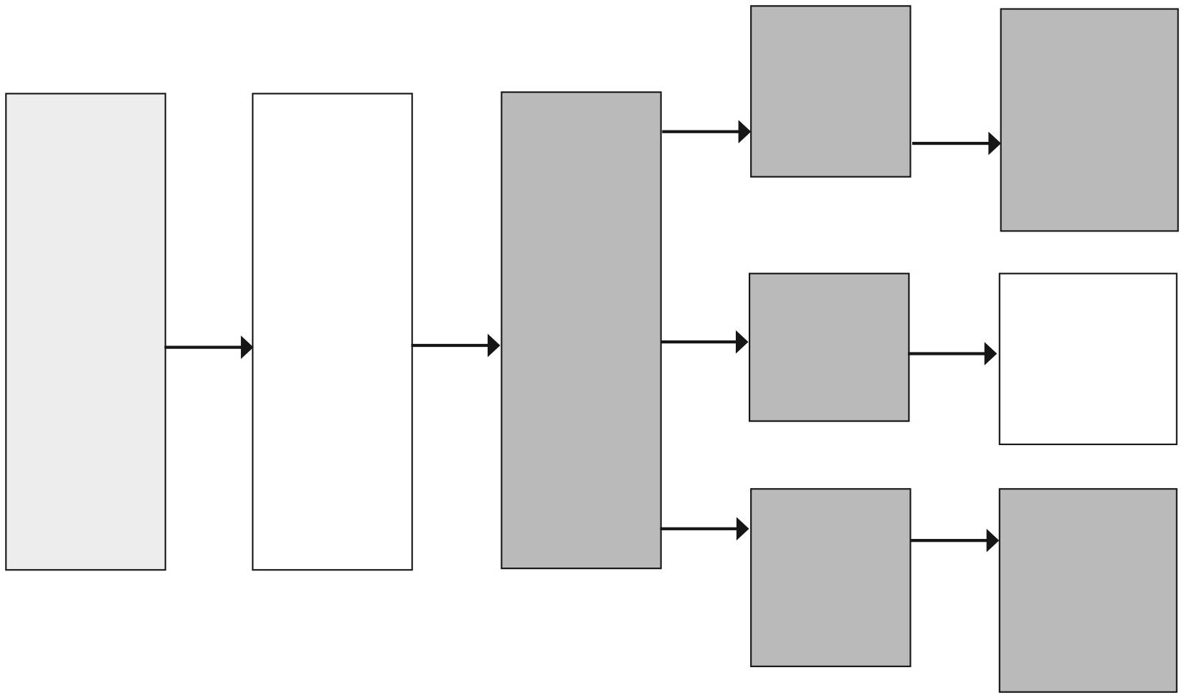
EARTH IN SPACE
Temperature and day length changes over the year – this pattern is referred to as the seasons Y1 Seasonal change
The Sun appears to move across the sky
The Earth, Sun and Moon are approximately spherical Y5 Earth and space
The Earth is one of eight planets that orbit the Sun
Y5 Earth and space
The Moon orbits the Earth and looks different at different times of the month
Y5 Earth and space
The Earth orbits the Sun once every year
Y5 Earth and space
The Earth rotates on its own axis once every 24 hours Y5 Earth and space
The seasons change as the Earth’s position changes relative to the Sun
It is due to the rotation of the earth that we experience day and night
Y5 Earth and space

