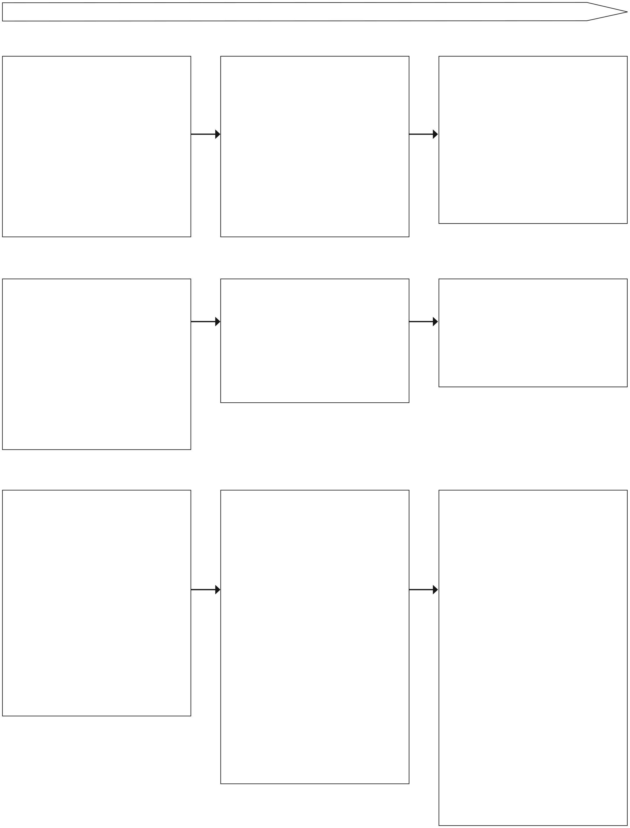
Children should be helped to develop their understanding of scientific ideas by using different types of scientific enquiry to answer their own questions, including:
• observing changes over a period of time
• noticing patterns
• grouping and classifying things
• carrying out simple comparative tests
• finding things out using secondary sources of information
WORKING SCIENTIFICALLY
Approaches to enquiry
Children should ask their own questions about what they observe and make some decisions about which types of scientific enquiry are likely to be the best ways of answering them including:
• observing changes over time
• noticing patterns
• grouping and classifying things
• carrying out simple fair tests
• finding things out using secondary sources of information
Children should select the most appropriate ways to answer science questions using different types of scientific enquiry, including:
• observing changes over different periods of time
• noticing patterns
• grouping and classifying things
• carrying out fair tests
• finding things out using a wide range of secondary sources of information
Ask simple questions
• Begin to shape questions using different question stems
• Ask questions about how and why objects, materials and living things:
o change
o are similar or different to each other
o connect with each other
o are made or work
• Suggest questions to investigate
Asking questions
Ask relevant questions
• Recognise questions that can be investigated scientifically and those that cannot
• Ask a clear scientific question
• Recognise when questions can be answered by first hand or second sources of evidence
Use results to raise further questions
• Independently ask questions and offer ideas for scientific enquiry

Use test results to make predictions to set up further comparative and fair tests
Recognise that questions can be answered in different ways
• With support:
o uggest how to find things out
o Identify changes to observe and measure
o Identify patterns to observe and measure
o Identify variables to change and measure
o Identify sorting criteria
o Suggest how to take measurements
o Suggest next steps or a sequence of steps in a plan
Planning
Use different types of scientific enquiries to answer them
• dentify different ways to answer a question
• Choose the most appropriate method

Set up simple practical enquiries, comparative and fair tests
• Decide what observations to make, how often and what equipment to use
• Decide what measurements to take, how long to make them for and whether to repeat them
• Decide what sorting or classification criteria to use
• Recognise when a simple fair test is necessary
• With help, decide what variables to change and measure
Plan different types of scientific enquiries to answer questions
• Explain why an enquiry method is the most appropriate to answer a question
• Plan systematic collection of data and which equipment to use
• Plan collection of sufficient data
• Recognise when research using secondary sources will answer questions
• Decide which sources of information to use to answer questions

Recognise and control variables where necessary
• Recognise when variables need to be controlled and why
• Recognise when variables cannot be controlled and a pattern seeking enquiry is appropriate
• Identify which variables have the greatest effect on the result

Developing independence and autonomy in raising questions, planning and carrying out investigations

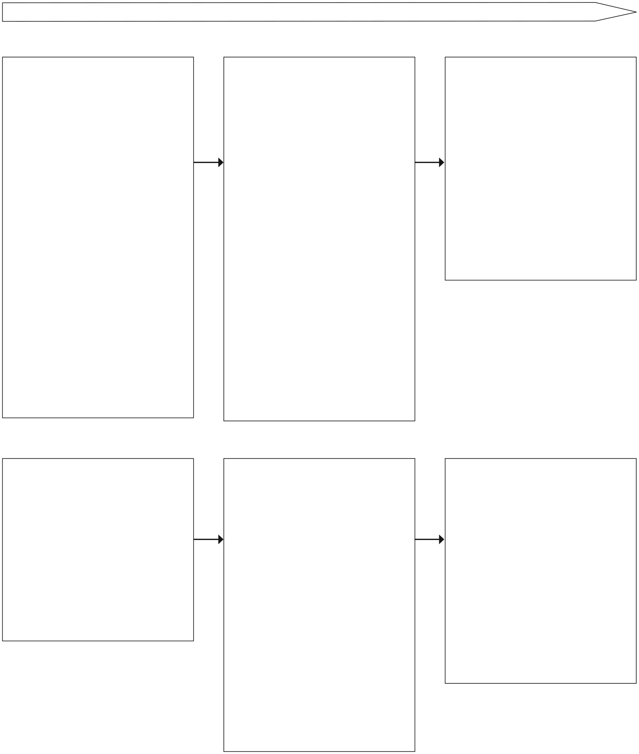
Becoming more systematic and accurate in collecting, recording and presenting data
Collecting data
Observe closely, using simple equipment
•Choose and use appropriate simple equipment to make observations
•Use non-standard units to collect observations
performing simple tests
•Choose and use appropriate simple equipment with increasing accuracy to collect comparative data
•Use non-standard units to collect data
identifying and classifying
•Sort objects by observable and behavioural features
•Make comparisons between simple features
gathering data to help in answering questions
•Gather data to answer questions from a variety of sources including talking to people, simple books and electronic media, first hand observation and practical activity
Make systematic and careful observations where appropriate, take accurate measurements using standard units, using a range of equipment, including thermometers and data loggers
•Use a range of equipment including data loggers to collect data using standard measures
•With support take accurate measurements on measuring equipment, recognising when to repeat them
•Carry out simple tests to sort and classify materials according to properties or behaviour

Gather data in a variety of ways to help in answering questions
•Gather data to answer questions from a variety of sources including using textbooks, simple keys, electronic media, first hand observation, practical activity and data collected by others
Take measurements, using a range of scientific equipment with increasing accuracy and precision
•Use a range of equipment accurately without support to collect observations and measurements
•Repeat sets of observations or measurements, where appropriate, selecting suitable ranges and intervals
•Use a series of tests to sort and classify materials
•Use relevant information and data from a range of secondary sources to answer questions
Record data to help in answering questions
•Talk about what has been found out and how
•Record observations in word and pictures
•Record observations and test results in simple prepared pictograms, tables, tally charts, bar charts and maps including ICT formats
•Record sorting in sorting circles or tables
Presenting data
Record data in a variety of ways to help in answering questions
•Make notes
•Record data in tables and bar charts
•Use graphs produced by data loggers

Classify in a variety of ways to help in answering questions
•Use Carroll diagrams, and Venn diagrams to classify
•Use and make simple keys to identify and classify

Present data in a variety of ways to help in answering questions
•Drawings, labelled diagrams
•Bar charts, bar line graphs, simple scatter graphs and tables using ICT where appropriate
Record data and results of increasing complexity using scientific diagrams and labels, classification keys, tables and bar and line graphs and models
•Decide how to record data accurately and appropriately
•Use appropriate scientific language in oral and written presentations
•Make keys and branching databases with 4 or more items
•Use more than one source of scientific evidence to identify and classify things
•Present data in line graphs, scatter graphs and frequency charts

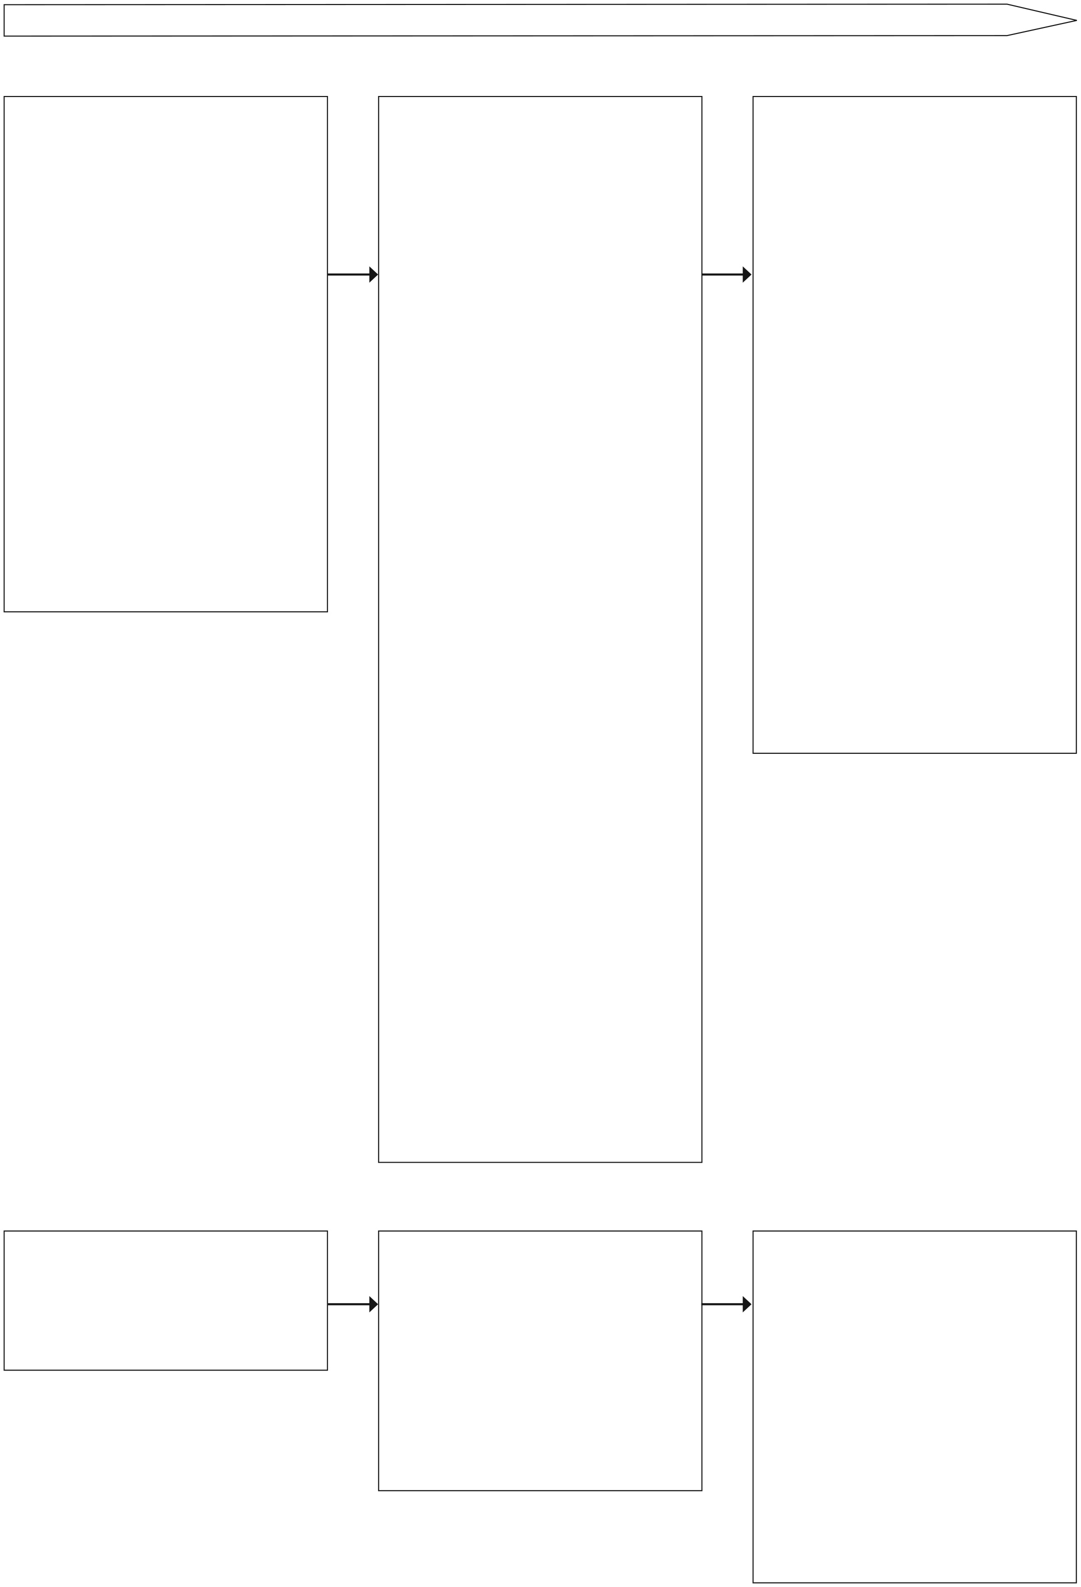
Increasingly using scientific knowledge and understanding in conclusions and explanations
Concluding
Use their observations and ideas to suggest answers to questions
• Use simple scientific language to talk about observation or findings
• Use results to answer the investigation question
• Identify simple changes
• Sequence changes
• Say whether the change was expected
• Identify similarities and differences
• Make simple comparisons
• Make links between two sets of observations
• Identify simple patterns and talk about them
• Say whether the pattern was expected
• Identify simple causal relationships
• Say if the relationship was expected
Report on findings from enquiries, including oral and written explanations, displays or presentations of results and conclusions
• Draw simple conclusions about changes observed and link these to scientific ideas
• Refer to a table or graph when reporting findings
• Begin to use and interpret graphs produced by data loggers
• Draw a simple conclusion about similarities and differences identified and link these to scientific ideas
• Draw conclusions about simple patterns between two sets of data
• Draw simple causal conclusions from fair tests
• Draw conclusions from data from different secondary sources

Identify differences, similarities or changes related to simple scientific ideas and processes
• Make links between:
o observed changes
o similarities and differences
o simple patterns between two sets of data
o simple causal relationships
o data from secondary sources
• and simple scientific ideas and processes

Use straightforward scientific evidence to answer questions or to support their findings
Refer to evidence from practical tests and observations or from secondary data sources when answering questions or explaining findings
• Use simple scientific language in a range of oral and written presentations suitable for different audiences to present findings
Report and present findings from enquiries, including conclusions, causal relationships and explanations of results in written forms such as displays and other presentations
• Use scientific evidence to answer questions or support findings
• Draw valid conclusions about changes, similarities and differences, and causal relationships from data collected
• Draw valid conclusions that utilise more than one piece of supporting evidence
• Use scientific knowledge to explain findings
• Use simple models to help describe scientific ideas
• Explain differences in repeated observations or measurements, identifying reasons for any anomalies noticed

Communicate findings in written form, displays, multi-media and other forms of presentation using scientific language
• Say whether data was useful
• Say whether an information source was useful

Give an opinion about some further information
Evaluating
Use results to draw simple conclusions, make predictions for new values, suggest improvements, and raise further questions
• Make predictions for new values within or beyond the collected data collected
• Identify new questions arising from the data
• Find ways of improving enquiries
Identify scientific evidence that has been used to support or refute ideas or arguments
• Begin to separate opinion from fact
• Use scientific evidence to justify ideas
• Talk about how scientific ideas have developed over time

Identify when further tests and observations might be needed

Evaluate the effectiveness of their working methods, making practical suggestions for improving them

