ST MARGARET’S CE VA PRIMARY SCHOOL
MATHEMATICS POLICY
“Encourage one another and build each other up”
1 Thessalonians 5:11

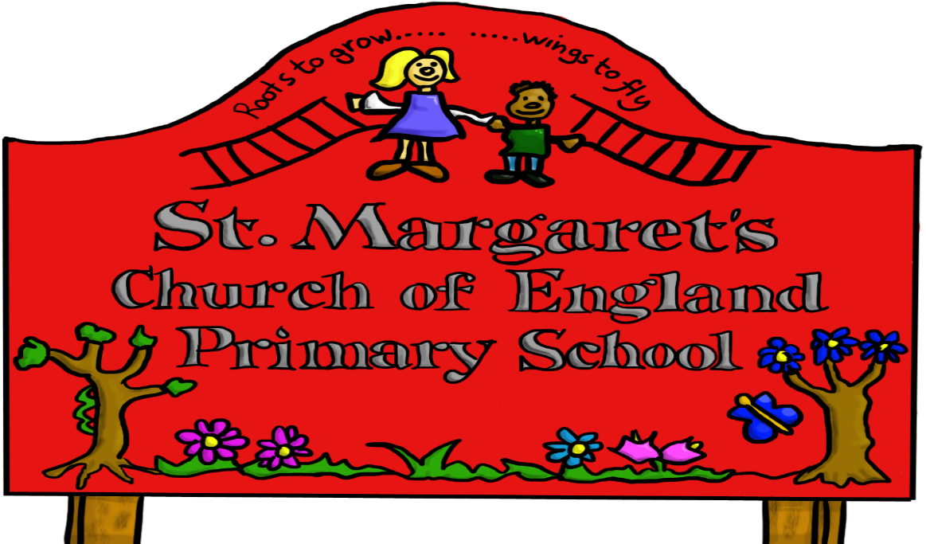

Approved by: | Governors | Date:
Last reviewed on: | OCT 2020
Next review due by: | OCT 2023

ST MARGARET’S C OF E PRIMARY SCHOOL
Policy for Mathematics

What is Mathematics?
Mathematics is a creative and highly inter-connected discipline that has been developed over centuries, providing the solution to some of history’s most intriguing problems. It is essential to everyday life, critical to science, technology and engineering, and necessary for financial literacy and most forms of employment. A high-quality mathematics education therefore provides a foundation for understanding the world, the ability to reason mathematically, an appreciation of the beauty and power of mathematics, and a sense of enjoyment and curiosity about the subject.
From the Programme of Study New Maths Curriculum

The importance of Maths
Mathematics equips pupils with a uniquely powerful set of tools to understand and change the world. These tools include logical reasoning, problem-solving skills, and the ability to think in abstract ways.
Mathematics is important in everyday life and is an integral part of many forms of employment. Therefore, it is vitally important that we aim to equip our children with these essential life skills.
Different cultures have contributed to the development and application of mathematics. Today, the subject transcends cultural boundaries and its importance is universally recognised. Mathematics is a creative discipline. It can stimulate moments of pleasure and wonder when a pupil solves a problem for the first time, discovers a more elegant solution to that problem or suddenly sees hidden connections.

The aims of the Maths curriculum at St Margaret’s are:

- To develop competent mathematicians who can apply their knowledge and skills to a variety of contexts.
- To develop pupils who are fluent in the fundamentals of mathematics so that they have a conceptual understanding and are able to recall and apply their knowledge rapidly and accurately to problems.
- To develop pupils who can reason mathematically by following a line of enquiry by conjecturing relationships & generalisations and developing an argument or proof using mathematical language.
- Pupil can solve problems by applying their mathematics to as variety of problems and are able to persevere in seeking solutions.
- Can develop a good financial understanding with regards to money and its importance in everyday life. These include knowledge of: -
budgeting, financial awareness, including financial institutions, and making good financial decisions.

Principle of the teaching and learning of Maths
St Margaret’s Primary School follows the New Maths Curriculum Programmes of Study:

- Number
- Measurement
- Geometry
- Statistics

Problem Solving is interwoven into every strand of the new curriculum (Number, Measurement, Geometry and Statistics).

At Foundation Stage
In Foundation Stage Maths is taught daily but in a very practical way through songs, games and stories and is frequently linked to other learning units. Pupils learn about the meaning of number and then move onto calculations and number sentences.

Key Stage 1
Mathematics at KS1 builds on the Early Learning Goals of the Foundation Stage. The principal focus of mathematics teaching in Key Stage 1 is to ensure that pupils develop confidence and mental fluency with whole numbers, counting, and place value. This involves pupils working with numerals, words, and the four operations and also practical resources.

Pupils will develop their ability to recognise, describe, draw, compare and sort different shapes and use the related vocabulary. Teaching will also involve using a range of measures to describe and compare different quantities such as length, mass, capacity/volume, time and money.

By the end of Year 2 pupils will be able to recall and use addition and subtraction facts to 20 fluently.
Pupils will read and spell mathematical vocabulary at a level consistent with their increasing word reading and spelling knowledge at key stage 1.

Number – including place value, addition and subtraction, multiplication and division, fractions.

Measurement – including mass and weight, volume and capacity, using standard units to estimate and measure and to know coin values and addition and subtraction of money, telling and writing the time to five minutes.

Geometry – including properties of 2D and 3D shapes, position and direction

Statistics – pupils record, interpret and construct simple pictograms and tally charts, block diagrams and tables, and collate, organise and compare information.

Lower Key Stage 2
The principal focus of mathematics teaching in lower key stage 2 is to ensure that pupils become increasing fluent with whole numbers and the four operations, including number facts and the concept of place value. Pupils will develop efficient written and mental methods and perform calculations accurately with increasing large whole numbers.

Pupils will develop their ability to solve a range of problems, including with simple fractions and decimal place value. Teaching will ensure that pupils draw with increasing accuracy and develop mathematical reasoning so that they can analyse shapes and their properties and confidently describe the relationships between them. Teaching will ensure that pupils can use measuring instruments with accuracy and make connections between measure and number.

By the end of year 4, pupils should have memorised their multiplication tables up to and including the twelve times table, and show precision and fluency in their work.

Pupils will read and spell mathematical vocabulary correctly and confidently using their growing word reading knowledge and their knowledge of spelling.

Number – including place value, addition and subtraction, multiplication and division, fractions (including introducing decimals in year 3)
Measurement – including mass and weight, volume and capacity, time, perimeter, and scales.

Geometry – Properties of 2-D and 3-D shapes, angles, perpendicular and parallel lines, symmetry, classifying different triangles and quadrilaterals, position and direction.

Statistics – using bar charts, pictograms and tables, solving one-step and two-step problems using information presented in scaled bar charts, pictograms and tables, solve comparison, sum and difference problems using information in bar charts, pictograms, tables and other graphs.

Upper Key Stage 2
The principal focus of mathematics teaching in upper key stage 2 is to ensure that pupils extend their knowledge of the number system and place value to include larger integers. This will develop the connections that pupils make between multiplication and division with fractions, decimals, percentages and ratio.

Pupils will develop their ability to solve a wider range of problems, including increasingly complex properties of numbers and arithmetic and problems demanding efficient written and mental methods of calculation. Once this is gained pupils will be introduced to the language of algebra as means of solving a variety of problems. Teaching in geometry and measures will consolidate and extend knowledge developed in number. Teaching will ensure that pupils classify shapes with increasing complex geometric properties and that they learn the vocabulary they need to describe them.

By the end of Year 6 pupils will be fluent in the written methods for all four operations, including long multiplication and division, and in working with fractions, decimals and percentages.

Pupils will read, spell and pronounce mathematical vocabulary correctly.

Number – including place value, addition and subtraction, multiplication and division, fractions (including decimals and percentages)

Measurement – convert between different units, perimeter and area, using formula for area and volume, finding the area of parallelograms and triangles.
Geometry - properties of shapes, drawing and measuring angles, distinguish between regular and irregular polygons, finding the circumference of a circle, position and direction including reflection and translation and describing positions on the four-quadrant grid.

Statistics – solve problems using information on line graphs, information tables and time tables, pie charts and line graphs, calculate and interpret
the mean as an average.

Ratio and Proportion –solve problems involving comparing quantities and sizes.

Algebra –to be able to use simple formula and to generate linear number sequences

Strategies for the Teaching of Mathematics
Mathematics at St Margaret’s is taught by the class teacher:

- In a daily lesson of 60 minutes throughout school.

- Whole class teaching, differentiated according to the needs of the children.

- Pupils work individually, in pairs or in larger groups.

- Maths is continually interspersed throughout the day in a variety of situations and contexts (every opportunity is used to reinforce mathematical knowledge and skills).

- When required maths is taught in small intervention groups, tailored to the individual needs of the children.

- Lunchtime and after school maths clubs are used to reinforce mathematical understanding and close gaps/extend children’s learning.

- Pupils are invited to showcase their reasoning, and problem- solving skills by displaying work on the Maths Board

- To support maths learning we use online Maths programmes such as Times Tables Rock Stars and Mathletics (Key Stage 2)

There are also opportunities to support and reinforce areas of the Maths Curriculum through: -

- The use of Focus Sessions
- Maths Revision Club (Yr 6)
- Magical Maths Club (Yrs 1 – 6)
- Cross-curricular opportunities
- Times Tables Rock Star (TTRS) Club

Cross Curricular Links
The skills developed in the teaching of Maths are applicable across all areas of the curriculum, and frequently links are made with other subjects.

Equal Opportunities
Please refer to the Accessibility and Equality Policies
All pupils irrespective of gender, race, religion or disability, are entitled to a broad and balanced Maths curriculum. We have high expectations of all our pupils. All children access the curriculum at the appropriate level and suitable resources and learning environments are made available to enable children to access the learning required.

Health and Safety
The general teaching requirement for health and safety applies in this subject. We encourage the children to consider their own safety and the safety of others when performing certain tasks. Where specific equipment is used in Maths e.g. compasses and scissors, children are taught the correct practice for using these and some may be given extra guidance or supervision. Cooking activities will require close adult supervision.

Spiritual, moral, social and cultural development
The teaching of Maths offers opportunities to support the social development of our children through the way we expect them to work with each other in lessons. Groupings allow children to work together and give them the chance to discuss their ideas and mathematical thinking. Children learn to respect and work with each other, and develop a better understanding of themselves and of each other.

Inclusion Provision

Please refer to our Special Needs Policy

Resources
There are a wide range of resources to support the teaching of Maths across the school. Commercially available schemes of work are used in part to provide a framework for teaching staff, which is supported by a variety of other activities. They are not to be used as a direct replacement. Each class has access to Maths equipment; however, classes will share certain resources when required.

Several different resources are used to support teaching in maths; identify gaps and assess mastery, including: - White Rose, NCTEM, NRich, TTRS and Mathletics (for years 5 and 6).

Monitoring
Regular monitoring is undertaken in various ways:

- Regular lesson observations usually with a focus that is a whole-school issue or area for development
- Scrutiny of pupils’ work
- Learning walks
- Moderation of pupil outcomes
- Pupil discussions

Assessment
Children’s learning is assessed in lessons and formally on a termly basis. The outcomes of these are then used to inform teacher’s planning and further improve pupil’s progress and attainment.

Reporting
Parents are given the opportunity to discuss Maths with their child’s teacher through Parents Evenings and through a termly written report.

Home Learning
Home Learning is used to support mathematics through specific tasks set by teachers; playing of number games/puzzles (Reception and Year 1); learning times tables (expected of all pupils from Year1 onwards).

Celebrating Maths
Excellence in Maths is celebrated in the following ways:

- Displays of children’s work in class and around school on the maths board
- Praise and stickers awarded in Congratulations Assembly.
- Mathletics participation certificates/wristbands/badges and trophy (Years 5 and 6).

Mrs C Humphries
Maths Leader

October 2020

