St Margaret’s C of E Primary School

Calculation Policy

“Encourage one another and build each other up”
1 Thessalonians 5:11

Adopted: June 2020
Original document written and prepared by Anthony Reddy, Dave Godfrey and Laurence Hicks
Sense of Number Maths Consultants
© www.senseofnumber.co.uk



Contents:

Page
2 General Principles of Calculation
3 Concrete & Pictorial Resources / ‘Mastery’ of Mathematics
4 Overview of Calculation Approaches
8 Calculation Vocabulary
9 Mental Methods of Calculation
10 CPA & Informal Written Methods / Mental Jottings
11 Formal (Column) Written Methods of Calculation
12 National Curriculum Objectives – Addition and Subtraction
13 National Curriculum Objectives – Multiplication and Division
14 Addition Progression
26 Subtraction Progression
40 Multiplication Progression
60 Division Progression

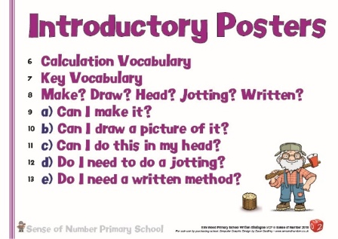
General Principles of Calculation

When faced with a calculation, children are able to decide which method is most appropriate and have strategies to check its accuracy. Whatever method is chosen (in any year group), it must still be underpinned by a secure and appropriate knowledge of number facts.

By the end of Year 5, children should:
- have a secure knowledge of number facts and a good understanding of the four operations in order to:
  - carry out calculations mentally when using one-digit and two-digit numbers
  - use particular strategies with larger numbers when appropriate
- use notes and jottings to record steps and part answers when using longer mental methods
- have an efficient, reliable, compact written method of calculation for each operation that children can apply with confidence when undertaking calculations that they cannot carry out mentally;
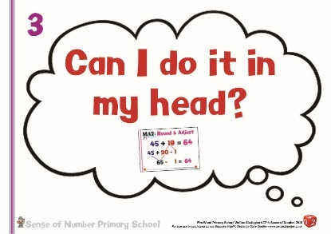
Children should always look at the actual numbers (not the size of the numbers) before attempting any calculation to determine whether or not they need to use a written method.
Therefore, the key question children should always ask themselves before attempting a calculation is
‘Can I do this in my head?’

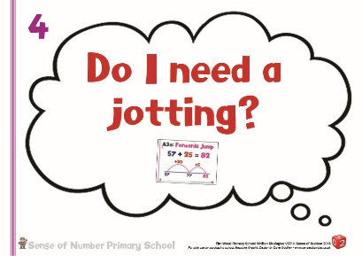
This should be the first principle for any calculation, whether addition, subtraction, multiplication & division. If a child is asking themselves this question it means that they are looking at the actual numbers and using their sense of number to determine whether there is an easier method that they could use rather than column / standard procedures.

In the previous curriculum, the next question that children should ask themselves (if they could answer the calculation mentally) would be whether or not they needed to jot something down to support their thinking and help them calculate – ‘Do I need a jotting?’. If the answer to this question was ‘yes’ then the children would access the wide range of mental strategies & jottings outlined later in this document.
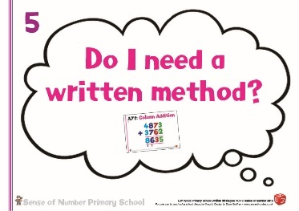
If, however, the numbers were too difficult or unwieldy for a mental method or jotting to be appropriate then they would ask the question
‘Do I need a written method?’. Again, if the written method was the most efficient and appropriate way to find the answer, they would access one of the written methods (either informal or standard) found later in this document.
(NB. Section 5 explains this principle in detail, with examples for each of the four operations) ```

The 2014 National Curriculum, though, recommends a Mastery approach to teaching calculation, meaning that there are now 2 additional questions which children should be asking before moving to jottings or written methods – ‘Can I make it?’ and ‘Can I draw a picture of it?’.
These are explained in the next section. (see below)

Concrete and Pictorial Resources / ‘Mastery’ of Mathematics

The ability of a child to work calculations out mentally, and also to successfully master a written procedure should initially come from a secure understanding of each calculation.
This is achieved through the use of concrete and pictorial resources throughout EYFS and both Key Stages.
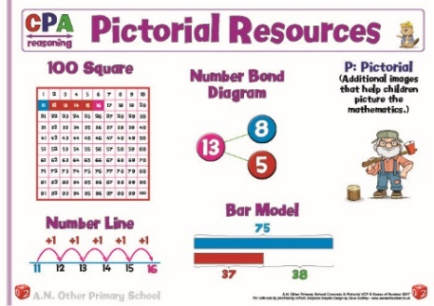
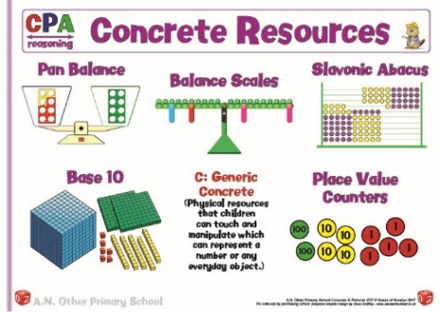
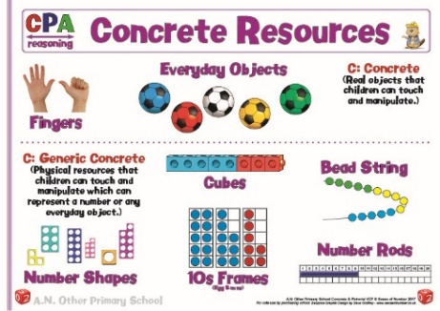

The 2014 National Curriculum advocates a ‘mastery’ approach to mathematics suggesting all children should master conceptual understanding of any calculation they are attempting to solve.
Mastery is the approach adopted in the Far East when teaching mathematics, (particularly in Singapore and Shanghai), and aims to ensure that children are given a substantial depth of understanding in place value for each year group.

This understanding, which is built up through regular use of concrete apparatus becomes the foundation of the CPA (Concrete – Pictorial – Abstract) approach to teaching.

Children who have developed secure visual place value through the use of concrete apparatus, manipulatives and images (such as Base 10 / Tens Frames / Number Rods / Numicon / Place Value Counters etc) are then able to apply it when learning methods of calculation.
This ensures that they fully understand a calculation rather than just learning a method by rote. Consequently, the written method ‘makes sense’ and can be retained much more easily as it is based on conceptual understanding.

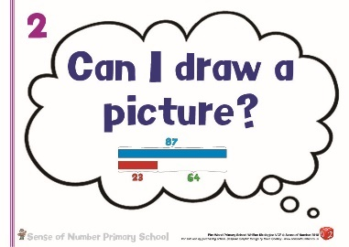
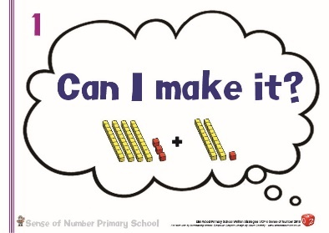
Therefore, a child who has ‘mastered’ a calculation can now ask themselves two additional questions that enable them to either explain their understanding (‘Can I make it?’)
or give them a visual alternative to a written method (‘Can I draw a picture?’).

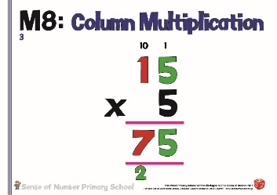
The example below shows the development of 15 x 5 from Concrete understanding (Place Value Counters and Base 10) to mental jottings (Number Line) to informal methods that support mental arithmetic (Grid Method / Partitioning) to an expanded method and finally to the column procedure.

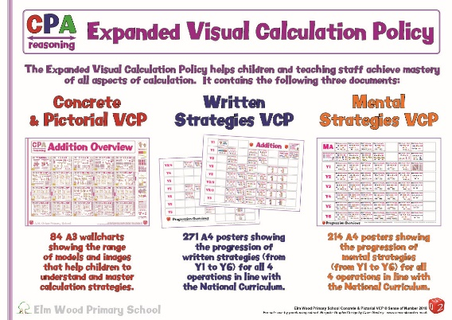
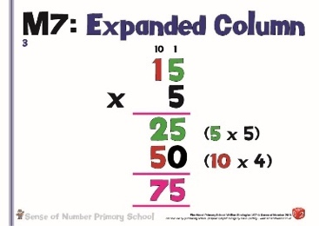
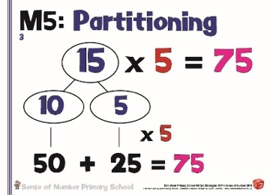
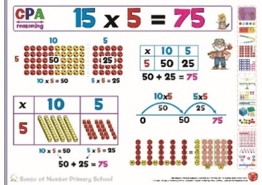
This calculation policy has been upgraded in line with the 2014 National Curriculum to reflect Mastery, and (as seen above) each calculation method now begins with Concrete materials before progressing to the mental and written methods advocated by the previous curriculum.

Overview of Calculation Approaches

Early Years into KS1
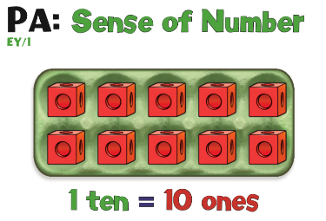
- Visualisation to secure understanding of the number system, especially the use of place value resources such as Tens Frames, Base 10, Numicon, 100 Squares and abacuses.

- Secure understanding of numbers to 10, using resources such as Tens Frames / Egg Boxes, Numicon, fingers, tallies and multi-link.

- Subitising to begin making links between the different images of a number and their links to calculation.

- Practical, oral and mental activities to understand calculation

- Personal methods of recording.
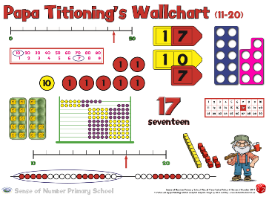
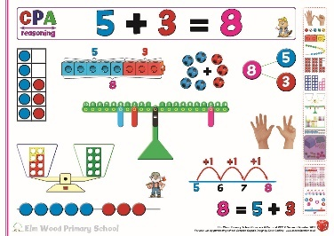
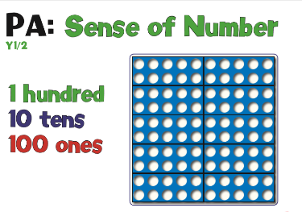

Key Stage 1
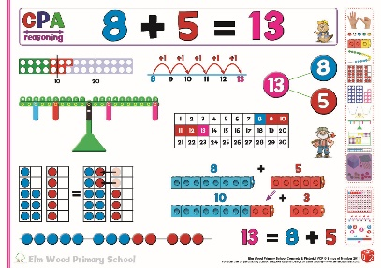
- Introduce signs and symbols
(+ , -, x, ÷ in Year 1 and <, > signs in Year 2)

- Extended visualisation to secure understanding of the number system beyond 100, especially the use of place value resources such as Base 10, Place Value Charts & Grids, Number Grids, Arrow Cards and Place Value Counters.
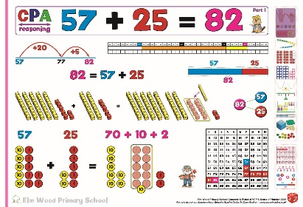
- Further work on subitising and Tens Frames to develop basic calculation understanding, supported by Numicon and multi-link.

- Continued use of practical apparatus to support the early teaching of 2-digit calculation. For example, using Base 10 or Numicon to demonstrate partitioning and exchanging before these methods are taught as jottings / number sentences.
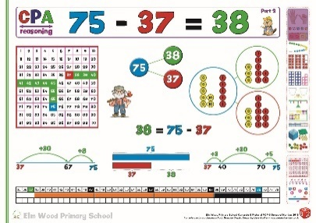
- Methods of recording / jottings to support calculation (e.g. partitioning or counting on).

- Use images such as empty number lines to support mental and informal calculation. Children start to adopt a range of mental strategies that they apply when appropriate, especially partitioning for addition and counting on for subtraction.
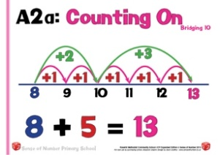
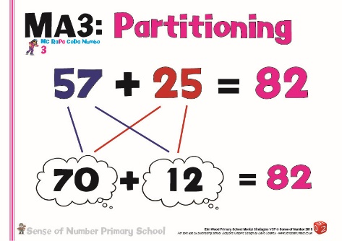

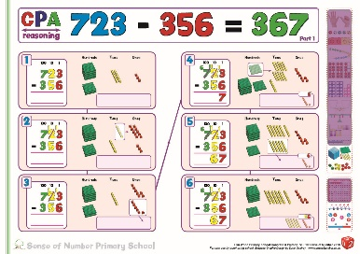
Years 3 & 4

- Continued use of practical apparatus, especially Place Value Counters, Base 10 and Numicon to visualise written / column methods before and as they are actually taught as procedures.

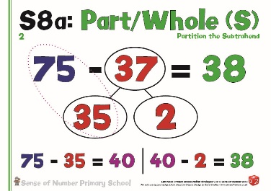
Children need to be given ample opportunity within their maths lessons to ‘make’ the calculations, dealing with the principles of exchanging / regrouping in Ones, Tens &
Hundreds.

Once they can make and explain a procedure with apparatus then they can firstly draw the calculation and finally use column procedures.

- Continued use of mental methods and jottings for 2 and 3-digit calculations. As before, the first principle is still ‘Can I do it in my head?’

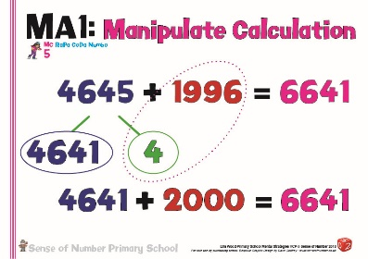
- Introduction to more efficient informal written methods / jottings including expanded methods and efficient use of number lines (especially for subtraction).

- Column methods, where appropriate, for 3-4-digit additions and subtractions.

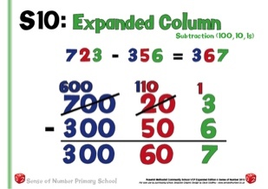
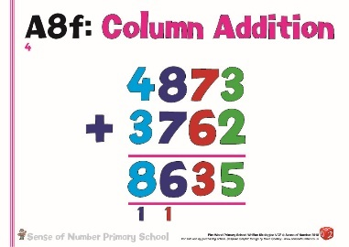
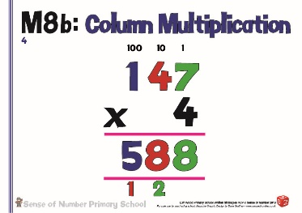

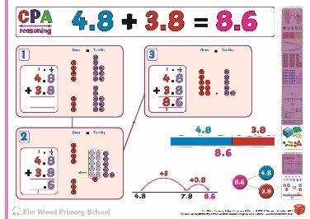
Years 5-6
- Even in Years 5 & 6 it is crucial that the children have a visual picture of certain calculations in order to ‘master’ their understanding of what the calculation actually looks like.

They must still be allowed access to practical resources to help visualise these calculations, including those involving decimals
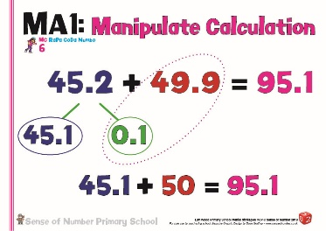
For 5/6-digit numbers this is usually quite difficult, and therefore the children will instead need to explain the methods using place value.

- Continued use of mental methods for any appropriate calculation up to 6 digits.

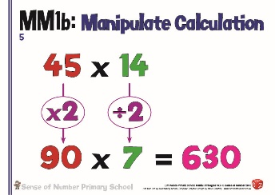
Even when the numbers are much larger or contain decimals, children need to use their sense of number to determine when a mental method or jotting would be far more appropriate than a written procedure.

This will include all four operations and involves the children learning and applying a detailed bank of mental strategies depending on the size and value of the numbers in question.
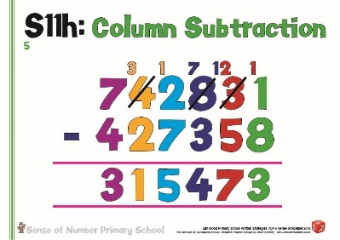
- Standard written (compact) / column procedures to be learnt for all four operations

- Efficient informal methods (expanded addition and subtraction, grid multiplication, division by chunking) and number lines are still used when appropriate. Develop these to larger numbers and decimals where appropriate.

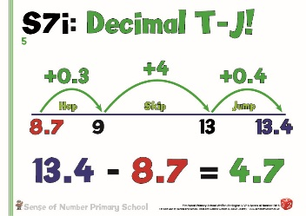
The Importance of Vocabulary in Calculation
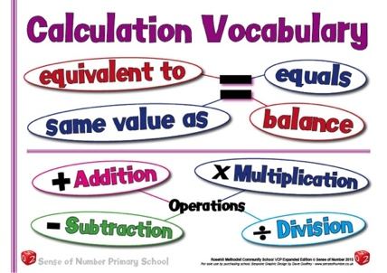
It is vitally important that children are exposed to the relevant calculation vocabulary throughout their progression through the four operations.

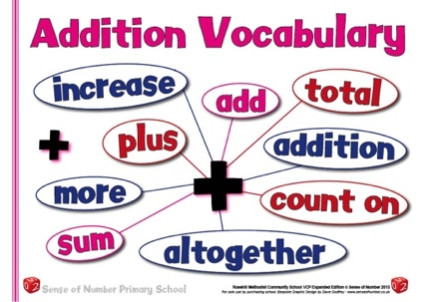
Key Vocabulary: (to be used from Y1)

Addition: Total & Sum Add
E.g. ‘The sum of 12 and 4 is 16’, ‘12 add 4 equals 16’
’12 and 4 have a total of 16’

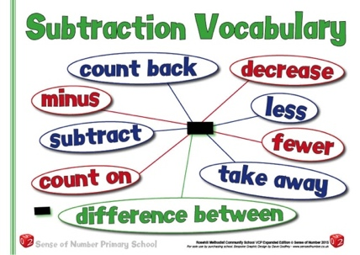
Subtraction: Difference
Subtract (not ‘take away’ unless the strategy is take away / count back)
E.g. ‘The difference between 12 and 4 is 8’,
‘12 subtract 4 equals 8’

Multiplication: Product Multiply
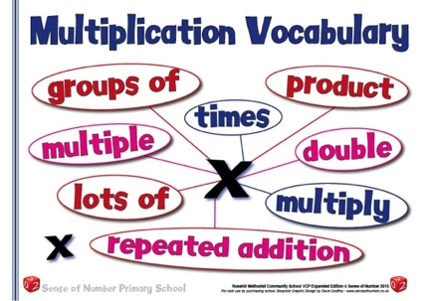
E.g. ‘The product of 12 and 4 is 48’,
‘12 multiplied by 4 equals 48’

Division: Divisor & Quotient Divide
E.g. ‘The quotient of 12 and 4 is 3’,
‘12 divided by 4 equals 3’
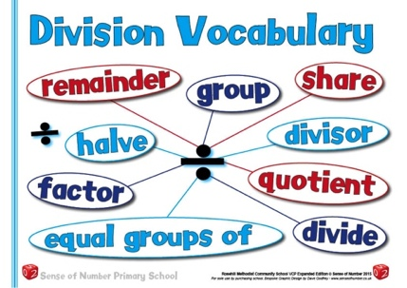
‘When we divide 12 by 4, the divisor of 4 goes into 12 three times’
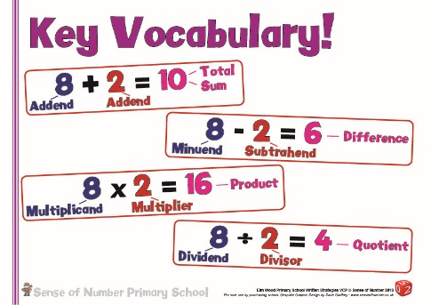

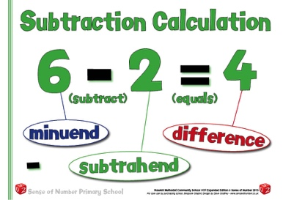
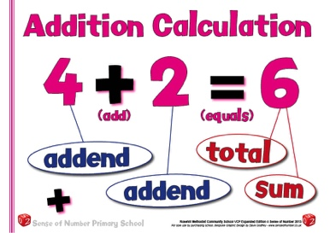
Additional Vocabulary:
The VCP vocabulary posters contain both the key and additional vocabulary children should be exposed to.
Conceptual Understanding
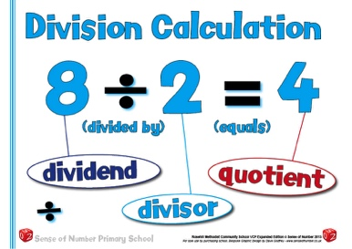
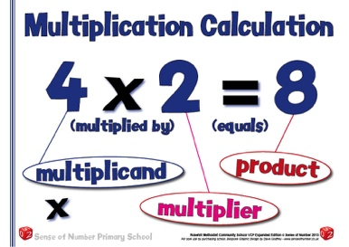
Using key vocabulary highlights some important conceptual understanding in calculation. For example, the answer in a subtraction calculation is called the difference. Therefore, whether we are counting back (taking away), or counting on, to work out a subtraction calculation, either way we are always finding the difference between two numbers.
Mental Methods of Calculation

Oral and mental work in mathematics is essential, particularly so in calculation.
Early practical, oral and mental work must lay the foundations by providing children with a good understanding of how the four operations build on efficient counting strategies and a secure knowledge of place value and number facts.
Later work must ensure that children recognise how the operations relate to one another and how the rules and laws of arithmetic are to be used and applied.
On-going oral and mental work provides practice and consolidation of these ideas. It must give children the opportunity to apply what they have learnt to particular cases, exemplifying how the rules and laws work, and to general cases where children make decisions and choices for themselves.

The ability to calculate mentally forms the basis of all methods of calculation and has to be maintained and refined. A good knowledge of numbers or a ‘sense’ of number is the product of structured practice and repetition. It requires an understanding of number patterns and relationships developed through directed enquiry, use of models and images and the application of acquired number knowledge and skills. Secure mental calculation requires the ability to:
- recall key number facts instantly – for example, all number bonds to 20, and doubles of all numbers up to double 20 (Year 2) and multiplication facts up to 12 × 12 (Year 4);
- use taught strategies to work out the calculation – for example, recognise that addition can be done in any order and use this to add mentally a one-digit number to a one-digit or two-digit number (Year 1), add two-digit numbers in different ways (Year 2), add and subtract numbers mentally with increasingly large numbers (Year 5);
- understand how the rules and laws of arithmetic are used and applied – for example to use commutativity in multiplication (Year 2), estimate the answer to a calculation and use inverse operations to check answers (Years 3 & 4), use their knowledge of the order of operations to carry out calculations involving the four operations (Year 6).

The first ‘answer’ that a child may give to a mental calculation question would be based on instant recall.
E.g. “What is 12 + 4?”, “What is 12 x 4?”, “What is 12 – 4?” or “What is 12÷ 4?” giving the immediate answers “16”, “48”, “8” or “3”
Other children would still work these calculations out mentally by counting on from 12 to 16, counting in 4s to 48, counting back in ones to 8 or counting up in 4s to 12.

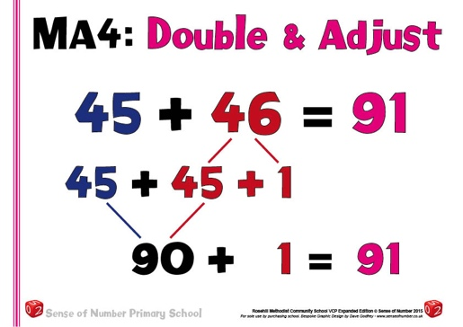
From instant recall, children then develop a bank of mental calculation strategies for all four operations, in particular addition and multiplication.
These would be practised regularly until they become refined, where children will then start to see and use them as soon as they are faced with a calculation that can be done mentally.

CPA & Informal Written Methods / Mental Jottings

The New Curriculum for Mathematics sets out progression in written methods of calculation, which highlights the compact written methods for each of the four operations. It also places emphasis on the need to ‘add and subtract numbers mentally’ (Years 2 & 3), mental arithmetic ‘with increasingly large numbers’ (Years 4 & 5) and ‘mental calculations with mixed operations and large numbers’ (Year 6).
There is very little guidance, however, on the ‘jottings’ and informal methods that support mental calculation, and which provide the link between answering a calculation entirely mentally (without anything written down) and completing a formal written method with larger numbers.
Although the New Curriculum, as mentioned previously, also advocates the Mastery / CPA (Concrete – Pictorial – Abstract) approach to teaching calculation, it again gives almost no guidance as to what this approach would look like in the classroom.
This policy, for all four operations, provides very clear guidance not only as to the development of formal written methods, but also: -
- some of the key concrete materials and apparatus that can be used in the classroom to support visualisation and depth of understanding for many of the calculation methods
- the jottings, expanded & informal methods of calculation that embed a sense of number and understanding before column methods are taught. These valuable strategies include:
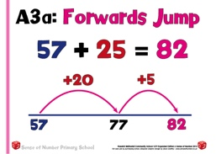
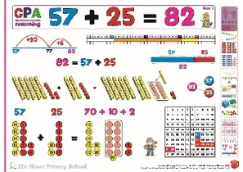
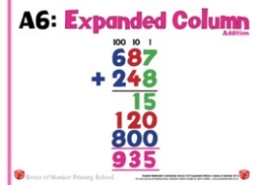
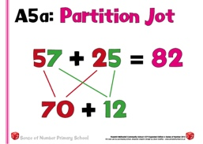
Addition – concrete materials number lines partitioning expanded methods

(In addition to the 6 key mental strategies for addition - see ‘Addition Progression’)
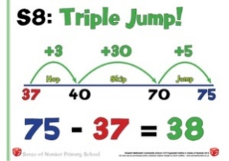
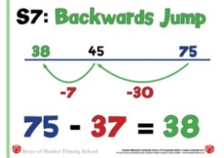
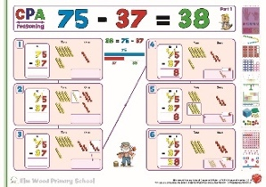
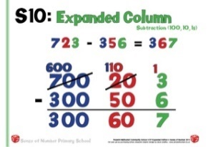
Subtraction – concrete materials number lines (especially for counting on) expanded subtraction

(In addition to the 6 key mental strategies for subtraction - see ‘Addition Progression’)
Multiplication
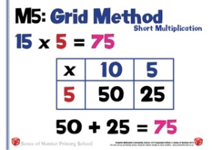
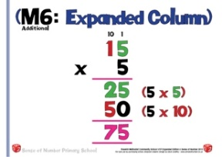
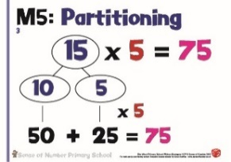
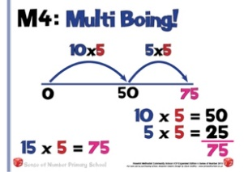
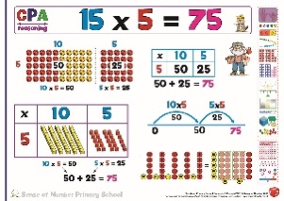
Concrete materials number lines partitioning expanded grid method
(In addition to the 10 key mental strategies for multiplication (see ‘Multiplication Progression)
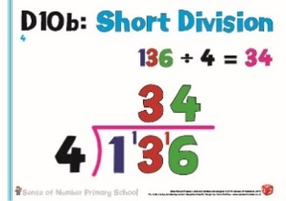
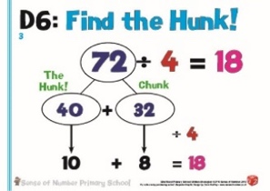
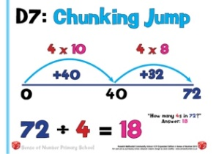
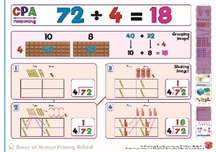
Division Concrete materials number lines chunking formal method

(In addition to the 7 key mental strategies for division (see ‘Division Progression)
Formal (Column) Written Methods of Calculation

The aim is that by the end of Year 5, the great majority of children should be able to use an efficient written method for each operation with confidence and understanding with up to 4 digits.
This guidance promotes the use of what are commonly known as ‘standard’ written methods –methods that are efficient and work for any calculation, including those that involve whole numbers or decimals. They are compact & consequently help children to keep track of their recorded steps.
Being able to use these written methods gives children an efficient set of tools they can use when they are unable to carry out the calculation in their heads or do not have access to a calculator. We want children to know that they have such a reliable, written method to which they can turn when the need arises.

In setting out these aims, the intention is that schools adopt greater consistency in their approach to calculation that all teachers understand and towards which they work.
There has been some confusion previously in the progression towards written methods and for too many children the staging posts along the way to the more compact method have instead become end points. While this may represent a significant achievement for some children, the great majority are entitled to learn how to use the most efficient methods.
The challenge for teachers is determining when their children should move on to a refinement in the method and become confident and more efficient at written calculation.

The incidence of children moving between schools and localities is very high in some parts of the country. Moving to a school where the written method of calculation is unfamiliar and does not relate to that used in the previous school can slow the progress a child makes in mathematics. There will be differences in practices and approaches, which can be beneficial to children. However, if the long-term aim is shared across all schools and if expectations are consistent then children’s progress will be enhanced rather than limited.

The entitlement to be taught how to use efficient written methods of calculation is set out clearly in the National Curriculum objectives. Children should be equipped to decide when it is best to use a mental or written method based on the knowledge that they are in control of this choice as they are able to carry out all methods with confidence.

This policy does, however, clearly recognise that whilst children should be taught the efficient, formal written calculation strategies, it is vital that they have exposure to models and images (CPA), and have a clear conceptual understanding of each operation and each strategy.
The visual slides that feature below (in the separate progression documents) for all four operations have been taken from the Sense of Number Visual Calculations Policy.
They show, wherever possible, the different strategies for calculation exemplified with identical values. This allows children to compare different strategies and to ask key questions, such as, ‘what’s the same, what’s different?’

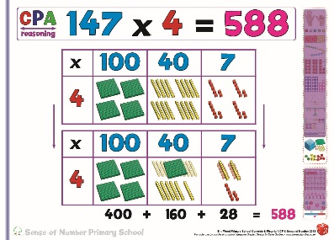
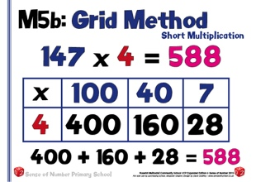
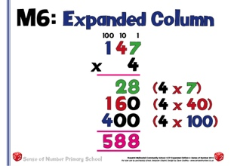
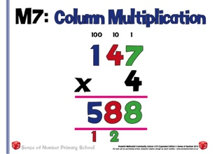
National Curriculum Objectives – Addition and Subtraction

National Curriculum Objectives – Multiplication and Division

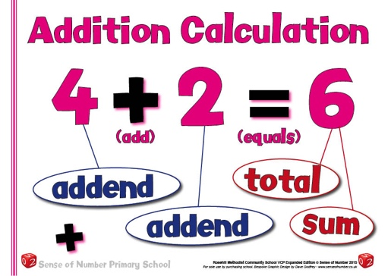
Addition Progression

The aim is that children use mental methods when appropriate, but for calculations that they cannot do in their heads they use an efficient written method accurately and with confidence.
Children need to acquire one efficient written method of calculation for addition that they know they can rely on when mental methods are not appropriate.

To add successfully, children need to be able to:
- recall all addition pairs to 9 + 9 and complements in 10;
- add mentally a series of one-digit numbers, such as 5 + 8 + 4;
- add multiples of 10 (such as 60 + 70) or of 100 (such as 600 + 700) using the related addition fact, 6 + 7, and their knowledge of place value;
- partition two-digit and three-digit numbers into multiples of 100, 10 and 1 in different ways.

Note: It is important that children’s mental methods of calculation are practised and secured alongside their learning and use of an efficient written method for addition.

Mental Addition Strategies

There are 6 key mental strategies for addition, which need to be a regular and consistent part of the approach to calculation in all classes from Year 2 upwards.
These strategies will be introduced individually when appropriate, and then be rehearsed and consolidated throughout the year until they are almost second nature.
These strategies are Partitioning, Counting On, Manipulate the Calculation, Round & Adjust, Double & Adjust and using Number Bonds. The first two strategies are also part of the written calculation policy (see pages 14-18) but can equally be developed as simple mental calculation strategies once children are skilled in using them as jottings.
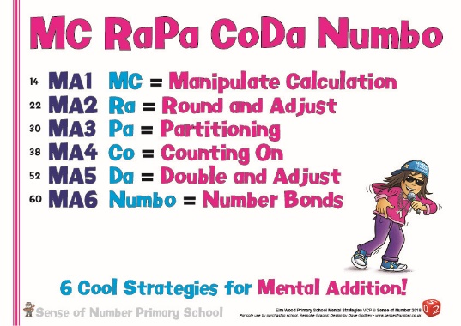
Using the acronym MC RAPA CODA NUMBO, children can be given weekly practice in choosing the most appropriate strategy whenever they are faced with a simple addition, usually of 2 or 3-digit numbers, but also spotting the opportunities when they can be used with larger numbers (E.g. 3678 + 2997) or decimals (E.g. 4.8 + 2.2)
MC Manipulate Calculation
RA Round & Adjust
PA Partitioning
CO Counting On
DA Double & Adjust
NUMBO Number Bonds

This policy not only provides examples of the 6 different strategies as mental jotting.
There is also a Concrete / Pictorial slide for each strategy, demonstrating how to give a visual picture of the strategy in question using key apparatus or manipulatives (usually Base 10). The visual slide is to give the children conceptual understanding of the mental strategy so that they can picture it before starting to write it down or use it mentally.
For example, using the number 45 (see examples below), we can look at the other number chosen, and decide on the most appropriate mental calculation strategy.
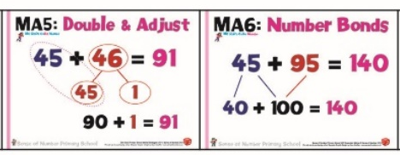
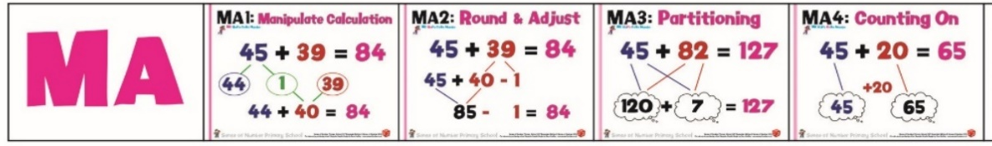

Manipulate the Calculation / Round & Adjust.

Both of these strategies use the same mathematical thinking but in a slightly different way.
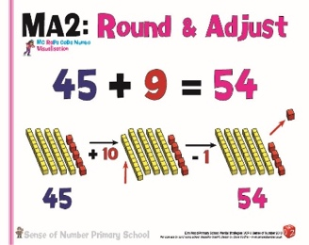
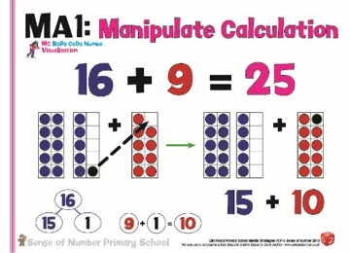
The first 2 slides show the strategies using resources.
16 + 9 in Ten Frames shows that ‘1’ of the counters from the ‘16’ can be ‘given’ to the ‘9’ so that there will now be 15 + 10. You have ‘manipulated the calculation’ to make it easier.

45 + 9 with Base 10 shows that it is much easier to add a ‘10’ and remove a ‘1’ rather than count on / add nine ‘1’s’
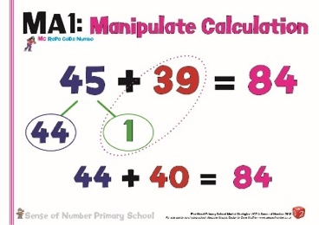
For 45 + 39, it would not be as efficient to partition or count on (though it would be relatively easy). 39 is only 1 away from 40 so there are two alternatives.

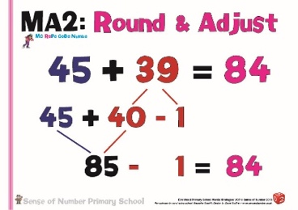
We could simply make an easier calculation (Manipulate the Calculation) by ‘passing 1’ from the 45 to the 39. This would give us a new calculation of 44 + 40.

Alternatively, we could use the Round & Adjust strategy of adding 40 to the 45 then subtracting 1, as advocated by the National Numeracy Strategy.

Partitioning
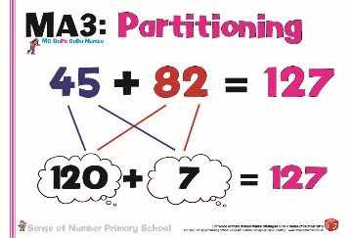
The first slide shows a straightforward partition for 43 + 21 using Base 10. The four 10s are added to the two 10s and the three 1s are added to the single 1, making six 10s and four 1s (or 64).

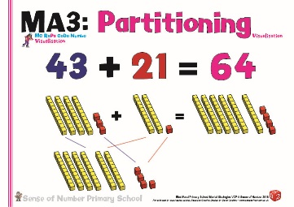
For 45 + 82, the strategy is a simple Partition Jot, adding the four 10s (40) to the eight 10s (80) and the five 1s (5) to the two 1s (2), making twelve 10s (120) and seven 1s (7) or 127

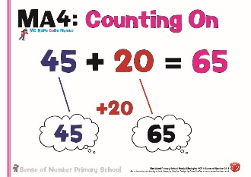
Counting On
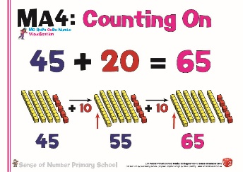
The first slide shows how easily children can demonstrate the Count On strategy using Base 10. This resource really allows the children to see what ‘counting on’ in 10s actually looks like. It isn’t just a verbal number pattern ’45, 55, 65’ but it really represents four 10s (40) and five 1s (5) to which two 10s are added, giving a total of six 10s and five 1s (65).

As a mental strategy this is usually represented by a straightforward ‘count on in my head’ picture or, as will be seen later in the written methods section, a number line image.

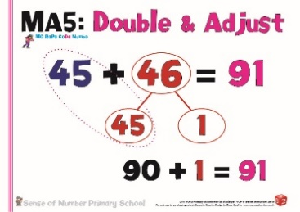
Double & Adjust
This strategy requires a real sense of number, in that children have to look at both numbers and recognise that because they are ‘close together’ in size it is easier to use a ‘near double’ in order to work out the answer to the calculation.
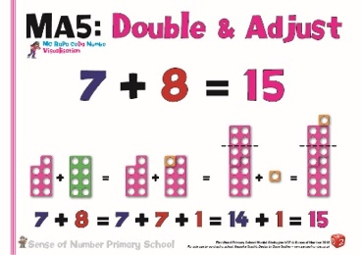
In Year 2, for example, spotting that 7 + 8 is almost ‘double 7’ is far easier than counting on (as long as you know the answer to double 7). The first slide demonstrates this using Numicon / Number Frame pieces to visualise the ‘near double’, which can then be adjusted.

For 45 + 46, it should then become clear that it is much easier / more efficient to use the known fact of ‘Double 45’ then add an extra 1 rather than partitioning (80 + 11) or counting on (45 + 40 + 6). If, however, doubles haven’t been yet learnt then one of the other strategies will need to be used instead.

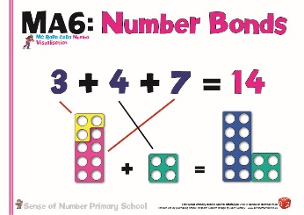
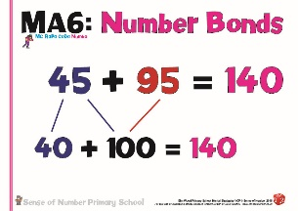
Number Bonds
In a similar way to ‘Double & Adjust’ the Number Bonds strategy requires the children to know and recognise key number bonds to 10 / 100 / multiples of 10, and use these to make a calculation easier. The Year 2 calculation 3 + 4 + 7 can be simplified by immediately making a bond to 10 then adding 4 (as shown on the slide using the Numicon pieces.

For 45 + 95, it is more efficient and sensible to make a number bond of 100 using the 95 and 5 and then adding the 40 for a total of 140.

The grid below shows a complete overview of the 6 main mental calculation strategies across the year groups. It displays examples from the Visual Calculation Policy for each method from Year 1 – Year 6. In it, you can see the progression of each strategy using appropriate examples of numbers as exemplification.
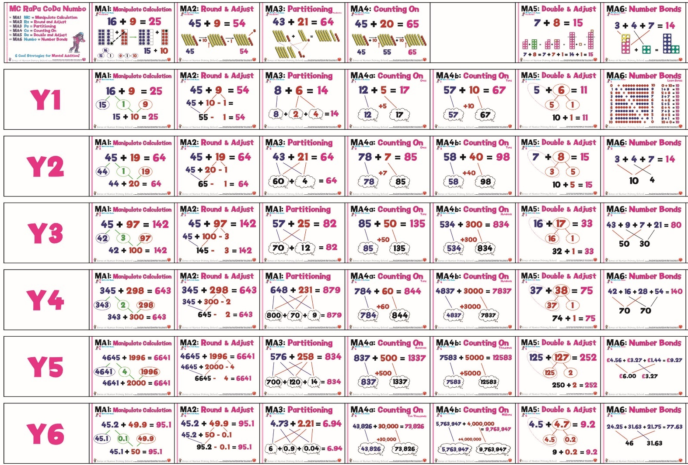

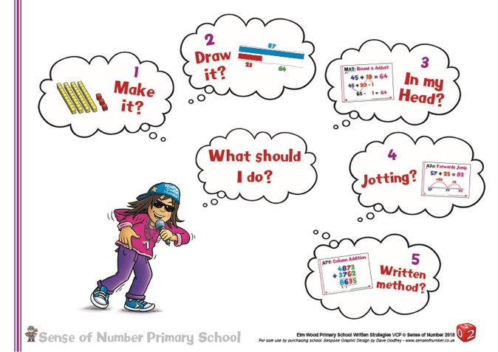
The 6 key strategies need to be linked to the key messages from pages 2 and 3 –
The choice as to whether a child will choose to use a mental method, or a jotting will depend upon
a) the numbers chosen and
b) the level of maths that the child is working at.
For example, for 57 + 35
a Year 2 child may use a long jotting or number line
a Year 3 child might jot down a quick partition jotting,
a Year 4 child could simply partition and add mentally.

As a strategy develops, a child will begin to recognise the instances when it would be appropriate: -
E.g. 27 +9, 434 + 197, 7.6 + 1.9 and 5.86 + 3.97 can all be calculated very quickly by using the Round & Adjust strategy.

Models of Addition

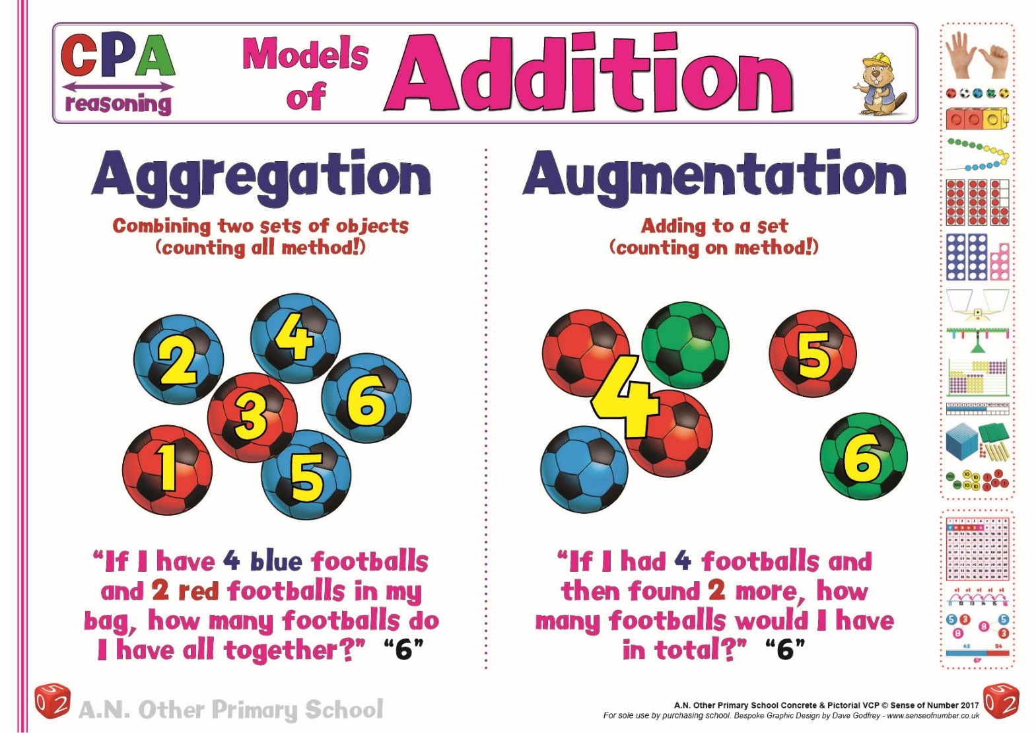
As the images above show, it is important that children are introduced to the two main models for addition using practical resources.
In EYFS this would be real objects such as footballs, shells, cakes, cars, dinosaurs etc.
In KS1 this would progress from concrete materials such as counters or cubes to pictorial models and sketches.

The two models of addition, aggregation and augmentation will develop into the two main mental / written methods of partitioning (aggregation) and counting on (augmentation).
In simplistic terms, aggregation involves 2 separate groups that are combined to give an ‘aggregate’ total. E.g. There are 7 cakes in the first box and 5 cakes in the second box. How many cakes are there altogether?

Augmentation, however, involves adding on to an existing group. E.g. There are 7 cakes in a box. My friend gives me 5 more cakes. How many cakes do I have now?

Both of these principles are explored in the actual written calculation policy below

Written Methods of Addition

Stage 1 | Finding a Total and the Empty Number Line | Alternative Method:  Counting on Mentally  or as a jotting
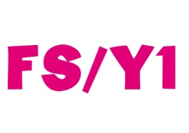 | Initially, children need to represent addition using a range of different resources and understand that a total can be found by counting out the first number, counting out the second number then counting how many there are altogether.
 | 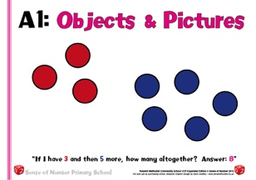  This is augmentation (see above) and can be done in either order (3+5 or 5+3) | 3 (held in head) then use fingers to count on 5  (“3… 4,5,6,7,8)
 | This will quickly develop into placing the largest number first, either as a pictorial / visual method or by using a number line. The use of the number line, however, should be delayed until the children are completely secure in their understanding of 5 + 3. Otherwise it becomes a tool that limits their understanding of what they are actually representing  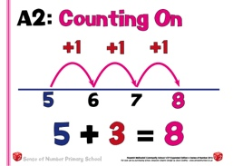  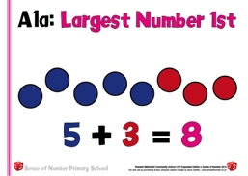 | 5 (held in head)  then count on 3  (“5 … 6, 7, 8”)
The ‘Egg Box’ / ‘Ten Frame’ image is an excellent visual tool to support both models of addition
Aggregation Augmentation
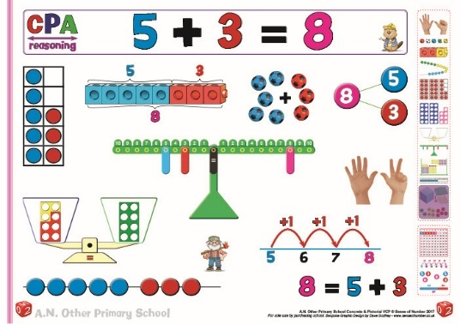
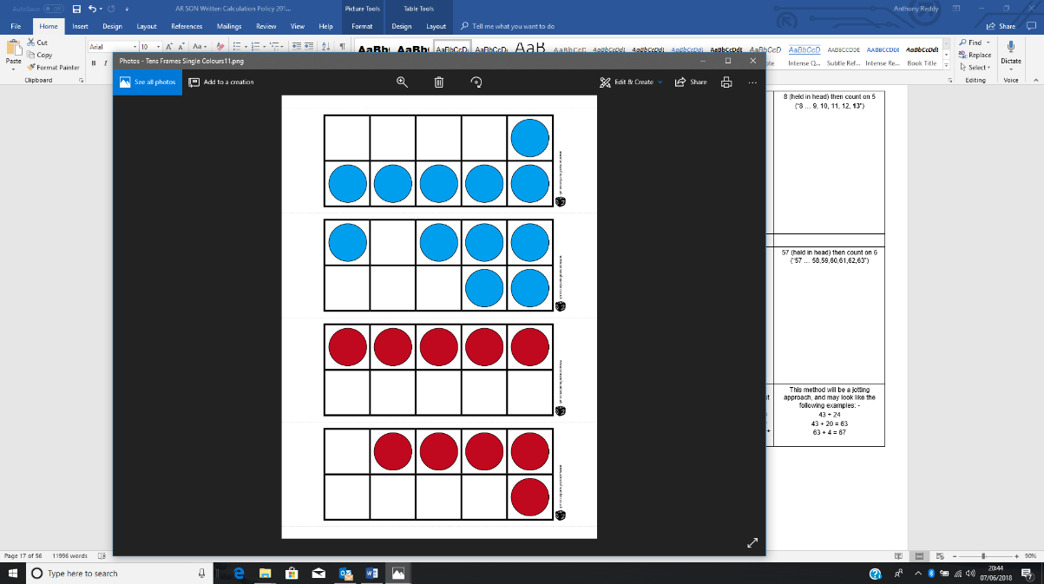
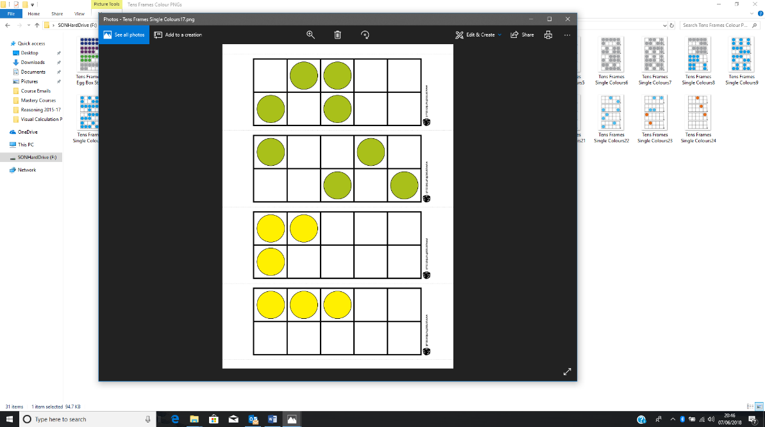
Before moving onto jottings or written methods (for any calculation), children need to be shown a wide range of images that support their understanding.
For simple calculations, the ‘equals’ sign can be viewed as a way to show the total (egg boxes, cubes, footballs, fingers) but also as a ‘balance’ (Numicon, peg balance), where 5 and 3 have a value that is equal to / the same as, or that balances 8.
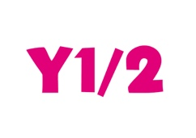 | When bridging through 10, a calculation can be seen as a straightforward ‘count on’ process (see number line and 100 square images below), a balance image as before (see balance and number bond diagram) but, more importantly as a strategy where the ‘5’ is partitioned into 2 and 3 (see Numicon, multi-link and Ten Frame images).  In effect, for these images / strategies, the calculation is being re-written as 8 + 5 = (8 + 2) + 3 = 10 + 3 = 13  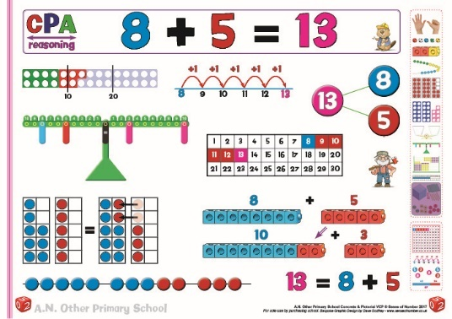 | When developing the concrete picture into a jotting the number line can be used to display the ‘count on’  (8 + 1 + 1 + 1 + 1 + 1)  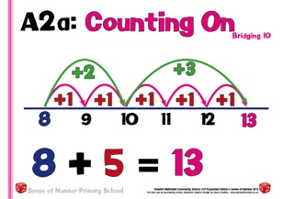  or the partition (8 + 2 + 3).  Once this image is secure, the same strategies can be done mentally: -  8 (in head) then count on 5  (“8 … 9, 10, 11, 12, 13”)  Or “8 + 2 = 10…  10 + 3 = 13).
 | The next step is to bridge through a multiple of 10. As above, the models and images show different strategies for finding the total or balancing the equation.  The 100 square & number rod images show counting on in 1s  Tens Frames show a balanced equation created by passing over some counters from the 6 to the 57.  Base 10 is used to show partitioning. The 1s have been set out Tens Frame style to visualise how the 5s can be combined to make a 10.  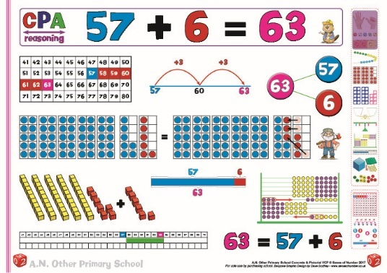 | 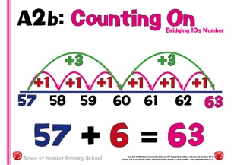  Again, the number line jotting can display counting on (57+1+1+1+1+1+1) or partitioning (57 + 3 + 3)  This picture then becomes the mental strategies: -  57 (in head) - count on 6 (“57, 58,59,60,61,62,63”)  Or “57 + 3 = 60 …  60 + 3 = 63)
 | There are a wide range of ways in which children can explore / visualize / create two-digit calculations.  The Base 10 and Place Value Counters demonstrate partitioning and recombining (adding the 10s and adding the 1s)  Numicon shows the ‘answer’ once the 10s & 1s are combined.  Th number rods and 100 square display counting on 20 then 4.  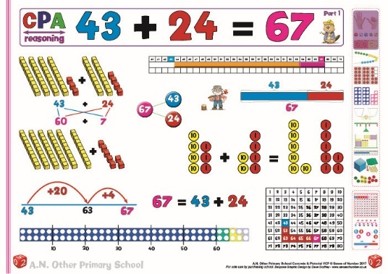  There is also a part/whole bar model and number bond diagram. | The number line shows how to keep one number whole, whilst partitioning the other number.  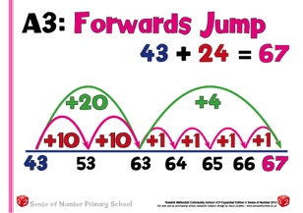  Firstly, add the tens then the ones individually  (43 + 24 =  43+10+10+1+1+1+1)  before counting on in tens and ones (43 + 20 = 63 ..  63 + 4 = 67)
The most crucial element of teaching addition is to ensure that the children have a ‘picture’ of partitioning and exchanging / regrouping, meaning that they can visualize the calculation before they move on to written / column procedures.
This needs to be done practically many times before they are asked to show the ‘method’ in a column.
See ‘column method’ section for further examples of column addition using concrete materials to embed understanding.
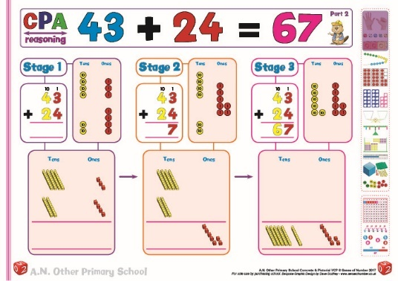

Develop to crossing the 10s, then the 100s boundary
57 + 25 = 82 86 + 48 = 134
 | Even as the calculations increase, and start to deal with exchanging, it is important that they are initially visualised using a range of resources / images.  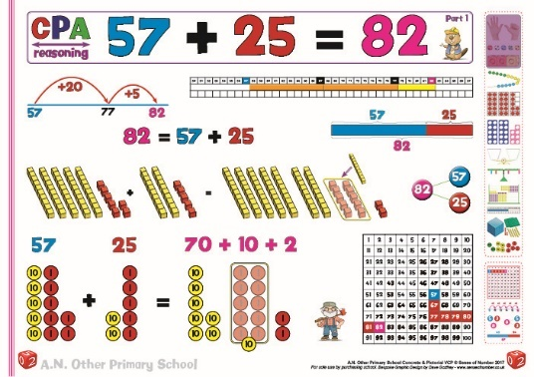  Using either Base 10 or place value counters, calculations which involve exchanging can be demonstrated.  Note the layout of the resources in Tens Frame style so that it is much easier to see the five 1s from the 57 added to the five 1s from the 25 to make an extra 10. | By this stage the number line no longer counts in individual 10s & 1s.  57 + 20 = 77…  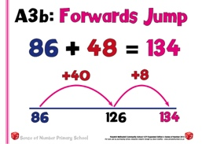  77 + 5 = 82  86 + 40 = 126…  126 + 8 = 134
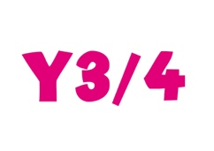 | 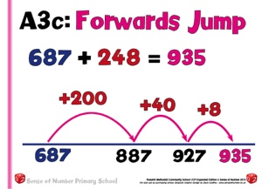  For some children, the number line method can still be used for 3-digit calculations. 687 + 200 = 887…  887 + 40 = 927…  927 + 8 = 935  Or 687 + 200 + 40 + 8 = 935
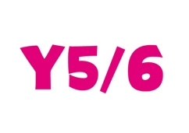  Number lines support children’s thinking if they find partitioning / column addition difficult, as it simply involves counting on in 100s, 10s & 1s. | 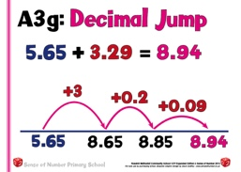  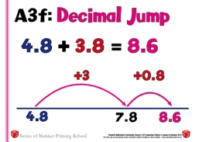  In Years 5 and 6, if necessary, children can return to the number line method to support their understanding of decimal calculation  4.8 + 3 = 7.8  7.8 + 0.8 = 8.6  Or 4.8 + 3 + 0.8 = 8.6  Hopefully, with the above calculation, many children would mentally Round & Adjust (4.8 + 4 – 0.2 = 8.6)

Stage 2 | Partition Jot | Alternative Method:  Traditional Partitioning
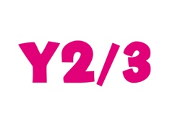 | Traditionally, partitioning has been presented using the method on the right. Although this does support place value and the use of arrow cards, it is very laborious, so it is suggested that adopting the ‘partition jot’ method will improve speed and consistency for mental to written (or written to mental) progression | Record steps in addition using partition, initially as a jotting: -  43 + 24 = 40 + 20 + 3 + 4 =  60 + 7 = 67  Or, preferably  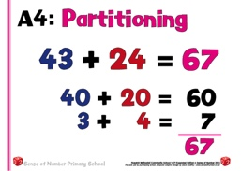
As soon as possible, refine this method to a much quicker and clearer ‘Partition Jot’ approach
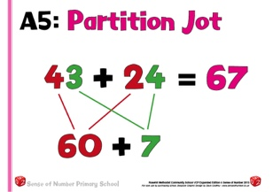
 | As before, develop these methods, especially Partition Jot, towards crossing the 10s and then 100s.
 | 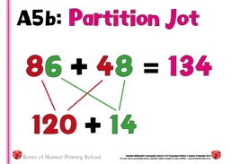 | 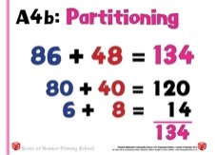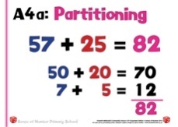
 | This method will soon become the recognised jotting to support the teaching of partitioning. It can be easily extended to 3 and even 4-digit numbers when appropriate. | For certain children, the traditional partitioning method can still be used for 3-digit numbers, but it is probably too laborious for 4-digit numbers.
 | 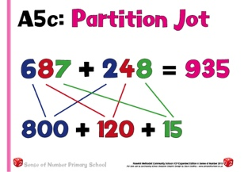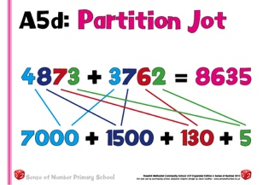 | 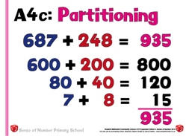
 | Partition jot is also extremely effective as a quicker alternative to column addition for decimals. | Some simple decimal calculations can also be completed this way.
 | 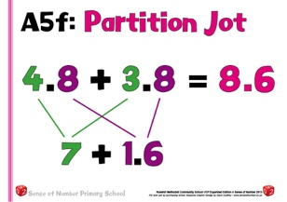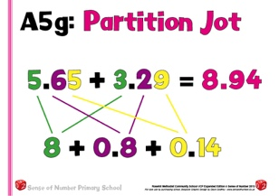
 | For children with higher-level decimal place value skills, partition jot can be used with more complex decimal calculations or money.
 | 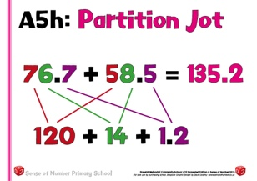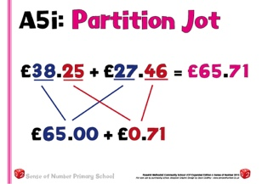

Stage 3 | Expanded Method in Columns
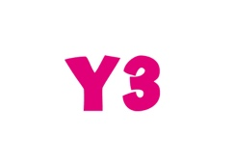 | Column methods of addition are introduced in Year 3, but it is crucial that they still see mental calculation as their first principle, especially for 2-digit numbers.  Column methods should only be used for more difficult calculations, usually with 3-digit numbers that cross the Thousands boundary or most calculations involving 4-digit numbers and above.  N.B. Even when dealing with bigger numbers / decimals, children should still look for the opportunity to calculate mentally (E.g. 4675 + 1998)
 | 2 digit examples are used below simply to introduce column methods to the children. Most children would continue to answer these calculations mentally or using a simple jotting.
 | Using the column, children need to learn the principle of adding the ones first rather than the tens.
 | The ‘expanded’ method is a very effective introduction to column addition. It continues to use the partitioning strategy that the children are already familiar with, but begins to set out calculations vertically. It is particularly helpful for automatically ‘dealing’ with the ‘carry’ digit. It is crucial, however, to ensure that practical apparatus has been used first before any sort of columnar procedure is introduced (see examples below in the ‘Column Method’ section
 | A. Single ‘carry’ in units  ‘Eighty plus forty equals one hundred and twenty, because ‘eight plus four equals twelve. | B. ‘Carry’ in units and tens
 | 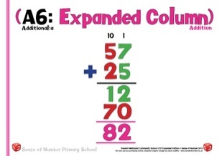 | 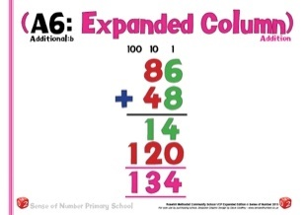
 | Once this method is understood, it can quickly be adapted to using with three-digit numbers. It is rarely used for 4 digits and beyond as it becomes too unwieldy.
 | 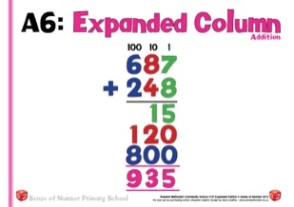
The time spent on practicing the expanded method will depend on security of number facts recall and understanding of place value.
Once the children have had enough experience in using expanded addition and have also used practical resources (Base 10 / place value counters) to model exchanging in columns, they can be taken on to standard, ‘traditional’ column addition.

Stage 4 | Column Method
As with the expanded method, begin with 2-digit numbers, simply to demonstrate the method, before moving to 3-digit numbers.
Make it very clear to the children that they are still expected to deal with all 2-digit (and many 3 digit) calculations mentally (or with a jotting), and that the column method is designed for numbers that are too difficult to access using these ways. The column procedure is not intended for use with 2-digit numbers unless completely necessary for certain children who have no other strategy.

‘Carry’ ones then ones and tens.
The most important part of the transition from mental and jotting approaches towards the use of column methods is the initial use of concrete materials to make / create and discuss the understanding behind the method. If children have had regular experience of using Base 10 apparatus and then Place Value Counters to make and solve calculations, (especially the regrouping of 10 ‘ones’ into 1 ‘Ten’ and 10 ‘Tens’ into 1 ‘Hundred’) then the column method is simply a written version of what they already understand.
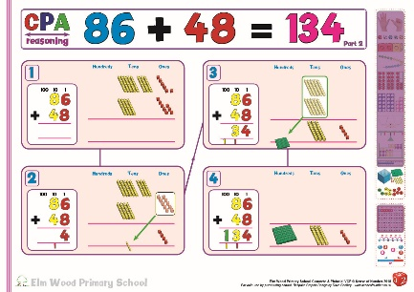
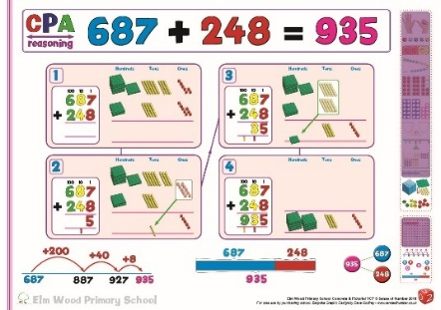
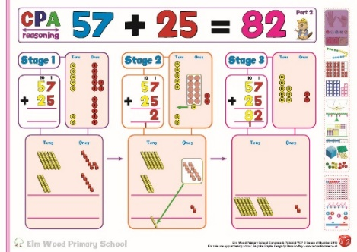

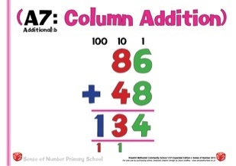
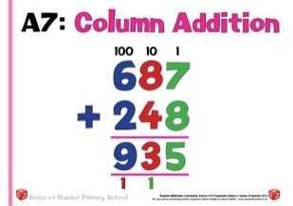
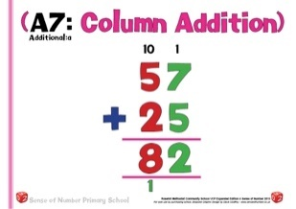
Use the words ‘carry ten’ and ‘carry hundred’, not ‘carry one’
Record carry digits below the line.

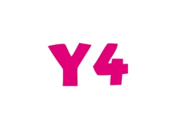 | 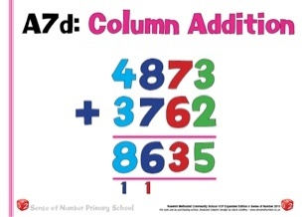  Once confident, use the column method with 4-digit numbers. At this point the apparatus is not necessary as calculation procedure should be fully understood.
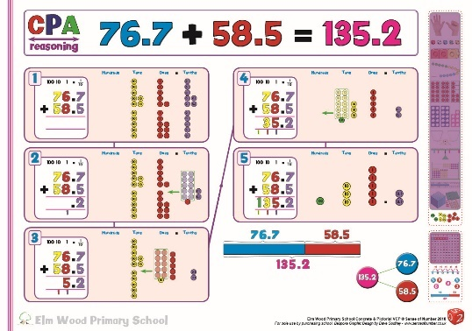
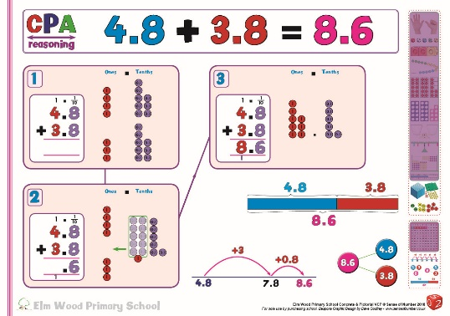
Extend column methods to 5/6-digit calculations then decimal calculations (Year 5). Even with decimals, it makes sense to embed the CPA approach, using Decimal Place Value Counters to create and practice the calculation first, explaining the method and describing the principles which takes place when the children are exchanging / regrouping tenths and hundredths
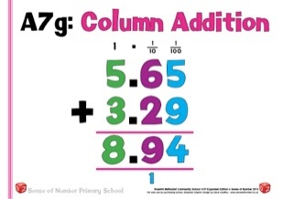
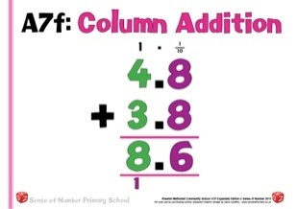
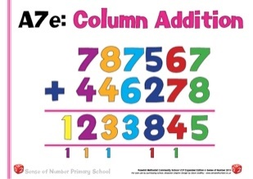
If children make repeated errors at any stage, they can return to the expanded method or an earlier jotting.

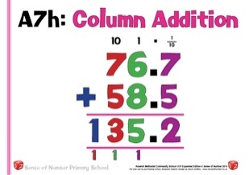
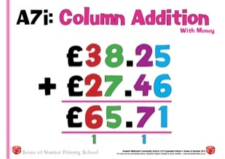
 | The key skill in upper Key Stage 2 that needs to then be developed, usually in Year 6, is the laying out of the column method for calculations with decimals in different places.
 | 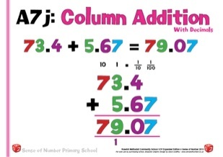

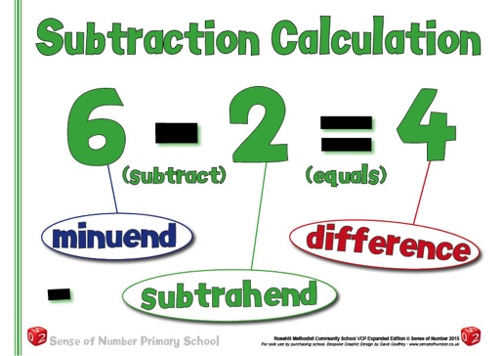
Subtraction Progression

The aim is that children use mental methods when appropriate, but for calculations that they cannot do in their heads they use an efficient written method accurately and with confidence.

To subtract successfully, children need to be able to:
- recall all addition and subtraction facts to 20;
- subtract multiples of 10 (such as 160 – 70) using the related subtraction fact (e.g. 16 – 7), and their knowledge of place value;
- partition two-digit and three-digit numbers into multiples of one hundred, ten and one in different ways (e.g. partition 74 into 70 + 4 or 60 + 14).

Note: It is important that children’s mental methods of calculation are practised and secured alongside their learning and use of an efficient written method for subtraction.

Mental Subtraction Strategies

There are 6 key mental strategies for subtraction, which need to be a regular and consistent part of the approach to calculation in all classes from Year 2 upwards.
These strategies will be introduced individually when appropriate, and then be rehearsed and consolidated throughout the year until they are almost second nature.
These strategies are Counting On, Counting Back, Partitioning, Manipulate the Calculation, Round & Adjust and using Number Facts. The first two strategies are also part of the written calculation policy (see pages 14-18) but can equally be developed as simple mental calculation strategies once children are skilled in using them as jottings.
Using the acronym MC RAPA CoOCoB NumFa, children can be given weekly practice in choosing the most appropriate strategy whenever they are faced with a simple subtraction, usually of 2 or 3 digit numbers, but also spotting the opportunities when they can be used with larger numbers (E.g. 3678 + 2997) or decimals (E.g. 4.8 + 2.2)

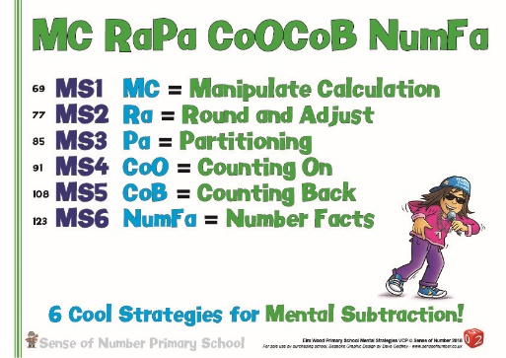

This policy not only provides examples of the 6 different strategies as mental jottings.
There is also a Concrete / Pictorial slide for each strategy, demonstrating how to give a visual picture of the strategy in question using key apparatus or manipulatives (usually Base 10). The visual slide is to give the children conceptual understanding of the mental strategy so that they can picture it before starting to write it down or use it mentally.

Children need to acquire one efficient written method of calculation for subtraction, which they know they can rely on when mental methods are not appropriate.

NOTE: They should look at the actual numbers each time they see a calculation and decide whether or not their favoured method is most appropriate (e.g. If there are zeroes in a calculation such as 206 -198) then the ‘counting on’ approach may well be the best method in that particular instance).
Therefore, when subtracting, whether mental or written, children will mainly choose between two main strategies to find the difference between two numbers: -

Counting Back (Taking away) Counting On
When should we count back and when should we count on?
This will alter depending on the calculation (see below), but often the following rules apply;

If the numbers are far apart, or there isn’t much to subtract (278 – 24) then count back.
In many cases, either strategy would be suitable, depending on preference (743 – 476)

If the numbers are close together (206 – 188), then count up

Models of Subtraction

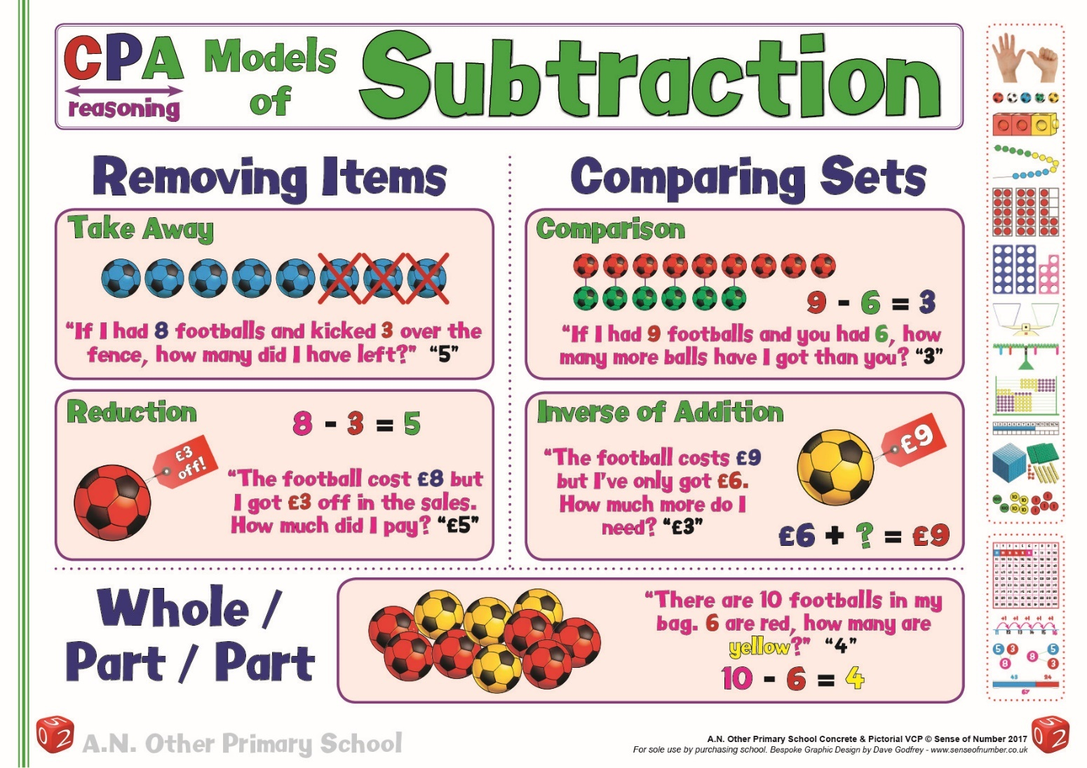
It is fairly common for children (and teachers) to view subtraction in one simplistic way – as a ‘take away’. Even when reading subtraction calculations such as 42 – 38 the most common way in which it is read aloud would be ’42 take away 38’.

Although we could count back 30 then count back 8 from 42 (with or without a number line), and might even count out 42 items then remove 38 of them (Base 10 or otherwise), the easiest / most efficient way to solve the calculation would be to ‘count on’ 4 from 38 to 42 (or simply to recognise the difference of 4).

Therefore, it is vital that everybody, both teachers and children, are encouraged / persuaded to read all calculations using the correct language (’42 subtract 38’ or ‘What is the difference between 42 and 38?’) and then allow the person answering the question the opportunity to choose the most appropriate strategy.

As can be seen in the later parts of this section, the ‘count on’ approach is usually demonstrated via the use of a number line or jotting, whilst the ‘take away ‘ approach is explored using Base 10 apparatus and Place Value Counters (as with addition) to allow visualisation and understanding of the exchanging / regrouping principles.

The poster on the previous page gives a clear overview of subtraction and allows any member of teaching staff (especially the Subject Leader) to realise that there are actually 5 ways to visualise subtraction, not just one.

Two of them involve removing ‘items’ – the ‘take away’ story (I have 7 cakes and eat 2 of them, how many are left?) and the ‘reduction’ story (The price of the bag of cakes cost £7 but was reduced in the sale. How much did I pay?).

In both of these examples we end up with ‘less’ than we started with, which fit in with the standardised view of subtraction as ’take away’ and ‘less than’

The right-hand side of the column, however, explores the other key aspect of subtraction, that of comparison. In a standard ‘comparison’ story (I have 7 cakes and my friend has 2 cakes. How many more cakes do I have?) or an inverse of addition story (It costs £7 to buy the cakes, but I only have £2. How much more do I need?) there is no taking away whatsoever.

In the first example there are actually 9 cakes altogether, none of them are eaten / taken away; they are simply compared. In the second example, there is only £2 and £5 more is needed. Despite the fact that nothing is removed, these are both clearly subtraction calculations.

The final example is neither removing items or comparing. It is a way of using subtraction to discuss the parts of a whole.
In a ‘part / whole’ story (There are 7 cakes in a bag, either cream cakes or chocolate brownies. 2 of them are brownies, how many are cream cakes?) nothing is taken away and nothing is added or compared. Subtraction (as with a bar model or number bond diagram) explores the two parts. If there are 7 in total and 2 of them are brownies, then 7 subtract 2 must give me the number of cream cakes.

As with addition, it is important that children are introduced to the different models for subtraction (especially ‘take away’ and ‘compare’ using practical resources.
In EYFS this would be real objects such as footballs, shells, cakes, cars, dinosaurs etc.
In KS1 this would progress from concrete materials such as counters or cubes to pictorial models and sketches.

The two main models of subtraction – ‘removing items’ and ‘comparison’, will develop into the two main mental / written methods of ‘subtraction by counting back’ (take away’ / decomposition) and ‘subtraction by counting on’ (‘complementary addition’ / counting up on a number line).

All of these principles are explored in the actual written calculation policy below

Written Methods of Subtraction

INTRO | Subtraction by counting back  (or taking away) | Subtraction by counting up  (or complementary addition)
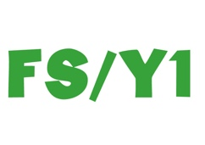 | Early subtraction in EYFS will primarily be concerned with ‘taking away’, and will be modelled using a wide range of models and resources. These will usually be natural resources and real-life objects, and will often be part of a story telling scenario where the children can ‘make’ subtraction to tell the story
 | This will continue in Year 1, using resources such as multi-link cubes, Numicon, Ten Frames, bead strings and pictures (like the footballs shown below) to model the ‘take away’ approach to subtraction.  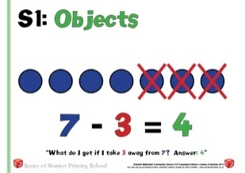  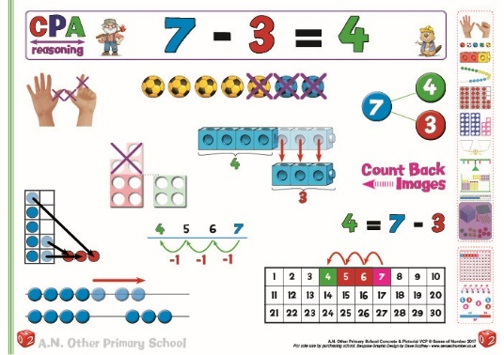  Once this is secure then images such as the desktop number track / line can be used to practice taking away practically, and then developed into counting back on demarcated number lines. | In Year 1, it is also vital that children understand the concept of subtraction as ‘finding a difference’ by comparison and realise that any subtraction can be answered in 2 different ways, either by counting up or counting back.  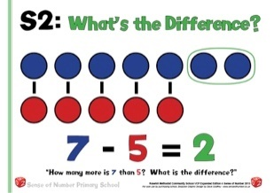  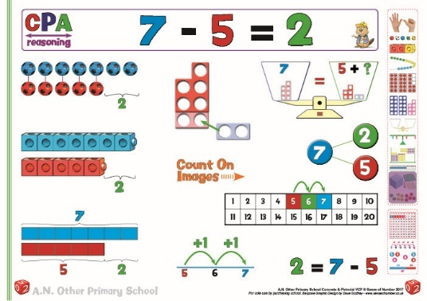  Again, this needs to be modelled and consolidated regularly using a wide range of resources, especially multilink towers, counters and Numicon. The images below also show the early version of bar modelling, as well as the Numicon pieces being used to demonstrate the equals sign as a balance (7 is equal to 5 + __

Stage 1 | Using the empty number line
Stage 1 | Subtraction by counting back  (or taking away) | Subtraction by counting up  (or complementary addition)
Before developing any jottings, mental methods or column procedures, children need to explore, discuss and visualize the two main models of subtraction using a wide range of models, images and apparatus. (including Numicon, multi-link cubes and Tens Frames). It is not advised to begin using a number line as a tool for calculation until the children understand the principles behind why it is being used. Otherwise the number line becomes a method, rather than a tool to embed and further understanding and fluency.
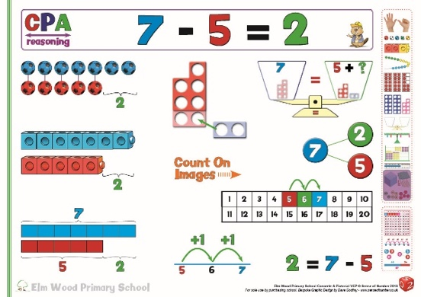
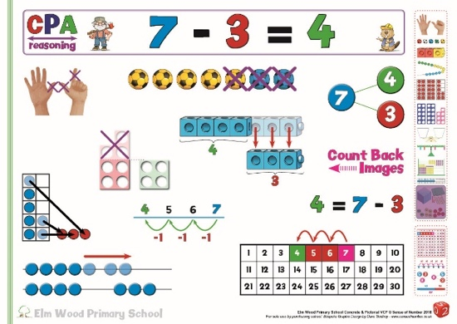
Images for ‘counting back’ Images for ‘counting on

 | Before using a number line, therefore, children need to be given the opportunity to ‘make’ both models of subtraction using resources.  For 12 - 3, the multi-link and Ten Frame pictures clearly show 12-2-1, whilst the footballs display the ‘take away’.  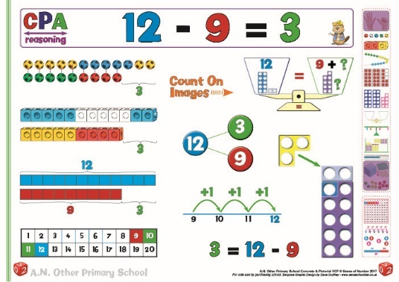  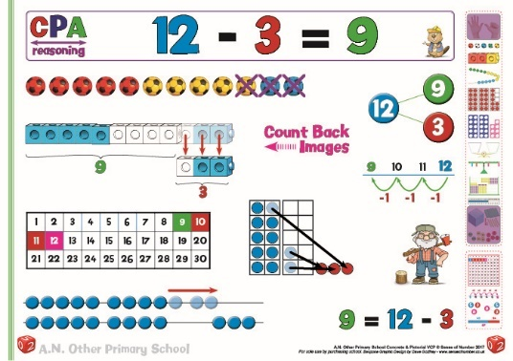  For 12 – 9 the number rods, cubes and footballs display a clear comparison, where the difference of 3 can be seen.
The empty number line helps to record or explain the steps in mental subtraction.
It is an ideal model for counting back and bridging ten, as the steps can be shown clearly.
It can also show counting up from the smaller to the larger number to find the difference.
 | The steps often bridge through a multiple of 10.  12 – 3 = 9  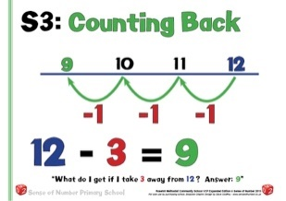 | Small differences can be found by counting up  12 – 9 = 3  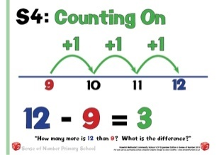
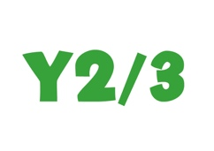 | This is developed into crossing any multiple of 10 boundary.  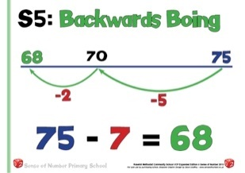  75 – 7 = 68 | For 2 (or 3) digit numbers close together, count up. First, count in ones  83 – 78 = 5  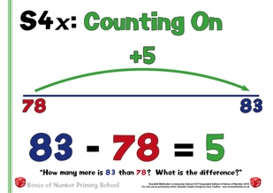  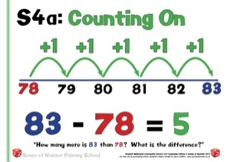  Then, use number facts to count up in a single jump
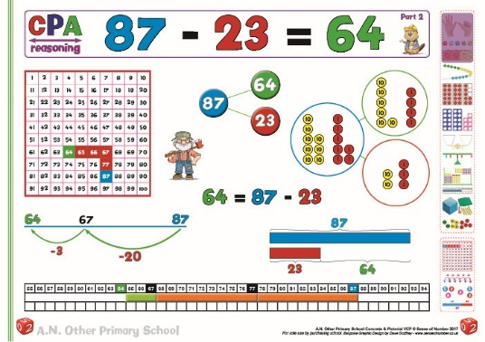
For 2-digit numbers, count back in 10s and 1s. As with addition, it is important to let the children manipulate materials in order to ‘see’ the calculation. Base 10 and Place Value Counters are particularly crucial as these are images which are used throughout the topic (see expanded method section for these images). The image below uses Place Value Counters to demonstrate the Number Bond diagram. Once secure, model the use of the empty number line where tens and ones are subtracted in single jumps (87 – 20 – 3)
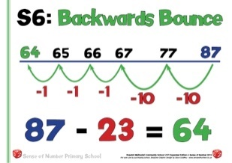
Continue to spot small differences
with 3-digit numbers
(403 – 397 = 6)

Some numbers (75 – 37) can be subtracted just as quickly either way.
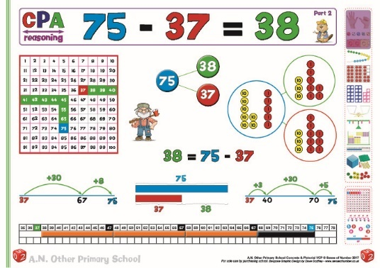
The images below show 75-37 as a Number Bond Diagram (also visualised with Place Value Counters), as a ‘count up’ image using the number line (explored further below in 2 different ways) and number rods, and as a take away / count back image on the 100 Square.

The number line itself is an excellent visual jotting for both counting on and counting back, depending on the children’s preferred strategy: -
 | 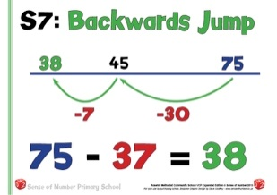  Either count back 30 then count back 7 | 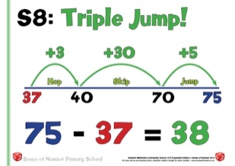  Or count up from smaller to the larger number, initially with a ‘triple jump’ strategy of jumping to the next 10, then multiples of 10, then to the target number.  This can also be done in 2 jumps.  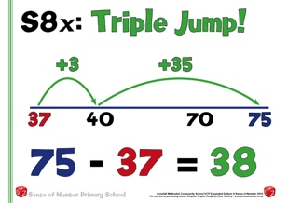
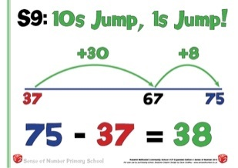
Some children prefer to jump in tens and ones, which is an equally valid strategy, as it links to the mental skill of ‘counting up from any number in tens’

Stage 2 | Expanded Method & Number Lines (continued)
Stage 2 | Subtraction by counting back  Expanded Method | Subtraction by counting up  Number Lines (continued)
In Year 3, according to the New Curriculum, children are expected to be able to use both jottings and written column methods to deal with 3-digit subtractions.
This is only guidance, however – as long as children leave Year 6 able to access all four operations using formal methods, schools can make their own decisions as to when these are introduced.
It is very important that they have had regular opportunities to use the number line ‘counting up’ approach first (right hand column below) so that they already have a secure method that is almost their first principle for most 2 and 3-digit subtractions.
This means that once they have been introduced to the column method they have an alternative approach that is often preferable, depending upon the numbers involved.
The number line method also gives those children who can’t remember or successfully apply the column method an approach that will work with any numbers (even 4-digit numbers and decimals) if needed.
It is advisable to spend at least the first term in Year 3 focusing upon the number line / counting up approach as a jotting through regular practice, while resources such as Base 10 are being used to explore decomposition practically. The column method can then be introduced in the 2nd / 3rd term once the understanding is secure.
Ideally, whenever columns are introduced, the expanded method should be practiced in depth (potentially up until 4-digit calculations are introduced). This should be done firstly with apparatus to build up a visual picture, and then gradually developed into the column procedure.
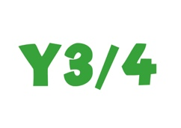 | The expanded method of subtraction is an excellent way to introduce the column approach as it maintains the place value and is much easier to model practically with place value equipment such as Base 10 or place value counters.  Introduce the expanded method with 2-digit numbers, but only to explain the process.  Column methods are very rarely needed for 2-digit calculations.  Give the children ample opportunity to extend their place value skills into column subtraction by ‘making’ the calculation and explaining the process before writing it down.  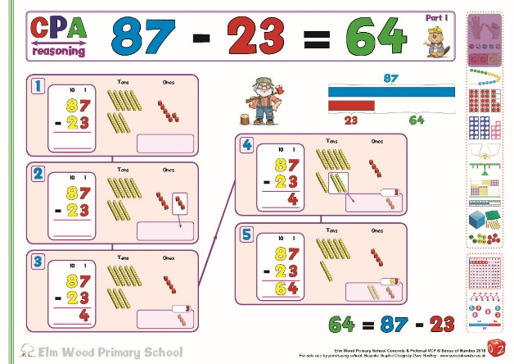  Partition both numbers into tens & ones, firstly with no exchange then exchanging from tens to ones.  Make sure that children are explaining the process of exchanging / regrouping whilst using the materials. Give them many opportunities to take the 1 Ten and exchange / regroup as 10 Ones before writing this down in expanded form.  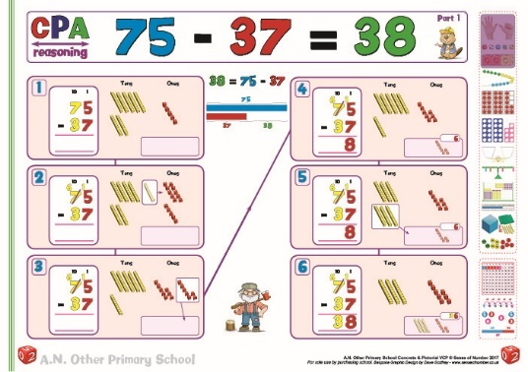  87 – 23 75 – 37  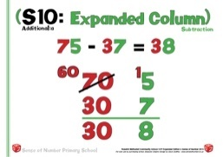  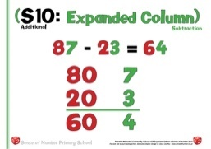
 | Develop into exchanging from hundreds to tens and tens to ones, always ‘making’ and discussing with apparatus first. Be explicit in explaining how the apparatus leads to the column procedure.  N.B. Please note the layout of the Base 10 resources in Tens Frame style, so that the groups of 5 can be seen immediately and don’t need to be re-counted.  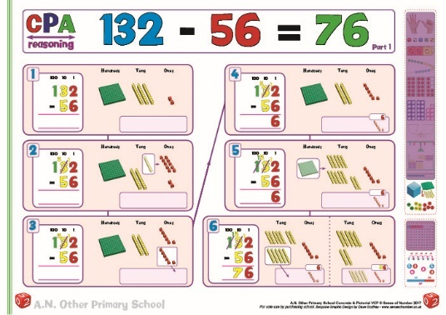  132 – 56  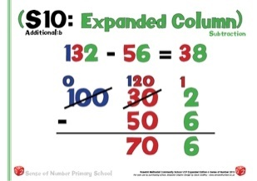 | The number line method is equally as effective when crossing the hundreds boundary, either by the triple / quad jump strategy or by counting in tens then ones.  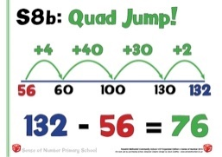  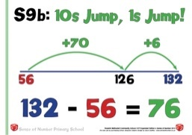  The ‘quad jump’ can be completed by many children in fewer steps, either a triple or double jump.  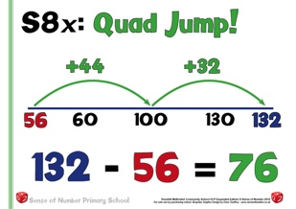  For examples without exchanging, the number line method takes considerably longer than mental partitioning or expanded.
A | Develop the method into three-digit numbers.  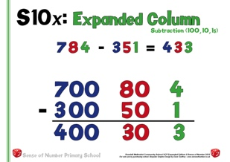  Subtract the ones, then the tens, then the hundreds.  Demonstrate without exchanging first.
B | Move towards exchanging from hundreds to tens and tens to ones, in two stages if necessary. Use practical apparatus first at all times, especially when dealing with 3-digit calculations.  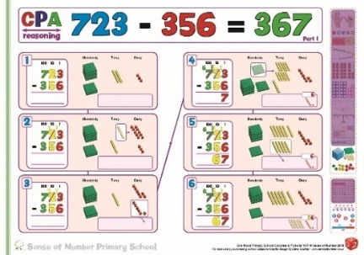  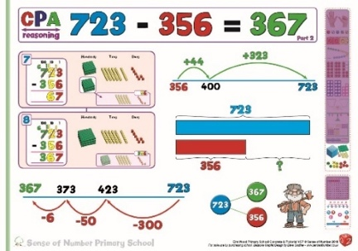  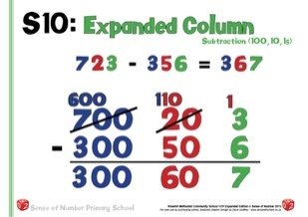 | 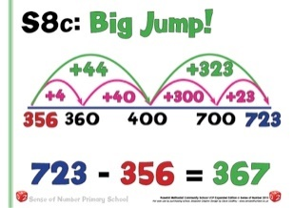  The example below shows 2 alternatives, for children who need different levels of support from the image.
 | For examples where exchanging is needed, then the number line method is equally as efficient, and is often easier to complete | 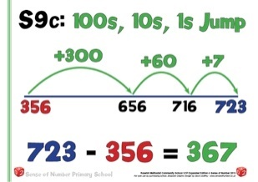  As before, many children prefer to count in hundreds, then tens, then ones.
C | Use some examples which include the use of zeros  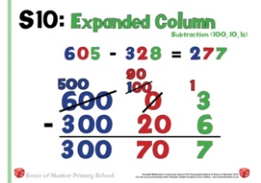  Continue to use expanded subtraction until both number facts and place value are considered to be very secure! | 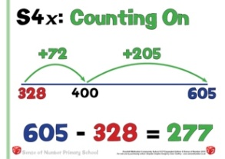  For numbers containing zeros, counting up is often the most reliable method.

Stage 3 | Standard Column Method (decomposition)
Stage 3 | Subtraction by counting back  Standard Method | Subtraction by counting up  Number Lines (continued)
Mainly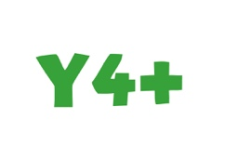 | Decomposition relies on secure understanding of the expanded method, and simply displays the same numbers in a contracted form.  As with expanded method, and using practical resources such as place value counters to support the teaching, children in Years 3 or 4 (depending when the school introduces the column procedure) will quickly move from decomposition via 2-digit number ‘starter’ examples to 2 / 3 digit and then 3-digit columns.  75 – 37 132 – 56  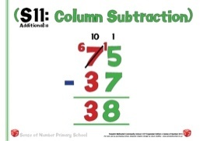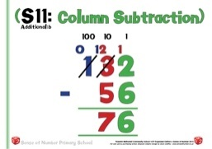
723 – 356
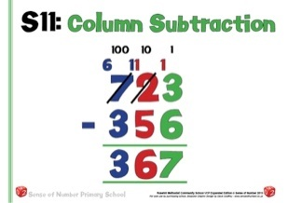
Continue to refer to digits by their actual value, not their digit value, when explaining a calculation. E.g. One hundred and twenty subtract fifty.

 | Again, use examples containing zeros, remembering that it may be easier to count on with these numbers (see Stage 2)  605 – 328  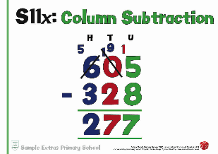 | It is even possible, for children who find column method very difficult to remember, or who regularly make the same mistakes, to use the number line method for 4 digit numbers, using either of the approaches.
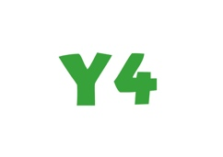 | From late Y4 onwards, move onto examples using 4-digit (or larger) numbers and then onto decimal calculations.  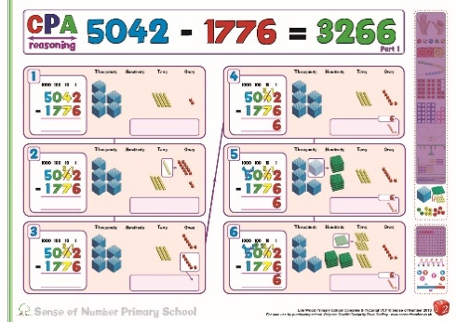  If necessary, apparatus can still be used to demonstrate the exchange / regroup principle.  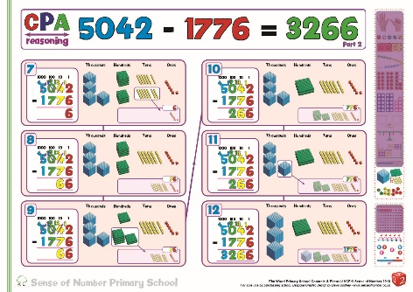  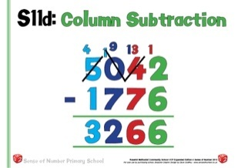 | 5042 – 1776  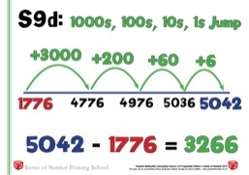  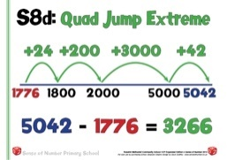
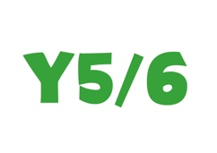 | 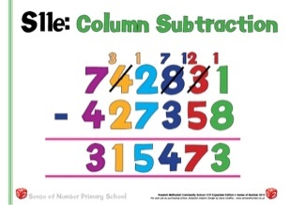  In Years 5 & 6 apply to any ‘big number’ examples.
 | Both methods can be used with decimals, although the counting up method becomes less efficient and reliable when calculating with more than two decimal places.
 | 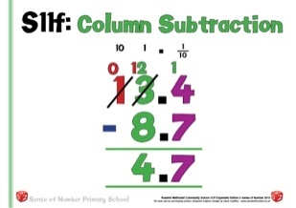  13.4 – 8.7 | 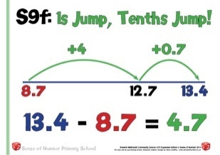  13.4 – 8.7
 | 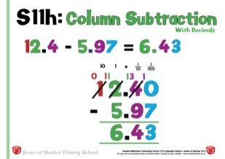  12.4 – 5.97 | 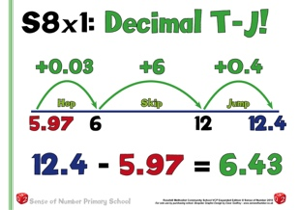  12.4 – 5.97
 | 72.43 – 47.85  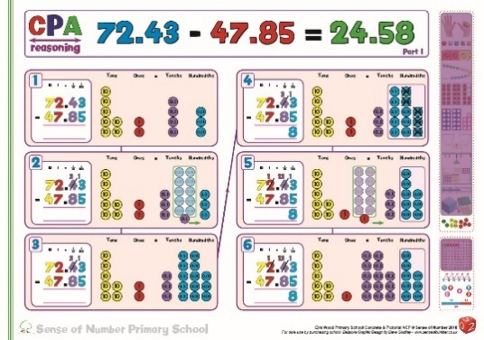  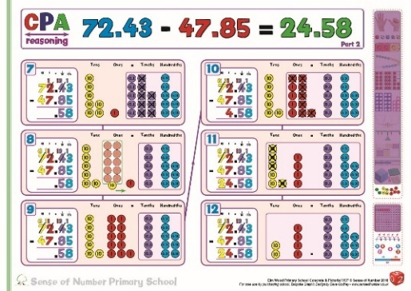  Even with calculations to 2 decimal places, practical apparatus can be used initially to explore / embed understanding or at a later stage for the children to demonstrate greater depth. In these instances, they can recreate a column method with decimals and explain each stage of the procedure.  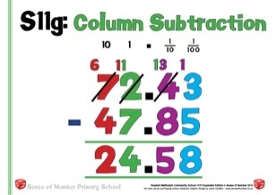 | 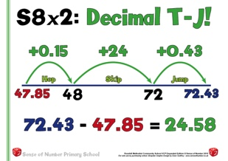

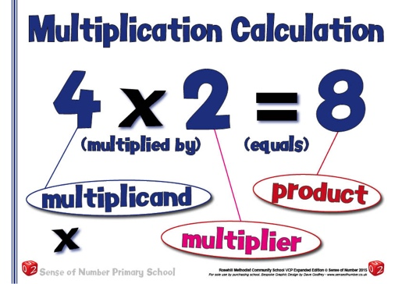
Multiplication Progression

The aim is that children use mental methods when appropriate, but for calculations that they cannot do in their heads they use an efficient written method accurately and with confidence.

These notes show the stages in building up to using an efficient method for
- two-digit by one-digit multiplication by the end of Year 3,
- three-digit by one-digit multiplication by the end of Year 4,
- four-digit by one-digit multiplication and two/three-digit by two-digit mult. by the end of Year 5
- three/four-digit by two-digit multiplication and multiplying 1-digit numbers with up to 2 decimal places by whole numbers by the end of Year 6.

To multiply successfully, children need to be able to:
- recall all multiplication facts to 12 × 12;
- partition numbers into multiples of one hundred, ten and one;
- work out products such as 70 × 5, 70 × 50, 700 × 5 or 700 × 50 using the related fact 7 × 5 and their knowledge of place value;
- similarly apply their knowledge to simple decimal multiplications such as 0.7 x 5, 0.7 x 0.5, 7 x 0.05, 0.7 x 50 using the related fact 7 × 5 and their knowledge of place value;
- add two or more single-digit numbers mentally;
- add multiples of 10 (such as 60 + 70) or of 100 (such as 600 + 700) using the related addition fact, 6 + 7, and their knowledge of place value;
- add combinations of whole numbers using the column method (see above).

Note:
Children need to acquire one efficient written method of calculation for multiplication, which they know they can rely on when mental methods are not appropriate.
It is important that children’s mental methods of calculation are practised and secured alongside their learning and use of an efficient written method for multiplication.
These mental methods are often more efficient than written methods when multiplying.
Use partitioning and grid methods until number facts and place value are secure

For a calculation such as 25 x 24, a quicker method would be ‘there are four 25s in 100 so 25 x 24 = 100 x 6 = 600

When multiplying a 3 / 4 digit x 2-digit number the standard method is usually the most efficient

At all stages, use known facts to find other facts.
E.g. Find 7 x 8 by using 5 x 8 (40) and 2 x 8 (16)

Mental Multiplication Strategies

In a similar way to addition, multiplication has a range of mental strategies that need to be developed both before and then alongside written methods (both informal and formal).
Some of these are the same strategies used for addition but adapted for multiplication.
Others are specifically multiplication strategies, which enable more difficult calculations to be worked out much more efficiently.
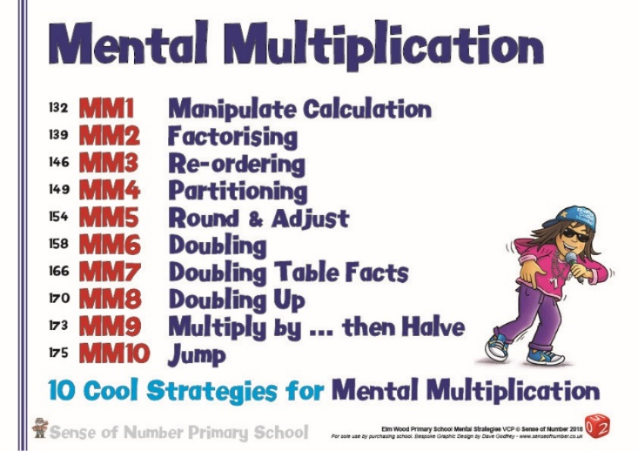

Tables Facts
In Key Stage 2, however, before any written methods can be securely understood, children need to have a bank of multiplication tables facts at their disposal, which can be recalled instantly.
The learning of tables facts does begin with counting up in different steps, but by the end of Year 4 it is expected that most children can instantly recall all facts up to 12 x 12.
The progression in facts is as follows (11’s moved into Y3 as it is a much easier table to recall): -

 | 1 x table
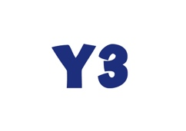
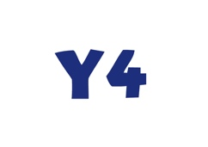

Once the children have established a bank of facts, they are ready to be introduced to jottings and eventually written methods.

Doubles & Halves
The other facts that children need to know by heart are doubles and halves. These are no longer mentioned explicitly within the National Curriculum, making it even more crucial that they are part of a school’s mental calculation policy.
If children haven’t learnt to recall simple doubles instantly, and haven’t been taught strategies for mental doubling, then they cannot access many of the mental calculation strategies for multiplication (E.g. Double the 4 times table to get the 8 times table. Double again for the 16 times table etc.). Halving numbers is particularly crucial when working with fractions (From 1/2s to 1/4s to 1/8s etc. Children who can halve numbers effectively can quickly work out that 1/8 of 136 is 17 by halving 3 times.

As a general guidance, children should know the following doubles & halves: -
Year Group | Year 1 | Year 2 | Year 3 | Year 4 | Year 5 | Year 6
Doubles and Halves | All doubles and halves from double 1 to double 10 /  half of 2 to half of 20 | All doubles and halves from double 1 to double 20 / half of 2 to half of 40  (E.g.double 17=34, half of 28 = 14) | Doubles of all numbers to 100 with units’ digits 5 or less, and corresponding halves (E.g. Double 43, double 72, half of 46)  Reinforce doubles & halves of all multiples of 10 & 100 (E.g. double 800, half of 140) | Addition doubles of numbers 1 to 100  (E.g. 38 + 38, 76 + 76) and their corresponding halves  Revise doubles of multiples of 10 and 100 and corresponding halves | Doubles and halves of decimals to 10 – 1 d.p.  (E.g. double 3.4, half of 5.6) | Doubles and halves of decimals to 100 – 2 d.p. (E.g. double 18.45, half of 6.48)

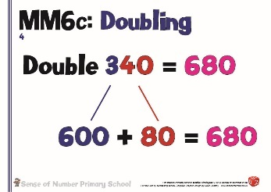
Before certain doubles / halves can be recalled, children can use a simple jotting to help them record their steps towards working out a double / half.
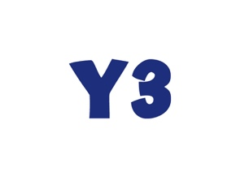
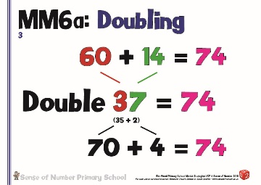
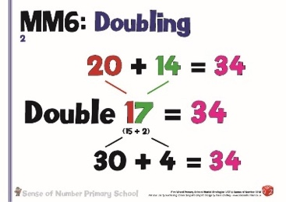

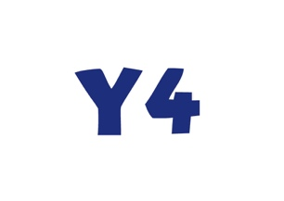
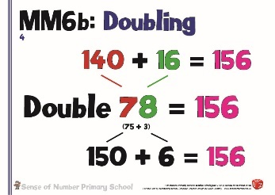

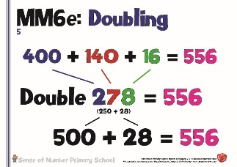
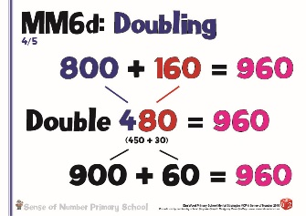
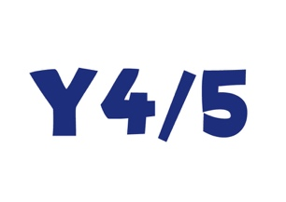

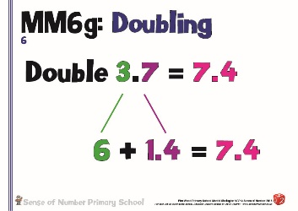
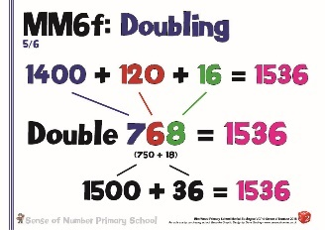
Y5/6

Once the children have learnt their doubles and their tables facts, there are then several mental calculation strategies that need to be taught so that children can continue to begin any calculation with the question ‘Can I do it in my head?’

The majority of these strategies are usually taught in Years 4 – 6, but there is no reason why some of them cannot be taught earlier as part of the basic rules of mathematics.

Multiplying by 10 / 100 / 1000

This strategy is usually part of the Year 5 & 6 teaching programme for decimals, namely that digits move to the left when multiplying by 10, 100 or 1000, and to the right when dividing.

This also secures place value by emphasising that the decimal point doesn’t ever move, and that the digits move around the decimal point (not the other way around, as so many adults were taught at school).

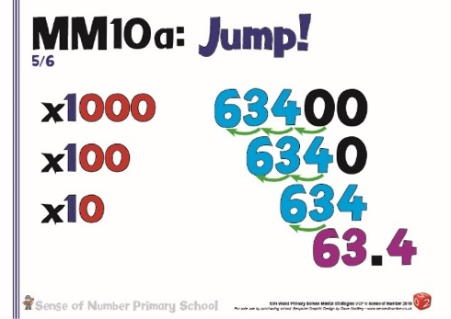
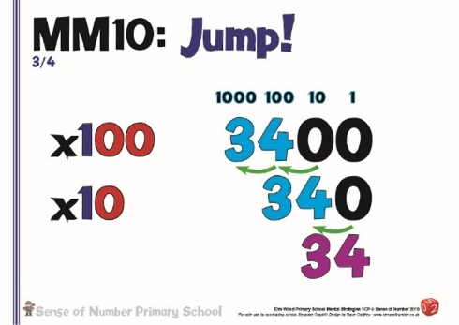

It would be equally beneficial to teach a simplified version of this strategy in KS1 / Lower KS2, encouraging children to move digits into a new column, rather than simply ‘adding zeroes’ when multiplying by 10/100.

The 2014 Curriculum emphasises the need for children to have conceptual understanding of any procedures that they have learnt, and ‘zero as a place holder’ can be taught very effectively with place value resources such as Base 10.

For example, multiplying 34 by 10 (the numbers seen above) would involve getting 3 Tens and 4 Ones then making each 10 times bigger.

3 Tens multiplied by 10 would give 30 Tens (which would be exchanged for 3 Hundreds)
4 Ones multiplied by 10 would give 40 Ones (which would be exchanged for 4 Tens.
The image would then be 3 Hundreds and 4 Tens or 340.

In the section on Mental Addition there were 6 key strategies outlined.
The following 4 strategies for mental multiplication can be explicitly linked to 4 of the strategies in mental addition –

Partitioning, Round & Adjust, Re-Ordering (Number Bonds) & Manipulate the Calculation

Partitioning

Partitioning is an equally valuable strategy for multiplication as it is for addition.
It can be quickly developed from a jotting to a method that is completed entirely mentally.
It is clearly linked to the grid method of multiplication, but should also be taught as a ‘partition jot’ so that children, by the end of Year 4, have become skilled in mentally partitioning 2 and 3 digit numbers when multiplying (with jottings when needed).

By the time children leave Year 6 they should be able to mentally partition most simple 2 & 3 digit, and also decimal multiplications, and should, wherever possible, be trying to work these out mentally.

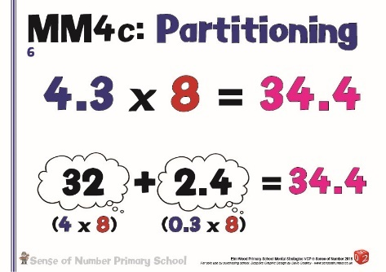
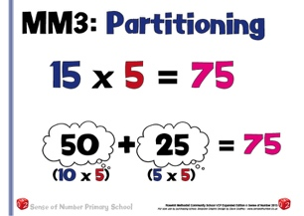

Round & Adjust

Round & Adjust is also a high quality mental strategy for multiplication, especially when dealing with money problems in upper KS2. Once children are totally secure with rounding and adjusting in addition, they can be shown how the strategy extends into multiplication, where they round then adust by the multiplier.
E.g. For 49 x 3 round to 50 x 3 (150) then adjust by 1 x 3 (3) to give a product of 150 – 3 = 147.
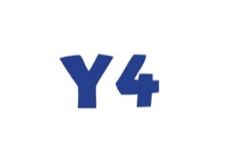
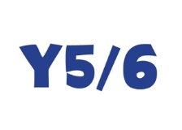

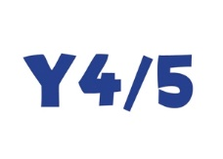
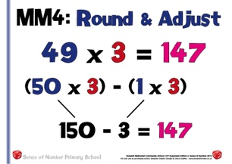
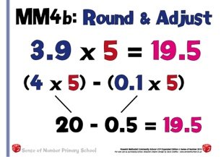
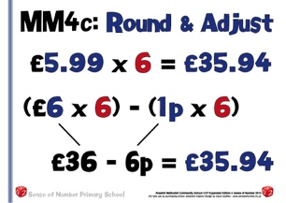
For 198 x 4, round to 200 x 4 (800) then adjust by 2 x 4 (8) for a product of 200 – 8 = 192
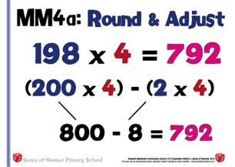

Re-ordering

Re-ordering is similar to Number Bonds in that the numbers are calculated in a different order.
With Number Bonds in addition the children look for a simple bond that will make the numbers easier to add.
In Re-ordering, the children look at the numbers that need to be multiplied, and, using commutativity, rearrange them so that the calculation is easier to complete.

The slides below show various examples of re-ordering.
Each slide re-orders the calculation in 3 ways. The asterisked calculation in each of the examples is probably the easiest / most efficient rearrangement of the numbers. For example, when multiplying 7 x 4 x 5 it is much quicker to multiply the 5 x 4 first.
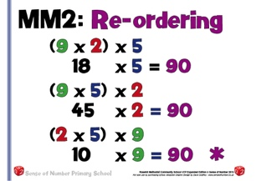
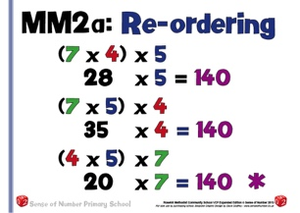
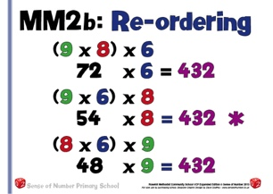

Manipulate Calculation

In addition, when applying this strategy, the children ‘passed over’ part of one number to the other in order to simplify the calculation.

In multiplication, however, they look at the numbers involved and determine whether an easier calculation can be created by dividing one of the numbers by a chosen amount and then multiplying the other by the same amount

This is probably the best strategy available for simplifying a calculation quickly, as long as the numbers being multiplied are appropriate.

To develop understanding of this strategy in Key Stage 1 or lower Key Stage 2, children can use practical apparatus to create an array. (E.g. 8 x 3)
They can then split the array in half, moving one half over the top of the other. This creates a new array of 4 x 6.
If they repeat this again they can create an array of 2 x 12. If they repeat it a final time then the array would be 1 x 24.

This demonstrates the general principle that if you double one number within a multiplication, and halve the other number, then the product stays the same.

Once this has been proved, the strategy can be developed to show that if you treble / quadruple one number within a multiplication, and third / quarter the other number, then the product will still stay the same. This can then be generalised for any multiple /. Fraction.

E.g. 27 x 3 is a 2 digit by 1 digit calculation. It can be manipulated into a known fact (9 x 9) if the 27 is divided by 3 and the 3 is multiplied by 3.

26 x 32 is quite a difficult long multiplication but if we multiply the 26 by 4 (by doubling twice) and divide the 32 by 4 we manipulate the calculation into a far easier 104 x 8.
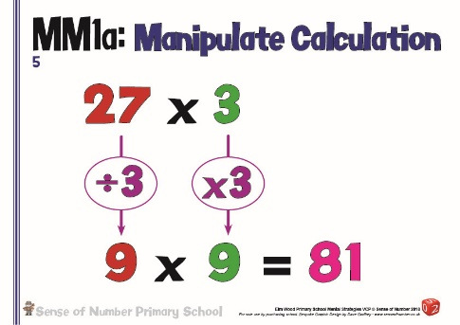
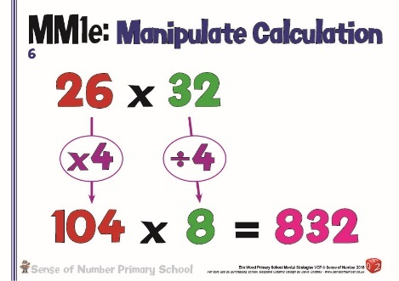

Doubling strategies are probably the most crucial of the mental strategies for multiplication, as they can make difficult long multiplication calculations considerably simpler.

Doubling Tables Facts
Initially, children are taught to double one table to find another.
E.g. Doubling the 4s to get the 8s (E.g. 1 below)
If 4 x 6 = 24 then 8 x 6 must be 48 because 8 is double 4 (4 x 12 is also 48 as 12 is double 6)

This can then be applied to any table: -

If 8 x 7 = 56 then 16 x 7must be 112 because 16 is double 8 (or 8 x 14 = 112)

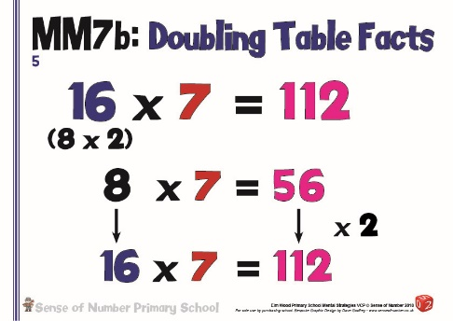
If 11 x 12 is 132 then 22 x 12 must be 264 because 22 is double 11 (or 11 x 24 = 264)
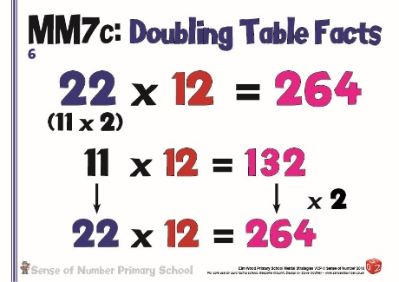
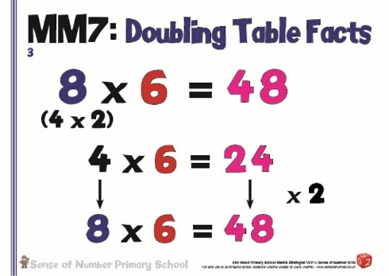
Doubling Up
This strategy develops the above strategy further, enabling multiples of 4, 8 and 16 onwards to be calculated by constant doubling.
It is linked very closely to the mental division ‘halving’ strategy, where we can divide by 8 by halving three times.: -

Multiply by 4 – double twice Multiply by 8 – double 3 times Multiply by 16 – Double 4 times

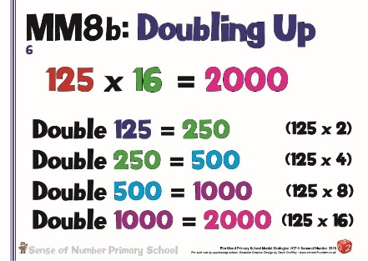
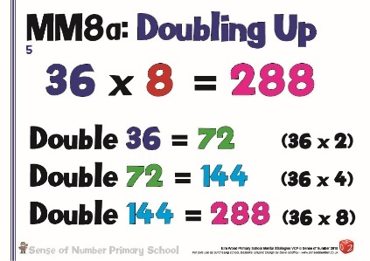
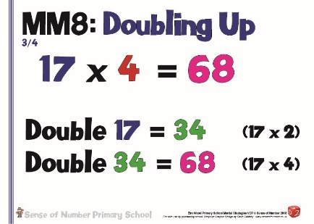

Multiplying by 10 / 100 / 1000 then halving / quartering
The final doubling / halving strategy works on the principle that multiplying by 10 / 100 is straightforward, and this can enable you to easily multiply by 5, 50 or 25.
Because 5 is half of 10 you can multiply a number by 10 then half it.
E.g. 86 x 10 = 860 so 86 x 5 must be 430.
In a similar way, 56 x 100 = 5600 so 56 x 25 must be a quarter of that amount (1400)
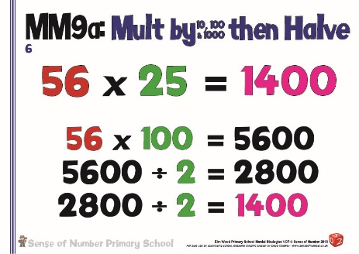
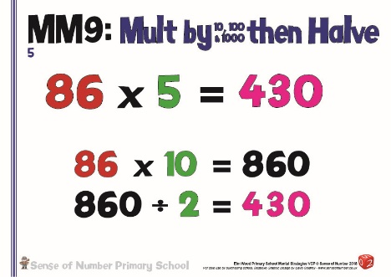

Factorising
The final mental strategy within the policy is factorising.
If children use their tables knowledge they can re-write a calculation to simplify it.
15 = 5 x 3 so multiplying 32 x 15 can be simplified as 32 x (5 x 3). 32 x 5 = 160 and 160 x 3 = 480

Multiplying a 2-digit number by 24, for example, may be easier if multiplying by a factor pair of 24. 52 x 24 = 52 x (4 x 6) 52 x 4 is a simple 208 then 208 x 6 is also a relatively straightforward 1248
This calculation could also be factorised as 52 x (8 x 3). 52 x 8 = 416. 416 x 3 = 1248
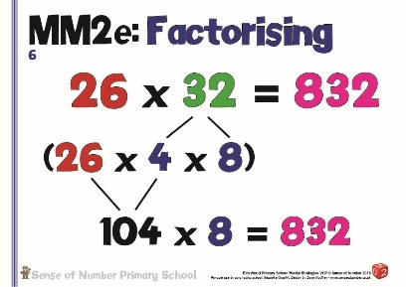
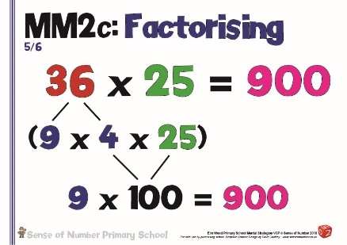
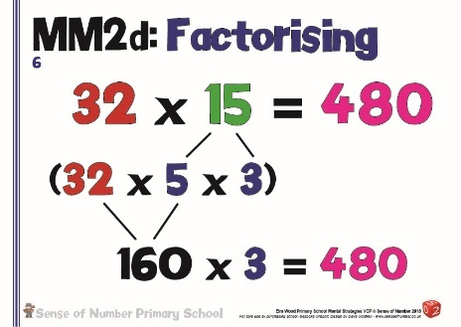

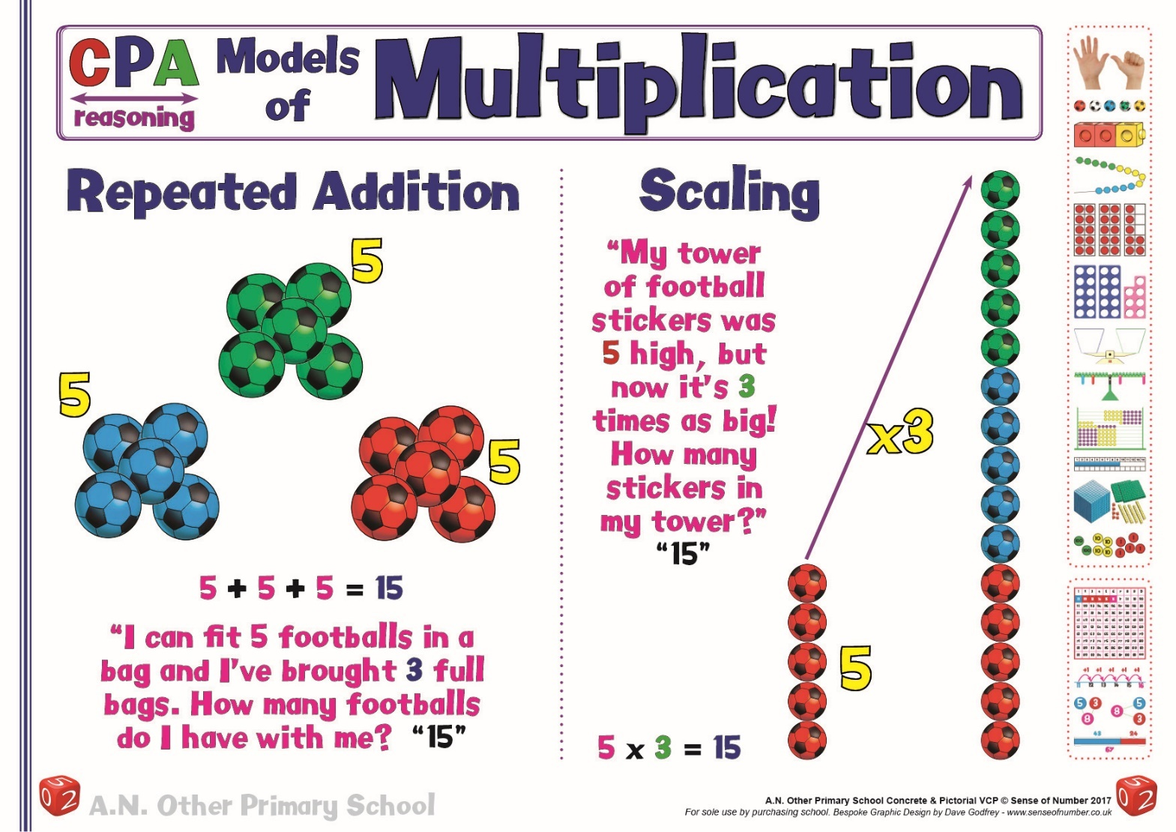
Models of Multiplication

The poster above shows the two images for multiplication which are used within the Visual Calculation Policy, either repeated addition or scaling, the reasons for adopting these models are explained below: -

Understanding Multiplication

One of the most difficult aspects when teaching multiplication is to ensure that it is taught consistently across the school. Due to the way that most teachers were themselves taught multiplication, there tend to be two approaches adopted across the UK.

For a calculation such as 6 x 3, it is commonly viewed either as ‘6 lots of 3’ (see left hand side of image below) or ‘6 repeated three times’ (see right hand image).
Teachers in KS1 sometimes move between the two images without realising, but usually settle on one particular explanation.

In later years, however, the image / explanation taught in KS1 often conflicts with the understanding needed to visualise a higher level calculation in KS2. Therefore, it is important that the image and explanation introduced in KS1 is the same image / explanation which continues to be used and developed in KS2.

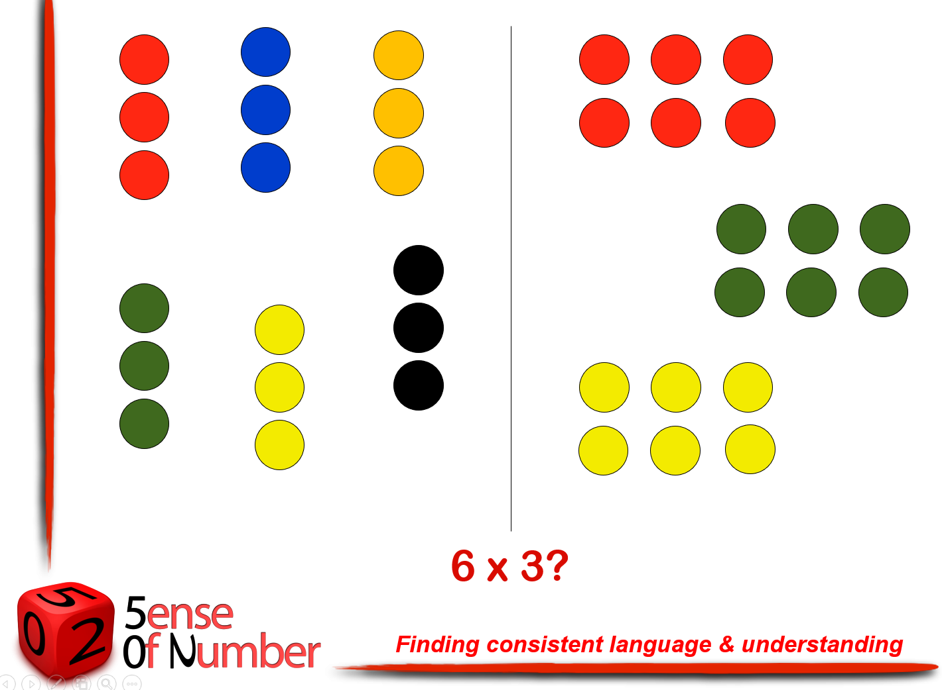

‘Lots of’ or ‘Repeat a number of times’???

It can be argued that both images above are models of 6 x 3, depending on your own interpretation, but only one image is mathematically accurate if we are teaching multiplication.
The key question to ask is ‘Which image is actually showing 6 multiplied by 3?’ In effect, which image takes 6 then multiplies it to make it 3 times as big?
This means that the correct image is the second one.
If we use the correct vocabulary and regularly say ‘multiplied by’ when reading a multiplication calculation then the second image would be the one which would automatically come to mind.
For example, ‘10 multiplied by 4’ would mean 10 objects (fingers on hands) repeated 4 times.

Teaching children that 6 x 3 is ‘6 lots of 3’ does give the same answer of 18, and when displayed as an array can be read either way, but saying that ‘times means lots of’ is not mathematically accurate and means that you are unable to use the word multiply correctly.

Consequently, this policy is consistent throughout in its use of ‘repeated addition’ and ‘multiply by’. In the example above, 6 x 3 means ‘take 6 objects then multiply the 6 objects by 3’, showing us ‘6 three times’

Scaling
The other way in which 6 x 3 can be explained correctly is through the use of scaling.
6 x 3 means 6 scaled up to be ‘3 times as big’.
This interpretation is commonly used throughout Europe and means that children see a multiplication calculation and immediately picture the answer as something which has been scaled up or down in size.
For example, 8 x 5 could be used for a word problem such as ‘John has an 8cm piece of string. Louise has a piece of string which is 5 times as long. How long is Louise’s string?’
In this instance there is no repeated addition or ‘lots of’. Louise’s string isn’t 8cm repeated 5 times (although that would give the same answer if they were laid out end to end) and it certainly isn’t 8 lots of 5 cm. It is a single 40cm piece of string which is 5 times longer than John’s 8cm piece.

Scaling is also very helpful for multiplying by fractions. 12 x 1/3 would mean 12 scaled to be 1/3 as big (i.e. 3 times smaller) 1/3 x 12 would be 1/3 made 12 times as big or 1/3 repeated 12 times. Both methods would give the correct answer of 4.

This is why the poster shows the two images for multiplication used within the Visual Calculation Policy as either repeated addition or scaling, but not ‘lots of’.
To summarise, here are the key reasons why ‘lots of’, although giving the correct answer, is not mathematically accurate: -

Conclusion: Why is 6 x 3 not really ‘6 lots of 3’?

- If we use the word multiply we would take 6 then multiply it by 3 - i.e. Get 6 (6x1) then another 6 (6x2) then another 6 (6x3)
- Multiplying can also be interpreted as scaling – 6 x 3 would be 6 made 3 times bigger (or scaled up 3 times)
- The ‘x’ sign is an ‘operator’ – it ‘operates’ or does something to the first number: -
  - 6 + 3 - you have 6 and then add more
  - 6 - 3 - you have 6 and then remove 3 or find the difference
  - 6 ÷ 3 - you have 6 then share it between 3 or group it into 3s
Therefore
  - 6 x 3 - you would have 6 and then get 2 more sixes i.e. you wouldn’t suddenly decide to pick up 3s
- If we ask the question ‘What is another way to say ‘x2’ the usual response is ‘double’.
If we then ask the question ‘What is another way to say ‘x3’ the usual response is ‘triple’ or ‘treble’.
Therefore… if we take 6 then times by 3 we are trebling the 6.

Written Methods of Multiplication

Stage 1 | Number Lines, Arrays & Mental Methods
FS | In Early Years, children are introduced to grouping, and are given regular opportunities to put natural resources and real life objects into groups of 2, 3, 4, 5 and 10.  They also stand in different sized groups, and use the term ‘pairs’ to represent groups of 2.  This is then developed into using resources such as Base 10 apparatus, Numicon, multi-link or an abacus. Children begin to visualise counting in ones, twos, fives and tens, saying the multiples as they count the pieces.  E.g. Saying ’10, 20, 30’ or ‘Ten, 2 tens, 3 tens’ whilst counting Base 10 pieces
 | 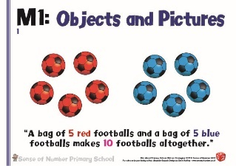  Begin by introducing the concept of multiplication as repeated addition. Before using mathematical apparatus, use real objects and equipment such as cups, cakes, footballs, pencils, apples etc.)  Children will firstly make then draw these objects in groups giving the product by counting up in 2s, 5s, 10s and beyond, and finally by writing the multiplication statement.  The picture above will begin as an addition ‘story’ (5 footballs and 5 footballs make 10 footballs) but will then be written as a multiplication calculation (5x 2 = 10)  Make sure from the start (as explained in the introduction to this section) that all children say the multiplication fact the correct way round, using the word ‘multiply’ more often than the word ‘times’ so that they understand what ‘multiplication’ means’  For the example above, there are 5 footballs in 2 groups, showing 5 multiplied by 2 (5x2), not 2 times 5. It is the ‘5’ which is being repeatedly added / scaled up / made bigger / multiplied.  ‘5 multiplied by 2’ shows ‘2 groups of 5’ or ‘Two fives’  Again, using resources and real life objects, involve the children in telling stories and creating pictures for the 3s and 4s, and then into writing multiplication statements.  E.g. 3 footballs + 3 footballs + 3 footballs + 3 footballs would show 3 x 4 = 12 footballs
The array
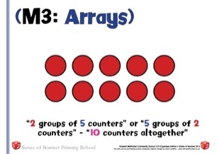
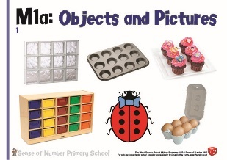

Build on children’s understanding that multiplication is repeated addition, using arrays and number lines to support their thinking.
Start to develop the use of the array to show linked facts (commutativity). .
Make arrays with a wide range of objects, especially those which naturally occur in real-life such as windows, egg boxes, drawers or cake trays.
Emphasise that all multiplications can be worked out either way (2 x 5 = 5 x 2 = 10) as this will support the children in the future learning of their tables facts.
Practice counting in both steps (E.g. Both 2s and 5s) to prove that the answer is the same no matter which way round they are counted.
Encourage the children to see how the array makes it easier to see the calculation as a multiplication rather than a repeated addition.

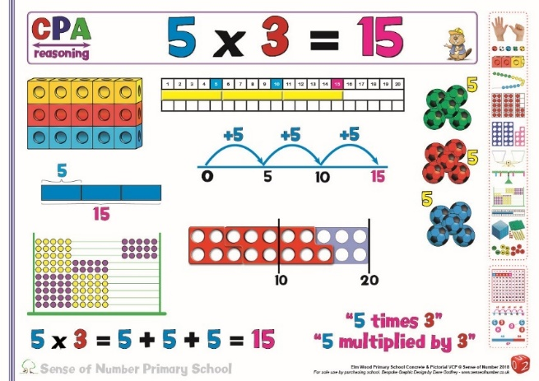
As with addition & subtraction, the key to developing clear understanding of multiplication is to involve the children in visualizing calculations with a wide range of resources. Using manipulatives such as Numicon, abacuses, number rods & multi-link, children can demonstrate & discuss their interpretation of multiplication statements
Continue to emphasise multiplication the correct way round.
E.g. 5 x 3 = 5 + 5 + 5
5 multiplied by 3 = 15

The above ‘materials can then be used alongside simple pictures and jottings which support the transition from repeated addition to multiplication.
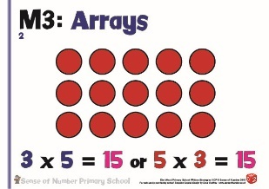
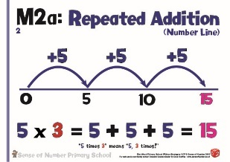
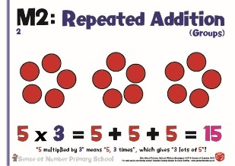

& | Extend the above to include the 3, 4, 8 and 11 times tables (Year 3)  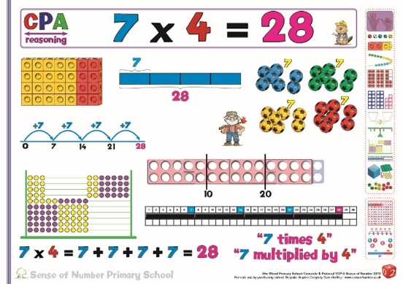  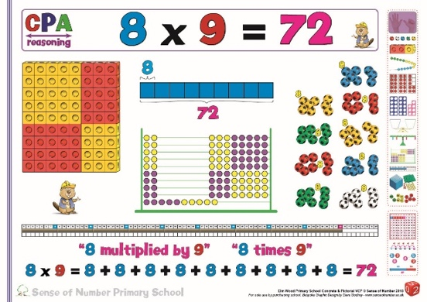  then the 6, 7, 9 & 12 times tables (Year 4)  Even when dealing with larger tables such as the 7’s and the 8’s it is crucial that children can create a model or image of the calculation.  The footballs simply show four 7s and nine 8’s as a real life picture, but the other images support children in either seeing the product or understanding the calculation in more depth.  The Multi-link and Abacus images are especially useful as they allow the 7 times table to be seen as a combination of the 5s and 2s and the 8 times table as 5s and 3s.  E.g. the 7 x 4 multi-link / abacus images are colour-coded to show a 5x4 array and a 2x4 array. The 8 x 9 images show 3x9 and 5x9.  The Number Rod image places the four 7s / nine 8s on a track to display the products 28 / 72, whilst the Numicon pieces are arranged on a Numicon ‘track’ to show the same product.  If the children become accustomed to using resources to support their counting, then use similar resources when displaying a visual for multiplication, they will automatically feel more confident when asked to picture / create / visualize a higher level calculation such as those later in this policy.
Extend the use of resources for 2 digit x 1 digit calculations so that children can visualize what the calculation looks like before they are taught any specific written methods or jottings.
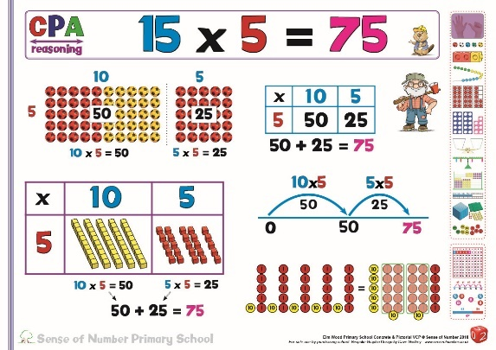

In each of the images above, 15 x 5 can be shown as a basic Tens and Ones partition
(I.e. 10 x 5 and 5 x 5) but the images allow different visualisations.

The footballs are laid out like a Slavonic abacus, allowing a clear visual of all 75 footballs but in an arrangement which makes them very easy to calculate.

The Base 10 apparatus is probably the most important image, and shows how the Tens and Ones are actually partitioned within a Grid Method – 5 Tens and 5 Ones.
This is the model (along with the Place Value Counters) which the children need to ‘make’ most often in class so that they become accustomed to exchanging / regrouping Ones into Tens (and then Tens into Hundreds with more complex calculations)

The Place Value Counters then demonstrates how the Tens and Ones are regrouped.
Twenty of the Ones are exchanged / regrouped into 2 Tens, giving 7 Tens and 5 Ones.

The Grid Method (covered in detail later) and number line (see below) are also pictured.

Once the general models and images for multiplication are secure, begin to partition the 2 digit number using jottings and number lines.
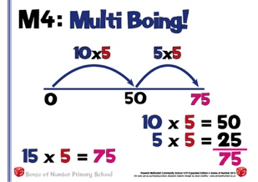
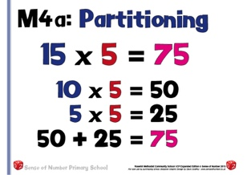
Extend the methods above to calculations which give products greater than 100.
Each of these methods can be used in the future if children find expanded or standard methods difficult.

Use of ‘Grid’ Method within the New Curriculum

In the New Curriculum (2014), the Grid Method is not exemplified as a written method for multiplication. The only methods specifically mentioned are column procedures.

Most schools in the UK, however, have effectively built up the use of the grid method over the past 15 years, to the extent that it is generally accepted as one of the most appropriate ‘written’ methods for simple 2 and 3 digit x single digit calculations (short multiplication).
It develops clear understanding of place value through partitioning as well as being an efficient method, and is especially useful in Years 4 and 5.

Consequently, grid method is a key element of this policy, but, to align with the New Curriculum, is classed as a mental ‘jotting’. It builds on partitioning, and is also the key mental multiplication method used by children in KS2 (pg. 44 – multiplication partitioning)
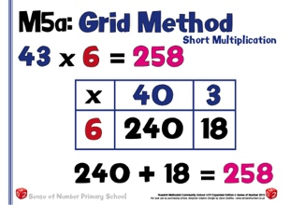
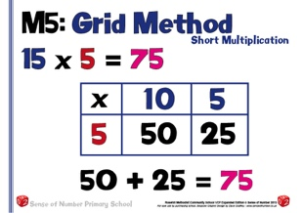

The examples above show the development of grid method from a straightforward 2 digit x 1 digit calculation with a product below 100 (15 x 5) to a more complex version (43 x 6) and then a 3 digit x 1 digit calculation (147 x 4). In each example the partitioning / place value link is very clear.
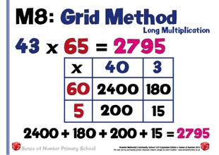
The Grid Method is equally as efficient for 2 digit x 2 digit calculations, providing an excellent basis and security for long multiplication.
Many children who find the column procedure difficult when faced with long multiplication are far more successful with the Grid Method, which builds on all of the place value and partitioning work developed earlier.
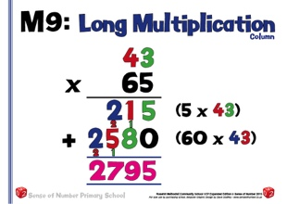
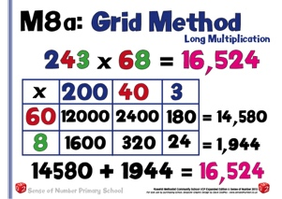
Column procedures still retain some element of place value, but, particularly for long multiplication, tend to rely on memorising a ‘method’, and can lead to many children making errors with the method (which order to multiply the digits, when to ‘add the zero’, dealing with the ‘carry’ digits’ etc.) rather than the actual calculation. In these instances, children will continue to use the grid method.

Once the calculations become more unwieldy (4 digit x 1 digit or 3 / 4 digit x 2 digit) then grid method begins to lose its effectiveness, as there are too many zeroes and part products to deal with.

At this stage column procedures are far easier, and, once learnt, can be applied much quicker.
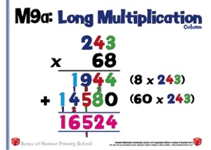
Grid methods can still be used by some pupils who find columns difficult to remember, and who regularly make errors, but children should be encouraged to move towards columns for more complex calculations

Stage 2 | Written Methods - Short Multiplication
Stage 2 | Grid Multiplication  (Mental ‘Jotting’) | Column multiplication  (Expanded method into standard)
 | The grid method of multiplication is a simple, alternative way of recording the partitioning jottings shown previously.  As shown earlier, it can initially be taught using an array to show the actual product  It is recommended that the grid method is used as the main method within Year 3. It clearly maintains place value, and helps children to visualise and understand the calculation better. | The expanded method links the grid method to the standard method.  It still relies on partitioning the tens and units, but sets out the products vertically.  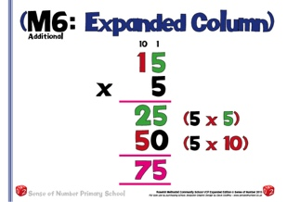  Children will use the expanded method until they can securely use and explain the standard method.
At some point within the year, the column method can be introduced, and children given the choice of using either grid or standard. Some schools may delay the introduction of column method until Year 4
Place the ‘carry’ digit below the line

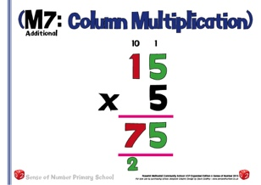
When setting out calculations vertically, begin with the ones first (as with addition and subtraction).

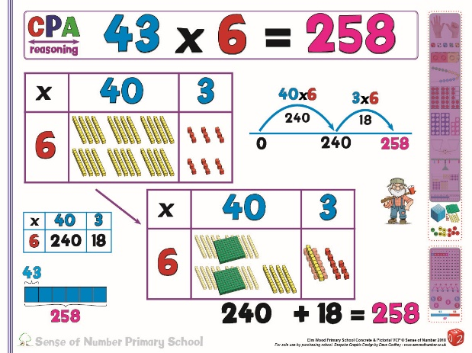
it is important to continue adopting the CPA approach by making and explaining the more complex 2 digit x 1 digit calculations.
E.g. Using Base 10 apparatus, children can demonstrate 43 x 6 as 4 Tens repeated 6 times
and 3 Ones repeated 6 times.
They can actually display this image within a Grid Method and then exchange / regroup 20 of the Tens into 2 Hundreds.
Continue to use apparatus regularly to support the place value and conceptual understanding of the calculation.
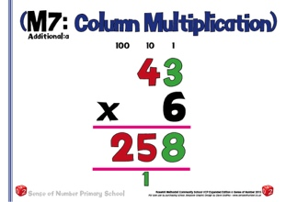
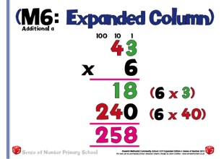
Continue to use both grid and column methods in Year 4 for more difficult 2 digit x 1 digit calculations, extending the use of the grid method into mental partitioning for those children who can use the method this way and can simply jot down the sub products and answer.

At this point, the expanded method can still be used when necessary (to help ‘bridge’ grid with column), but children should be encouraged to use their favoured method (grid or column) whenever possible.

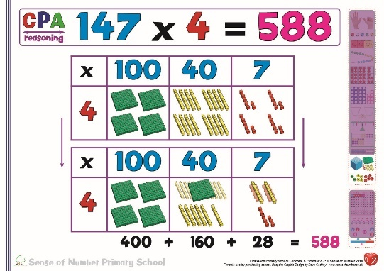
Using apparatus for 3 digit x 1 digit calculations is an excellent way to continue developing the conceptual understanding of what the calculations look like and the actual size of the number that is being manipulated.

In the example displayed, children can create
100 x 4, 40 x 4 and 7 x 4 using Base 10 then show how the 16 Tens can be exchanged / regrouped into 1 Hundred and 6 Tens.

For 3 digit x 1 digit calcualtions, both grid and standard methods are efficient.
Continue to use the grid method to aid place value and mental arithmetic.
Use column method for speed, and to make the transition to long multiplication easier.
If both methods are taught consistently then children in Year 4 will have a clear choice of 2 secure methods, and will be able to develop both accuracy and speed in multiplication.

 | 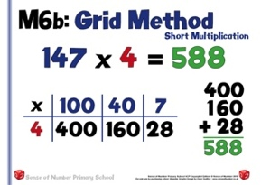  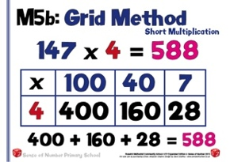  Sometimes children find the multiplication and place value parts of Grid Method to be fairly simple, but then struggle with the actual addition at the end (see 1st example above).  In these instances, encourage them to complete the addition using a column method (see 2nd example above) |  | 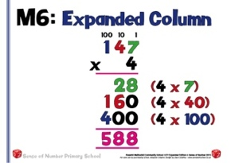  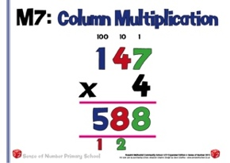  Expanded method can still be used for children who need extra support with place value (and as a ‘bridging’ method between grid and column procedures.  Once this is secure then they can practice the speed and security of the column method, but ensuring they can still explain the place value (using apparatus if necessary) when required
 | 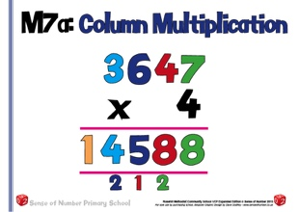  For a 4 digit x 1 digit calculation, the column method, once mastered, is quicker and less prone to error.  The grid method may continue to be the main method used by children who find it difficult to remember the column procedure, or children who need the visual link to place value.

Stage 3 | Long Multiplication (TU x TU)
Stage 3 | Grid Multiplication | Column multiplication  (Expanded method into standard)
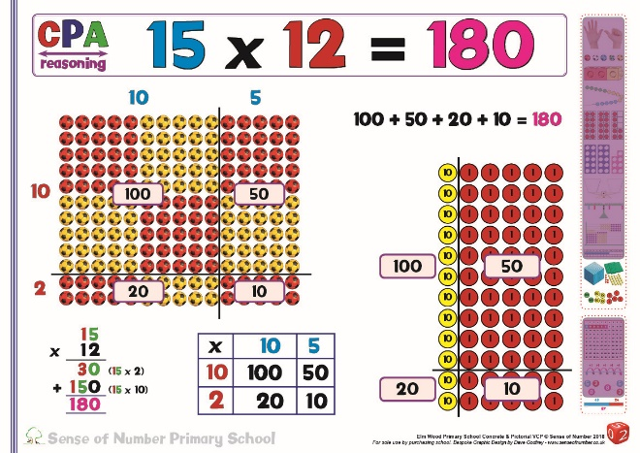
Even a simple long multiplication calculation can be displayed visually using an array set out in a Slavonic Abacus arrangement. The image on the poster shows a straightforward away to quickly see all 180 counters
At this stage, using Place Value Counters rather than Base 10 enables the calculation to be created more efficiently.

 | Extend the grid method to TU × TU, asking children to estimate first so that they have a general idea of the answer.  (43 × 65 is approximately 40 × 70 = 2800.)  As mentioned earlier, grid method is often the ‘choice’ of many children in Years 5 and 6, due to its ease in both procedure and understanding / place value and is the method that they will mainly use for simple long multiplication calculations. | Children should only use ‘standard’ column method for long multiplication if they can regularly get it correct using this method.  There is no ‘rule’ regarding the position of the ‘carry’digits. Each choice has advantages and complications.  Either carry the digits mentally or have your own favoured position for these digits.
  Again, estimate first:  243 × 68 is approximately 200 × 70  = 14000. | 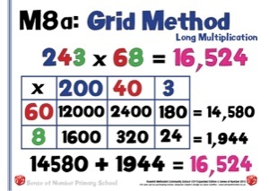  For 3 digit x 2 digit calculations, grid method is quite inefficient, and has much scope for error due to the number of ‘part-products’ that need to be added.  Use this method when you find the standard method to be unreliable or difficult to remember. | 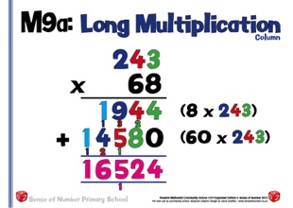  Most children, at this point, should be encouraged to choose the standard method. For 3 digit x 2 digit calculations it is especially efficient, and less prone to errors when mastered.  Although they may find the grid method easier to apply, it is much slower / less efficient.
 | 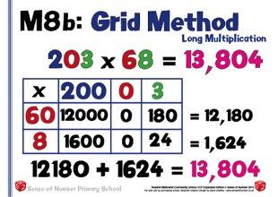  The Grid Method is an interesting way to show the part products that are created when multiplying with a 3 digit number with no Tens (or Zero in the Tens place).  The 4 parts are either very large (12000&1600) or quite small (180&24). As the method shows 6 parts altogether, it is clear that 2 of them are not used. | 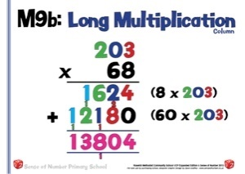  The column method shows the same overall product as the Grid Method (13,804)  It doesn’t, however, appear to be any different to a regular 3 digit x 2 digit calculation as the display simply shows the 2 part products created when multiplying by 68
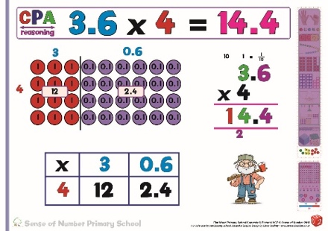
Even when multiplying decimals, Place Value Counters can be used first in order to visualise the calculation before progressing onto Grid and Column Methods
 | 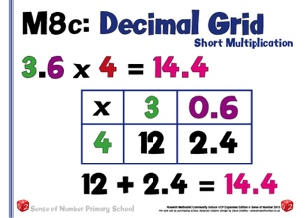  Many children will find the use of Grid method as an efficient method for multiplying decimals. They must also practice mental partitioning for decimal calculations such as the one above. | 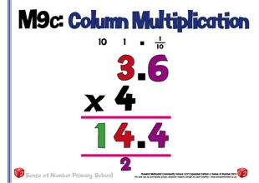  Extend the use of the column method into decimal multiplication.  It is advisable to set out the columns as shown on the example above so that the place value remains secure.  It is also helpful to the children in showing how many digits will need to be displayed after the decimal point.
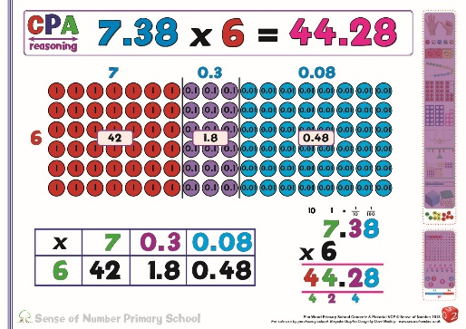
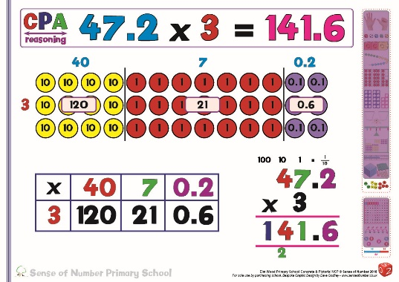

Even when the calculations become quite complex, Place Value Counters allow an instant visualise not only of the actual calculation but also of the exchanging / regrouping which needs to take place. Ask the children to make the calculation and explain the procedure before moving to column method
 | 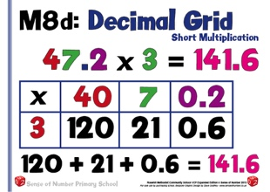 | 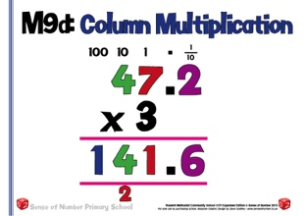
 | 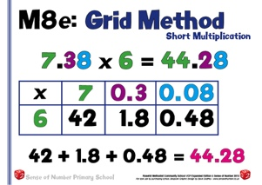 | 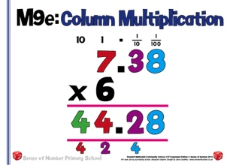
 |  | In the examples above, continue to think carefully about the layout of the calculation, keeping the place value accurate when multiplying.
 | 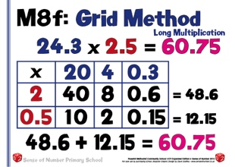 | 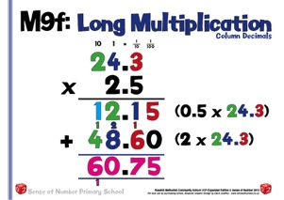
 | At this point children can use either standard method or grid method, but the coloumn procedue tends to be more efficient.
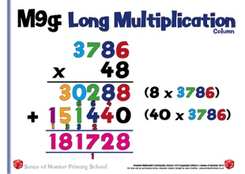

By the time children meet 4 digits by 2 digits, the only efficient method is the standard method for Long Multiplication.

Division Progression
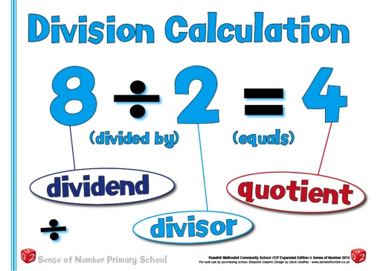
The aim is that children use mental methods when appropriate, but for calculations that they cannot do in their heads they use an efficient written method accurately and with confidence.

These notes show the stages in building up to long division through Years 3 to 6 – first using short division 2 digits ÷ 1 digit, extending to 3 / 4 digits ÷ 1 digit, then long division 4 / 5 digits ÷ 2 digits.

To divide successfully in their heads, children need to be able to:
- understand and use the vocabulary of division – for example in 18 ÷ 3 = 6, the 18 is the dividend, the 3 is the divisor and the 6 is the quotient;
- partition two-digit and three-digit numbers into multiples of 100, 10 and 1 in different ways;
For example, without a clear understanding that 72 can be partitioned into 60 and 12, 50 and 22, 40 and 32 or 30 and 42 (as well as 70 and 2), it would be difficult to divide 72 by 6, 5 4 or 3 using the ‘chunking’ method.
72 ÷ 6 ‘chunks’ into 60 and 12
72 ÷ 5 ‘chunks’ into 50 and 22
72 ÷ 4 ‘chunks’ into 40 and 32
72 ÷ 3 ‘chunks’ into 60 and 12 or 30 and 42 (or 30, 30 and 12)

- recall multiplication and division facts to 12 × 12, recognise multiples of one-digit numbers and divide multiples of 10 or 100 by a single-digit number using their knowledge of division facts and place value;
- know how to find a remainder working mentally – for example, find the remainder when 48 is divided by 5;
- understand and use multiplication and division as inverse operations.

Children need to acquire one efficient written method of calculation for division, which they know they can rely on when mental methods are not appropriate.

Note: It is important that children’s mental methods of calculation are practised and secured alongside their learning and use of an efficient written method for division.

To carry out written methods of division successfully, children also need to be able to:
- visualise how to calculate the quotient by visualising repeated addition;
- estimate how many times one number divides into another – for example, approximately how many sixes there are in 99, or how many 23s there are in 100;
- multiply a two-digit number by a single-digit number mentally;
- understand and use the relationship between single digit multiplication, and multiplying by a multiple of 10.
(e.g. 4 x 7 = 28 so 4 x 70 = 280 or 40 x 7 = 280 or 4 x 700 = 2800.)
- subtract numbers using the column method (if using the NNS ‘chunking’ method)
The above points are crucial. If children do not have a secure understanding of these prior-learning objectives then they are unlikely to divide with confidence or success, especially when attempting the ‘chunking’ method of division.

N.B. Please note that there are two different ‘policies’ for chunking, both of which are outlined and explained within this document.

Chunking Option 1: National Numeracy Strategy Model:

The first would be used by schools who have continued to adopt the NNS model. This model was part of the curriculum for 15 years but was never embraced to the same level as the grid method of multiplication or the number line method of subtraction. Many schools found NNS chunking to be ‘unwieldy’ and very difficult for children to memorise, even though it was based on clear mathematical principles. There were often too many stages to ‘chunking’ and only children with a very secure knowledge of tables and a strong sense of number were able to use it consistently and accurately. It does, however, provide an alternative approach to long division which some children favour.
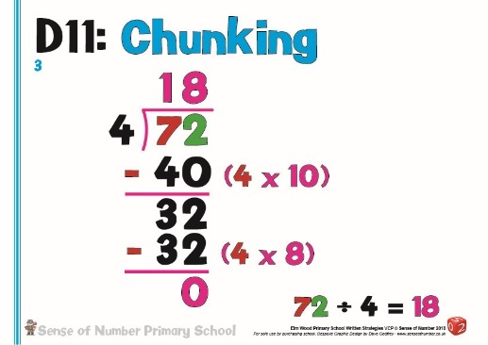
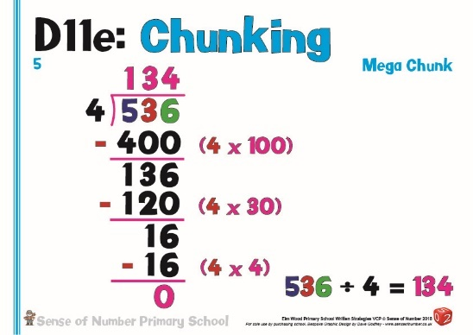

Chunking Option 2 (recommended): ‘Find the Hunk’ Model:

The second ‘recommended’ model of chunking is for schools who have made the (sensible) decision to teach chunking as a mental arithmetic / number line process, and prefer to count forwards in chunks rather than backwards. The model will be entitled ‘Find the Hunk’ within this policy, and will be part of both the mental division policy (as a quick mental chunk) and also the written policy (as a jotting to support mathematical thinking). ‘Find the Hunk’ has a clear link to partitioning as it requires children to understand how a number can be partitioned in different ways.
(See ‘Mental Division’ for a detailed overview of ‘Find the Hunk!’)
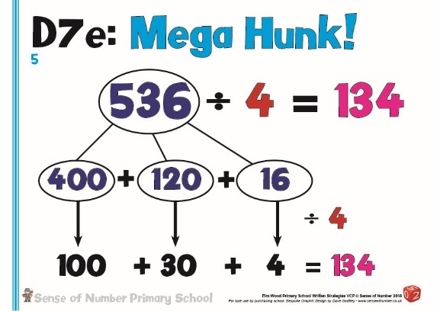
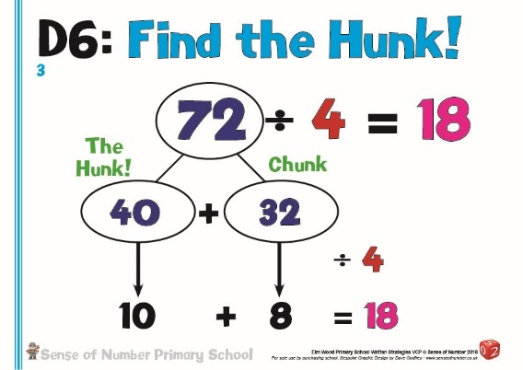

Mental Division Strategies

In general, when faced with a division calculation, most people choose to use a written method. This is usually the formal ‘bus stop’ method of division, and tends to be the chosen strategy no matter which numbers are being divided.

There are, however, quite an extensive range of mental division strategies which can be used depending on the numbers involved. Children need to be encouraged to use their sense of number and to approach each calculation in the same way as addition, subtraction and multiplication, asking themselves ‘Can I do it in my head?’

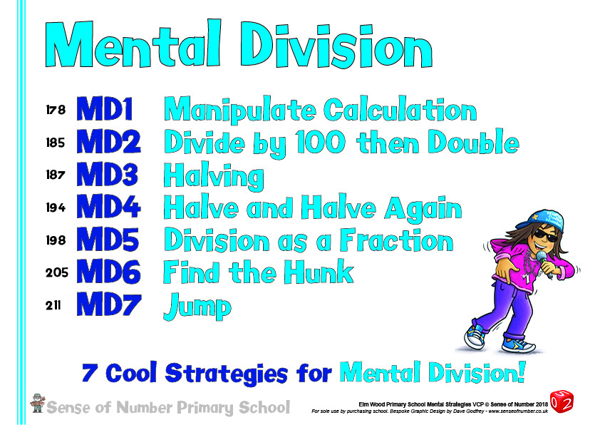

Doubles & Halves

As mentioned earlier within the section on multiplication, children need to know by heart certain doubles and halves. As these are no longer mentioned explicitly within the National Curriculum, it is crucial that they are part of a school’s mental calculation policy.

In a very similar way to doubling, if children haven’t learnt to recall simple halves instantly, or, more importantly, haven’t been taught strategies for mental halving, then they cannot access some of the mental calculation strategies for division (E.g. Halve twice to divide by 4, halve three times to divide by 8, divide by three then halve to divide by 6)

Halving numbers is particularly crucial when working with fractions (From 1/2s to 1/4s to 1/8s, from 1/3s to 1/6s to 1/12s etc. Children who can halve numbers effectively can quickly work out that 1/8 of 60 is 7.5 by halving 3 times or 1/12 of 90 is also 7.5 by finding a third then halving twice

(See multiplication section for general guidance on which
doubles and halves children should know in each year group)

Halving (MD3)
Before certain doubles / halves can be recalled, children can use a simple partition jotting to help them record their steps towards working out a double / half. This begins with a straightforward halving of the Tens and halving of the Ones (see Y2 & Y3 examples below).
Children, however, also need to see that there are often easier ways to halve if they use their skill of partitioning in different ways.
Halving 92 can be worked out by halving 90 and halving 2 but also by halving 80 and halving 12, which many children find easier (See Y3/4 example below)
Similarly, for children who know half of 32 is 16, half of 326 can be worked out in two steps rather than 3 (see Y4/5 example)
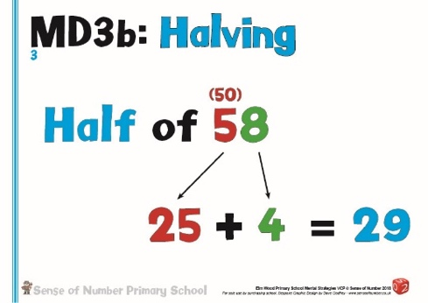
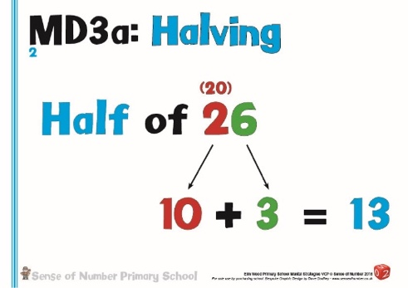
Y3
Y2

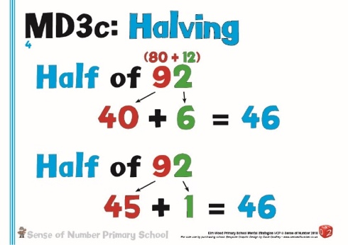
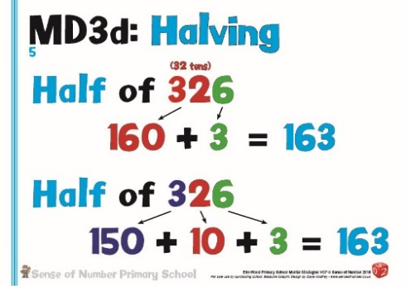
Y4/5
Y3/4

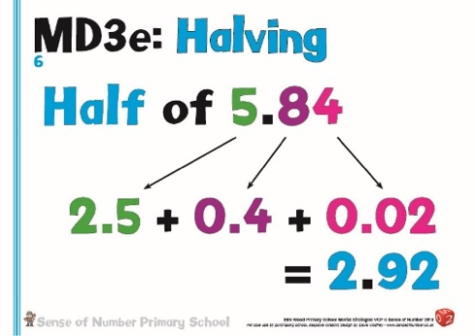
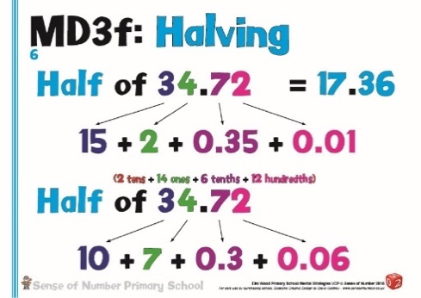
Y5
Y6

Once the children have learnt their halves (and their tables facts), there are then several mental calculation strategies that need to be taught so that children can continue to begin any calculation with the question ‘Can I do it in my head?’

The majority of these strategies are usually taught in Years 4 – 6, but there is no reason why some of them cannot be taught earlier as part of the basic rules of mathematics.

Halve & Halve (& Halve) Again (MD4)

As outlined above, the main use of halving as a mental strategy is in order to make dividing by 4 or dividing by 8 much easier.
To divide 128 by 4, rather than using a written procedure, it makes more sense to simply halve the number twice.

Dividing 360 by 8 can be done several ways, including mentally chunking the number into 320 and 40 then dividing both parts by 8 (see ‘Find the Hunk’ strategy below). The easiest method, however, for many children (& adults!) is to halve the 360 three times.

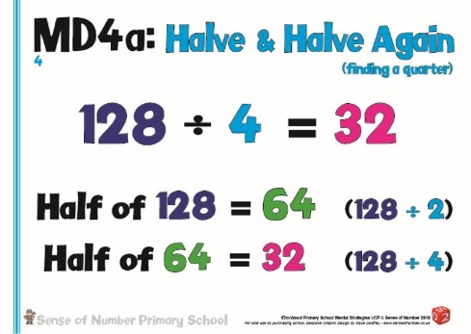
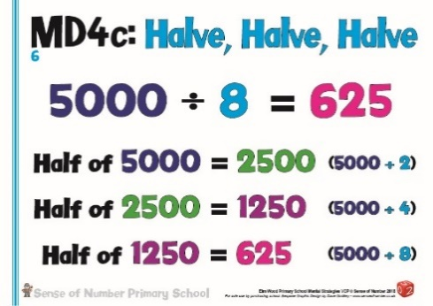
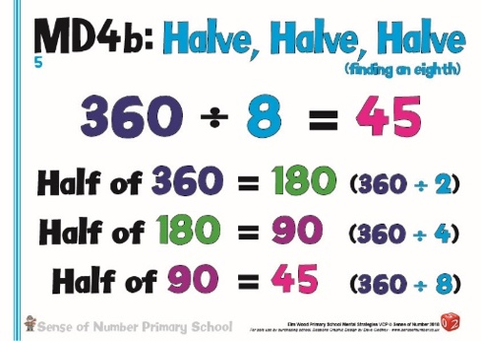
Similarly, dividing 5000 by 8 would normally involve a bus stop method. This can be made far easier by halving 5000 to give 2500, halving again to give 1250 then halving a third time to leave a quotient of 625.

Dividing by 100 then double / double twice (MD2)

The final doubling / halving strategy works on the principle that dividing by 10 / 100 is straightforward, and this can enable you to easily divide by 5, 50 or 25.
Because 5 is half of 10 you can divide a number by 10 then double it.
E.g. 240 ÷ 5 (how many 5s are there in 480) could be simplified by dividing by 10 (how many 10s are there in 240?) then doubling the answer.
240 ÷ 10 = 24 so 240 ÷ 5 must be 48.
Similarly, because 50 is half of 100 you can divide a number by 100 then double it.

Using the examples below, for 800 ÷ 50 we can use 800 ÷ 100 = 8 so 800 ÷ 50 must be 16
In a similar way, for 800 ÷ 25 we can double the answer twice: -
800 ÷ 100 = 8 therefore 800 ÷ 50 must be 16 and therefore 800 ÷ 25 must be 32
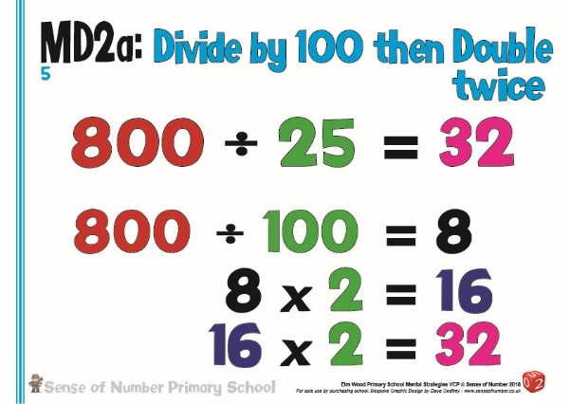
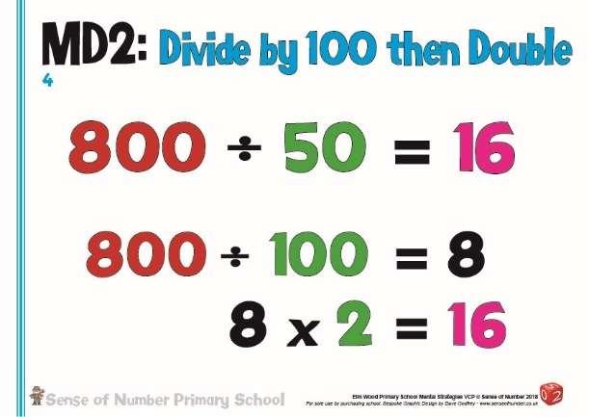

Dividing by 10 / 100 / 1000 – Jump! (MD7)

As with multiplication, this strategy is usually part of the Year 5 & 6 teaching programme for decimals, namely that digits move to the left when multiplying by 10, 100 or 1000, and to the right when dividing by 10 / 100 / 1000
This also secures place value by emphasising that the decimal point doesn’t ever move, and that the digits move around the decimal point (not the other way around, as so many adults were taught at school).

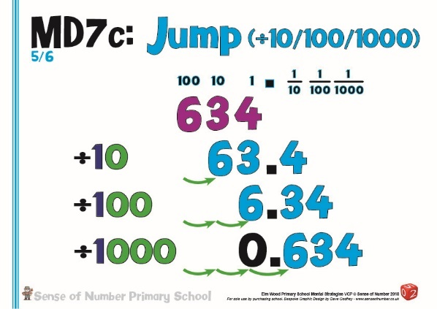
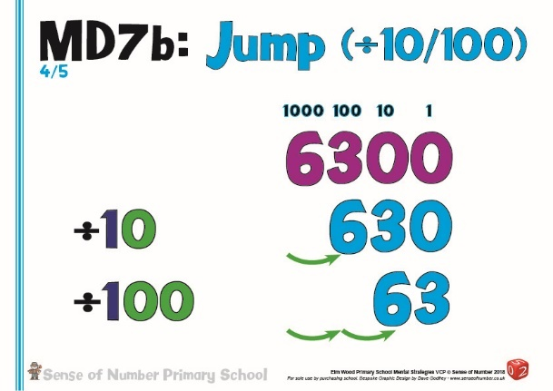

It would be equally beneficial to teach a simplified version of this strategy in KS1 / Lower KS2, encouraging children to move digits into a new column, rather than simply ‘removing zeroes’ when dividing by 10/100.

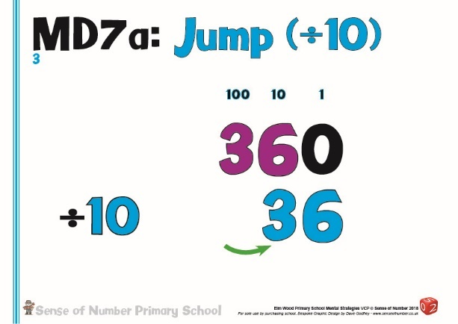
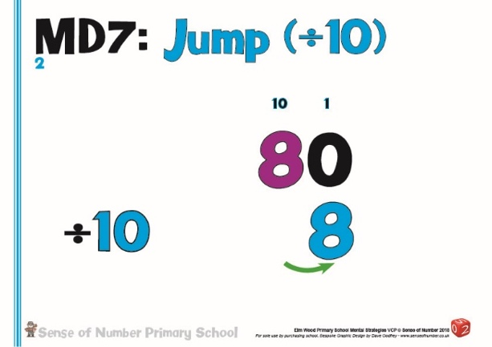

The 2014 Curriculum emphasises the need for children to have conceptual understanding of any procedures that they have learnt, and ‘zero as a place holder’ can be taught very effectively with place value resources such as Base 10.

For example, dividing 360 by 10 (the numbers seen above) would involve getting 3 Hundreds and 6 Tens then making each 10 times smaller.
3 Hundreds divided by 10 would give 3 Tens (visualise this by highlighting 1/10 of each of the Hundreds)
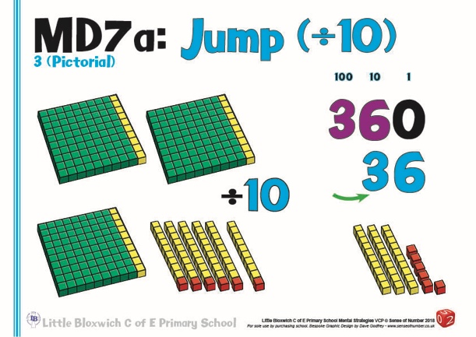
6 Tens divided by 10 would give 6 Ones (visualise this by highlighting 1/10 of each of the Tens)

The new image would then be 3 Tens and 6 Ones or 36.

Manipulate the Calculation (MD1)

As with the other three operations, ‘Manipulate the Calculation’ involves adapting the calculation to make it much easier. Children should be taught that any division calculation can be manipulated by either multiplying or dividing both the dividend and the divisor by the same amount.
If understood, this is an outstanding strategy that allows many complicated divisions to be re-written in a simplified form.
In principle this is the same strategy applied when creating equivalent fractions; the numerator and denominator are either multiplied or divided by the same number.
E.g. 35/50 can be simplified by dividing both numbers by 5 to make an equivalent fraction of 7/10.
As a division, this could also be written as
35 ÷ 50
÷ 5 ÷ 5
7 ÷ 10
If the same principle is applied to a more traditional division, when the dividend is larger than the divisor, a complex calculation can be made much easier.

In the first example,140 ÷ 20 can be manipulated into 14 ÷ 2 if both numbers are divided by 10.
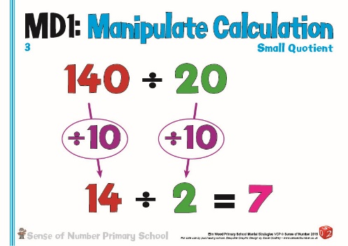
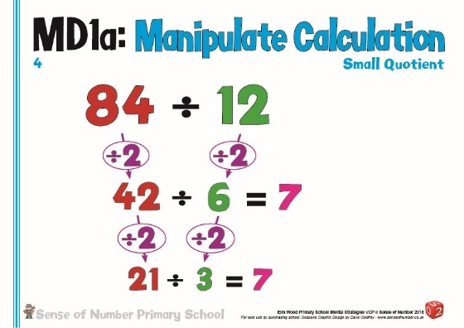
The second example shows how a Year 4 calculation 84 ÷ 12 can be rewritten as 42 ÷ 6 or even 21 ÷ 3 if both of the numbers are halved.

The third example demonstrates an excellent way to simplify a calculation.
162 ÷18 appears to be a fairly complex long division, but if both numbers are halved then the calculation has been manipulated into a straightforward 81 ÷ 9.

In some instances division calculations can also be simplified by multiplying the dividend and divisor by the same amount. This is especially true when faced with a decimal division.
9.3 ÷ 0.3 is a challenging calculation (in effect asking you to work out how many times 3/10 can be divided into 9 and 3/10).
If both numbers are multiplied by 10 the resulting calculation is a far simpler 93 ÷ 3.
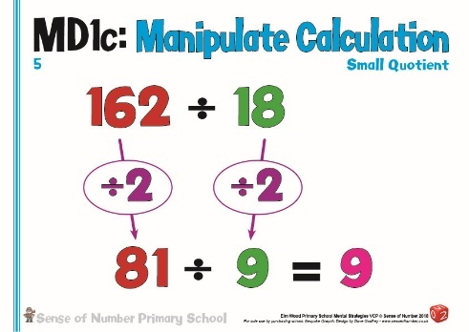
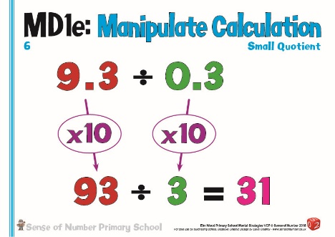
Division as a Fraction (MD5)

This a much higher level strategy that is usually left until Year 6, or even at high school, but there is no reason why children cannot be introduced to it much earlier if they are secure in their understanding that every division can be written as a fraction and every fraction can be written as a division.

The earliest understanding of this strategy begins in Year 1, when children first meet the fractions ½ and ¼.
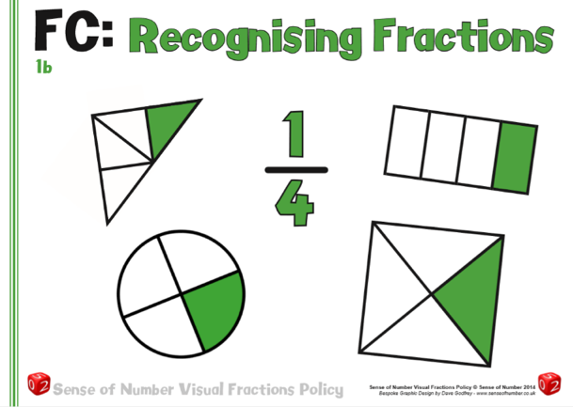
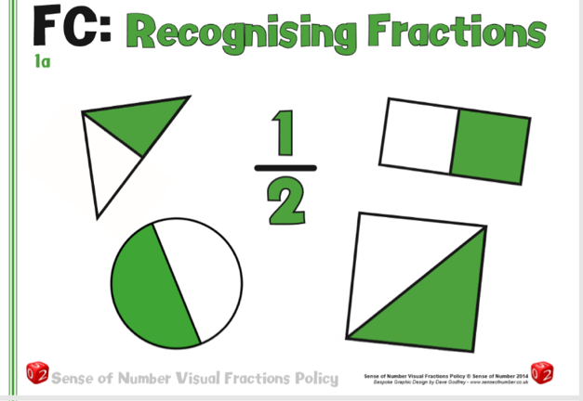
In almost all instances, they are given a simple picture of a half as ‘1 out of 2’ and a quarter as ‘1 out of 4’. They are also introduced to the written fractions ½ and ¼.

The fraction line/bar (or the ‘vinculum’) is then described as meaning
‘out of’ (1 piece out of 4 equal pieces),
‘shared between’ (1 cake shared between 4 people)
or ‘divided by’ (1 whole divided by / into / between 4)
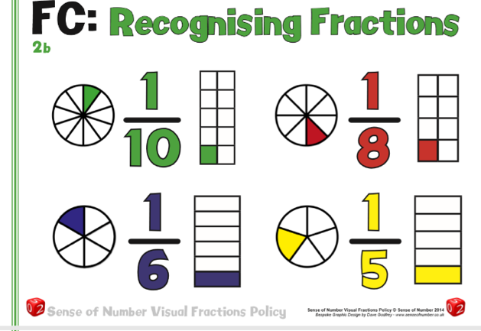
These definitions continue in Key Stage 2 with other unit fractions.

1/6 is 1 out of 6,

1 cake shared between 6

1 whole divided by 6 / into 6 pieces / between 6

Unfortunately, it is rare for the actual division statement to also be written alongside the fraction.

½ could also be written as 1 ÷ 2.
¼ could also be written as 1 ÷ 4.
1/6 could also be written as 1 ÷ 6.

If this understanding was developed throughout the school then all fractions can be written and displayed in different ways.
The usual way to show 3/5 would be 3 out of 5 (as seen in the first picture below) – this picture is in effect showing 3/5 of 1 whole.
The alternative image, though, (following the principles outlined for ½, ¼ and 1/6) would be 3 divided between 5.
If 3 cakes were divided between 5 people, how much would each person get?
Using the second picture, they would get 1/5 from each cake, or 3/5 altogether.
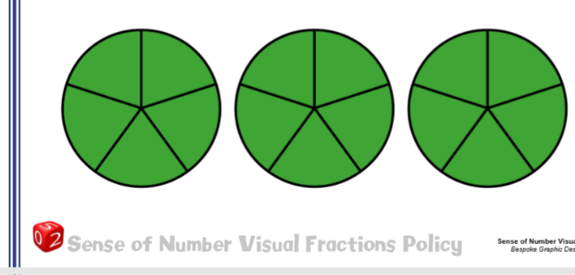
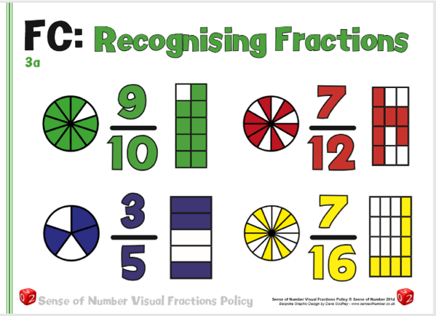

Therefore, children could be taught that every ‘fraction’ statement
could potentially be made easier if written as a division statement.

At a very simple level, ¼ of 20 could be re-written (and displayed) as 20 ÷ 4
or 1/8 of 24 could be re-written (and displayed) as 24 ÷ 8.

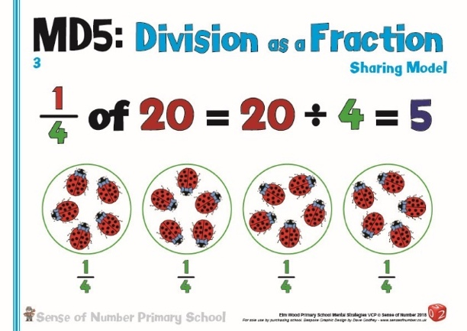
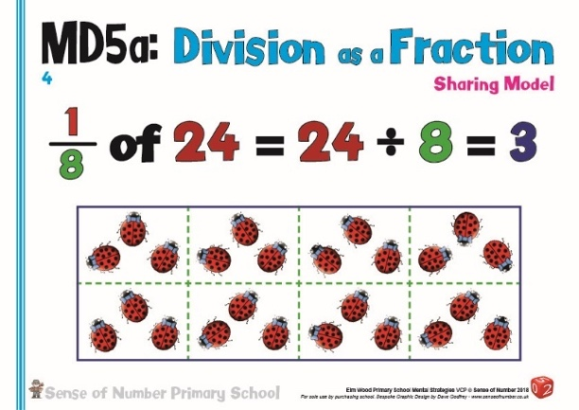

Developing this further, a calculation that appears to be quite complex for a child within Year 4, such as ¼ of 3, can be answered extremely quickly if rewritten as a division and then manipulated into a fraction.
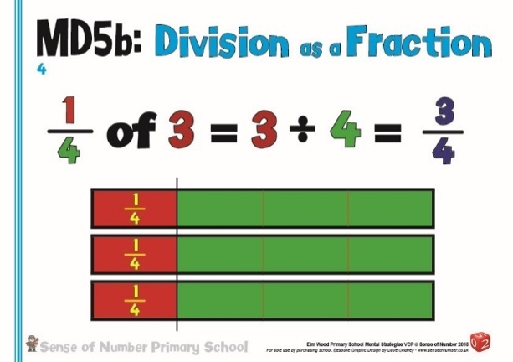

¼ of 3 means 3 ÷ 4.
3 ÷ 4 can be rewritten as ¾.

This strategy can then be applied alongside the understanding / strategy of converting improper fractions to mixed numbers in Years 5 & 6.

Consequently, calculations which appear to be extremely difficult to answer mentally can be rewritten as a mental jotting and then worked out quickly.

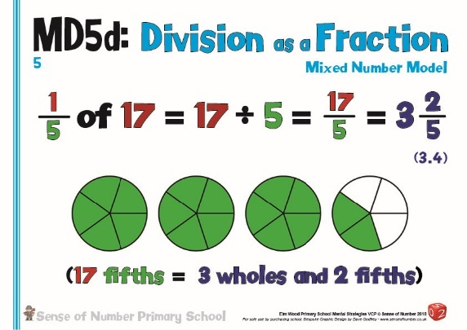
1/5 of 17 also means 17 ÷ 5
(Y3 – division with remainders)
17 ÷ 5 can be rewritten as 17/5
(Y5 – Improper fraction to mixed number)
17/5 = 3 and 2/5 (or 3.4)
(Y5/6 – Fraction to decimal equivalence)

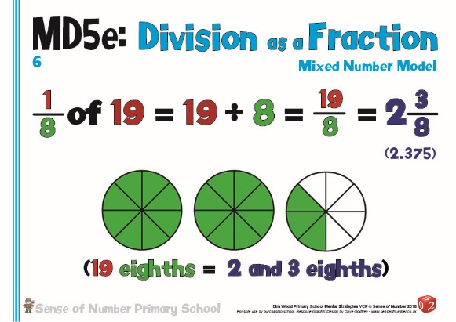

1/8 of 19 also means 19 ÷ 8.
19 ÷ 8 can be rewritten as 19/8.
19/8 = 2 and 3/8 (or 2.375)

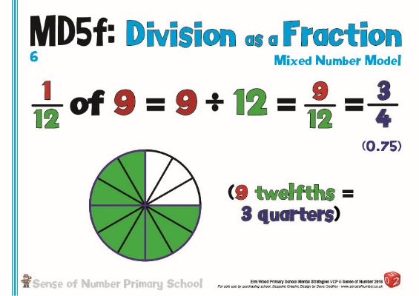
Even 1/12 of 9 also means 9 ÷ 12.
9 ÷ 12 can be rewritten as 9/12.
9/12 = 3/4 (or 0.75)

Find The Hunk! (MD6)

The final mental method is the only strategy which is part of both the mental and written policies. It provides an excellent way to mentally calculate division calculations but is equally an extremely efficient and helpful written jotting.

The other strategies outlined so far are mainly specific to certain types of numbers. They should be chosen when the children are looking carefully at the numbers involved and as such selecting the most appropriate strategy.

‘Find the Hunk!’, however, can be applied to almost any division calculation as a quick way to make the calculation easier.
It does require the children to have a secure bank of multiplication and division facts, but once these have been learnt it can be taught on a regular basis.
Schools who have used the ‘Find the Hunk!’ strategy for several years find that their children have a far better understanding of conceptual division, and are able to manipulate numbers much more quickly and easily.

The foundations of ‘Find the Hunk!’ are found in the Year 2 / 3 objectives related to partitioning in different ways.
If children are confident and accustomed to seeing 2 and 3 digit numbers displayed in different ways then they can apply this knowledge in order to divide mentally.

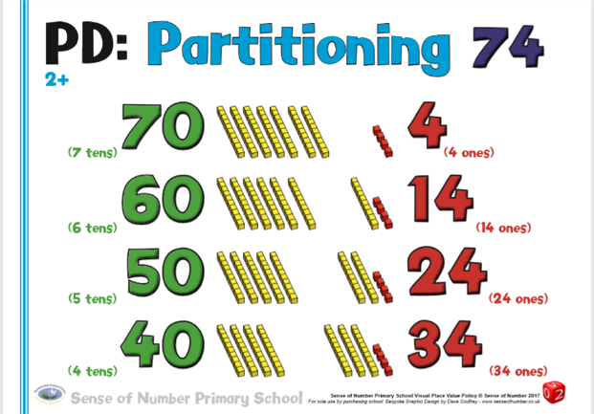
In the example on the left, the number 74 can be partitioned in a conventional way as 70 and 4.
By moving the Tens pieces, though, it becomes clear that 74 can also be modelled as: -

60 and 14
50 and 24
40 and 34

If this understanding is applied to any 2 digit number then it becomes apparent that all 2 digit numbers can be written in a range of different ways.
For example: -
52 could be rewritten as 40 and 12
84 could be rewritten as 60 and 24
91 could be rewritten as 70 and 21

If we were now asked to calculate 56 ÷ 4, 48 ÷ 3 or 91 ÷ 7 we could use the different partitions to help us get the answer mentally.

52 ÷ 4 52 = 40 + 12 If 40 ÷ 4 = 10 and 12 ÷ 4 = 2 then 52 ÷ 4 = 13 (10 + 3)
84 ÷ 6 84 = 60 + 24 If 60 ÷ 6 = 10 and 24 ÷ 6 = 4 then 84 ÷ 6 = 14 (10 + 4)
91 ÷ 7 91 = 70 + 21 If 70 ÷ 7 = 10 and 21 ÷ 7 = 3 then 91 ÷ 7 = 13 (10 + 3)

‘Find the Hunk’ turns the above principle into a simple jotting, which is eventually stored and applied mentally. It is a mental strategy based on mental partitioning.
The first stage of the jotting is to ‘Find the Hunk’.
The ‘Hunk’ is the largest chunk of the divisor that can be quickly made from the dividend
For most examples, the Hunk is defined as being 10 times the divisor.
i.e. the divisor is 4, so the Hunk will be 4 x 10 = 40.

Both chunks are then divided by the divisor and then the groups totalled.

From the previous examples,
for 52 ÷ 4, the ‘Hunk’ would be 40 (4 x 10),
for 84 ÷ 6, the ‘Hunk’ would be 60 (6 x 10)
and for 91 ÷ 7, the ‘Hunk’ would be 70 (7 x 10)

52 ÷ 4 84 ÷ 6 91 ÷ 7

40 12 60 24 70 21
÷ 4 ÷ 6 ÷ 7

10 3 = 13 10 4 10 3

Using the examples below from the Mental (and Written) Calculation Policy, it can be seen how ‘Find The Hunk’ can be developed from a simple division with a whole number answer into a 2 digit by single digit division with a remainder.

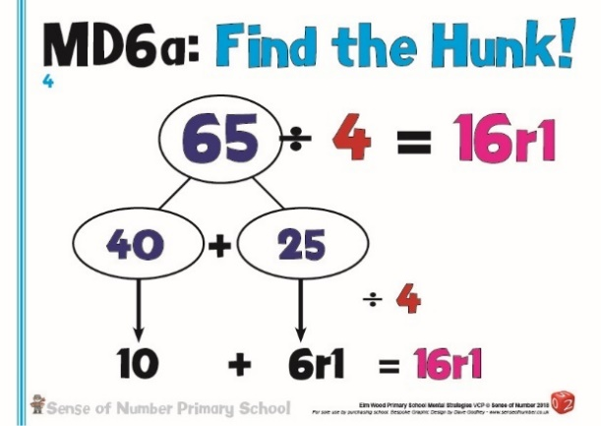
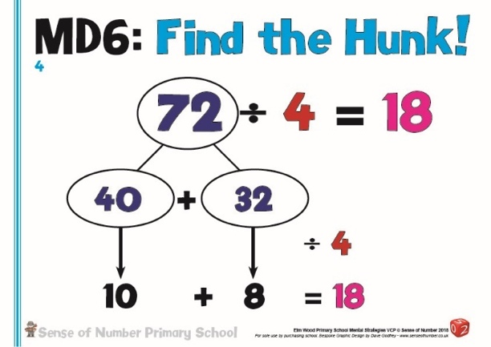

Mega Hunk
The natural development of Find The Hunk uses the same strategy for 3 digits divided by a single digit, and is usually termed ‘Mega Hunk’.
Mega Hunk is defined as being multiples of 10 times the divisor.

If we are dividing a number by 4 which is larger than 79 then we will need more than one ‘Hunk’.
For an example such as 136 ÷ 4 we would need 3 ‘Hunks’ (40 + 40 + 40 + 16).

As this would take far too long and would not be an efficient method, children are encouraged to find the maximum number of ‘Hunks’ that they could use.

In the first example below the divisor is 4, so the Hunk will be 40 and the Mega Hunk 40 x 3 = 120.
This would leave 16.
Both chunks (120 and 16) are then divided by the divisor (4) and then the answers totalled.
120 ÷ 4 = 30 and
16 ÷ 4 = 4 30 + 4 = 34 therefore 136 ÷ 4 = 34

In the second example, 394 ÷ 6, you would quickly decide that the Hunk was 60 and therefore the Mega Hunk would be 60 x 6 = 360. This would leave 34.
Both chunks (360 and 34) are then divided by the divisor (6) and then the answers totalled.
360 ÷ 6 = 60 and
34 ÷ 6 = 5 r 4 60 + 5 r4 = 65 r4 therefore 394 ÷ 6 = 65 r4

In the final example, 536 ÷ 4, you would quickly decide that the Hunk was 40 and therefore the first Mega Hunk would be 40 x 10 (or 4 x 100) = 400
and the second Mega Hunk would be 40 x 3 = 120. This would leave 16.
All three chunks (400, 120 and 16) are then divided by the divisor (4) and then the answers totalled.
400 ÷ 4 = 100,
120 ÷ 4 = 30 and
16 ÷ 4 = 4 100 + 30 + 4 = 134 therefore 536 ÷ 4 = 134

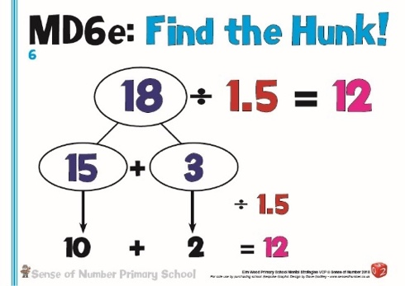
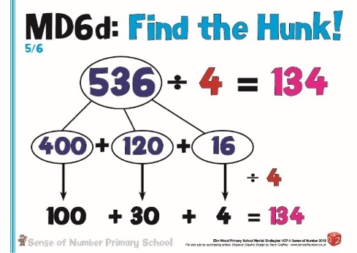
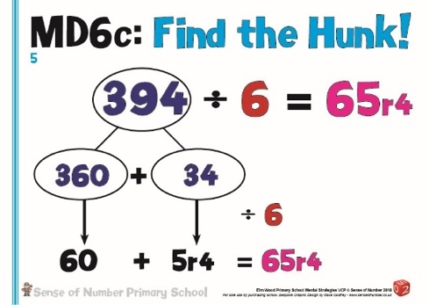
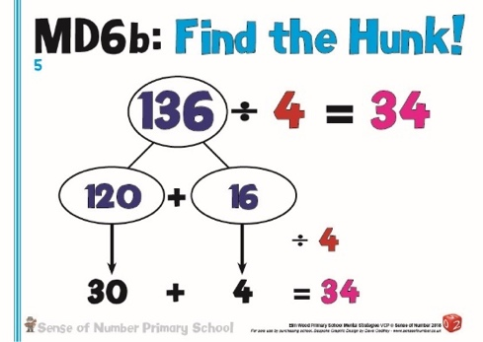
The strategy is so efficient when mastered that it can even be used for decimal division.
For 18 ÷ 1.5, the Hunk would be 15 (1.5 x 10).
This would leave 3.
15 ÷ 1.5 = 10
and 3 ÷ 1.5 = 2 10 + 2 = 12 therefore 18 ÷ 1.5 = 12

Models of Division

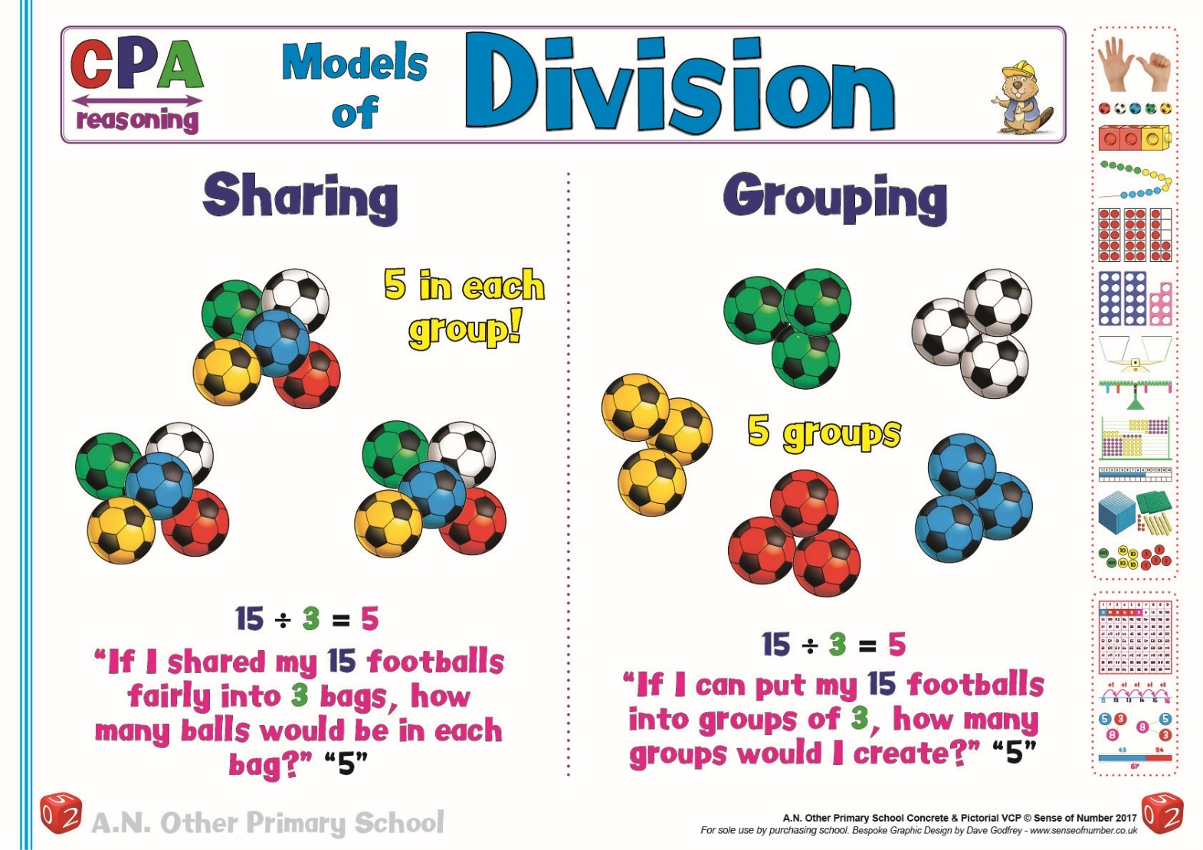

The poster above clearly shows that division can be viewed in two entirely different ways.

A calculation such as 15 ÷ 3 can mean one of two things: –
‘15 shared between 3 or ‘How many 3s in 15?’

As the images show, if there are 15 footballs then they can be shared equally between 3 bags (with 5 in each bag) or groups of 3 footballs can be put into each bag (with there being 5 bags).

If the question is in a word problem format then the interpretation is specified, but if it is simply an abstract calculation then children can choose either meaning in order to answer the question.

It is crucial that children’s early experiences of division allow them to model, demonstrate, explain, draw and practice answering division calculations using both interpretations.

They should be given calculations such as 20 ÷ 5, 16 ÷ 2, 12 ÷ 4 and 30 ÷ 10, and asked to solve them practically then pictorially using both methods. Resources such as counters, cubes, pencils, balls, food, toys etc can be shared or grouped so that division is not seen as an abstract concept.

This means that they will always have two options open to them for any given division, allowing them to use tables facts and grouping for certain calculations, and equal sharing for others.
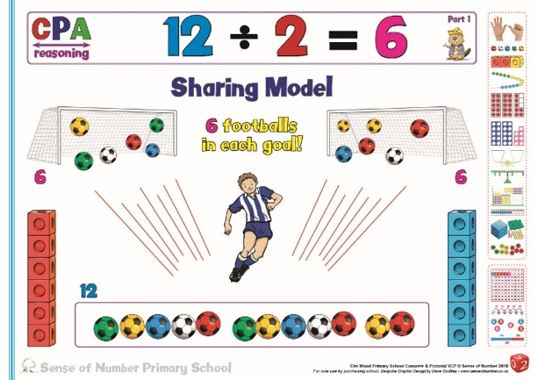
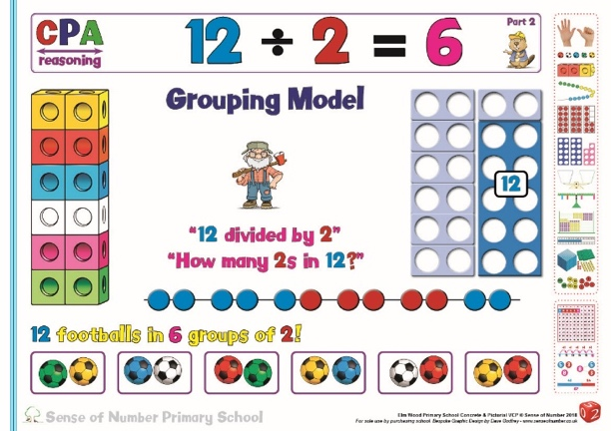

They will also realise that, in a similar way to subtraction (counting on or counting back), they aren’t restricted to a single method or strategy.

Division In Key Stage 1 –
Should Grouping or Sharing Be The Default Model?

When children think conceptually about division, their default understanding should probably be Division is Grouping, as this is the most efficient way to divide and is the principle which is most commonly used in Key Stage 2.

The most common principle explored with children in KS1, however, is usually that of sharing. This ‘traditional’ approach to the introduction of division is to begin with ‘sharing’ as it is seen to be more ‘natural’ for children to demonstrate, and is viewed as being easier to understand.

Many children see the division symbol and are encouraged to recognise it as the ‘share’ sign.
Whilst this is one interpretation, it is absolutely crucial that it is never called the share sign.

The division symbol should always be given the name ‘divide’ and,
as mentioned, be taught as both sharing and grouping

Children who are only given the ’sharing’ interpretation of division often spend the majority of their time ‘sharing’ counters and other resources.

(i.e. seeing 20 ÷ 5 as 20 shared between 5’) – a rather laborious process which can only be
achieved by counting, and which becomes increasingly inefficient as both the divisor and the
number to be divided by (the dividend) increase)

These children are given little opportunity to use the grouping approach, which comes
through exploring the inverse link to multiplication

(i.e. 20 ÷ 5 means how many 5’s are there in 20?’) – far simpler and can quickly be achieved by
counting in 5s to 20, something which most children in Y1 can do relatively easily.
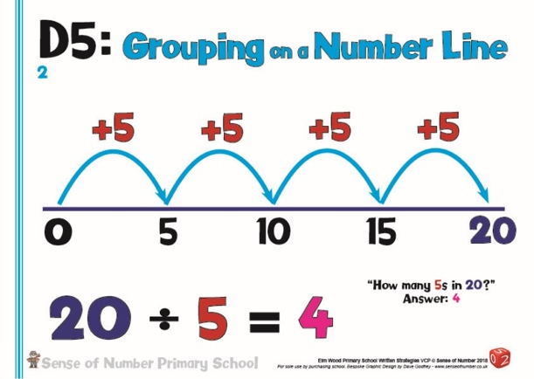
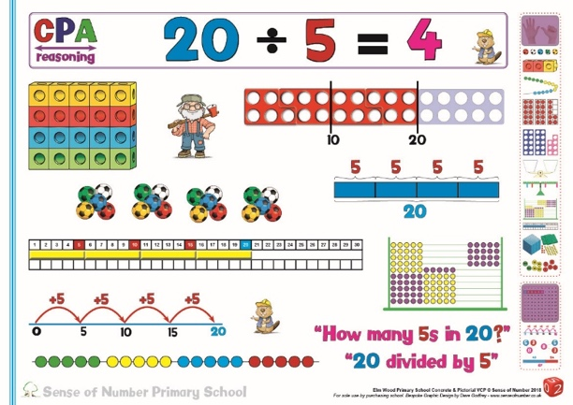

Grouping in division can also be visualised extremely effectively using number lines, Numicon, bead strings, abacuses and number rods.
The only way to really visualise sharing is through counting.

Grouping, not sharing, is the inverse of multiplication.

Sharing is division as fractions, and, as explored within the mental division section, does have
its own set of strategies.

Once children have grouping as their first principle for division they can answer any simple
calculation by counting in different steps (2s, 5s, 10s then 3s, 4s, 6s etc.). As soon as they
learn their tables facts then they can answer immediately.

E.g. How much quicker can a child answer the calculations 24 ÷ 2, 35 ÷ 5, 70 ÷ 10 or even calculations such as 100 ÷ 20 or 300 ÷ 25 using grouping?

Children taught sharing would find it very difficult to even attempt these calculations as
they would need far too many resources and it would take a long time to count them all out in order to share them.

Children who have sharing as their first principle tend to get confused in KS2 when the
understanding moves towards ‘how many times does one number ‘go into’ another’.

As the image below shows, division as grouping not only allows regular calculations to be
answered quickly by the use of tables facts (or by quickly counting up in different steps).
It also enables children to visualise and answer higher level calculations such as 18 ÷ 1.5.

Using grouping we can ask the question ‘How many 1.5s are there in 18?’ The question can
then be answered pictorially (or practically using number rods or fraction circles) or simple worked
out by counting in 1.5s to 18.
18 shared between 1 ½ or 1.5 would be almost impossible to imagine / visualise.
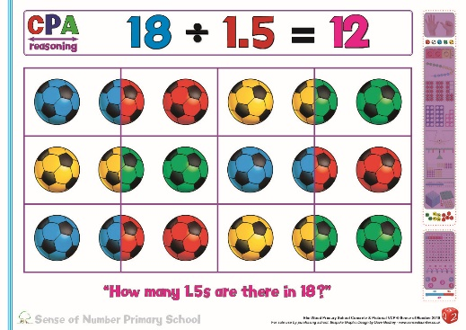

When children are taught grouping as their default method for simple division questions it
means that they;
- secure understanding that the divisor is crucially important in the calculation
- can link to counting in equal steps on a number line
- have images to support understanding of what to do with remainders (Numicon)
- have a far more efficient method as the divisor increases
- have a much firmer basis on which to build KS2 division strategies

Consequently, this policy is mainly structured around the teaching of mental and regular division as grouping, moving from counting up in different steps to learning tables facts and eventually progressing towards the mental chunking and NNS chunking methods of division in KS2.

Sharing is introduced as division in KS1, but is then taught mainly as part of the fractions curriculum, where the link between fractions and division is emphasised and maintained throughout KS2.

As mentioned, due to its efficiency, grouping is the default method for most simple division calculations.

For conceptual understanding, however, when teaching formal ‘bus stop’ division, the sharing model is ideal for explaining how / why this method actually works. Therefore, this policy bases its written methods on both sharing (bus stop) and grouping (chunking)

(See ‘Written Methods of Division’ below for practical examples of bus stop division)

Written Methods Of Division

Stage 1 | Concepts and Number Lines (pre-chunking)
Stage 1 | Grouping | Sharing
EYFS | From EYFS onwards, children need to explore practically both grouping and sharing.  Links can then be made in both KS1 and KS2 between sharing and fractions.  For example, children can be asked to put their 12 dinosaurs into groups of 2, 3. 4 or 6.          The children could share 6 sweets between 2 or 3 people.
 | Begin by giving children opportunities to use concrete objects, pictorial representations and arrays with the support of the teacher.  Use the words ‘sharing’ and ‘grouping’ to identify the concepts involved.  Before using mathematical apparatus, use real objects and equipment such as cups, cakes, footballs, pencils, apples etc.  Children will firstly make then draw these objects by grouping and sharing them, working out the quotient by either counting the number of groups or the number within each group, then finally by writing the division statement.
Make sure that the children have experience in representing the same division calculation in both ways for a range of different calculations.
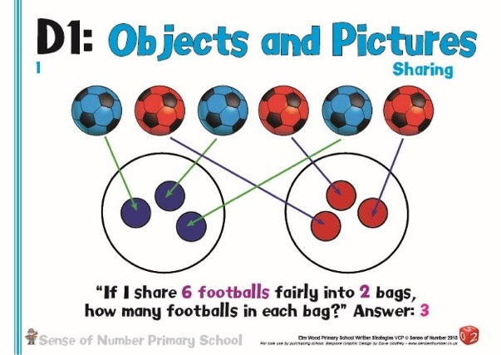
For example 6 ÷ 2 needs to be ‘made’ as both 6 in groups of 2 (How many 2s in 6?) and 6 shared between 2.
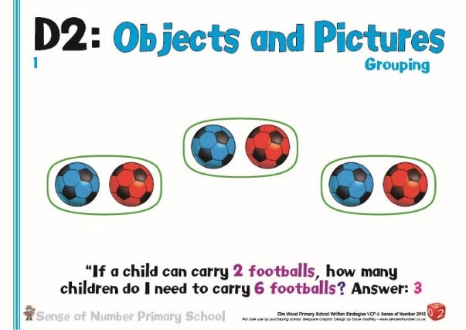

 | Identify the link between multiplication and division using the array image.  Begin to build on children’s understanding that division is the inverse of multiplication, using arrays and number lines to support this thinking.  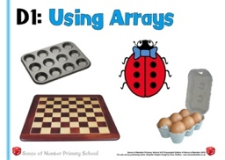  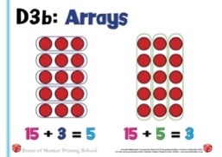  Start to develop the use of the array to show that the same picture can be used to show both multiplication and division, and that the array demonstrates both sharing and grouping with one individual image.  As with multiplication, make arrays using a wide range of objects, especially those which naturally occur in real-life such as windows, egg boxes, drawers or cake trays.  Emphasise that all simple divisions can be worked out and pictured both ways (sharing or grouping)  Encourage the children to see how the array makes it very easy to see both models of division, and practice circling the array depending on whether they want to show either: -  - Grouping demonstrated both ways (see above)  - Sharing demonstrated both ways (same pictures but opposite calculation written below each image)  - The same calculation as either sharing or grouping (the second image in the first picture above as 15 ÷ 5 (grouping) or 15 ÷ 3 (sharing)
 | Identify Grouping as the key model for simple division. Relate Grouping to knowledge of multiplication facts / the inverse of multiplication.  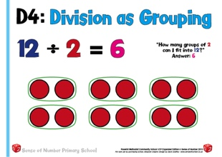  Regularly use the key vocabulary: 12 ÷ 2 means how many 2’s can I fit into 12?’  or ‘20 ÷ 5 means how many 5’s can I fit into 20?’  Begin to move away from real life objects / natural resources, instead using mathematical apparatus to show the same division calculation.  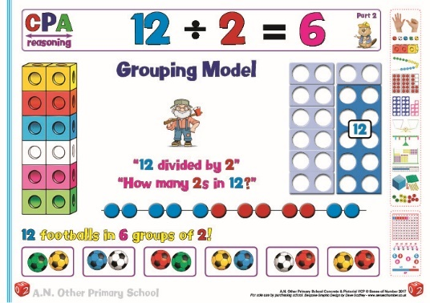  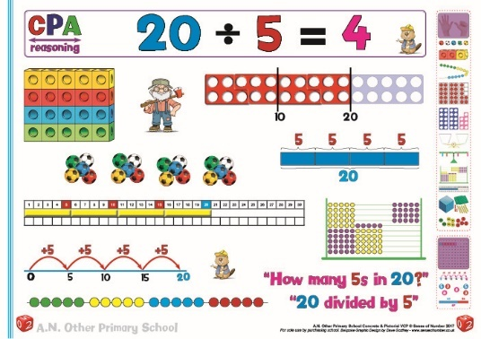 | Identify Sharing as the secondary model of division.  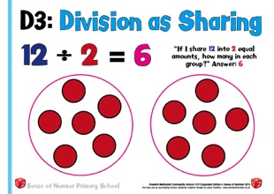  Relate sharing to fractions, showing that sharing between 2 is the same as halving.  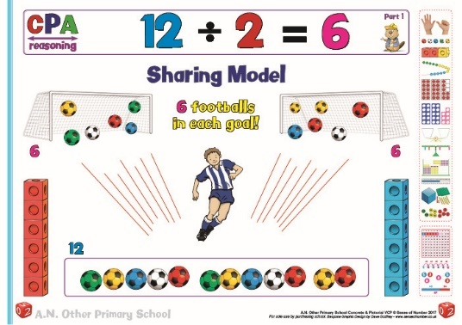
 | Moving towards a slightly more abstract visual, but one which still maintains clear understanding, the number line is an excellent way to quickly show how counting on (rather than counting back) is the easiest way to use a number line when solving a division calculation.  This is particularly beneficial if dealing with remainders. Using the example below, it is far easier to count forwards in 5s to 15 then count on 2 than starting at 17 and counting backwards in 5s.  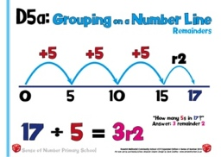  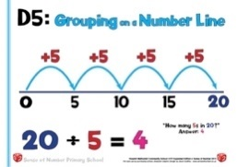 | Regularly stress the link between multiplication and division, and how children can use their tables facts to divide by counting forwards in steps.
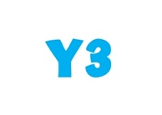 | It is really important to maintain the use of concrete materials as the calculations become gradually more complex, and tables facts harder to instantly recall.  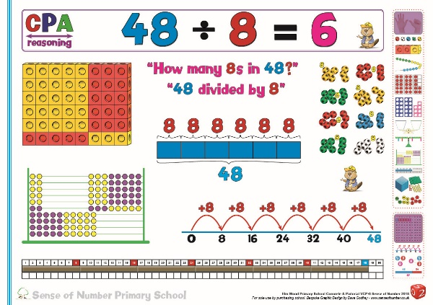  Children using apparatus such as number rods, abacuses, Numicon and cubes can still explain the division and have a better understanding of the calculation if they are asked to make it.
Continue to give children practical images for division by grouping when dealing with simple remainders.
Asking the question ‘How many 5s are there in 23?’ allows the opportunity to visualize the remainder.
The images of the cubes or the abacus below show 4 complete groups of 5 and a remainder of 3.
The Numicon image allows the ‘5’ and ‘3’ pieces to be placed over three ‘10’ pieces and see how many 5s make 20, along with the additional 3.
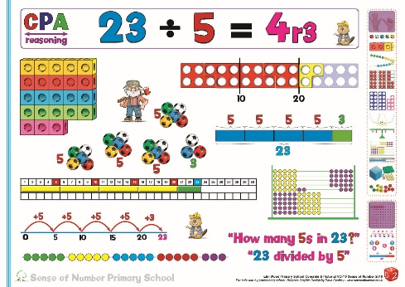
The number rod image is almost a practical representation of a number line, especially when placed on the number track.

Division as grouping both with and without remainders can also be shown very effectively using children.
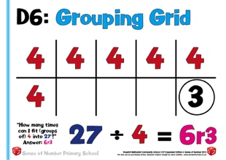
For 27 ÷ 4: - In the hall, use PE mats and ask children to move into groups of 4. The remainder go into a hoop.
The image on the left
(Grouping Grid) can then be used back in class, with the 4s being the mats and 3 the remainder in the hoop.

Teaching the Short Division ‘Bus Stop’ Method with Understanding
Through the use of Concrete & Pictorial Apparatus

Short Division as Sharing
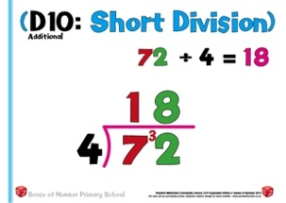
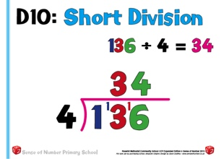

For many years the calculations above have been taught using the language of grouping.
For the first calculation, the usual language associated with teaching it is ‘How many 4s in 7?’ (1 remainder 3) then ‘How many 4s in 32?’ (8)
For the second calculation, the language would be ‘How many 4s in 1?’ (0) so carry the 1 to the 3 then How many 4s in 13?’ (3 remainder 1) and How many 4s in 16?’ (4).
Although this ‘method’ does get the correct answer and is relatively easy to explain, it unfortunately removes all of the place value that children have been developing in addition, subtraction and multiplication so far.
The ‘7’ is actually worth 70 (or 7 Tens) in the first calculation. The ‘1’ is worth 100 (or 10 Tens) in the second calculation. If a child were to ask the teacher why they weren’t using place value, and that, by partitioning 136: -
100 ÷ 4 is 25 (i.e. there are 25 fours in 100), 30 ÷ 4 is 7 remainder 2 and 6 divided by 4 is 1 remainder 2
how would the teacher respond?

The other main problem with the traditional teaching approach to standard short division is the lack of an image to support the teaching. So far, for addition, subtraction and multiplication we have used Base 10 to visualise the calculation; therefore it would seem sensible to use the same images for division.
Holding up a 100 piece, however, and asking ‘How many 4s are in this 100 would still generate the answer 25.

The ‘answer’ to this potential problem is to rethink the language used when representing the calculation, and to teach the ‘bus stop’ method as a sharing rather than grouping method. If the language of sharing is used then the Base 10 picture for either of the calculations above is relatively easy to visualise and explain.
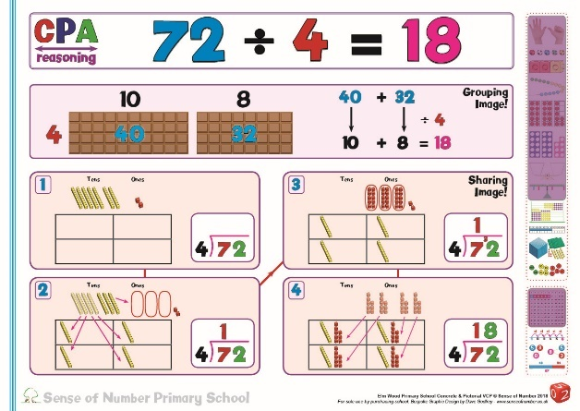

We begin with 7 Tens and 2 Ones and ask the question Using the picture below, four of the Tens can be
‘How many whole Tens can be shared between 4? shared between 4 in whole Tens, leaving 3 Tens

The 3 remaining Tens are then exchanged / regrouped The 32 Ones are then shared between 4, with 8
into 30 Ones, giving a total of 32 Ones given to each set

Using Base 10 to explain bus stop method by sharing, the answer is seen as 72 shared between 4 equals 18 each.

In a similar way, we can visualise 136 ÷ 4.
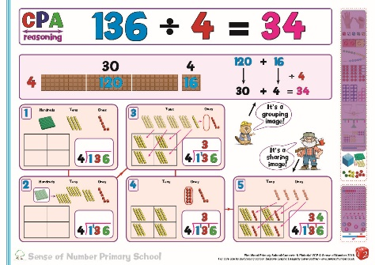

We start with 1 Hundred, 3 Tens & No whole Hundreds can be shared The 13 Tens can now be shared
6 Ones, asking the question ‘How many between 4 so we exchange / regroup in whole Tens between 4, giving
whole Hundreds can be shared between 4?’ the Hundred into 10 Tens. We now 3 Tens to reach set.
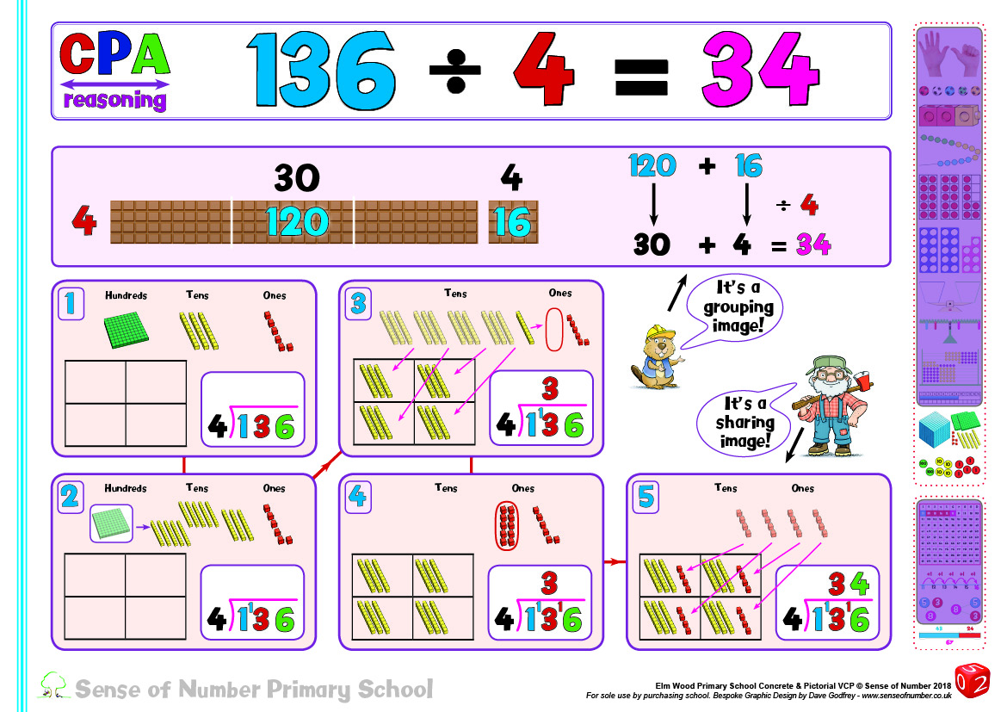
have 13 Tens

We can’t share the remaining Ten The 16 Ones are then shared between 4,
between 4 so we exchange / regroup it with 4 Ones given to each set
into Ones. We now have 16 Ones
Using Base 10 to explain bus stop method by sharing, the answer is seen as 136 shared between 4 equals 34 each.

If the sharing model is adopted for all visualisations of ‘bus stop’ method / standard short division, and is practised many times practically before it is actually written down then children will not only have a far better concrete understanding of dividing 2 and 3 digit numbers by a single digit, they will also be able to give clear, reasoned explanations as to why the bus stop method works.

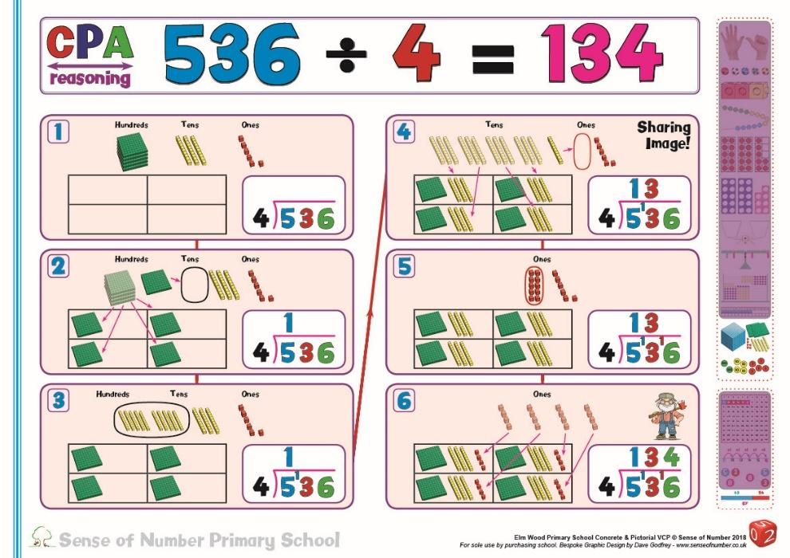
Children should continue to use apparatus to support their understanding of the calculation even as the dividend gets larger.
Explaining the process on the left: -
We share 5 Hundreds (in Hundreds) between 4, giving 1 Hundred each (Pics 1&2).
The remaining Hundred is regrouped into Tens, giving 13 Tens (Pic 3).
These are shared between 4, giving 3 Tens each (Pic 4).
The remaining 10 is regrouped into Ones. The 16 Ones are now shared between 4, giving 4 each (Pics 5 & 6).

Once this process is clearly understood and can be explained with a range of examples, the children are then equipped to use the ‘bus stop’ method. At any point the teacher can confirm their understanding by asking them to explain how the method works.
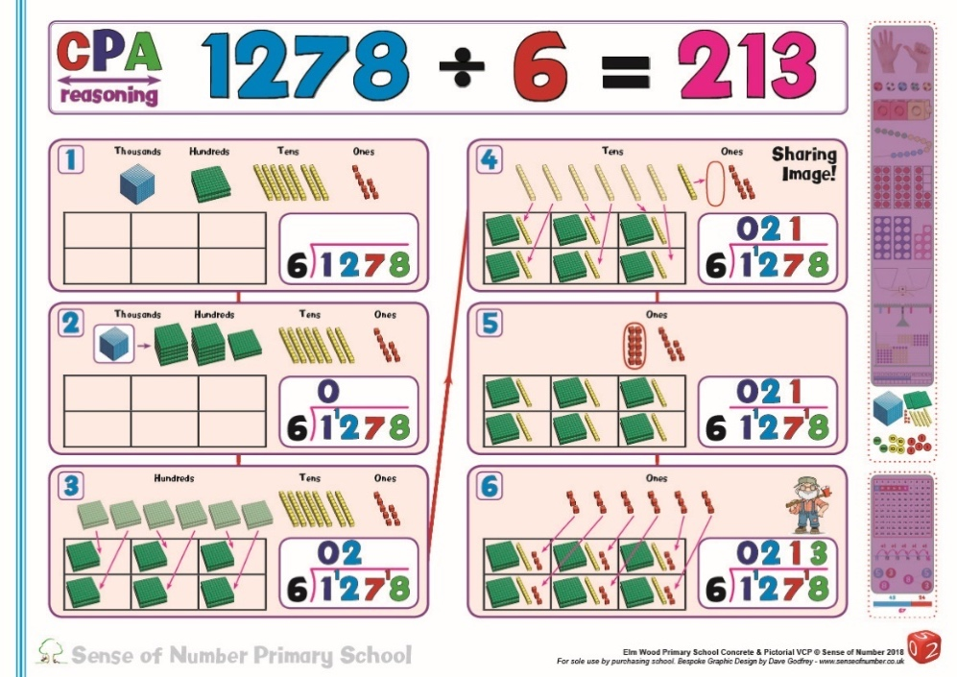
Even when the dividend is beyond 1000 it is worth spending a few lessons using apparatus and / or drawing the Base 10 to explain 4 digit regrouping.
In brief, as the process on the left demonstrates: -
The Thousand cannot be shared (in thousands) between 6 (Pic1) so it is regrouped into 10 Hundreds (Pic2). There are now 12 Hundreds, which are equally shared between 6, giving 2 each (Pic3).
The 7 Tens are shared between 6, giving 1 each (Pic4). The remaining Ten is regrouped into 10 Ones (Pic5). There are now 18 Ones which are shared equally between 6, giving 3 each.

The policy below for written methods demonstrates and explains standard methods as sharing, initially using apparatus, and then purely in the abstract for long division.

The chunking method (both Find The Hunk and NNS formats) give an alternative approach / jotting for both short and long division.

Stage 2 | Chunking & Standard Methods
Stage 2 | Standard Methods |  | Chunking  Find the Hunk &  NNS Chunking
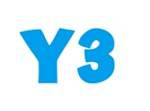 |  |  | 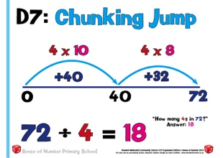  As previously encountered in Y2, developing an understanding of division with the number line is an excellent way of linking division to multiplication. It can show division both as repeated subtraction, but it is simpler to show division by counting forward to find how many times one number ‘goes into’ another.
 | These slides introduce the Short Division  (Bus Stop) method in Year 3.  It is recommended that when children start to use this strategy, it is only introduced once tables facts are relatively secure.  When introducing Short Division formally, use Base 10 and make sure you introduce it using the sharing model (as mentioned in the ‘Teaching Short Division’ explanation on the previous two pages)  The calculation starts with, ‘I have 7 Tens, to share between 4. That’s 1 Ten each with 3 remaining. These 3 Tens are regrouped into 30 Ones. The 32 Ones are now shared between 4– that’s 8 Ones each.  As mentioned previously, children should be taken to the standardised ‘bus stop’ format for short division only when they have mastered the use of apparatus and are able to explain the process.  At any stage they can revert back to the use of concrete materials to recap / aid their understanding, or to deal with higher level calculations in later year groups |  | 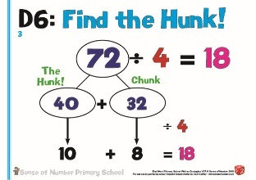  The alternative approach to written division, which should be taught alongside the ‘bus stop’ method so that it can be used for examples which can be easily accessed, is known as ‘Find the Hunk’.  Find the Hunk’, as explained earlier, is really a mental strategy based on partitioning in different ways. For a detailed overview of ‘Find the Hunk’ please read the section on mental division.  It can also be used as a quick written jotting to suppport mathematical thinking, enabling children to deal with the calculation quickly  For the example above, the Hunk is defined as being 10 times the divisor.  The divisor is 4, so the Hunk will be 4 x 10 = 40. This leaves a chunk of 32 remaining.  Both chunks are then divided by the divisor and then the answers to each totalled.  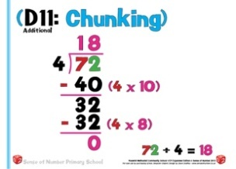  ‘Find the Hunk’ is a mental strategy based on simply partitioning numbers in different ways.  The National Numeracy Strategy chunking method, however, is based on subtraction / repeated addition.  In the example above, 40 (4 x 10) is initially subtracted from the dividend, followed by 32 (4 x 8). This means that altogether 4 x 18 has been subtracted, making 18 the answer. This method requires the children to be secure in their division facts, to be able to carry out column subtraction effectively, to write the separate quotients as multiplication statements and also to be able to remember a quite complex layout.  This strategy can be unwieldy, somewhat confusing and relatively difficult to master. Therefore, the recommendation within this to use Find the Hunk as the default strategy for chunking and only to adopt NNS chunking when tackling complex long divisions.
Once short division of 2 digit numbers with a whole number quotient has been mastered, begin to practise examples (using both ‘bus stop’ and chunking) of short division where the quotient includes remainders. The examples below are explained in exactly the same way as the previous example but the remainder is simply left as a whole number.
(In later years it will be expressed as a fraction or a decimal for a more accurate answer)

 | 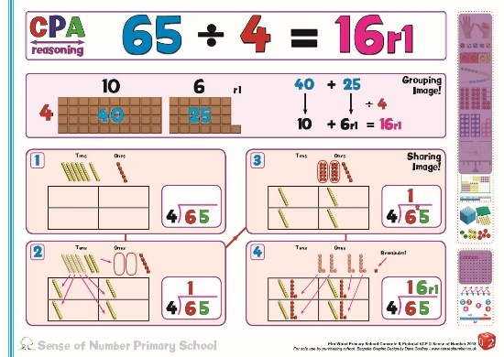  Base 10 will still be used for the first principles of Concrete – Pictorial – Abstract before the children progress to the abstract method.  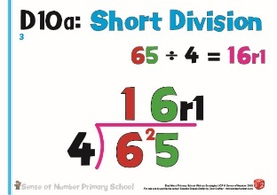 |  | 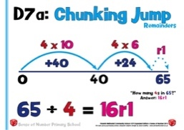  The number line provides an excellent image to show division with remainders, and can be used to support or instead of ‘Find The Hunk’  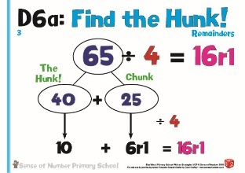  Find The Hunk is equally simple to use with remainders.  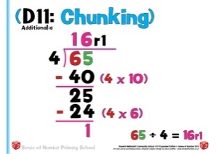  NNS Chunking remains a fairly tricky method to remember.
 | As described in more detail earlier, short division can now be developed into 3 digit dividends. Base 10 (or place value counters for children who have better understanding) is used tomodel and explain how the method works.  The calculation starts with, ‘I have 1 Hundred, which cannot be shared (in Hundreds) between 4.  The Hundred is regrouped into 10 Tens. The 13 Tens are now shared between 4 – 3 each. The remaining Ten is regrouped into 10 Ones. The 16 Ones are now shared between 4 – that’s 4 Ones each.  Once understood and explained with a range of calculations, children use the ‘bus stop’ method. |  | 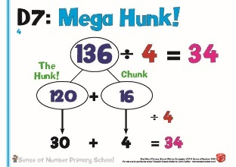  Mega Hunk’ is the natural development of the ‘Find the Hunk’ strategy, simply using bigger chunks when the dividend is much larger.  In the example above, Mega Hunk is defined as being multiples of the Hunk (which is usually 10 times the divisor) .  The divisor is 4, so the initial Hunk will be 40. The ‘Mega Hunk’ will be 40 x 3 = 120, leaving a remaining chunk of 36.  Again, both chunks are then divided by the divisor and then the answers totalled.  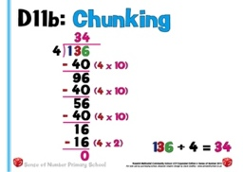  The National Numeracy Strategy chunking method is also based on multiples of 10 times the divisor. The example above is an expanded version of the example below.  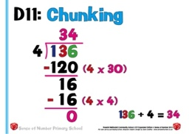  At first, children are asked to keep subtracting 10 times the divisor (40) until the remaining number is less than 40.  This can be extremely laborious and is open to multiple errors in calculation or layout, so children are then encouraged to look for bigger chunks that can be subtracted. The example above uses exactly the same chunks as ‘Mega Hunk’ but is a more complex layout.
 | 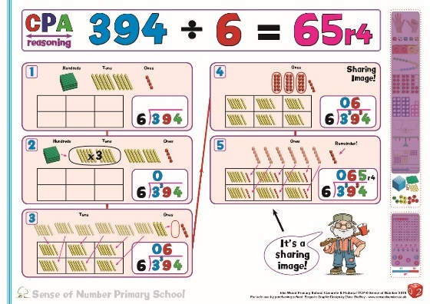  Continue to use apparatus to show division with remainders, and also where larger amounts of regrouping is needed.  In the example the 3 Hundreds can’t be shared between 6 so they are regrouped into 30 Tens.  The 39 Tens are shared between 6, giving 6 each.  The remaining 3 Tens are regrouped into 30 Ones. The 34 Ones are shared between 6, giving 5 each with a remainder of 4  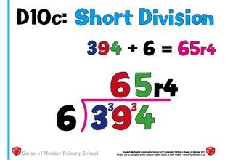 |  | 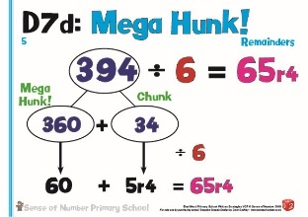  Continue to use the Find the Hunk strategy whenever possible.  Even with remainders it becomes a very efficient mental jotting. With the example above 394 can be regrouped as 360 + 34.  Both chunks can then quickly be divided by 6, leaving a remainder of 4.  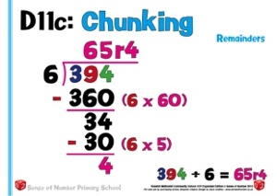  By this stage children using the NNS method should be finding much larger chunks of the divisor, making the method much easier to complete (although still less efficient than Find the Hunk)
 | 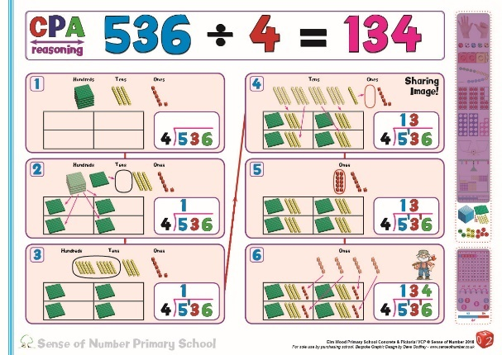  When the Hundreds can be shared between the divisor, it is beneficial to still use concrete materials, and allow the children to actually regroup / exchange the Hundreds and Tens.  In the example above, the 5 Hundreds can be shared (in Hundreds) between 4, giving 1 each.  The remaining Hundred is regrouped into Tens.  The 13 Tens are shared between 4, giving 3 each. The remaining Ten is regrouped into Ones.  The 16 Ones are shared between 4, giving 4 each.  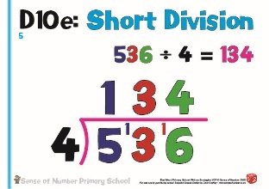  Once a child is confident with the apparatus then, as before, they can use the ‘bus stop’ method, explaining it when necessary. |  | 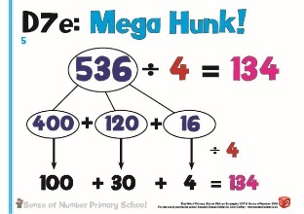  For this type of division, there are 3 ‘hunks’. 536 is regrouped / partitioned a different way into a multiple of 400 (400), a multiple of 40 (120) and a multiple of 4 (16).  Each of these 3 numbers is then divided by 4.  Children who have practiced ‘Mega Hunk’ for smaller numbers and are confident in their tables facts still find this a fairly simple jotting / method to complete.  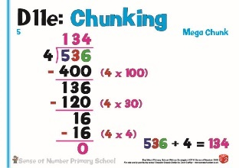  The NNS Chunking method, in effect, partitions the 536 in the same way as Find The Hunk. The need for subtraction and the complex layout makes it more difficult to remember without a very clear understanding, but it does allow children to practice a method that they may prefer once they are asked to do long division.
 | 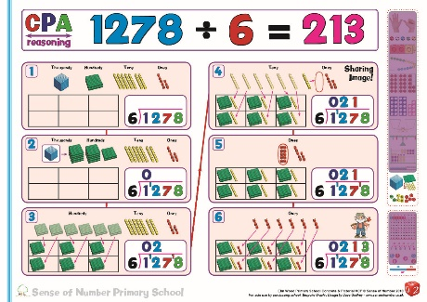  The final stage in which apparatus would usually be used is for simple 4 digit short division calculations.  Once children can explain a 4 digit calculation using concrete materials then they are ready to use ‘bus stop’ method for any calculations of 3 digits and above. |  | If the example on the left was to be completed using ‘Mega Hunk’ then it would be a very simple: -  1278 ÷6 = 213  1200 60 18  ÷6  200 10 3
 | 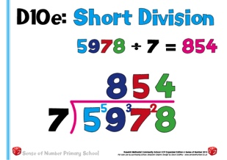  At this point the numbers would require far too much apparatus for the calculation to be viable visually so children would simpy use a ‘bus stop’ method. If at any point,however, they were asked to explain / reason their answer, they would be able to use the understanding developed through the use of Base 10. | 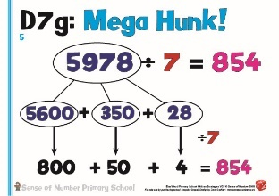  Even with 4 digit numbers, Mega Hunk is relatively simple for children who have a good sense of number.  5978 can be regrouped into 5600, 350 and 28. These numbers can then be divided by 4.  NNS chunking, as before, displays the same numbers but in a slightly more difficult layout.  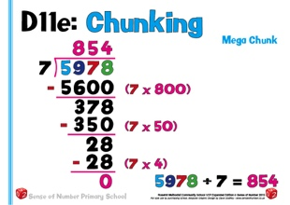
Children should develop the ability to represent the quotient initially as a straightforward remainder (given as a whole number) , but also as a decimal or fractional remainder.
The examples of short division below show the whole number remainder in the Mega Hunk & NNS examples, but also the fractional and decimal remainders in the ‘bus stop’ examples.
 | 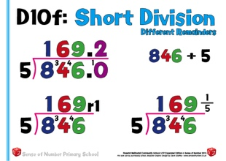  Once a child is in Upper Key Stage 2 they should be aware that giving a remainder as a whole number is not accurate enough.  A remainder of 1, for example, has a completely different meaning when the divisor changes.  When dividing by 2 it represents ½ (or 0.5), when dividing by 4 it is ¼ (or 0.25), when dividing by 10 it is worth 1/10 (or 0.1).  In the example above, when dividing by 5, the remainder represents / is worth 1/5 (or 0.2). |  | 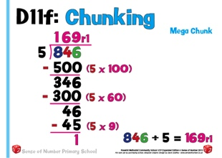  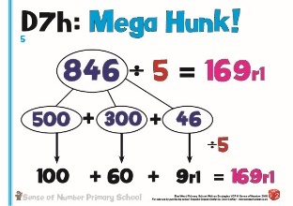
 | 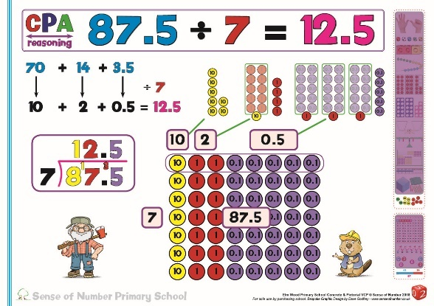  If necessary, place value counters can be used for children to explain short division using decimals.  In the example above, the 8 Tens, 7 Ones and 5 Tenths have been regrouped into 7 Tens, 14 Ones and 35 Tenths, each of which can be divided by 7.  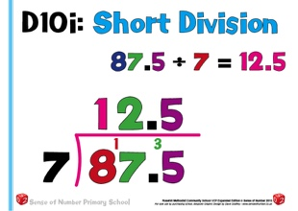 |  | 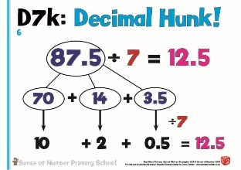  Decimal Hunk allows the children to represent a  relatively difficult calculation in a very efficient  way, one which can be answered extremely  quickly.  If 87.5 is regrouped into 70, 14 and 3.5, each  number can then be divided by 7, and the  quotient determined immediately.
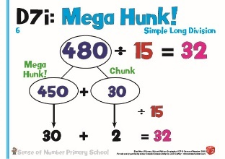
When introducing simple long division questions, where the multiples of the divisor are fairly easy to work out, it is often easier to find a quotient using the Mega Hunk strategy.
The example above is no more difficult than many short divisions.
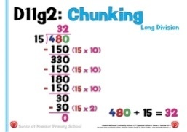

As with some of the earlier examples, NNS chunking can be unwieldy if the smaller chunk is repeatedly subtracted (see above). The method is much more efficient with a larger chunk subtracted (see below).
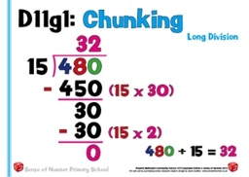

 | There are three different ways of calculating a more complex long division – continuing to use the short division method but with bigger numbers, learning the traditional method or using NNS Chunking. Find the Hunk is no longer an efficient strategy as the numbers are too big to work with efficiently.
 | 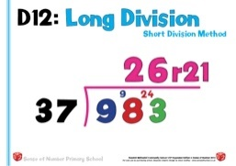  Only children who are extremely proficient with mental calculation would use the short division approach. It requires them to be able to work out a mental difference accurately, and often to ‘carry’ over a fairly substantial amount.  In the example above 98 Tens would be shared between 37, giving 2 each. The remaining 24 Tens would be regrouped into 240 Ones. The 243 Ones are then shared between 37, giving 6 each with a remainder of 21.  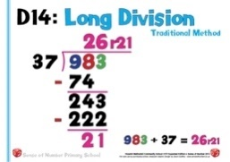  Most schools now adopt the traditional long division method, where multiples of the divisor are subtracted, and digits are ‘dropped down’ to form a new calculation.  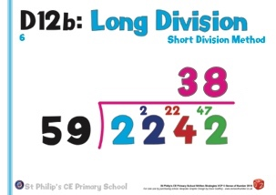  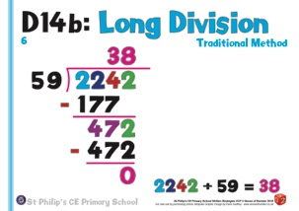  This can be a complicated method to remember for many pupils as it is very difficult to explain and doesn’t really require place value. It relies on them being able to memorise the method.  The examples below feature a 4-digit dividend. |  | 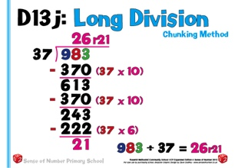  It is only at this final stage where NNS Chunking becomes the preferred method. Unlike the traditional method (see the left hand column), where it is difficult to explain the method using place value, the NNS method maintains place value.  In the extended example above, the chunk of 370 is repeatedly subtracted, followed by a chunk of 222.  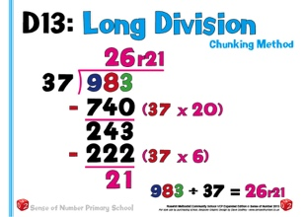  The ‘abridged’ or shortened NNS chunking method is probably the most sensible and efficient way to approach long division.  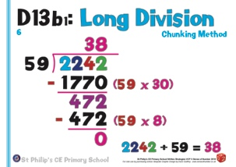  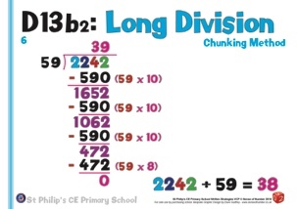  Using larger complete chunks of the divisor means that the children can see exactly what is being subtracted and don’t have to rely on ‘dropping down’ any of the digits. Looking at this example alongside the one on the left, it is clear that NNS Chunking is almost the same methods as traditional long division, but with secure place value (i.e. 740 being subtracted rather than 74).  The examples below feature a 4-digit dividend.  This would be the recommended Sense of Number method for long division.
Written by Anthony Reddy, Dave Godfrey and Laurence Hicks – Sense of Number Maths Consultants
© www.senseofnumber.co.uk 2018

