ST MARGARET’S CE VA PRIMARY SCHOOL
Modern Foreign Languages Policy
“Encourage one another and build each other up”
1 Thessalonians 5:11

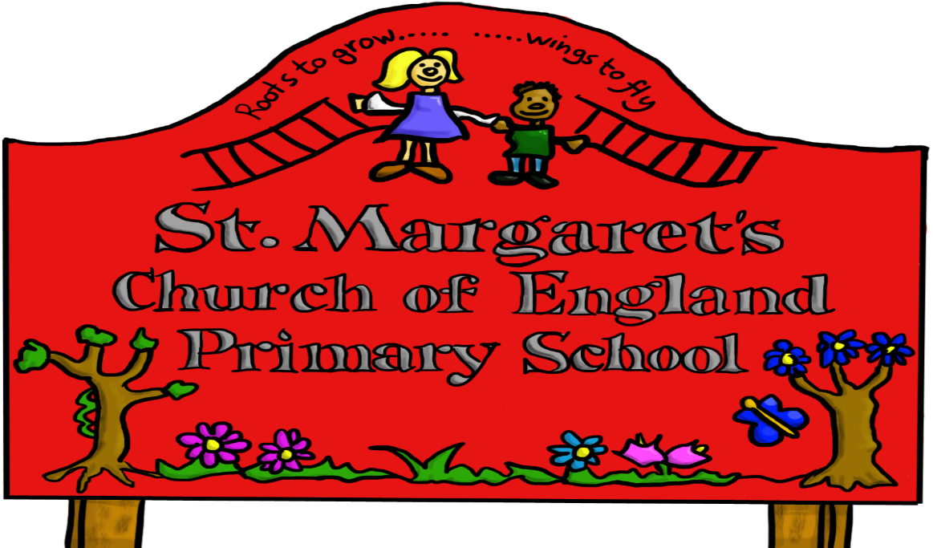

Approved by: | Governors | Date:
Last reviewed on: | Oct 2020
Next review due by: | Oct 2023

St Margaret’s C of E Primary School

Policy for Modern Foreign Languages

At St Margaret’s C of E Primary School we believe that the learning of a foreign language provides a valuable educational, social and cultural experience for our pupils. It helps them to develop communication skills including key skills of speaking and listening and extends their knowledge of how language works. Learning another language gives children a new perspective on the world, encouraging them to understand their own cultures and those of others.

Document Purpose

This policy document sets out the school's aims, principles and strategies for the delivery of the Modern Foreign Languages (MFL) entitlement. It gives guidance on planning, teaching and assessment. This policy is intended to be used in conjunction with the KS2 National Curriculum Languages programmes of Study and the Planit French Scheme of Work for MFL, which give details of what pupils in each age group will cover.

Aims and objectives of Primary Languages education at School

The aims of Primary Languages teaching at St Margaret’s C of E Primary School are to
- foster an interest in language learning by introducing children to other languages in a way that is enjoyable and accessible to all pupils
- stimulate and encourage children’s curiosity about language and creativity in experimenting with it
- support oracy and literacy, and in particular develop speaking and listening skills
- help children develop their awareness of cultural similarities and differences
- lay the foundations for future language study by pupils
- provide an added perspective on first language teaching and learning
- give an extra dimension to teaching and learning across the curriculum

Principles of teaching and learning

The main focus of MFL teaching at St Margaret’s C of E Primary School is French. All pupils begin learning French with their class teacher in Year 3. Pupils in KS1 and the Foundation Stage are involved in introductory activities and informal teaching of modern languages.

The study of MFL can benefit and support National Curriculum subjects, providing opportunities for the children to make connections, and reinforce understanding and learning.

Learning outcomes are in line with KS2 National Curriculum Programmes of Study and work is enhanced by a range of strategies and resources to assist learning.

Speaking and listening

The children will learn to:-
- listen carefully and recognise sounds and combinations of sounds which are similar to, or different from, those of English
- understand and respond with increasing competence, accuracy and confidence in a range of situations
- join in songs, rhymes, raps and stories which enable them to practise the sounds of the language in an enjoyable and non-threatening way
- take part in conversations at an appropriate level, reacting to instructions and questions and expressing opinions and feelings
- memorise and recite short texts, and prepare and give a talk on a familiar subject confidently and with regard for the audience

Reading and writing

The children will learn to:-
- remember grapheme-phoneme correspondences and vocabulary directly taught and reinforced through word games and similar activities
- read stories and rhymes for enjoyment and to gain awareness of the structure of the written language
- read, copy and write independently familiar words and simple phrases in context e.g. name, age, date, classroom items, display labels, weather chart etc
- write sentences and short texts independently and from memory

Intercultural understanding

Primary Languages provides a basis for teaching and learning about other cultures, and this is incorporated into many areas of the curriculum. Each half term the children will learn to:-

- describe the life of children in the countries where the language is spoken
- identify similarities and differences in everyday life, social conventions, traditional stories and celebrations
- recognise how symbols, products and objects can represent the culture of a country, and how aspects of the culture of different countries become incorporated in the daily life of others
- Understand and respect cultural diversity

At St Margaret’s C of E Primary School we integrate language learning into everyday school life, with staff and children using and experimenting with their knowledge of different languages whenever the opportunity arises.

There are three main contexts in which language teaching and learning take place:-

1 Languages lessons

Although Primary Languages cuts across the curriculum, children are taught specific skills, concepts and vocabulary in a weekly dedicated focus session with the class teacher. The content of these sessions is reinforced by the class teacher during the week. Visiting secondary specialists and Foreign Language Students will occasionally be involved in the delivery of MFL sessions. Online resources are used where appropriate to enhance teaching and learning.

2 Languages embedded into other lessons

MFL provides opportunities for teaching cross-curricular themes. Where appropriate, teachers give children opportunities to practise their foreign language in the context of lessons in other subject areas. For instance, some instructions may be given in another language in a PE lesson; or children may count in another language while carrying out a numeracy activity. This acts to reinforce the vocabulary and structures they have learned.

3 ‘Incidental’ language

Languages are part of the day to day life of the school. For example, teachers use the foreign language to give simple classroom instructions (‘come in quietly’; ‘listen’; ‘look’), to ask questions (‘who wants school dinner?’; ‘what’s today’s date?’) and to take the register, lead Assembly and give permission for children to leave the room. Children are encouraged to respond using the language they have learned, and sometimes teachers and pupils develop new language skills together, teachers acting as role models in the learning process.

This integrated approach is a strong model for teaching and learning, giving children opportunities to use and develop their language for communicating in stress-free real-life contexts.

Curriculum and School Organisation

French is taught regularly to ensure progression and skills development but other languages are occasionally taught on suitable occasions to ensure that the linguistic expertise of all staff/visitors is used.

The Planit French Scheme of Work outlines which topics are covered in each year group. MFL is also part of the school day and, as such, is ongoing throughout all of children’s learning.
We also have a teaching unit called Cultural Appreciation which we teach alongside our other units. This is to enable pupils to improve their understanding and knowledge about the culture of France.

The subject co-ordinator will facilitate the development of MFL in the following ways:

- By managing the implementation of the MFL policy
- By updating the policy and scheme of work
- By ordering/updating/allocating resources
- By identifying need and arranging INSET so that all staff are confident in how to teach and assess the subject and have sufficient subject knowledge
- By keeping staff abreast of new developments
- By taking an overview of whole school planning to ensure that there is continuity between year groups and that progression is taking place
- By supporting staff in developing pupils' capability
- By attending appropriate courses to update knowledge of current developments and by keeping links with the Advisory Team for MFL
- By contributing to the School Integrated Development Plan on an annual basis
- By management of the native speaker if available
- By liasing with feeder and or receiving school.

It is the responsibility of the head teacher to ensure that statutory requirements are being met (entitlement).

Planning and resources

Primary Languages is planned following the guidelines set out in the Key Stage 2 Framework for Languages (DfE 2014). The school’s Scheme of Work ensures that there is continuity and progression in both skills and content across all classes.

Resources include: Planit Schemes of Work for each year group and topic specific resources, (including dictionaries, maps and games). Every school PC/laptop has access to Interactive White Board resources including/lesson plans/display ideas for teachers to share and use in their own classrooms.

Inclusion
All pupils, regardless of race or gender, shall have the opportunity to develop MFL capability. The school promotes equal opportunities and fairness of distribution of MFL resources. Children with other languages at home are encouraged to use them for educational benefit and parental involvement is welcomed.
Positive images of languages being spoken by people of both sexes will be promoted. The school recognises the motivational advantages of the use of MFL by children with special educational needs.

Language learning activities are planned in such a way as to encourage the full and active participation of all pupils. Work is differentiated as appropriate to the needs of individual children. Pairs and groups for collaborative work may be made up in different ways, depending on the task.

Assessment, and Record Keeping
Most assessment is formative and is used to support teaching and learning and inform future planning. As the class teacher works through the scheme of work they record their observations where appropriate and assess the children's progress in the target language based on their achievement of the learning objectives in lessons. These informal assessments will be used to identify gifted linguists and those requiring extra support. This information is shared with the next class teacher.
Written work produced is marked in line with the school policy on marking and children are encouraged to self-assess their learning through the Planit French ‘I can’ statements.
Monitoring progress
Monitoring is carried out by the Headteacher, and MFL coordinator, in the following ways:
- Informal discussion with staff and pupils
- Observation of MFL displays
- Looking at the work in individual learner files or notebooks
- Classroom observation
Staff Development and Training
Staff are given opportunities and encouragement to develop their own language and language teaching skills, through supported individual study, in-school (INSET) and local authority training. Through the MFL Hub the school has strong links with the main secondary feeder school and benefits from specialist advice, including secondments from Foreign Language Students.
Links outside school
Primary Languages gives us an ideal opportunity for making links outside school. We encourage children to share their experiences of visiting or living in other countries, and from time to time we welcome visiting speakers who are able to talk about life in the countries where the focus language is spoken. We make full use of ICT links to approved sites on the Internet, to find out about life in other countries.

St Margaret’s regularly has a Global Celebration Week which enables all pupils to experience a variety of language and cultural experiences from other countries. Parents and other community members are also invited to participate.

Celine Humphries
MFL leader

October 2020

