ST MARGARET’S CE VA PRIMARY SCHOOL
SUPERVISION POLICY

“Encourage one another and build each other up”
1 Thessalonians 5:11

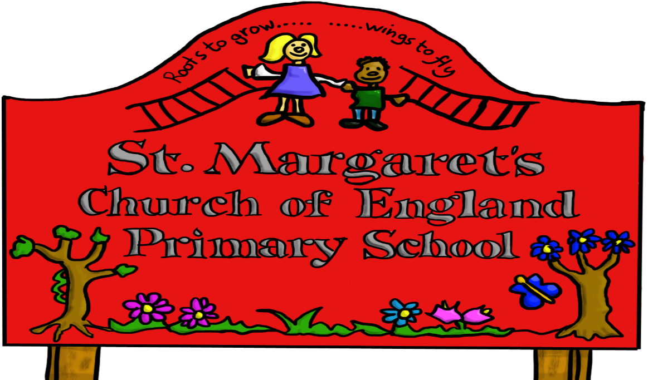

Approved by: | Governors | Date:
Last reviewed on: | Dec 2020
Next review due by: | Dec 2022

ST MARGARET’S CE VA PRIMARY SCHOOL

SUPERVISION POLICY

Duty of Care

The ‘duty of care,’ is a statutory and contractual obligation for all staff, but places a specific responsibility on the Head Teacher, as overall manager of the school, to ensure that full and appropriate supervision of all pupils occurs throughout the school day.

A significant part of the relationship between a teacher and pupils is based on the concept of duty of care. This principal has been upheld frequently in the courts and it follows that the teacher must exercise a standard of care as would be expected of a caring and prudent parent.

The Head Teacher along with the Leadership Team must ensure the maintenance of good order and discipline at all times during the school day (including the mid-day break) when pupils are present on the school premises and whenever the pupils are engaged in authorised school activities, whether on the school premises or elsewhere. She/He is also responsible for the security and effective supervision of the school buildings and their contents and of the school grounds.

All teachers are responsible for maintaining good order and discipline among the pupils and safeguarding their safety both when they are authorised to be on the school premises and when they are engaged in authorised school activities elsewhere.
The following points should be noted:
- It is necessary to go into a room itself to supervise a class.
- A teacher, LSP or other paid supervisor should be present to supervise pupils.
- The only safe system is to have one person in each room.

If a claim for negligence is bought against a teacher, the Head Teacher or the Governing Body (the employer), it is important to be able to show that a structured supervision plan exists, is known and understood by all involved, and that adequate care was being exercised at the time of the incident. High standards of supervision must be maintained at all times.

If an incident occurs, it is important that, in addition to the official accident report form, when necessary, an account should be written up for any incident other than a very trivial incident and recorded in the Accident Log Folder. Parents should be informed by telephone of serious accidents and bumps to the head. Bumps to the head should also be followed up by a note home. The Accident Logs are monitored to identify any patterns occurring in order that relevant measures can be put in place.
Accidents that occur through faulty equipment or apparatus should be reported to the head teacher and the equipment placed out of use until repaired or replaced.

Supervision before school

All parents are made aware of the time when the school doors open which is 8.45am. Prior to this starting time parents themselves are responsible for the supervision of their child.

Registration

The responsibility to ensure that a pupil attends regularly is that of the parents or guardian. Up to date contact telephone numbers are available should a child be absent without notification. Staff in the school office will attempt to contact the parent or guardian of any child whose absence has not been authorised on the first day of absence.
Parents are informed that a note, verbal message or telephone call is necessary to validate their child’s absence.

Pupils offsite

Pupils will not be allowed off site unaccompanied, during school hours, unless there is clear evidence of a request from a parent or guardian. Any letter making such a request should be kept for a half term. No pupil should be sent off site on a personal errand on behalf of any member of staff.
Pupils leaving school with a parent or guardian will be issued with a permission slip. Pupils arriving after registration will be logged as late by the office staff and a reason recorded on the SIMS register.

Lesson time

No class of pupils should be left unsupervised for any reason. In the case of pupils’ excused normal lessons, for example, P.E. or assembly, adequate supervision within available staffing resources, needs to be provided. Supervision is needed for activities such as moving P.E. equipment or chairs and tables. Pupils should be reminded of the correct way to carry chairs, tables and apparatus.
Pupils who are not following the school rules regarding classroom behaviour must be escorted to another class, to the deputy head teacher or head teacher with an LSP or another responsible pupil. Pupils being disciplined should not be sent to sit or stand outside the classroom without supervision.
Evidence of pupils being sent out of lessons must be kept in the class behaviour logs and be dated and signed; wherever possible they should take work to complete.

Monitors may be used for a variety of jobs. They are expected to act in a safe, sensible and reliable manner. This encourages independence and fosters self confidence. Monitors must not be allowed to set out or put away heavy P.E. equipment without supervision.

Supervision at break times

Adequate supervision must be provided both indoors and outdoors through school break times. A staff rota is provided and at least two staff should be on duty. A rota is provided for classes to take turns in using the outside apparatus and playing football.
Pupils should never be left in classrooms at break times without a member of staff being present. Pupil librarians and office managers are allowed to complete their duties unsupervised at certain times of the day.
The only exception is if a child has a genuine medical reason and needs to stay inside. In this case a buddy support system is used, and then staff should check on these pupils periodically.

Midday Supervision

The safety and discipline of the pupils on the premises before, during and after the midday meal must be ensured as far as is reasonably practical. The supervisory staff will be responsible for one class of pupils, at certain parts of the lunch break; pupils from different classes may be joined together if some of the class are still in the dining area. KS1 and Reception class pupils may go into the hall together.
Pupils are not allowed inside the school building without the permission of a lunch time supervisor.
The senior supervisor will initially deal with any problems brought to her attention by the supervisory staff. The Head or Deputy Head teacher will be informed by the senior supervisor about any incidents of a serious nature, or where further action may be necessary.

Supervision after school

Staff should ensure that the parent/carer or guardian responsible for collecting KS1 and Foundation Stage pupils are there to take charge of them before letting the pupils leave their care.
All KS2 staff will take their pupils to the KS2 door to release them at the end of the day. Pupils are instructed to come back into their class teacher if there is no one to collect them.
Parents, however, are made aware that any child left on the premises after the school day has ended, is their responsibility. If they neglect to make provision for the pupils’ safe return home, action may be taken by Social Services. Parents should contact the school at the earliest opportunity if they are delayed in traffic. Pupils may be placed in the Helping hands After School Club in an emergency situation, providing a place is available and the pupils concerned are already registered with Helping Hands. Class teachers, the Head or Deputy will attempt to contact the parents to ask them to make arrangements to collect their children.
Reception, Year 1 and Year 2 pupils attending Helping Hands Club will be collected from their classrooms by their staff. Other pupils attending the club will line up by the Year 1 exit door.

Breakfast and After School Club

This provision is currently organised by a private company, “Helping Hands”, who are responsible for good supervision of all children in their care, at all times. They are responsible for providing risk assessments for all activities they carry out on school grounds. Helping Hands is situated in the School Canteen building. Parents enter the school site via the back gate and through the playground in the morning.

Supervision of pupils travelling to and from school

The Head Teacher is not responsible for the supervision of pupils travelling to and from school. However, the Head should inform parents of any inappropriate or unacceptable behaviour particularly if it affects the safety of any child.

Supervision of Physical Education

In addition to the same general principles of care, the class teacher must bear in mind the requirements of the Health & Safety at Work Act. In the event of an accident, an action for damages would be unlikely to succeed if the teacher could show that he/she had employed reasonable care. Factors to be considered include the safety of the apparatus, the conditions of the floor, the suitability of the children’s clothing and footwear whether the exercises and activities are within the capabilities of the pupils as well as being properly taught.

There must be a high degree of supervision during athletic activities, especially field events and at the swimming baths. Pupils should not be allowed into the hall to use gymnastic equipment or go onto the pool side, unless they are properly supervised.

Extra Curricular Activities

The same level of supervision is necessary as for similar activities in normal school time. Sandwell Offsite Guidelines and procedures are followed for all residential visits, on and off site clubs and visits, including relevant risk assessments, registers with contact details and ensuring all staff has current a DBS. Staff must follow the guidelines regarding staff to pupil ratio for the age of the pupils in their care.

Permission should be obtained from parents whose children will be participating in after school activities and who will be late home. A written notification of pupils making their own way home is required. Parents should be notified in the event of the cancellation of such activities at the earliest opportunity.

When pupils are taken from school on organised visits, the same duty of care arising from being ‘in loco parentis’ exists whether or not the visit is undertaken voluntarily and out of school hours. It covers the duration of the whole visit and should include arrangements, where appropriate for the collection of pupils at the end of the school day.
Where there is no male teacher to escort boys to the male toilets or changing rooms, every effort must be made to ensure the safety of the boys. The boys should not be allowed into the toilets alone, but in groups of at least three or four and should wait until they are all finished before coming out of the toilets.

Pupil Responsibilities

Class teachers should constantly reinforce school rules and challenge pupils they see inside at break times and lunch times. They should explain what is expected of them in out of school and on off site visits and how to deal with problems that may occur in order to keep them safe.

Dec 2020

