ST MARGARET’S CE VA PRIMARY SCHOOL
RE POLICY
“Encourage one another and build each other up”
1 Thessalonians 5:11

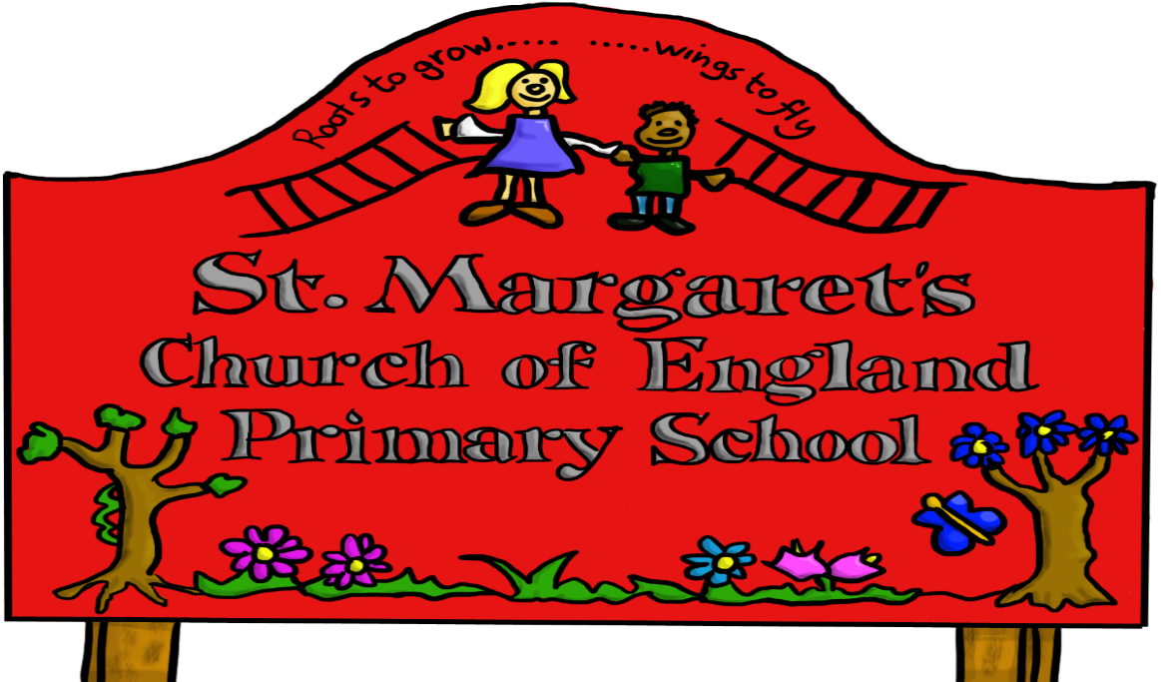

Approved by: | Governors | Date:
Last reviewed on: | June 2020
Next review due by: | June 2023

ST MARGARET’S CHURCH OF ENGLAND VA PRIMARY SCHOOL
RELIGIOUS EDUCATION POLICY

Policy Statement

The Christian ethos is implicit throughout the life and work of the School and explicit through planned activities that have continuity and progression and allow for the individuality of each child and their parents. The whole curriculum is informed by the Christian faith. As a church school we promote quality Worship and Religious Education and seek to build a lasting relationship between the school, church and community.
Religious Education at St Margaret’s School involves general, moral and spiritual education (the development of a zest for life and love of life, an ethos of caring, patience, forgiveness etc and the forming of relationships between children, staff and parents).
We seek to help all of our learners to ‘live and live splendidly’ (John 10:10), this is done through explicit and implicit means.
At St Margaret’s our RE curriculum has been developed as a more enquiry based scheme which include elements of the Sandwell and the Telford and Wrekin RE Syllabus (SACRE) and Understanding Christianity -Text Impact and Connections. We continue to maintain the balance of teaching 80% Christianity.

Aims and Objectives
Religious education enables children to investigate and reflect on some of the most fundamental questions asked by people.
Through the teaching of Religious Education at St Margaret’s we aim to improve the quality of education received by all pupils, so that they have the opportunity to develop morally, spiritually, socially and culturally.
By introducing the Understanding Christianity materials our children start to develop an understanding of theological concepts within Christianity with their own self- understanding and understanding of the world as part of their wider religious literacy. By introducing UC we are developing concepts such as God, Creation, People of God, Incarnation, Gospel, Salvation and Kingdom of God. In Religious Education lessons, as well as PSHE and our Collective Worship
Program, children are invited to reflect on their personal responses to issues, consider other people’s responses, and appreciate that for some people, belief in spiritual dimensions is important.
At St Margaret’s, we develop the children’s knowledge and understanding of the major world faiths and we address fundamental questions concerning, for example, the meaning of life and the existence of a divine spirit. We enable children to develop a sound knowledge, not only of Christianity, but also of other world religions, especially those that are the main faiths of children within our school. We provide opportunities for children to develop an understanding of people who do not follow a faith. Children reflect on what it means to have a faith and to develop their own spiritual knowledge and understanding. We help the children learn from religions as well as about religions

The aims of religious education are to help children:
- To make sense of a text, to understand the impact and to make connections between these and their own lives and understanding the world;
- To critically reflect upon, evaluate and apply their own learning to their own understanding of religion and belief of themselves the world and human experience;
- To develop their knowledge and understanding of God, Jesus Christ, the church and the central beliefs of Christianity;
- To develop an awareness of spiritual and moral issues in life experiences;
- To develop knowledge and understanding of other major world religions and value systems found in Britain including values of non -believers;
- To develop understanding of what it means to be committed to a religious tradition;
- To develop a positive attitude towards people of other faiths, their beliefs and practices;
- To develop investigative and research skills and to enable them to make reasoned judgements about religious issues;
- To be reflect on their own experiences and to develop their own personal opinions;
- To develop a good understanding of what it means to have a living faith;
- To have respect for other people’s views and celebrate the diversity in society.

The Legal Position of Religious Education

Our school curriculum for Religious Education meets the requirements of the 1988 Education Reform Act (ERA). The ERA stipulates that religious education is compulsory for all children, including those in the reception class who are less than five years old. The ERA allows parents to withdraw their child from religious education classes if they so wish, although only after they have given written notice to the school governors. The ERA also allows teachers to refuse to teach religious education, but only after they have given due notice of their intention to the school governors. The religious education curriculum forms an important part of our school’s spiritual, moral and social teaching. It also promotes education for citizenship. The ERA states that the RE syllabus should reflect the fact that religious traditions in Great Britain are in the main Christian and that it should, at the same time, take account of the teachings and practices of other major religions.

Teaching and Learning Style

We base our teaching and learning style in RE on the key principle that good teaching in RE allows children both to learn about religious traditions and to reflect on what the religious ideas and concepts mean to them. Our teaching enables children to extend their own sense of values and promotes their spiritual growth and development. We encourage children to think about their own views and values in relation to the themes and topics studied in the RE curriculum.

Our teaching and learning styles in RE enable children to build on their own experiences and to extend their knowledge and understanding of religious traditions. We use their experiences of religious festivals such as Easter, Christmas, Diwali etc. to develop their critical thinking.

Children carry out research into religious topics. They study particular religious faiths and also compare the religious views of different faith groups on topics such as rites of passage or festivals. Children investigate religious and moral issues either individual or in groups. Sometimes children share their learning of R.E in class and whole school assemblies. Whole school collective worship gives the school further opportunities to develop religious understanding and to share their developing knowledge and understanding with others.

We recognise the fact that all classes in our school have children of widely differing abilities, so we provide suitable learning opportunities for all children by matching the challenge of the task to the developing abilities of the children within each class. We achieve this in a variety of ways, for example, by:
- Setting tasks which are open-ended and can have a variety of responses;
- Setting tasks of increasing difficulty;
- Providing opportunities for the children to challenge themselves by choosing their own level of difficulty.
- Providing resources of different complexity adapted to the lesson outcomes.
- Using other adults where appropriate to support the work of individual or groups of children.

Curriculum Planning in Religious Education

We ensure that the units studied in religious education build on prior learning. We offer opportunities for children of all abilities to develop their skills and knowledge in each unit and we ensure that the curriculum offers the children increasing levels of challenge as they move through the school. The RE subject leader devises the plan in collaboration with teaching colleagues in each year group. Each teacher then adapts the medium- term plans to meet the needs of their pupils.

The Foundation Stage
We teach Religious Education to all children in the school including those in the Reception class.
In Reception class, Religious Education is taught through the topics covered during the year. As the Reception class is part of the Early Years Foundation Stage we relate the religious education aspects of the children’s work to the objectives set out in the EYFS Statutory guidance and Development Matters, which underpin the curriculum planning for children aged three to five.

The Role of the Subject Leader

The role of the subject leader involves the following:
- To have an in-depth knowledge of the subject;
- To support and advise other members of staff;
- To audit resources within the school;
- To order and organise resources in a way in which they are easy to use and accessible to all members of staff;
- To ensure that there is progression and continuity in Religious Education across all Key Stages;
- To work alongside teachers to ensure that there is good practice, and to gain an overview of practice in school;
- To monitor standards in RE and provide support and feedback to staff.
- To develop assessment procedures for Religious Education;
- To provide in-service training as and when required;
- To keep up to date with RE resources.

The Role of the Teacher

The role of the teacher involves the following

- To plan appropriate learning tasks which support and challenge all pupils;
- To discuss the children's learning and make appropriate interventions to improve their skills and knowledge;
- To plan opportunities which develop critical and enquiry skills;
- To encourage children to share, discuss and reflect on their work with other children;
- To help children draw on skills and knowledge they have learnt in other areas of the curriculum;
- To help children assess and evaluate their own work and the work of others;
- To be aware of any Health and Safety issues connected with visits off site.

Cross Curricular Links

Wherever possible we make links with other subjects.
English

Religious Education contributes significantly to the teaching of English in our school by actively promoting the skills of reading, writing and speaking and listening. Sometimes an RE context is used to reinforce a particular genre in writing.

Computing

We use ICT where appropriate in religious education. The children find, select and analyze information using the Internet. Sometimes children use their ICT skills to present RE information or to research a particular RE unit.

Personal, Social, and Health Education (PSHE)

Through our RE lessons we teach the children about values and moral beliefs that individual choices of behaviour. We also promote the values and attitudes required for citizenship in a democracy by teaching respect for others and the need for personal responsibility. By promoting tolerance and understanding of other people, we enable children to appreciate what it means to be positive members of our society. We encourage children to approach other beliefs with sensitivity.

Spiritual, Moral, Social and Cultural Development

Through Religious Education in our school, we provide opportunities for spiritual development. Children consider and respond to questions concerning the meaning and purpose of life. We help them to recognise the difference between right and wrong through the study of moral and ethical questions. We enhance their social development by helping them to build a sense of identity in a multicultural society. Children explore issues of religious faith and values and in so doing, they develop their knowledge and understanding of the cultural context of their own lives.

Equal Opportunities

We recognize the fact that all classes in our school have children of widely differing abilities and faiths and so we provide suitable learning opportunities for all children by matching the challenge of the task to the ability of the child and taking other’s views into consideration.
We enable all children to have access to the full range of activities involved in learning Religious Education.
Through our Religious Education teaching, we provide learning opportunities that enable all pupils to make good progress. We strive hard to meet the needs of those pupils with Special Educational Needs, those with disabilities, those with special gifts and talents and those learning English as an additional language and we take all reasonable steps to achieve this.

Health and Safety

It will be the responsibility of the Class Teacher with the support of the visit organiser:
- To complete the appropriate paper work and carry out a risk assessment before any proposed off-site visit;
- To ensure there are adequate adult helpers to accompany children on any proposed off-site visit.
- All staff who take children on visits have received Visit Leader Training and complete paperwork using the EVOLVE electronic system.
Assessment for Learning

Children demonstrate their ability in RE through a variety of different ways. Younger children might, for example, act out a famous story from the Bible, whilst older pupils might produce a presentation or video based on their investigation into significant figures. As in all subjects the teachers and staff use assessment for learning techniques to ensure work is well pitched and provides the necessary challenge for all learners. Higher order questions are planned and used to deepen thinking and teachers check regularly throughout the lesson the progress of all learners. Teachers will assess children’s work in Religious Education by making informal judgements as we observe them during lessons. On completion of a piece of work, the teacher assesses the work and gives the child written or verbal feedback to help guide progress and further understanding in line with the school Marking Policy.

Assessment of pupils' work and achievement should be seen as a formative tool, enabling the planning of appropriate future work. Assessment should be built into Religious Education lessons at
the planning stage, eg teachers should have a clear idea about what they want to assess.
Teachers should decide if they are going to assess the whole class, a group of children, or individual children, and what their focus will be:
- A formative assessment at the beginning of the module;
- A summative assessment at the end of the module;
- Ability to use a variety of sources;
- Ability to communicate their knowledge and understanding of Religious Education in a variety of ways;
- Ability to recall key teachings, events or stories, either orally, or written/drawn;
- Ability to make connections from a text to living in the world today.
There are some important areas that are developed through RE which are not suitable for assessment against a scale e.g. attitudes but these can be commented on in their termly written reports and at parent consultations.

Assessments are recorded at the end of each unit and are put onto a whole class grid.
Assessment of work in the Early Years Foundation Stage will be recorded in the pupil profiles which are passed onto the Year 1 teacher.

Monitoring of RE

RE is part of our school monitoring plan. Standards of achievement are monitored through book scrutinies, lesson observations and pupil discussions. These are carried out by the subject leader and sometimes the Leadership Team.

Reviewed June 2020

