Does TikTok have any parental controls?
TikTok does offer its users a range of settings to customise their experience and make it safer for young people. And although it’s important to bear in mind that settings and parental controls don’t eliminate risk, they can be a good first step.

How to make an account private
One of the main concerns parents often have about social media is that their child might be contacted by strangers who might not have their best interest at heart. By making an account private, other users must be approved before they can see and interact with your child’s content or contact them. Here’s how to set it up:
- Go to your child’s ‘Account’ section and tap the three-dot menu in the top-right corner of the screen.
- Select ‘Privacy and safety’ from the ‘Settings and privacy’ menu.
- Toggle the ‘Private account’ slider at the top of the page.
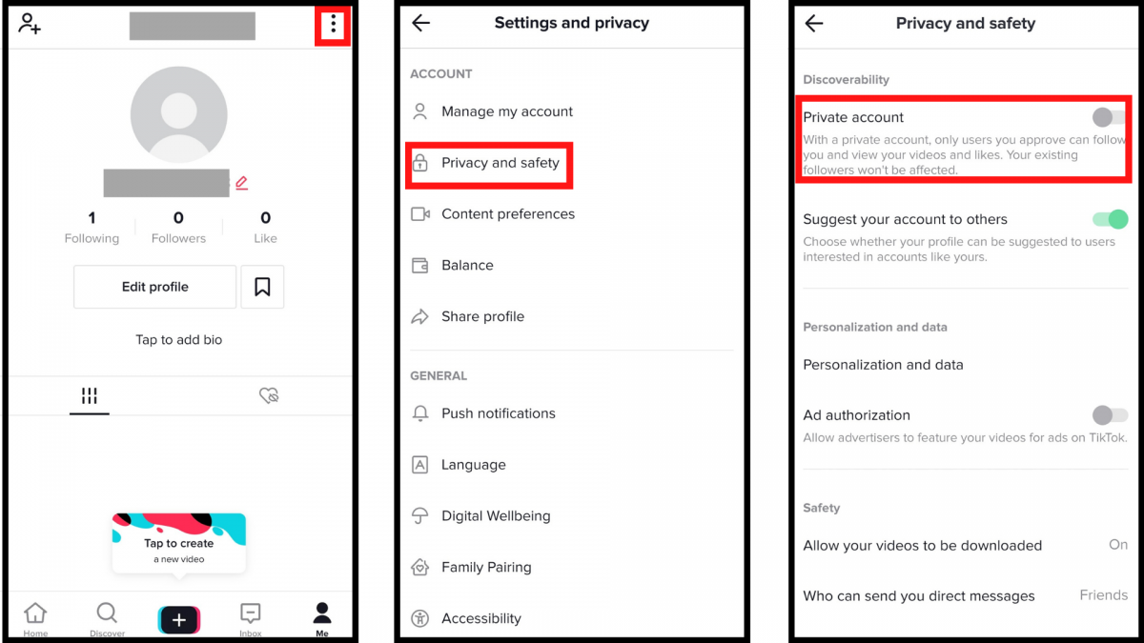

How to filter out inappropriate content
TikTok is moderated and content that does not uphold its community guidelines is continuously weeded out. But if you want to further minimise the risk of your child stumbling across mature content, it’s a good idea to enable ‘Restricted Mode’. TikTok doesn’t explicitly say how this works, merely that it “limits the appearance of content that may not be appropriate for all audiences”. To enable it:
- Go to your child’s ‘Account’ section and tap the three-dot menu in the top-right corner of the screen.
- Select ‘Digital Wellbeing’ further down on the ‘Settings and privacy’ menu.
- Go onto the page for ‘Restricted Mode’ and tap ‘Turn on Restricted Mode’.
- You’ll then be asked to set a password you need to enter to disable it again.
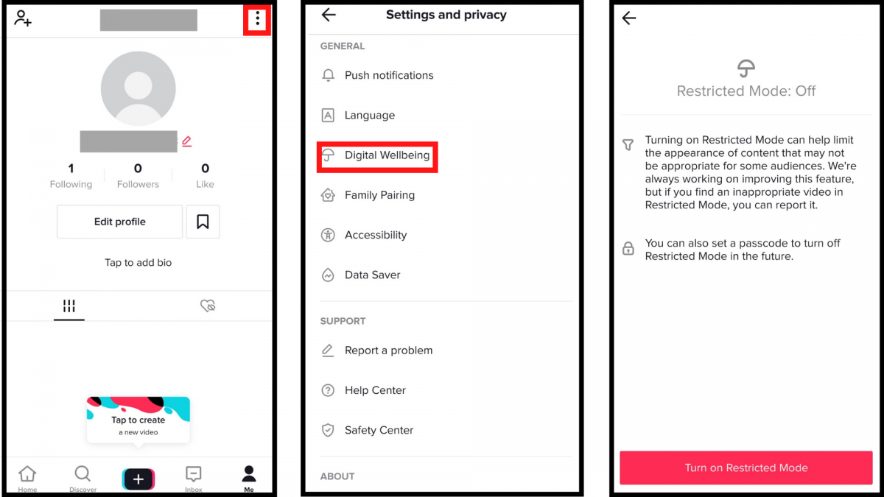

How to manage time spent on the app
Research has found that a moderate amount of screen time per day can be very beneficial for your child, but that doesn’t mean you can’t choose to set limits. TikTok offers a Screen Time Management feature which gives the user a custom daily quota, after which they’ll need to input a password to continue.
- Go to your child’s ‘Account’ section and tap the three-dot menu in the top-right corner of the screen.
- Select ‘Digital Wellbeing’ further down on the ‘Settings and privacy’ menu.
- Go onto the page for ‘Screen Time Management’ and tap ‘Turn on Screen Time Management’.
- You’ll then be asked to set a password you need to enter to disable it again. If you’ve already enabled ‘Restricted Mode’, it’ll be the same password.
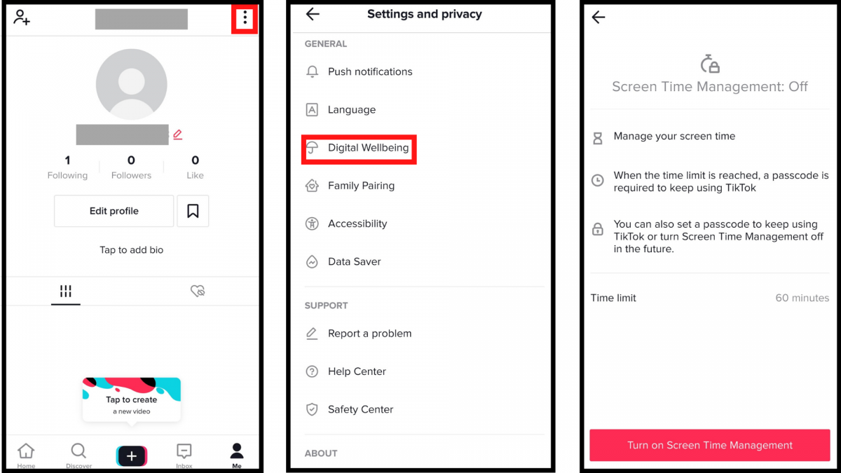

How can I help my child be safer on TikTok?
Using social media can be an enriching activity for young people and a good way to stay in touch with their social circle during these strange times. Although TikTok has significantly stepped up its efforts to keep young people safe, it’s important that your child is aware of the risks they could encounter and know how to respond.
First of all, remind your child to be mindful of what they share and who they share it with. If they choose to have an open profile, they need to understand what that means – everyone can see what they post and TikTok even has a feature that allows other users to save their videos (to disable this option, go to the Privacy and Safety option and turn off ‘Allow your videos to be downloaded’). Try going through the settings together, so you can both share your views on what should be adjusted.
Social media can be hotbeds for misinformation and scams, so encourage your child to think critically about the things they see in their feed. If something seems too good to be true, chances are it probably is.
It might seem obvious, but reassure your child that if they have any questions about the app or have had an uncomfortable experience, they can come to you for support.
And last but not least, make sure that your child knows how to report videos or users if they stumble across inappropriate content and how to block users who are bothering them.

How to report and block a user
- Go to the user’s profile and hit the three-dot menu in the top-right corner of the screen.
- Click either ‘Report’ or ‘Block’ from the menu that will appear at the bottom of the screen.
- In both cases you’ll be asked to give a brief description of the issue and complete a few more steps.

