ST MARGARET’S CE VA PRIMARY SCHOOL
EQUALITY STATEMENT AND POLICY

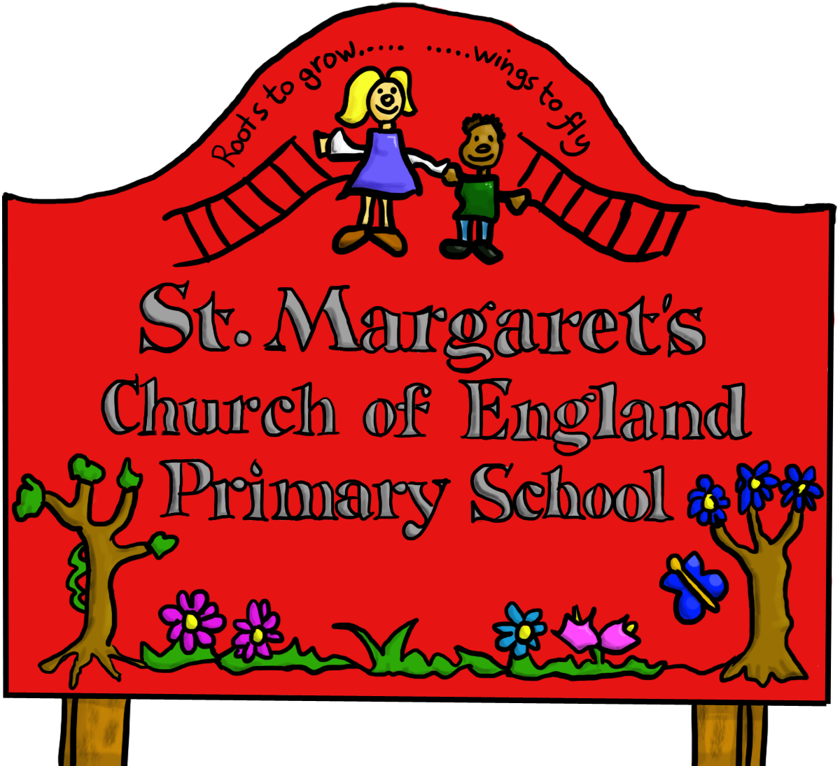

Last reviewed on: | [Date] February 2019
Next review due by: | [Date] February 2022

Contents

School Context 3

1. Aims 3

2. Legislation and guidance 4

3. Roles and responsibilities 4

4. Eliminating discrimination 4

5. Advancing equality of opportunity 4

6. Fostering good relations 5

7. Equality considerations in decision-making 5

8. Equality objectives 5

9. Monitoring arrangements 6

10. Links with other policies 6

School Context
Our school values the individuality of all our children. We are committed to giving all our children every opportunity to achieve the highest standards. Within this ethos of achievement, we do not tolerate bullying or harassment of any kind. This policy helps to ensure that this school promotes the individuality of all our children, irrespective of ethnicity, attainment, age, disability, gender or background. We aim to reflect the multi-ethnic nature of our society and ensure that the education we offer fosters positive attitudes to all people.

1. Aims
Our school aims to meet its obligations under the public sector equality duty by having due regard to the need to:
- Eliminate discrimination and other conduct that is prohibited by the Equality Act 2010

- Advance equality of opportunity between people who share a protected characteristic and people who do not share it

- Foster good relations across all characteristics – between people who share a protected characteristic and people who do not share it

- Promote equality of opportunity.

- Promote good relations between members of different racial, cultural and religious groups and communities.

In fulfilling our legal duties listed above, we are guided by three essential principles:

- Every pupil should have opportunities to achieve the highest possible standards, and the best possible qualifications for the next stages of their life and education

- Every pupil should be helped to develop a sense of personal and cultural identity, in which they are confident and open-minded, and are receptive and respectful towards other identities

- Every pupil should develop the knowledge, understanding and skills that they need in order to participate in Britain’s multi-ethnic society and in the wider context of an interdependent world.

2. Legislation and guidance
This document meets the requirements under the following legislation:
- The Equality Act 2010, which introduced the public sector equality duty and protects people from discrimination
- The Equality Act 2010 (Specific Duties) Regulations 2011, which require schools to publish information to demonstrate how they are complying with the public sector equality duty and to publish equality objectives
This document is also based on Department for Education (DfE) guidance: The Equality Act 2010 and schools.

3. Roles and responsibilities
The School Governors will:
- Ensure that the equality information and objectives as set out in this statement are published and communicated throughout the school, including to staff, pupils and parents, and that they are reviewed and updated at least once every four years.

- Delegate responsibility for monitoring the achievement of the objectives on a daily basis to the headteacher

The headteacher will:
- Promote knowledge and understanding of the equality objectives amongst staff and pupils

- Monitor success in achieving the objectives and report back to governors

4. Eliminating discrimination

The school is aware of its obligations under the Equality Act 2010 and complies with non-discrimination provisions.
Where relevant, our policies include reference to the importance of avoiding discrimination and other prohibited conduct.
Staff and governors are regularly reminded of their responsibilities under the Equality Act, for example during meetings.

5. Advancing equality of opportunity

As set out in the DfE guidance on the Equality Act, the school aims to advance equality of opportunity by:
- Removing or minimising disadvantages suffered by people which are connected to a particular characteristic they have (e.g. pupils with disabilities, pupils who are being subjected to homophobic bullying)

- Taking steps to meet the particular needs of pupils who have a particular characteristic (e.g. enabling pupils of different faiths to express their beliefs)

- Encouraging people who have a particular characteristic to participate fully in any activities (e.g. encouraging all pupils to be involved in the full range of school societies)
In fulfilling this aspect of the duty, the school will:
- Publish attainment data each academic year showing how pupils with different characteristics are performing
- Analyse the above data to determine strengths and areas for improvement, implement actions in response and publish this information
- Make evidence available identifying improvements for specific groups (e.g. declines in incidents of homophobic or transphobic bullying)

6. Fostering good relations
The school aims to foster good relations between those who share a protected characteristic and those who do not share it by:
- Promoting tolerance, friendship and understanding of a range of religions and cultures through different aspects of our curriculum. This includes teaching in RE, citizenship and personal, social, health and economic (PSHE) education, but also activities in other curriculum areas. For example, as part of teaching and learning in English/reading, pupils will be introduced to literature from a range of cultures

- By promoting equality in our class and school worship/ assemblies and by giving pupils opportunities to discuss relevant issues and concerns
.
- Working with our local community. This includes inviting leaders of local faith groups to speak at our worship/assemblies, and organising school trips and activities based around the local community

- As part of our school ethos and values we encourage the individuality of every pupil. All of our school teams (Worship Team, School Council, Online Safety Team,) have representatives from different year groups and a range of backgrounds and cultures.

7. Equality considerations in decision-making
St Margaret’s ensures it has due regard to equality considerations whenever significant decisions are made.
The school always considers the impact of significant decisions on particular groups. For example, when a school trip or activity is being planned, the school considers whether the trip:
- Cuts across any religious holidays
- Is accessible to pupils with disabilities
- Has equivalent facilities for boys and girls
The school keeps a written record (known as an Equality Impact Assessment) to show we have actively considered our equality duties and asked ourselves relevant questions. This is recorded at the same time as the risk assessment when planning school trips and activities. The record is completed by the member of staff organising the activity and is stored electronically with the completed risk assessment.

8. Equality objectives
Objective 1: Undertake an analysis of recruitment data and trends with regard to race, gender and disability by July 2019, and report on this to the Finance and Staffing –committee.
Why we have chosen this objective: So that governors are aware of the recruitment data for school
To achieve this objective we plan to: collate a grid identifying the above and then share with governors
Progress we are making towards this objective:

Objective 2
Include the 'Two Ticks' positive about people with disabilities symbol on all job adverts, application forms and information by January of next year, to help address the under-representation of people with disabilities in the school workforce.
Why we have chosen this objective: We have few people who apply for posts who have disability and to encourage this.
To achieve this objective we plan to: Make it clear in any advert that we comply with the Equality Act.
Progress we are making towards this objective:

9. Monitoring arrangements
St Margaret’s Governors are responsible for updating the equality information we publish at least every year.
This document will be reviewed by St Margaret’s governors at least every 4 years.
This document will be approved by St Margaret’s governors.

10. Links with other policies
This document links to the following policies:
- Accessibility plan
- Risk assessment
- Special Needs
- Behaviour
.

