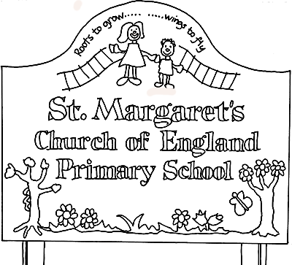

St Margaret’s CE Primary School
Foundation Stage Policy
Our Vision Statement
St Margaret’s CE Primary school is a happy, caring community of learners where there is a place for everyone in God’s family. Working together with Jesus besides us to achieve our full potential.
St Margaret’s seeks to promote a sense of self worth in everyone involved in our school community to promote the ideals of mutual respect and care for others. We nurture, motivate and challenge all our learners in a creative, enjoyable and safe environment. By understanding what our children already know we inspire leaning by bringing an innovative and rich curriculum to life.
We aim to develop thoughtful, confident and responsible young people who appreciate the world in which we live and are equipped with the skills and knowledge to succeed in life.
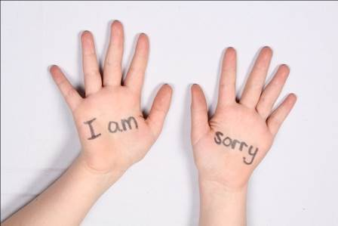
At St-Margaret’s we have recently launched our new school values. After much discussion, the staff and children have chosen six words that will create the core values we feel sum up the heart of the school and are important to us. The values we are focusing on are Thankfulness, Forgiveness, Perseverance, Truthfulness, Responsibility and Respect. We want to develop these values so the children understand the importance of these characteristics in their lives and society. When the children have started Reception they will bring home information about how you can support both us and them in teaching and using these values.
Responsibility Forgiveness Truthfulness

Thankfulness Perseverance Respect
St Margaret’s CE Primary school’s Foundation Stage includes a part time Nursery provision for 40 children and a full time Reception Class for 30 children. We follow a principled approach as set out in the Early Years Foundation Stage (EYFS) document. The aim of the EYFS is to help young children achieve the five Every Child Matters outcomes of staying safe, being healthy, enjoying and achieving, making a positive contribution, and achieving economic well-being by:
- Setting the standards
- Providing for equality of opportunity
- Creating the framework for partnership working
- Improving quality and consistency
- Laying a secure foundation for future learning

The EYFS is based upon four guiding themes with each being broken down into four commitments describing how each of the principles can be put into practice:
- A unique child recognises that every child is a competent learner from birth who can be resilient, capable, confident and self-assured. The commitments are focused around development; inclusion; safety; and health and well-being.
- Positive Relationships describes how children learn to be strong and independent from a base of loving and secure relationships with parents and or/ a key person. The commitments are focused around respect; partnership with parents; supporting learning; and the role of the key person
- Enabling Environments explains that the environment plays a key role in supporting and extending children’s development and learning. The commitments are focused around observation, assessment and planning; support for every child; the learning environment; and the wider context- transitions, continuity, and multi-agency working
- Learning and Development recognises that children develop and learn in different ways and at different rates, and that all areas of learning and development are equally important and inter-connected.

A Unique Child
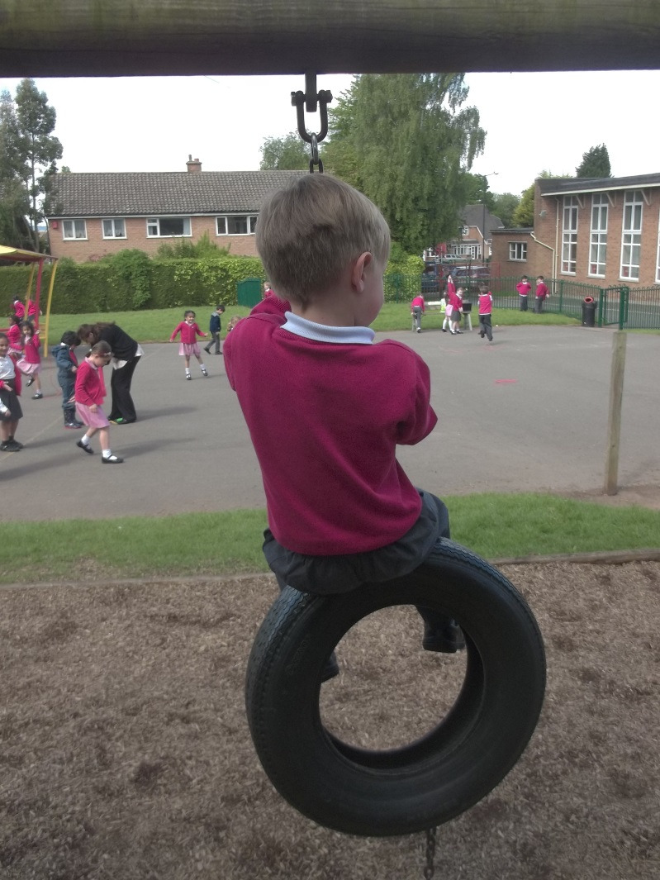
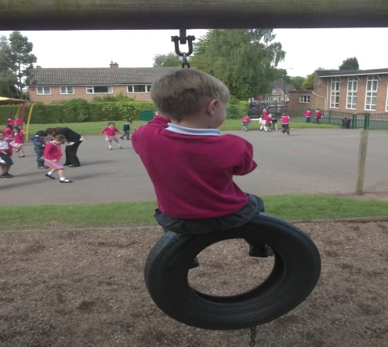

Child Development
At St Margaret’s we acknowledge that children develop in individual ways and recognise that all areas of development are equally as important. We seek to provide for their physical, cognitive, linguistic, spiritual, social and emotional needs through the experiences we provide in our setting.
Inclusive Practice
We value the diversity of individuals within the school and do not discriminate against children because of ‘differences’. All children at St Margaret’s are treated fairly regardless of race, religion or abilities. All children and their families are valued within our school.
In our school we believe that all our children matter. We give our children every opportunity to achieve their best. We do this by taking account of our children’s range of life experiences when planning for their learning. In the EYFS we set realistic and challenging expectations that meet the needs of our children. We achieve this by planning to meet the needs of boys and girls, children with special educational needs, children who are more able, children with disabilities, children from all social and cultural backgrounds, children of different ethnic groups and those from diverse linguistic backgrounds.
We meet the needs of all our children through:
- Planning opportunities that build upon and extend children’s knowledge, experience and interests, and develop their self esteem and confidence.
- Using a wide range of teaching strategies based on children’s learning needs.
- Providing a wide range of opportunities to motivate and support children and to help them to learn effectively.
- Providing a safe, supportive and positive learning environment in which the contribution of all children is valued.
- Using resources which reflect diversity and are free from discrimination and stereotyping.
- Planning challenging activities for children whose ability and understanding are in advance of their language and communication skills.
- Monitoring children’s progress and taking action to provide support as necessary.
Keeping Safe
It is important to us that all children in the school are ‘safe’. We aim to educate children on boundaries, rules and limits and to help them understand why they exist. We provide children with choices to help them develop this extremely important life skill. Children should be allowed to take risks, but need to be taught how to recognise and avoid hazards. We aim to protect the physical and emotional well being of all children. (See Whole School Safeguarding Children Policy)

Health and Well-being
“Children learn best when they are healthy, safe and secure, when their individual needs are met and when they have positive relationships with the adults caring for them.”
At St Margaret’s we understand that we are legally required to comply with certain welfare requirements as stated in the Statutory Framework for the Early Years Foundation Stage March 2012. We understand that we are required to:
- Promote the welfare of children.
- Promote good health, preventing the spread of infection and taking appropriate action when children are ill.
- Manage behaviour effectively in a manner appropriate for the children’s stage of development and individual needs.
- Ensure all adults who look after the children or who have unsupervised access to them are suitable to do so.
- Ensure that the premises, furniture and equipment are safe and suitable for purpose.
- Ensure that every child receives enjoyable and challenging learning and development experiences tailored to meet their needs.
- Maintain records, policies and procedures required for safe efficient management of the setting and to meet the needs of the children.
We endeavour to meet all these requirements.

Positive Relationships
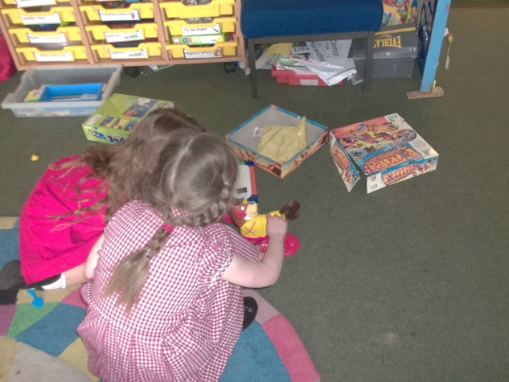

Respecting Each Other
At St Margaret’s CE Primary School we recognise that children learn to be strong and independent from secure relationships. We aim to develop caring, respectful, professional relationships with the children and their families.

Parents as Partners
We recognise that parents are children’s first and most enduring educators and we value the contribution they make. We recognise the role that parents have played, and their future role, in educating the children. We do this through:
- Induction meetings that involve both parents and children
- Offering parent’s regular opportunities to talk about their child’s progress and to contribute to their child’s Learning Journey Profile in both Nursery and Reception.
- By encouraging parents to make regular observational comments of their children's experiences and achievements on provided observational templates.
- Encouraging parents to talk to the child’s teacher if there are any concerns. Parents receive a written report on their child’s attainment and progress during each term followed by a formal meeting each term at which the teacher and the parent discuss the child’s progress in private.
- Organising a range of activities throughout the year that encourage collaboration between child, school and parents: Craft days, Opportunities to participate in their child’s learning, Science day, Sports Day, Concerts, Nativity play, Cooking sessions, Harvest festival, Summer Picnic etc...
- Curriculum letters and curriculum workshops, these have included phonic and reading sessions and Newsletters.

All staff involved with the EYFS form good relationships with all children, supporting them and taking time to listen. At our school Foundation Stage teachers act as a ‘Key Person’ to all children in EYFS, supported by the Learning Support Practitioners. As a Foundation Stage we plan days where the children in both Nursery and Reception play and learn together on a regular basis. We ensure continuity and coherence by sharing information about the children’s progress and development.

Enabling Environments
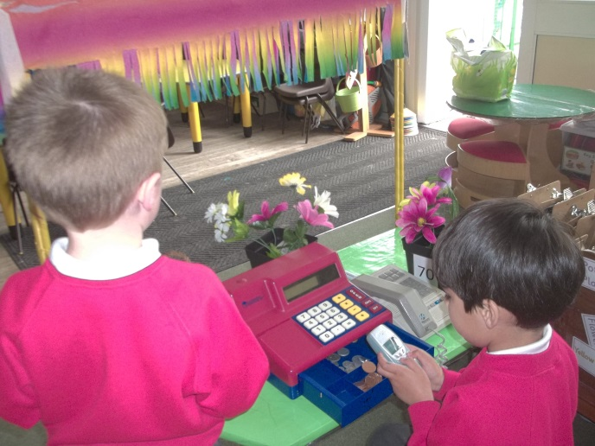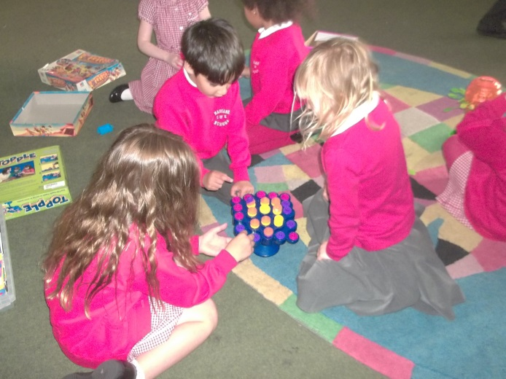

At St Margaret’s we recognise that the environment plays a key role in supporting and extending the children’s development. This begins by observing the children and assessing their interests, development and learning, before planning challenging but achievable activities and experiences to extend the children’s learning and knowledge.

Observation, Assessment and Planning
Both long term and medium term planning across the Foundation Stage are based on the children’s interest. These plans are used by the Foundation Stage teachers as a guide for weekly planning. Observations of the children and a weekly evaluation sheet are used to inform weekly planning with personalised learning for each of the children.
We make regular assessments of children’s learning and we use this information to ensure that future planning reflects identified needs. Assessment in the EYFS takes the form of observation, and this involves the teacher and other adults as appropriate. These observations are recorded in children’s individual Learning Journey Records. They also contain information provided by parents and other settings.
At St Margaret’s, we use the Wellcomm tool on entry to Nursery to determine a child’s level as a skilful communicator, this is used again on exit from Nursery and entry to Reception to track progress. Latest Government Guidelines, The Early Years Foundation Stage Framework 2012 is used to record judgements. Initially in Nursery and Reception against the Development Matters statements and then to conclude the Foundation Stage against the early Learning Goals. Each child’s level of development is recorded against 17 assessment statements and the children’s attainment is described as emerging, expected or exceeding.
Each term we provide a written summary to parents, reporting their progress against the Development Matters assessment scales. We then offer an opportunity for the parents to discuss these judgements with the EYFS teacher.

Supporting Every Child
At St Margaret’s we work together to build on the experiences of each child to plan challenges and activities that extend and enhance their learning.

The Learning Environment
Both Foundation Stage classrooms are organised to allow children to explore and learn securely and safely. There are areas where the children can be active, be quiet and rest. The classroom is set up in learning areas, where children are able to find and locate equipment and resources independently. The Foundation Stage have continuous access to the outdoor areas this has a positive effect on the children’s development. Being outdoors offers opportunities for doing things in different ways and on different scales than when indoors. It offers the children the chance to explore, use their senses and be physically active and exuberant. We plan activities and resources for the children to access outdoors that help the children to develop in all 7 areas of learning (Refer to Outdoor Learning Policy in the Early Years. The children will also access the Forest School environment and Mud Kitchen facilities.

The Wider Context
As a school we work in partnership with other settings, other professionals and groups in the community that support the children in their development, progress and transition. This includes health visitors, inclusion support, our designated children’s centre, childminders, before and after school clubs, etc.

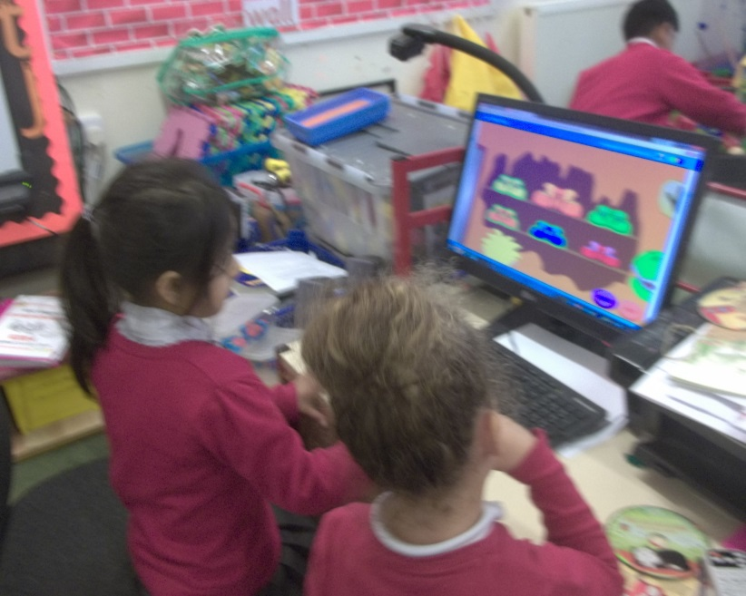
Learning and Development

Play and Exploration
“Children’s play reflects their wide ranging and varied interests and preoccupations. In their play children learn at their highest level. Play with peers is important for children’s development.”
Through play our children explore and develop learning experiences, which help them make sense of the world. They practise and build up ideas, and learn how to control themselves and understand the need for rules. They have the opportunity to think creatively alongside other children as well as on their own. They communicate with others as they investigate and solve problems. They express fears or re-live anxious experiences in controlled and safe situations.
To further support the children's learning through play and experiences; we have on site a Forest School area. In small groups the children have a block of ten afternoon sessions at a time. We also have a Mud Kitchen area, which they access every day. The children gain so much from both these facilities

Effective/Active Learning
“Children learn best through physical and mental challenges. Active learning involves other people, objects, ideas and events that engage and involve children for sustained periods.”
The Characteristics of Effective Learning are:
Playing and exploring – engagement
Finding out and exploring
Playing with what they know
Being willing to ‘have a go’
Active learning – motivation
Being involved and concentrating
Keeping trying
Enjoying achieving what they set out to do

Creating and thinking critically – thinking
Having their own ideas
Making links
Choosing ways to do things
Effective, Active and Engaged learning occurs when children are motivated and interested. Children need to have some independence and control over their learning. As children develop their confidence they learn to make decisions. It provides children with a sense of satisfaction as they take ownership of their learning.

Creativity and Critical Thinking
“When children have opportunities to play with ideas in different situations and with a variety of resources, they discover connections and come to new and better understandings and ways of doing things. Adult support in this process enhances their ability to think critically and ask questions.”
Children should be given opportunity to be creative through all areas of learning, not just through the arts. Adults can support children’s thinking and help them to make connections by showing genuine interest, offering encouragement, clarifying ideas and asking open questions. Children can access resources freely and are allowed to move them around the classroom indoors and out to extend their own learning.

Areas of Learning and Development
The EYFS /Development Matters are made up of seven areas of learning:
Personal, Social and
Emotional Development
Making relationships
Self-confidence and self-awareness
Managing feelings and behaviour
Physical Development
Moving and handling Prime areas of learning
Health and self-care
Communication and Language
Listening and attention
Understanding
Speaking

Literacy
Reading
Writing
Mathematics
Numbers
Shape, space and measure
Understanding the World
People and communities Specific areas of learning
The world
Technology
Expressive Arts and Design
Exploring and using media and materials
Being imaginative
None of these areas can be delivered in isolation from the others. They are equally important and depend on each other. All areas are delivered through a balance of adult led and child initiated activities. In each area there are Early Learning Goals (ELG’s) that define the expectations for most children to reach by the end of the EYFS.

Monitoring and review
It is the responsibility of the EYFS teachers to follow the principles stated in this policy. There is a named Governor responsible for the EYFS. This Governor will discuss EYFS practice with the practitioners regularly and provide feedback to the whole Governing Body, raising any issues that require discussion. The Head teacher and subject coordinator will carry out monitoring on the EYFS as part of the whole school monitoring schedule. Sandwell's Early Year's advisors also regularly monitor the Foundation Stage's assessment programme.
Policy Reviewed March 2016

